This document is a guide on Python submission presentation. If homework is not presentable, it will fail; even if all of the code runs properly. We are trying to instill the concepts used in Finance. If a submission receives poor marks for presentation you can be sure it would make your manager unhappy in a real job. We are trying to prepare you to avoid this. Below are tips. Please read them ALL.

**1. Properly commenting your code. Below is a good example from a recent student:**

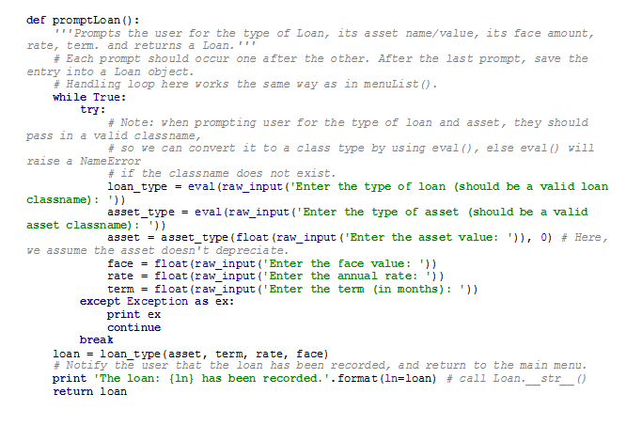

Some tips:

1. Each block of code or function should have a comment explaining its purpose
2. Each loop or statement should have a comment explaining what it is doing
3. If there are any conditions or errors, they should be explained in the comments
4. Too much commenting is GOOD commenting!

**2. Folder structure for your homework submission. You must follow this folder structure and the file naming conventions:**

STUDENTNAME_HOME_LEVEL1.ZIP>>

STUDENTNAME _LEVEL1_ROOT_FOLDER>>

1.1>>

1.1.1_to_1.1.3>>

__init__.py

1.1.1_to_1.1.3_main.py

1.1.4>>

__init__.py

1.1.4_main.py

1.2>>

1.2.1>>

…

1.3>>

Etc.

So the breakdown should be: ZIPFILE >> ROOT >> SECTIONS >> SINGLE QUESTION >> Init and main file

Just to clarify the above structure:

1. Make sure you have a __init__.py file in every Python folder
2. Have a folder for each section
3. Have a folder for each question within each section, though if a few are related (like 1.1.1🡪 1.1.3 you may group them together.
4. Your original zip file should contain a ROOT folder with all of the section folders within it.

**3. Outputs should have comments too!**

If the question asks for the Mean of a list, most students would just output as follows:

OUTPUT:

2.3

A much nicer output would be:

OUTPUT:

Mean: 2.3

Try to do this as much as possible. My viewing an output with a bunch of random numbers can get very confusing. Please clarify what the values are in the output.