**Colab (Google Colaboratory)** [**https://colab.research.google.com**](https://colab.research.google.com)

**Xinyao Wang**

1. Software compatibility with GitHub: How easy is it to integrate the technology with Github or other sources?

Answer: Very convenient. I will use this following Github provided by professor: <https://github.com/ravichas/ML-TC1> (Machine Learning) as an example.

Using Google Colab, it only takes one step to link with Github. When you open Google Colab using your own gmail, this is a section that you can put Github url and authorize Colab to link with you Github.

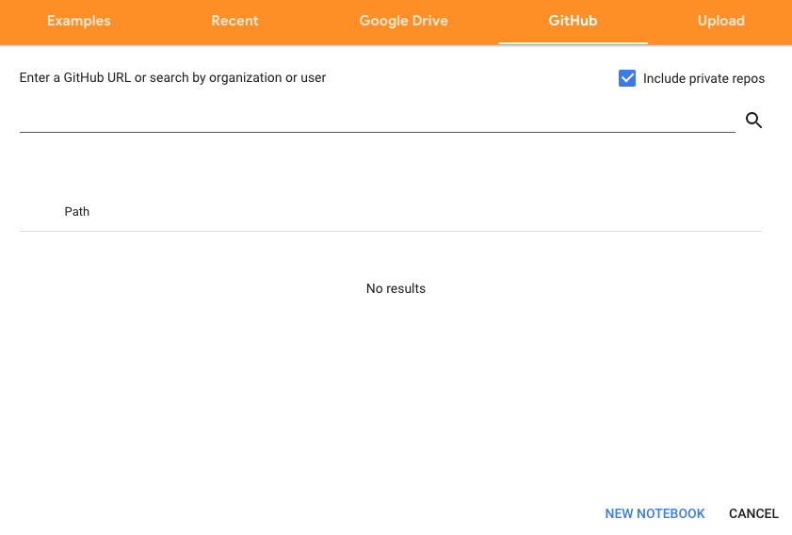

1. User friendliness:
   1. Packages: Many packages are already installed for users. You can check using !pip freeze command. You can install any packages you want using !pip install command.(! is needed before pip)
   2. Configuration/traffic:
      1. Default 13GB of RAM with maximum extension of 25GB
      2. Disk Space: free 100 GB
      3. 2vCPU @2.2GHz
      4. Idle cut-off 90 minutes
      5. Maximum run time of 12 hours
   3. Real-time Collaboration: Yes.
   4. Sharable: Yes.
   5. Keep as a private / local file: Yes
   6. Internet access: Yes
   7. Shortcuts: similar to Jupyter Notebook.
   8. Version Control: Use %tensorflow_version 1.x to check the version of tensorflow. If want to change version, use this following reference:

<https://colab.research.google.com/github/jrjohansson/scientific-python-lectures/blob/master/Lecture-7-Revision-Control-Software.ipynb>

1. Supporting Languages: over 40 programming languages including Python, R, Julia, Scala, etc.
2. Customizability (&ease) of the configuration file:

Not able to adjust configuration files.

1. Speed of deployment:

Instantly.

1. How effective is it to use these cloud deployments for running a workshop/teaching?

Google Colab has been widely used for work and education for several year. For example, in some of classes from our Columbia University, professors used Colab for in class exercise.

Specifically, for the predict-drugclass.ipynb notebook, we should follow these procedures. Firstly, we need to install RDkit package in the beginning, which is one of the three packages that we need to manually install. Then we need to switch to the correct folder to let images from Img folder show, by cloning original Github repository to Colab page. Lastly, using !pip install command for py3Dmol and Mordred packages to Colab environment. Here is Colab version after doing these steps: <https://colab.research.google.com/github/ellen26/FNL-BIDS-Project5-Colab/blob/master/ML-predict-drugclass/predict-drugclass-colab.ipynb#scrollTo=tmFOWhjB9_aK>

Pros:

1. Directly show the output for Github notebook
2. High speed for installing packages and running codes
3. Easy to link with Github account
4. Large RAM and disk space
5. Reader could run and edit the code directly
6. Free
7. Many resources and tutorials online

Cons:

1. Need to use personal Gmail rather than Edu Gmail
2. Need to refresh and save file often when multiple people working on same Colab file

Related Reference:

<https://colab.research.google.com/github/googlecolab/colabtools/blob/master/notebooks/colab-github-demo.ipynb>

<https://www.youtube.com/watch?v=ERvUf_lNopo&t=78s>