WP_analysis

library('RSQLite')  
mydb <- dbConnect(RSQLite::SQLite(), "flights.sqlite")   
dbListTables(mydb)

## [1] "airlines" "airports" "cities" "ny_flights" "stocks"

airlines<-dbGetQuery(mydb, 'SELECT * FROM airlines')   
airports<-dbGetQuery(mydb, 'SELECT * FROM airports')  
cities<-dbGetQuery(mydb, 'SELECT * FROM cities')  
ny_flights<-dbGetQuery(mydb, 'SELECT * FROM ny_flights')

ds=list(airlines=airlines, airports=airports, cities=cities, ny_flights=ny_flights)  
ds2=list("airlines", "airports", "cities", "ny_flights")  
for (i in 1:length(ds)){  
 print(ds2[[i]])  
 print(c('rows:', nrow(ds[[i]])))  
 print(c('cols:', length(ds[[i]])))   
 print(c('missings:', sum(!complete.cases(ds[[i]]))))  
 print(c('duplicates:', anyDuplicated(ds[[i]])))  
 print(' ')   
}

## [1] "airlines"  
## [1] "rows:" "1665"   
## [1] "cols:" "3"   
## [1] "missings:" "0"   
## [1] "duplicates:" "0"   
## [1] " "  
## [1] "airports"  
## [1] "rows:" "6520"   
## [1] "cols:" "3"   
## [1] "missings:" "1"   
## [1] "duplicates:" "0"   
## [1] " "  
## [1] "cities"  
## [1] "rows:" "5898"   
## [1] "cols:" "2"   
## [1] "missings:" "0"   
## [1] "duplicates:" "0"   
## [1] " "  
## [1] "ny_flights"  
## [1] "rows:" "825413"  
## [1] "cols:" "23"   
## [1] "missings:" "25158"   
## [1] "duplicates:" "0"   
## [1] " "

#(2) data cleaning;  
nrow(ny_flights)

## [1] 825413

ny_flights<-ny_flights[which(ny_flights$cancelled==0 & ny_flights$'diverted'==0), ]  
nrow(ny_flights)

## [1] 801595

citylt<-list()   
for (i in 1:nrow(cities)){   
 citylt[[i]]<-cities[i, 2]  
}  
names(citylt)<-cities[, 1]  
ny_flights$origin_city_market_nm<-citylt[as.character(ny_flights$origin_city_market_id)]  
ny_flights$dest_city_market_nm<-citylt[as.character(ny_flights$dest_city_market_id)]  
  
#merge airline names;   
airlns<-list()  
for (i in 1:nrow(airlines)){  
 airlns[[i]]<-airlines[i, "airline_name"]  
}   
names(airlns)<-airlines[, 'id']   
ny_flights$op_carrier_airline_nm<-airlns[as.character(ny_flights$op_carrier_airline_id)]  
  
#merge airport names;   
airpts<-list()  
for (i in 1:nrow(airports)){  
 airpts[[i]]<-airports[i, "airport_name"]  
}   
names(airpts)<-airports[, 'id']   
ny_flights$origin_airport_nm<-airpts[as.character(ny_flights$origin_airport_id)]  
ny_flights$dest_airport_nm<-airpts[as.character(ny_flights$dest_airport_id)]   
  
#add date features;   
ny_flights$fl_wkday <- weekdays(as.Date(ny_flights$fl_date))  
# unique(ny_flights$fl_wkday)  
ny_flights$fl_yr<-as.numeric(format(as.Date(ny_flights$fl_date, format="%Y-%m-%d"), '%Y'))  
ny_flights$fl_mon<-as.numeric(format(as.Date(ny_flights$fl_date, format="%Y-%m-%d"), '%m'))   
#define the route for analysis;   
orig_arpts=c(12953, 12478, 11618)  
dest_arpts=c(13930)  
routes<-ny_flights[which(ny_flights$origin_airport_id %in% orig_arpts & ny_flights$dest_airport_id %in% dest_arpts), ]   
  
table(routes$fl_yr)

##   
## 2018 2019   
## 10285 8702

table(routes$fl_yr, routes$fl_mon)

##   
## 1 2 3 4 5 6 7 8 9 10 11 12  
## 2018 0 0 0 0 0 1509 1490 1509 1462 1569 1396 1350  
## 2019 1333 1357 1531 1488 1527 1466 0 0 0 0 0 0

routes<-routes[routes$fl_yr==2018, ]  
nrow(routes)

## [1] 10285

# duplicated(routes)   
  
#(3) Visualizations;   
library("ggplot2")   
install.packages('ggthemes')

##   
## There is a binary version available but the source version is later:  
## binary source needs_compilation  
## ggthemes 3.4.0 4.2.0 FALSE

## installing the source package 'ggthemes'

library('ggthemes')  
test<-ny_flights  
  
#plot3;   
b<-ggplot(data=test, aes(x=distance))   
b2<-b+geom_density(color="black", fill="#0073C2FF", alpha=0.6,size=0.5, kernel='gaussian') #alpha: color depth; linetype='dotted',  
b2<-b2+labs(title="Density Plot of Flights Distance", y="Density", x="Distance Range")   
b2<-b2+theme(plot.title = element_text(color = "black", size = 12, face = "bold", hjust = 0.5, margin=margin(0,0,10,0)),  
 axis.title.x = element_text(family = "sans", size = 10, margin=margin(5,0,0,0)),  
 axis.title.y = element_text(family = "sans", size = 10, margin=margin(0,10,0,0)),   
 plot.margin=unit(c(0.3,0.3,0.3,0.3),"cm"), axis.ticks=element_blank())  
b2

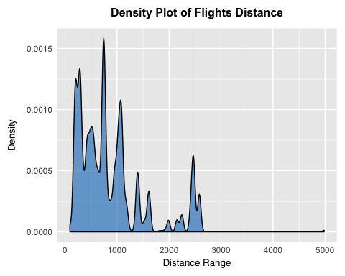

#plot5;   
d<-ggplot(data=test, aes(x=dep_delay, y=actual_elapsed_time))  
d<-d+geom_point(color="lightpink1")+geom_smooth(se=TRUE, linetype="solid", color="maroon1", size=0.8)   
d<-d+labs(title="Departure Delay v.s. Flight Elapsed Time", y="Elapsed Time (min)", x="Departure Delay (min)")   
d<-d+theme(plot.title = element_text(size = 10))  
d+theme_clean()

## `geom_smooth()` using method = 'gam' and formula 'y ~ s(x, bs = "cs")'

## Warning: Removed 936 rows containing non-finite values (stat_smooth).

## Warning: Removed 936 rows containing missing values (geom_point).

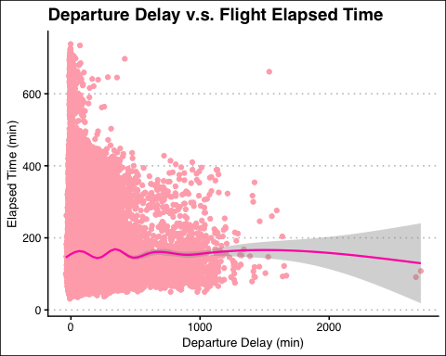

#plot6;   
temp1<-as.data.frame(table(ny_flights[ny_flights$fl_yr==2018, "op_carrier_airline_id"]))  
temp2<-as.data.frame(table(ny_flights[ny_flights$fl_yr==2019, "op_carrier_airline_id"]))  
temp1['year']<-2018  
temp2['year']<-2019  
temp<-rbind(temp1, temp2)  
temp<-merge(x=temp, y=airlines[airlines$id %in% temp1$Var1, ], by.x="Var1", by.y="id", all.x=TRUE)  
temp<-temp[, c("airline_name", "Freq", "year")]  
f<-ggplot(data=temp, aes(x=airline_name, y=Freq, fill=as.factor(year), group=as.factor(year)))  
f<-f+geom_bar(stat="identity") #width=0.5, position="dodge"  
f<-f+coord_flip(ylim=c(5, 12000))+scale_color_hue(l=40, c=35)  
f<-f+labs(title="Flight Voulme by Airline", y="Airline Volume", x="")   
f<-f+theme(legend.title = element_blank(),   
 legend.text=element_text(size=8),   
 plot.title = element_text(color = "black", size = 12, face = "bold", hjust = 0.5, margin=margin(0,0,10,0)),  
 axis.title.x = element_text(family = "sans", size = 10, margin=margin(5,0,0,0)),  
 axis.title.y = element_text(family = "sans", size = 10, margin=margin(0,10,0,0)),   
 plot.margin=unit(c(0.3,0.3,0.3,0.3),"cm"), axis.ticks=element_blank())  
f+scale_fill_brewer(palette="Set2", direction = -1)

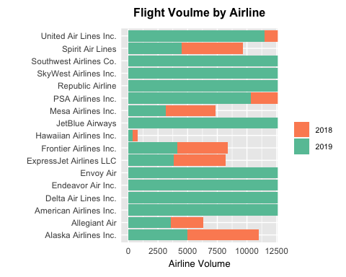

#plot4;   
b3<-b+geom_area(stat="bin", fill="deepskyblue3", alpha=0.5, bins=40)+theme_classic()  
b3<-b3+geom_vline(aes(xintercept=mean(distance)), color="blue", linetype="dashed", size=1)  
b3<-b3+labs(title="Density Plot of Flights Distance", y="Density", x="Distance Range")   
b3

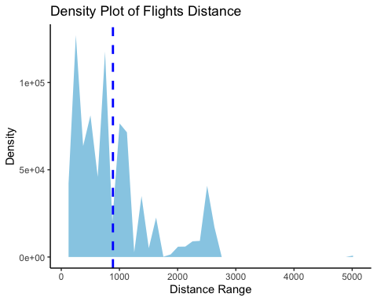

#plot1;   
a1<-table(test$fl_wkday)  
a1<-round(a1/sum(a1), 2)   
a1<-as.data.frame(a1)   
a2<-ggplot(data=a1, aes(x="", y=Freq, fill=Var1))   
a2<-a2+geom_bar(stat='identity', width=3)+coord_polar(theta="y", start=0)+scale_fill_brewer(palette=1)  
a2<-a2+labs(title="Distribution of Weekday Flights Volume", y="", x="")+theme_classic()   
a2<-a2+theme(legend.title = element_blank(),   
 legend.text=element_text(size=8),   
 legend.background = element_rect(color = NA),   
 plot.title = element_text(color = "black", size = 11, face = "bold", hjust = 0.5),   
 plot.margin=unit(c(0.4,0.2,0.01,0.2),"cm"))  
print(a2)

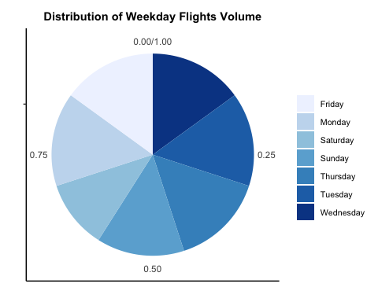

#plot2;   
b<-ggplot(data=test, aes(x=distance))   
b1<-b+geom_freqpoly(bins=20, color='royalblue4')+theme_economist()   
b1<-b1+labs(title="Majority of Flights Distance Stay between [0, 2000]", y="# of Flights", x="Distance Range")  
b1<-b1+theme(plot.title = element_text(color = "black", size = 13, face = "bold", hjust = 0.5, margin=margin(0,0,20,0)),  
 axis.title.x = element_text(family = "sans", size = 10, margin=margin(10,0,0,0)),  
 axis.title.y = element_text(family = "sans", size = 10, margin=margin(0,10,0,0)),   
 plot.margin=unit(c(0.3,0.3,0.3,0.3),"cm"), axis.ticks=element_blank())   
print(b1)

