Methods:

Chose a site at the southwest of Loch Morlich which had been felled recently. Found the centre point of our site which had coordinates 57.1571804N, 3.7300502W. We then randomly located 6 sample sites from here by using a random number generator between 0-100 to determine how many metres away from the centre point to go. We then had another random number generator between 1-4 to determine which direction to go out of NESW. The decision was made to avoid any digging of soil that would disturb any juvenile trees which had been planted in the area. We used a compass and a tape measure to locate the correct sites. At each sample site we used a shovel to dig up two shovels worth of soil which we put in a tray ready to all be mixed. We removed any vegetation from the soil before digging. We also only removed soil from the topsoil (top 20cm).

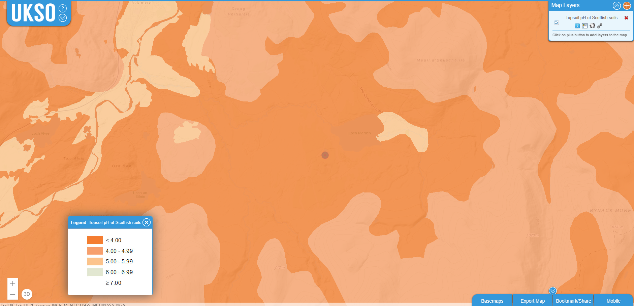

Lab-

Soil was prepared by mixing all the soil collected on site into one bulk soil, this was then sieved in 2mm sieves to remove any rocks/vegetation and insure all the soil grains are of uniformed size while further ensuring that the soil collected was homogenised.

To test the soil characteristics, we used a 20mL of a 0.01M calcium chloride solution with 2g of the 0%, 0.5%, 1%, 3%, 5% ochre soil into a 50mL centrifuge tube, repeating this 3 times for each ochre level. This was then shaken in an end-over shaker for 15 (5 minutes? - Ellen) minutes. Using a pH meter, after calibration, we measured the pH of all samples. (0% soil was measured wet, and all the other % were measured dry – don’t know if we want to mention this).

To measure the effect of Ochre we then separated the soil into aluminium drying pans labelled 0%, 0.5%, 1%, 3%, 5%, these containers weights where measured and then dried at 105oc for 2 hours, to remove any excess water, weighing the dried soil to measure water content in the soil samples. Each container had 100g of dried soil adding 0g, 0.5g, 1g, 3g, 5g of Ochre.

For each of the five ochre percentage treatments, 2 g of soil was weighed into centrifuge tubes. 20ml of phosphorus loading solution at one of five concentrations (0, 5, 10, 20, or 40 mgL) was added to each tube, with deionised water used for the 0 mg/L control. Each combination of ochre percentage and phosphorus concentration was repeated 3 times, resulting in 15 samples per ochre treatment and a total of 75 centrifuge tubes.

We performed a blank treatment to ensure there is no contamination throughout the process.

These samples were then shaken in an end-over shaker for 1 hour. Samples were then centrifuged at 8000 rpm for 5 minutes, we then removed 10ml of supernatant using a syringe and filter through a 0.45um syringe into labelled Sterlin tube ( same labels as previously used ( i.e 0%, 5mg/l , 1).

Centrifuged samples were then diluted based on the concentration of phosphate we added, so they could be scaled appropriately based on our calibration curve. Need to explain how we made our calibration curve.

Dilutions used:

|  |  |  |
| --- | --- | --- |
| P addition amount mg P L-1 | Volumes used for dilution | |
| Supernatant /ml | DI Water /ml |
| 5 | 1 | 9 |
| 10 | 1 | 9 |
| 20 | 0.5 | 9.5 |
| 40 | 0.5 | 19.5 |

Measuring phosphorous concentrations from the supernatant:

* Measure 10ml of filtered sample into a 15ml centrifuge tube (DI water as a blank)
* Add 1ml of mixed reagent into each tube, cap and swirl to mix
* After 5 mins measure the absorbance in a 1cm cuvette (after zeroing the spectrometer using DI water at 880nm)

**pH Adjustment methods**

2g of 3% ochre adjustment was added into 15 centrifuge tubes and 20ml of phosphorus loading solution at a c 20mg/L concentration was added.

The pH of the samples was measured with them averaging at around a pH of 5. 3 samples were left with a pH of 5 and the others were adjusted so that there were 3 replicates for pH’s of 3,4,6&7 as well.

A diluted solution of sodium hydroxide was used to increase the pH of the samples increased to 6/7 pH. The diluted solution was made up of 1ml of sodium hydroxide and 10ml of distilled water. Each sample was placed under the pH reader and drops of the solution were added until the desired pH was reached.

A diluted solution of nitric acid was used to lower the pH for the samples with a pH of 3/4. It was made using 1ml of nitric acid and 5 ml of distilled water. Drops of this were then added until the desired pH was reached.

Each sample had a metallic pill in to mix it whilst we were adding the different solutions to make sure we would get accurate pH readings.

Example results table showing our conditions:

|  |  |  |  |  |  |
| --- | --- | --- | --- | --- | --- |
| Ochre amendment level (%) |  | | | | |
| Phosphorous amendment (mg P L-1) | | | | |
| 0 | 5 | 10 | 20 | 40 |
| 0 |  |  |  |  |  |
| 0.5 |  |  |  |  |  |
| 1 |  |  |  |  |  |
| 3 |  |  |  |  |  |
| 5 |  |  |  |  |  |

Limit of detection:

* Calculated on blanks
* Repeat x3
* = mean of three blanks + the standard deviation of the blanks
* Include soil maps – potentially in the appendix – find from digimap
* Blanks of deionised water

<https://www.pda.org.uk/soil-texture-and-ph-effects-on-potash-and-phosphorus-availability/>

<https://www.mdpi.com/2073-4441/17/7/998>

* Under conditions ranging from pH 3.0 to 8.5, the adsorption of phosphate in soil decreases with increasing pH, consistent with reported behaviors of phosphate adsorption on minerals such as iron oxides and aluminum oxides ([**Figure 5**](https://www.mdpi.com/2073-4441/17/7/998#fig_body_display_water-17-00998-f005)) [[**13**](https://www.mdpi.com/2073-4441/17/7/998#B13-water-17-00998),[**15**](https://www.mdpi.com/2073-4441/17/7/998#B15-water-17-00998),[**45**](https://www.mdpi.com/2073-4441/17/7/998#B45-water-17-00998),[**46**](https://www.mdpi.com/2073-4441/17/7/998#B46-water-17-00998)]///////////////////////////////////

Advice from Helene:

* Make a diagram about how we chose our sites
* Justify why we used the loading solutions in the introduction, but if we think it fits in the methods better then that’s fine

We wanted to load with >5 mg/l so that we can see the effect of ochre, we needed to saturate the soil enough so this effect is visible

* Always mentions a figure in the text before you insert the figure
* In the caption, describe perfectly what the figure shows e.g. grouped bar graph showing the amount of P removed in percentage grouped by ochre amendement (include units)

Repeat ALL units in the figure caption

Say all the axis, say all the colours, say all the units, also include the number of samples (N= x)

* Discussion 🡪 really important to talk about the chemical principles, talk about the chemical principles that cause what is happening in the soil e.g. cation bridging, find papers that explain what the oxides do to the phosphates
* Be consistent with terminology e.g. loading (how much P was added), amendment (ochre level) and leaching (phosphate that comes off in the end)
* We spiked with phosphate, we’re measuring phosphate with the calibration curve – use phosphate throughout the paper, with an exception of when we’re citing other papers that refer to phosphate
* At least 20 references – properly read at least 5-6 papers, another 5 where you take parts from different sections etc.
* In conclusion, repeat the question, repeat what you found, the implications
* In