CS 349: Final

I chose Option 1, with the Coronavirus dataset from Johns Hopkins University. I visualized all three experiments which were provided with the dataset. Here is a link to the code and images: <https://github.com/ellencwade/coronavirus-2020>

Visualization 1: KNN_Raw

My code (viz_raw_manhattan.py and viz_raw_minkowski.py) visualized the results of knn_raw.py on the time_series_covid19_confirmed_global data to show similar countries’ data on one plot. Plots for all countries are in the exp/results folder. Below are some examples.

1a: Using Manhattan distance (in raw_manhattan folder)

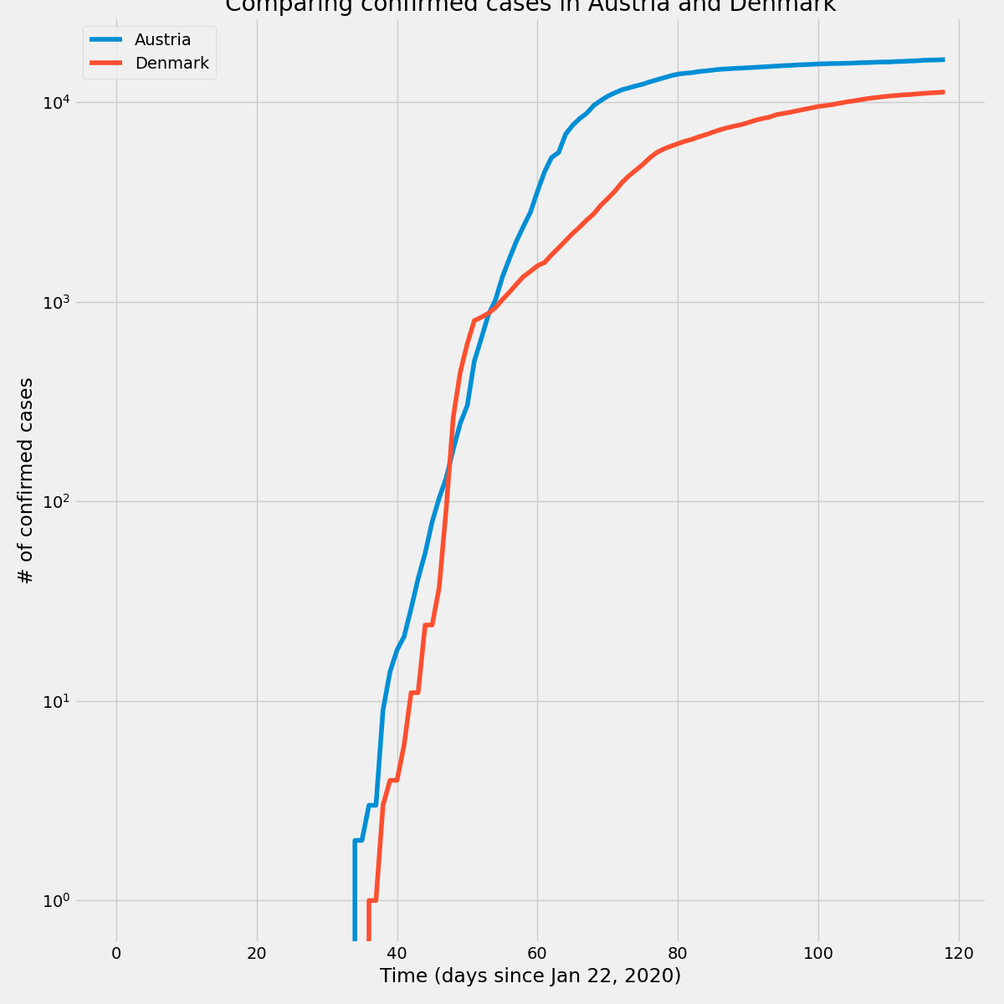  
Figure 1: Confirmed Cases in Austria vs Denmark

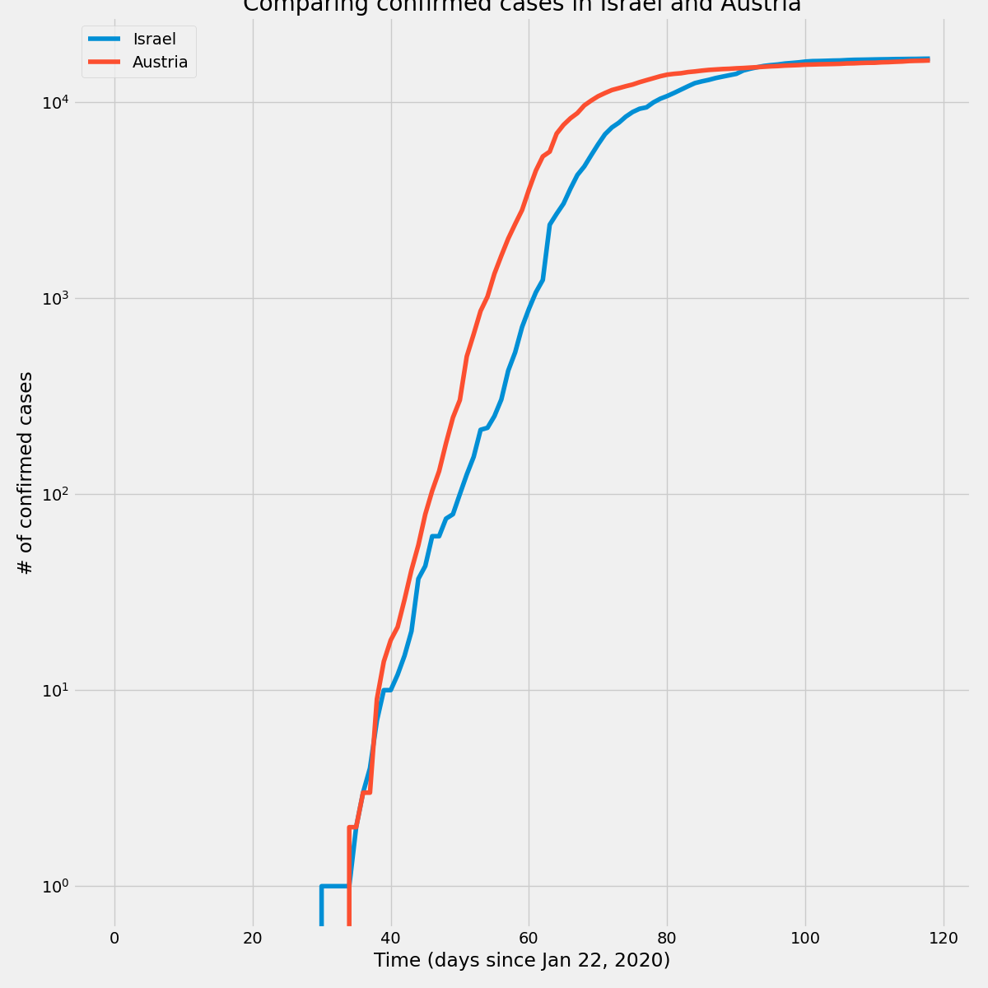  
Figure 2: Confirmed Cases in Israel vs Austria

1b: Using Minkowski distance (in raw_minkowski folder)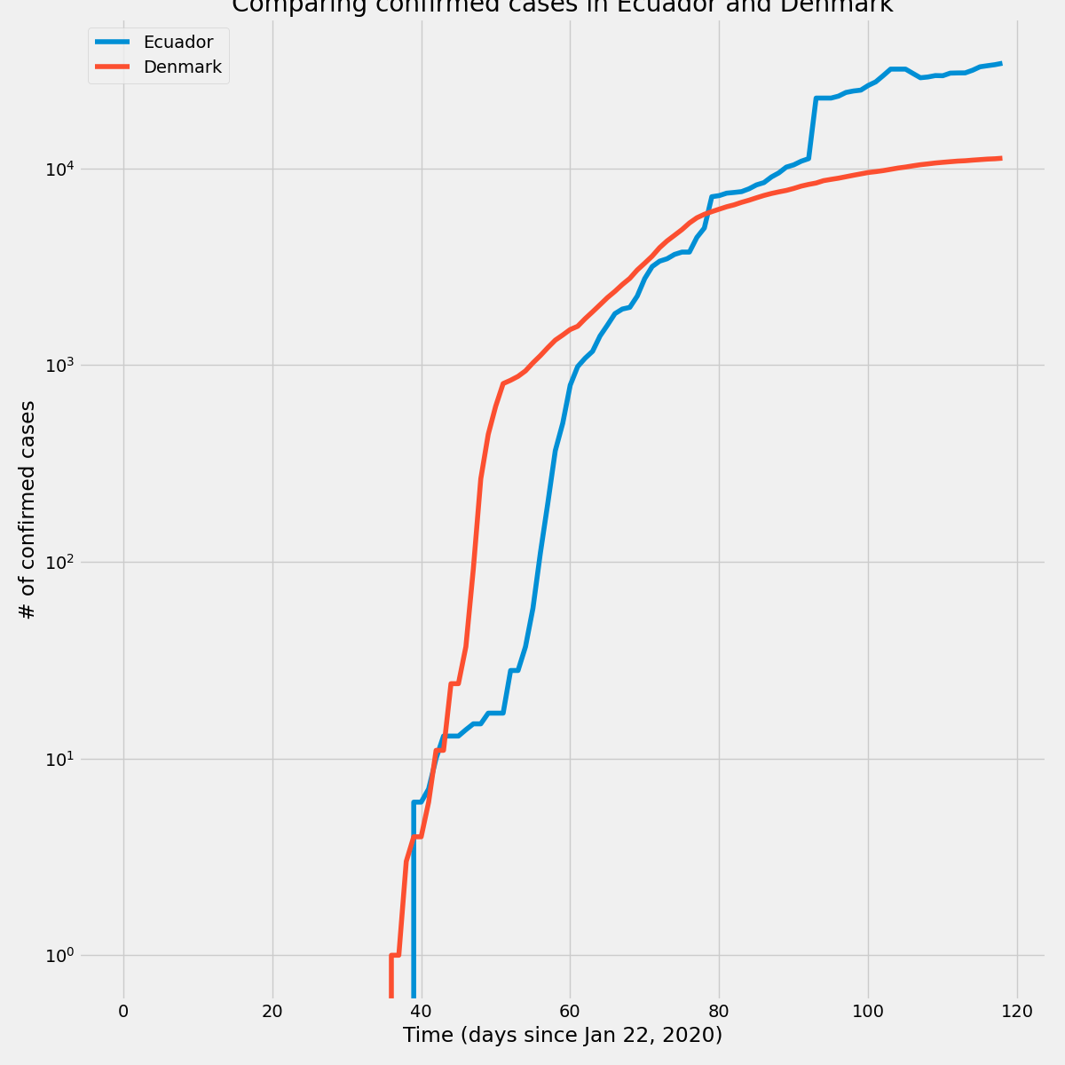  
Figure 3: Confirmed Cases in Ecuador vs Denmark

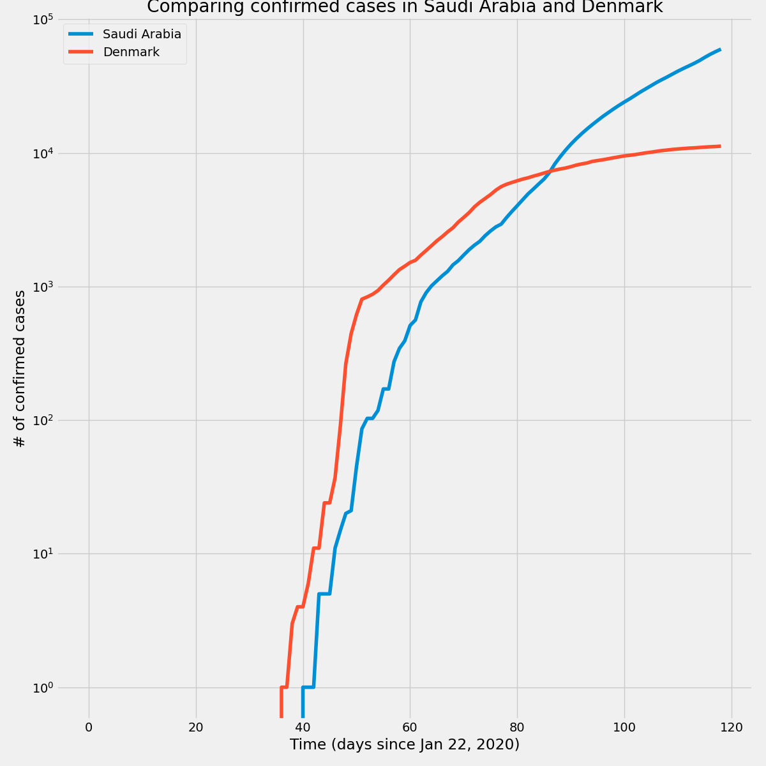  
Figure 4: Confirmed Cases in Saudi Arabia vs Denmark  
  
Visualization 2: KNN_Diff

My code (viz_diff_manhattan.py and viz_diff_minkowski.py) visualized the results of knn_diff.py on the time_series_covid19_confirmed_global data to show similar countries’ data on one plot. Plots for all countries are in the exp/results folder. Below are some examples.

2a: Using Manhattan distance (in diff_manhattan folder)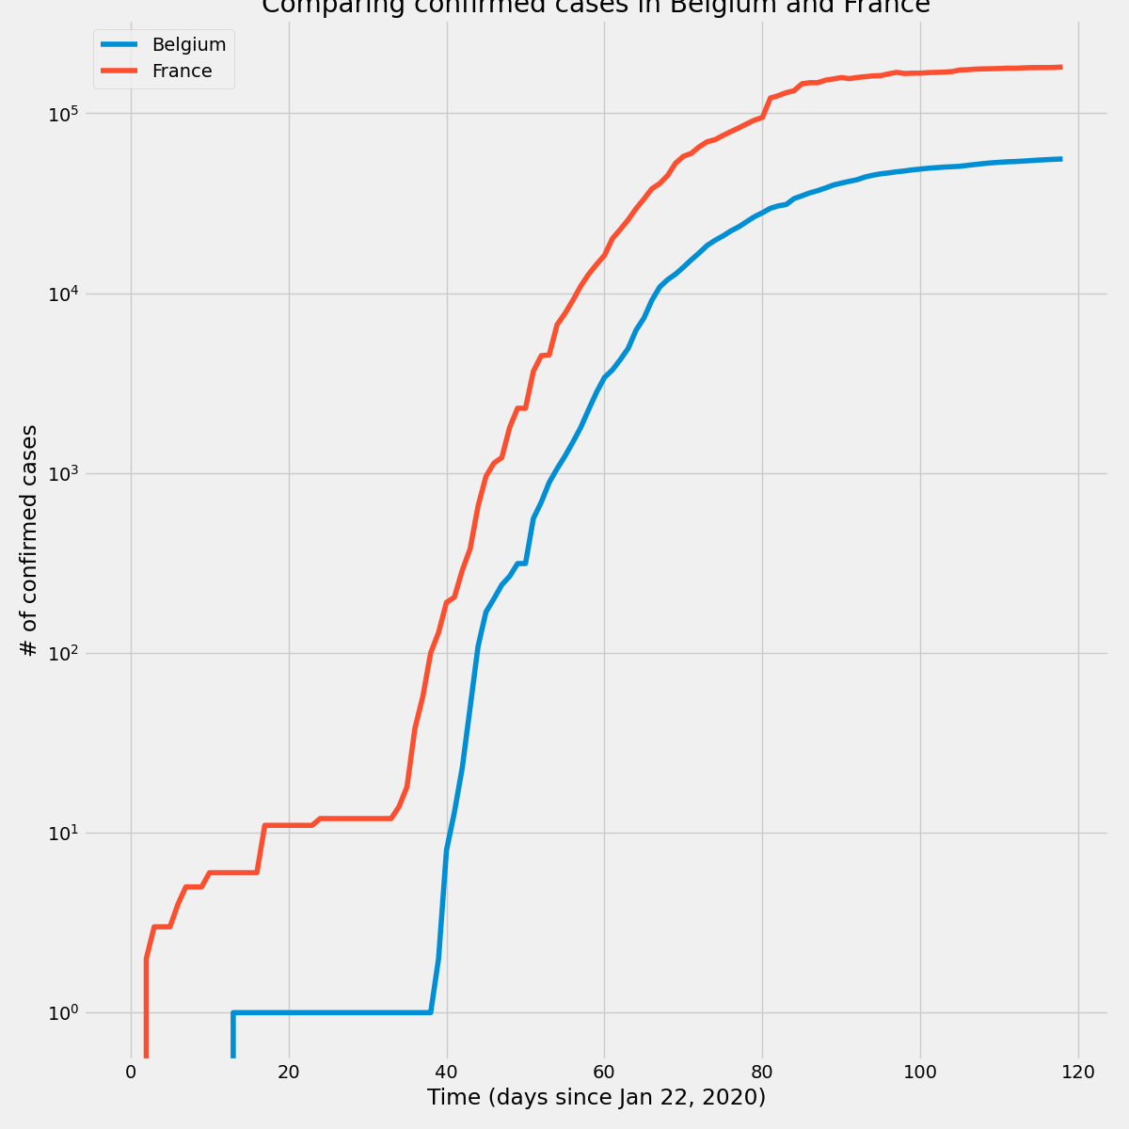

Figure 5: Confirmed Cases in Belgium vs France

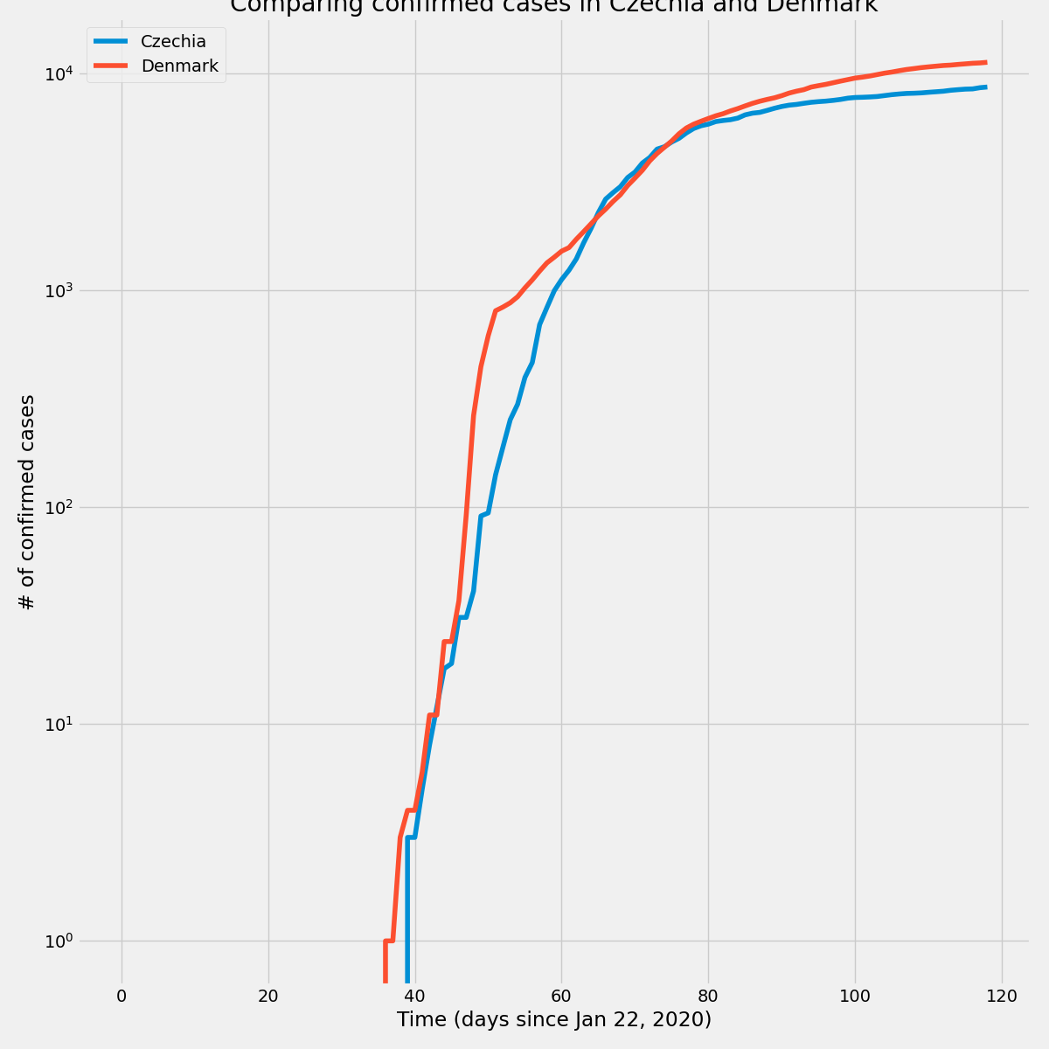

Figure 6: Confirmed Cases in Czechia vs Denmark  
  
2b: Using Minkowski distance (in diff_minkowski folder)  
Figure 7: Confirmed Cases in Israel vs Austria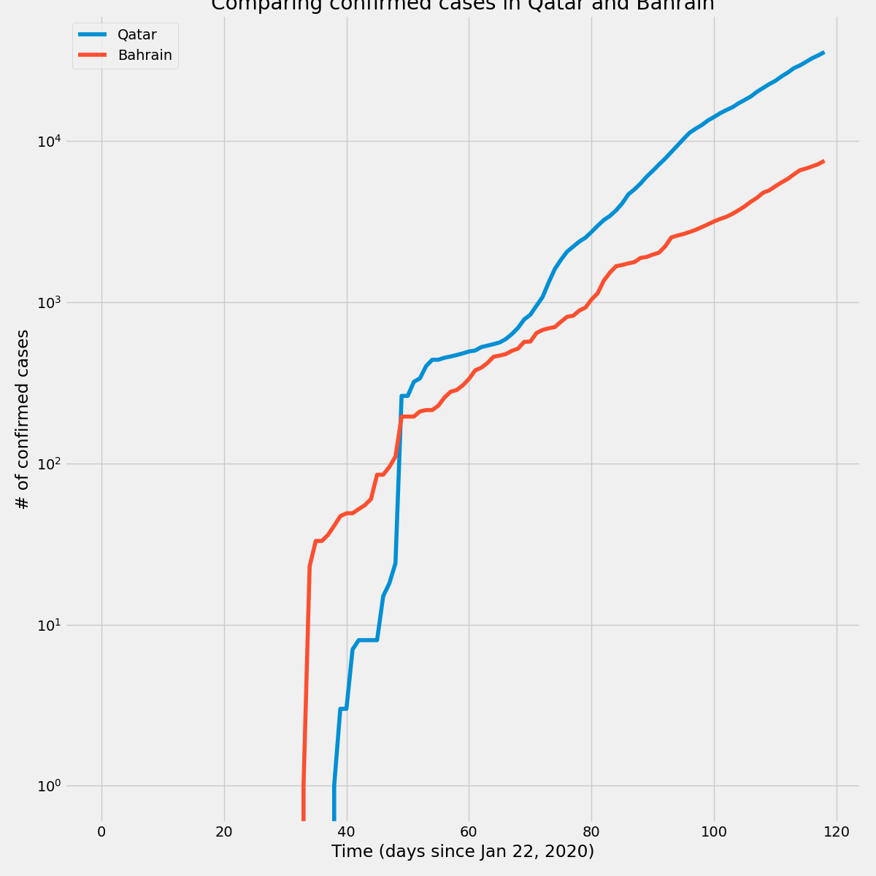

Figure 8: Confirmed Cases in Qatar vs Bahrain  
  
Visualization 3: KNN_Dist_Diff

My code (viz_dist_diff_manhattan.py and viz_dist_diff_minkowski.py) visualized the results of knn_dist_diff.py on the time_series_covid19_confirmed_global data to show similar countries’ data on one plot. Plots for all countries are in the exp/results folder. Below are some examples.

3a: Using Manhattan distance (in dist_diff_manhattan folder)

Figure 9: Confirmed Cases in Norway vs Austria

Figure 10: Confirmed Cases in Qatar vs Bahrain

1a: Using Minkowski distance (in dist_diff_minkowski folder)

Figure 11: Confirmed Cases in Iceland vs Bahrain

Figure 12: Confirmed Cases in South Africa vs Bahrain