**LiDAR CORRESPONDENCES**

Nov. 28-29, 2023

[ELLEN] Hi Jeff!! Do you have the LiDAR zone info for SAAN and PAAL? I couldn't find anything for those two parks in the LiDAR data you sent, unless they are under different names? For example, I saw there was an "Ra" and also some other park unit codes that I don't have bird data for--so maybe the names are just different

Also, there seem to be data for which the AREA is much smaller than I would expect for that circle radius. For example, for 200m radius I would expect an area approx. pi*200^2, but some are much smaller area than that. Does that mean those circles extended beyond the park boundaries, so LiDAR data are only available for part of the circle? Similarly, there are data rows with much smaller Count values than other records of the same circle radius. If Count is the number of pixels, what would cause Count values to be much smaller--does that mean the circle overlapped water or something like that, so LiDAR data are only available for part of the circle (though I would then expect Area to also be smaller for those)?

[JEFF] probably best to talk thru some of the spatial overlap issues with shared desktop.  Let me know if you have some time this week. we have other issues to . . . it seems as though I extracted densities for location ids as they are published in the protocol, while u have table(s) extracted from the DB with a different a format for ids.  These crosswalk fine for point numbers, but the coding conventions are different (see crosswalk table).  A third issue is that the DB locations in a few instances (no match in the attached table) are different than the protocol locations.  I think some points were moved bc of road noise, etc . . . I hope that the locations that I used from the protocol are accurate and the DB just isn't up-to-date? - I'll have to confer with Whitney on that one

[ELLEN]

[11:55 AM] Cheng, Ellen

How much do you think the LiDAR information at a site would change say over the course of a few years? Because the LiDAR information is for understory, and it's for a single year, but would we not expect the understory height to change much?

[11:56 AM] Cheng, Ellen

Also I was a little confused about the example of half the site being bare ground and half being 10m, so mean would be 5m. The half that is 10m would not even be counted in the zone estimates, right, because those estimates are only for vegetation up to 6m height or something?

[JEFF]

overlap with buffers is definitely happening (dunno what to say about that).  understory density may change over time . . . I might be concerned about some of the older lidar, but it prob needs to be considered on a pt by pt basis or at least at the similar-habitat scale

I just finished calculating the mean and standard deviation of vegetation density occurring between 1 and 5m above ground level.  Statistics were generated within 50, 100, and 200 meter buffers of GULN bird monitoring locations.  The attached table has a 'zone' field that identifies the site ID and the buffer size.  I also attached a layer package that could be opened in arcgis to visualize density across the sampling areas (like shown at GUIS NLO in image).  Just let me know if you'd like to chat through the process of calculating density, or the results.

Hi Jeff! I know this is from an embarrassingly long time back and way overdue from me--but can you help me with some fields from this file you sent to me of birds Lidar summaries:

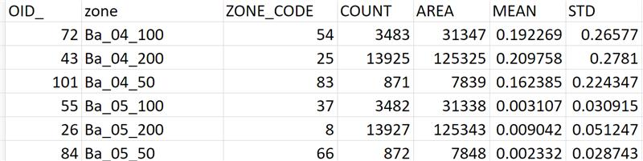

I'm guessing that OID is just an ID that I don't need to worry about. Zone is site and buffer size. Area is the area of the circle for that buffer size so pretty much is similar for all circles of the same buffer size (so I don't need to worry about). Questions then--(1) Mean and SD are mean vegetation height in meters? And if part of that circle is just soil/rock/low grass then it would be counted as nearly 0 height for that part of the circle and would be included in the average height? (2) What are Zone_code and Count?

Hi Ellen. You're intuition is correct about the first few fields mentioned.  (1) Yes, height in meters.  The 'zonal statistics' tool in arcgis does just averages all the cell values within a zone, so half bare earth and half 10m trees equals 5m average height.  To a degree, STD can be used to infer the homogeneity of the heights across zone. (2) Zone code is just an auto-assigned number, much like OID, and can be ignored - 'zone' is the go-to for a unique ID.  Count is simply the count of pixels that intersect with the zone (circular buffer in this case).  Here's a link the description of the tool that I used in arcgis [Zonal Statistics as Table (Image Analyst)—ArcGIS Pro | Documentation](https://pro.arcgis.com/en/pro-app/latest/tool-reference/image-analyst/zonal-statistics-as-table.htm)