**TO DO:**

* **Get STANDISTSAMP, DISTANCE, and gDISTANCE sampling estimates!! – MAKE SURE COVARIATES ARE CENTERED AND STANDARDIZED**
* **ESTIMATING ANNUAL POPULATION DENSITY—WHAT WAS THAT ISSUE I HAD??**
* **Do I need to redo to get trend p-values based on comparing models with and without trends?**
* **For N-mixture, did I just use detections within first 3 bins? I think not… (so can’t do density from abundance)**
* **Table of how other regions/networks analyze their data**
* **Summarize the possibilities and concerns with Solymos approach, which is what their protocol suggested. They think this can be done with the current unlimited bins b/c Solymos allows EDR**
  + **Calculate EDR for the subset of species that I can (i.e., don’t need to combine first two bins) so can see what the 95%CI’s look like and if the EDR’s are large or fairly small**
* **They want to know which common species we would need to combine 0-25 and 25-50 bins for**
* **A summary of park-species for which each of the detection/availability assumptions more or less can be met.**
* **Is observer a significant covariate for ALL approaches (glmm in addition to distance sampling and N-mixture)?**

DATA PRE-PROCESSING—WHAT AND WHY [CHECK THE TEST_START SCRIPT]

* COVARIATES
  + Time since sunrise [how did I calc]
  + Julian prop
  + Landsat
  + Coarse habitat groups
  + Wind—I combined some categories (also did this for others)
* VICK
  + Only used data from Daniel and only used data starting in 2012 (brms notes but all?)
* PAAL
  + Dropped 3 records that were missing the wind covariate (brms notes but all?)
  + Dropped hab_type_100 b/c too many missing (brms notes but all?) <<<
* SAAN
  + Dropped 1 record b/c missing hrs_since_sunrise (brms notes but all?) <<< [I think missing time bin means it was before or after the count]
  + Combined SAAN-RA and SAAN-MI in analyses but included a year*subunit interaction so each subunit has a separately calculated annual estimate and trend unaffected by the other subunit (brms notes but all?)
* GUIS
  + Combined GUIS-FL and GUIS-MS in analyses but included a year*subunit interaction so each subunit has a separately calculated annual estimate and trend unaffected by the other subunit (brms notes but all?)
* ALL SITES
  + There are point count locations that fall partly outside of park boundaries so we only have habitat info for part of the point circle—what to do? [MAKE A LIST OF THESE POINTS AND CHECK IF THEY REALLY FALL OUTSIDE OR IF IT’S JUST MY MAPS]
  + Dropped data with no time recorded—these were detections before or after the actual point count sampling period

THINGS TO DISCUSS

* **JELA trend in % of detections in last distance bin** **[GIVE STATS AND PLOTS OF RESULTING ANNUAL POPULATION ESTIMATES—does this occur for many birds? Is it related to bird abundance, e.g., the more birds the higher % far out? How does it relate to the veg changes that Jane showed? What about PAAL and the other parks?] Could be that with tree loss, the observers can see farther out from point center and that is why % in farthest bin is increasing**
* 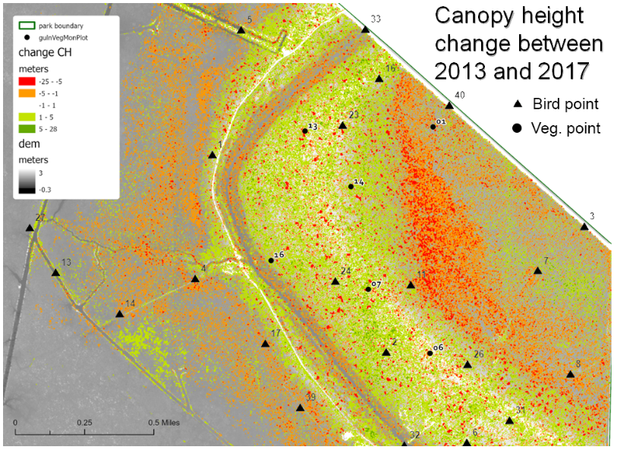
* **LiDAR data as covariate—this is a changing variable, and that needs to be reflected** in the analyses if this will be used as a covariate. How frequently do we need updated Landsat data? It depends on how quickly the understory veg changes over time. How will we account for the missing years of Landsat data? It depends on the nature of understory veg over time—if it’s gradual we can interpolate a rough linear trend. But if there are events like fires that cause sudden changes in the understory veg we can’t do it that way, and we would want to have updated Landsat data when these events occur
* **Cases where the trend estimate and/or CI differed much for glmm vs pcount vs distance** [create plots showing annual estimates and error bars for all the species I looked at—they are interested in this, and not trend]
* **How did repeat samples affect estimates? [Create plots showing annual estimates and error bars for all data vs just using first survey round vs just using the second survey round]**
* **Which park-species can we NOT get distance sampling estimates for?** **[THIS WILL TAKE A WHILE—FIGURE THIS OUT]**
  + Birds that have unusually high or low detections in 0-25m bin, not fitting any distance detection function
  + Birds that are primarily detected far (e.g., American crow)
  + Sites with nonrandom heterogeneity within or immediately around the point count area can bias the distribution of birds w/respect to distance from observer.

INTERPRETATION OF RESULTS

* Bird density in park. Don’t know how much of the park is considered sampleable habitat. For example, dense brush, steep terrain, etc. are all not sampleable and may have bird densities different from sampleable areas. So estimates of density will need the caveat that it pertains to sampleable areas.
* Exclude areas within 50m of road, building, etc. – so for edge species, potentially biasing park estimates low and would need to make that explicit; making inference to areas that are beyond that buffer
* What can they make inference to?
  + JELA- Points restricted to buffered corridors along accessible roads, trails and levees in Barataria Preserve
  + SAAN-All undeveloped areas, whole park
  + PAAL- All undeveloped areas, whole park
  + GUIS-Target unit approach: 13 in the Naval​ Live Oaks unit, 8 at Davis Bayou unit
  + BITH-Target unit, Turkey Creek
  + VICK -All undeveloped areas, whole park [Ellen’s note: But it “looks” like these points are along roads and trails??]

WHAT WOULD IT TAKE TO (POSSIBLY, BUT NOT GUARANTEED) USE THESE APPROACHES MORE RELIABLY? [CONFIRM WITH TOM]

* Distance methods
  + Distance measurements (some combination of these would also be needed calculate EDR with unlimited distance data—CHECK ON THIS??)
    - Additional bin so have AT LEAST 0-50m (to deal with that effect of first bin bias), 50-100, 100-150 (or some or number), OR
    - Estimate of maximum detectable distance so we can put a best-guess end distance on that last bin, OR
    - Estimate distances instead of bins
  + AND only count first auditory detection of a bird (can’t mix visual & auditory b/c these have different distance detection functions)
  + AND for point locations with relevant distance-habitat biases (i.e., the habitat differs in an ecologically meaningful way in the distance bins) we may not be able to use those data
* Time-to-removal
  + More data so we can estimate two-rate functions, OR
  + Distinguishing male vs female or only counting male detections b/c most likely cause of two rates is differences between male and female (though that may not always be the case)
  + As for distance sampling, would want to only count first auditory detection of a bird and drop the visual detections—CHECK ON THIS??