EXERCISE 3
- List all employees whose last names begin with P.
SELECT f_name, l_name
FROM employee_data
WHERE l_name LIKE "P%";
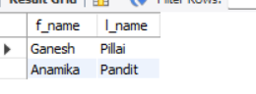

- Display the names of all employees in the marketing division.
SELECT f_name, l_name, title
FROM employee_data
WHERE title LIKE "%Marketing%";
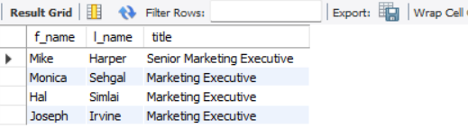
- What will the following statement display SELECT f_name, l_name, salary from employee_data where f_name like '%k%' ;
SELECT f_name, l_name, salary from employee_data where f_name like '%k%' ;
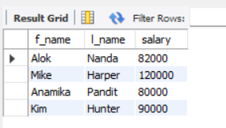
- List the last names and titles of all programmers
SELECT l_name, title
FROM employee_data
WHERE title LIKE "%Programmer%";
