EXERCISE 1
- CREATE DATABASE addressbook;
- DESCRIBE employee_data;
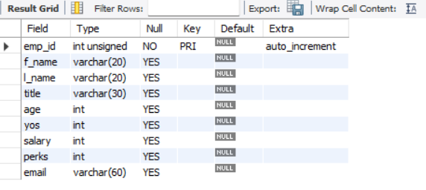
- SHOW DATABASES;
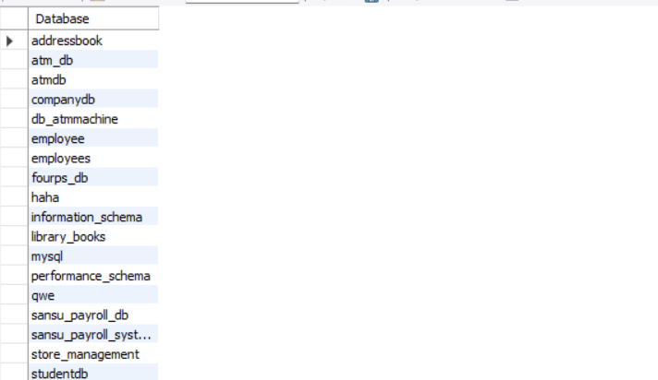
- INSERT INTO employee_data
(f_name, l_name, title, age, yos, salary, perks, email)
VALUES
("Rudolf", "Reindeer", "Business Analyst", 34, 2, 95000, 17000, "rudolf@bugnet.com");
- SELECT * FROM employee_data;
SELECT emp_id, f_name, l_name, title, age, yos, salary, perks, email FROM employee_data;
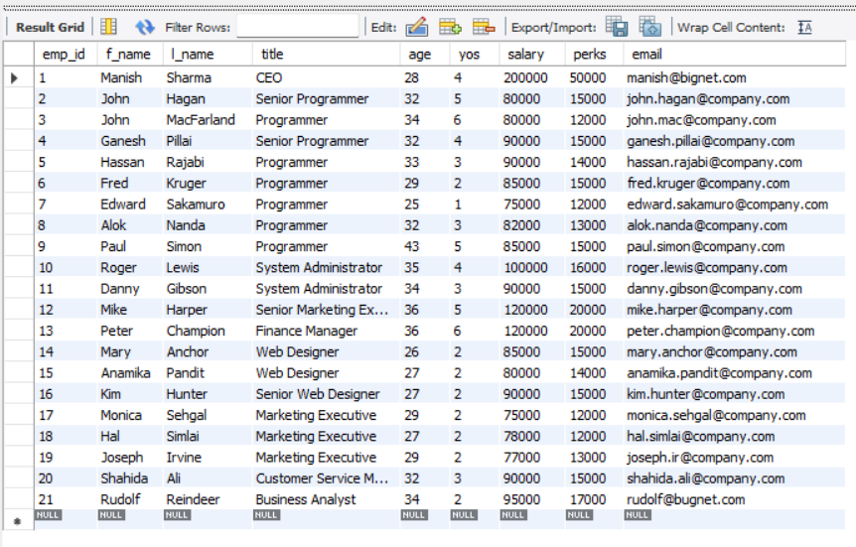
- SELECT f_name, email FROM employee_data;
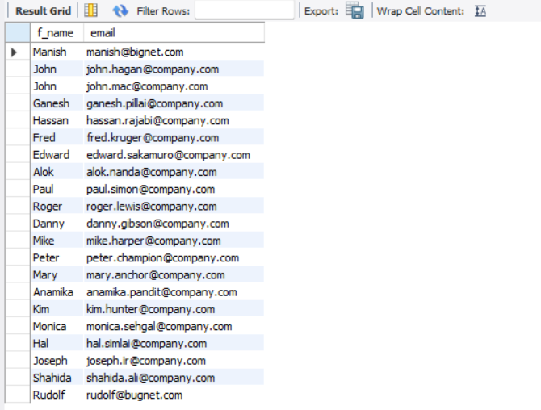
- SELECT salary, perks, yos FROM employee_data;
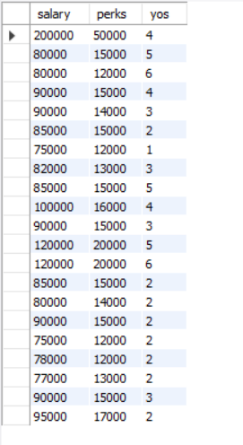
- SELECT COUNT(*) FROM employee_data;
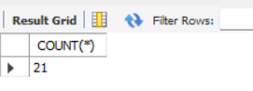

- SELECT salary, l_name FROM employee_data;
