EXERCISE 2
- ﻿﻿﻿Write the SELECT statement to extract the ids of employees who are more than 30 years of age.
SELECT emp_id
FROM employee_data
WHERE age > 30;
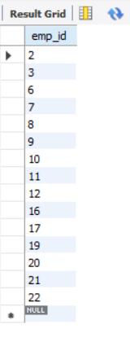
- ﻿﻿﻿Write the SELECT statement to extract the first and last names of all web designers.
SELECT f_name, l_name
FROM employee_data
WHERE title = "Web Designer";
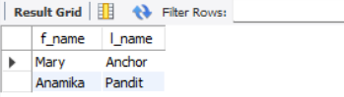
- What will the following SELECT statement display: SELECT * from employee data where salary <=100000;
SELECT * from employee_data where salary <=100000;

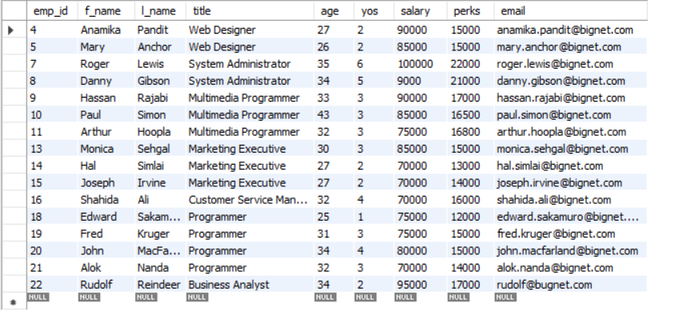
- How will you display the salaries and perks for employees who have more than $16000 as perks?
SELECT salary, perks
FROM employee_data
WHERE perks > 16000;
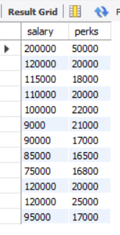
- ﻿﻿﻿List all employee names (last name followed by first name) who hold the title of Marketing Executive.
SELECT l_name, f_name
FROM employee_data
WHERE title = "Marketing Executive";
