EXERCISE 4
- ﻿﻿﻿List the first and last names of all employees who draw less than or equal to $90000 and are not Programmes, Senior programmers or Multimedia programmers.
SELECT f_name, l_name
FROM employee_data
WHERE salary <= 90000
AND title NOT LIKE "%Programmer%";
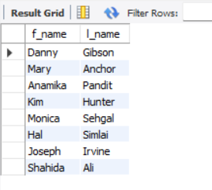
- What is displayed by the following statement? SELECT I_name, f_name from employee_data where title NOT LIKE '%marketing%' AND age < 30;
SELECT l_name, f_name from employee_data where title NOT LIKE '%marketing%' AND age < 30;
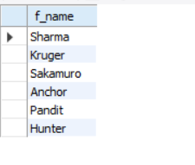
- List all ids and names of all employees between 32 and 40 years of age.
SELECT emp_id, f_name, l_name
FROM employee_data
WHERE age BETWEEN 32 AND 40;
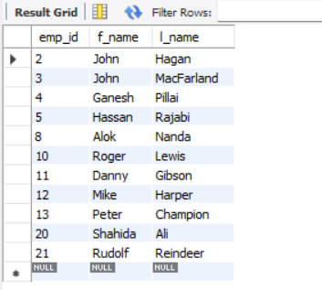
- ﻿﻿﻿Select names of all employees who are 32 years of age and are not programmers.
SELECT f_name, l_name
FROM employee_data
WHERE age = 32
AND title NOT LIKE "%Programmer%";
