Lunch Combination

|  |  |  |
| --- | --- | --- |
| A  Sweet & Sour Prawns  Soup or Salad  #100 | B  Egg Foo Young  Soup or Salad  #101 | C  Sweet & Sour Pork  Soup or Salad  #102 |
| D  Kung Pao Beef or Chicken  Soup or Salad  #103 | E*  Teriyaki Chicken or Beef  Soup or Salad  #104 | F*  Sweet & Sour Chicken  Soup or Salad  #105 |
| G  Chicken and Snowpeas  Soup or Salad  #106 | H  Boneless Almond Chicken  Soup or Salad  #107 | I*  Chicken Garlic  Soup or Salad  #108 |
| J*  Broccoli Chicken or Beef  Soup or Salad  #109 | K*  Mongolian Chicken or Beef  Soup or Salad  #110 | L  General Tso’s Chicken  Soup or Salad  #111 |
| M (Soft Noodle)  Chicken, Beef, Pork, or Vegetable Lo Mein  Soup or Salad  #112 | N (Crispy Noodle)  Chicken, Beef, Pork, or Vegetable Chow Mein  Soup or Salad  #113 | O*  Curry Chicken  Soup or Salad  #114 |
| P  Sesame Tofu  Soup or Salad  #115 | Q  Mixed Vegetables  Soup or Salad  #116 | R*  Chicken, Beef, Pork, or Vegetable Phad Thai  Soup or Salad  *STARRED ITEMS COULD BE SUBSTITUTED TO TOFU  #117 |

Served with Steamed Rice and Spring Roll

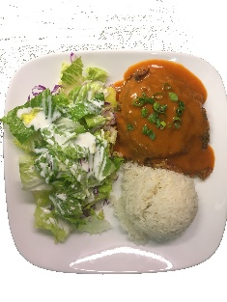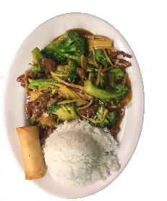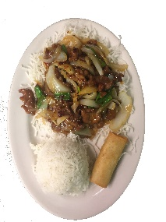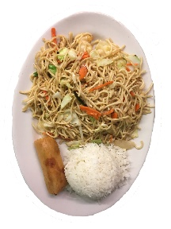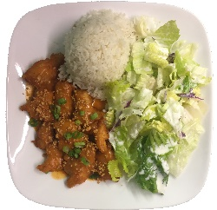

\

Rice Bowls

A heaping bowl of steamed rice covered with our chief's delicious toppings!

|  |  |
| --- | --- |
| Lunch | #131 |
| Dinner | #132 |