Binding study - fluorescent indicator displacement assay
This experiment is set to determine the binding affinities (Kd) of y guest molecules (e.g. chemotherapeutics, drug of abuse, etc) against x host molecules (macrocycles with various chemical modifications). Firstly, direct titration establishes the baseline binding between the hosts and a fluorescent indicator dye (DAPI), identifying the specific host concentration (IC90) required for near-maximal dye encapsulation. Then, a competitive assay is performed by introducing a concentration gradient of the guest molecules into the pre-formed host-dye complexes. Because the guests are non-fluorescent (ideally), their successful displacement of the dye from the host cavity results in a quantifiable decrease in the overall fluorescent signal. By measuring this signal loss across the gradient, the precise binding constants of the unlabelled guest molecules can be mathematically derived. The protocol is designed for measurement on NBS 384 greiner plates or Greiner cell-culture treated plates (F-bottom).
Day 1: Direct Titration (Host-Dye Binding)
Objective: Determine the K_{d} of DAPI for both hosts and calculate the specific Echo dispense volume (V_{IC90}) needed to achieve the IC90 concentration for Day 2.
1. Source Plate Loading
Load the following stocks into the Echo source plate and centrifuge to remove bubbles:
- DAPI Stock: 1 mM in water.
- Host Stocks: 5 mM in water.
- Backfill: water.
2. Destination Plate Dispense (in triplicates)
- Echo Dispense (Experimental Wells):
  - DAPI (Constant): Dispense DAPI into all titration wells (Yields 1 µM final).
  - Host (Variable): Dispense a n-point dilution curve for x Hosts in triplicates. Top concentration = 50 µM, followed by 2-fold serial dilution.
  - Backfill: Have the Echo backfill each well to same total volume.
- Echo Dispense (Blanks - 3 wells each host):
  - Buffer Blank: Backfill.
  - Dye Blank: 1 mM DAPI + Backfill (1 µM final).
  - Host Blanks (per Host): 5 mM Host + Backfill (50 µM final).
- Bulk Dispense: Dispense water and 0.1x PBS into all wells to reach 50 µL total volume (10% water + 90% 0.1x PBS).
3. Measurement & Analysis
Centrifuge the destination plate (1300 rpm, 10 sec). Leave to equilibrate for 10 min and read fluorescence on plate reader. Calculate the K_{d} and the exact volume V_{IC90} of 5 mM Host required to reach the IC90 concentration.


Day 2: Competitive Titration (Guest Binding)
Objective: Measure DAPI displacement by Guests.
1. Source Plate Loading
Load the following into the Echo source plate and centrifuge:
- DAPI Stock: 1 mM in water.
- Host Stocks: 5 mM in water.
- Guest Stocks: 10 mM in water.
- Backfill Fluid: water.
2. Plate 1 Setup & Dispense (Host 1 vs. y Guests)
- Echo Dispense (Experimental Wells):
  - DAPI (Constant): Dispense 1 mM DAPI (Yields 1 µM final).
  - Host 1 (Constant): Dispense 5 mM Host 1 (Yields IC90 final).
  - Guest (Variable): Dispense n-point curves for all y Guests in triplicates. Top concentration = 100 µM, followed by 2-fold serial dilution.
  - Backfill: Backfill each well to exactly same total volume.
- Echo Dispense (Blanks - 3 wells each):
  - Buffer Blank: Backfill.
  - Dye Blank: DAPI (1 µM final) + Backfill.
  - Host + Dye Blank (F_{max}): Host 1 (IC90 final) + DAPI (1 µM final) + Backfill.
  - Guest Blanks (3 wells per guest): Guest (100 -> 0 µM serial dilution) + Backfill.
  - Guest + Dye Blanks: Guest (100 -> 0 µM serial dilution) + DAPI (1 µM final) + Backfill.
- Bulk Dispense: Dispense water and 0.1x PBS into all wells to reach 50 µL total volume (10% water + 90% 0.1x PBS).
3. Repeat the exact protocol for Plate 1, but substitute Host X for your constant V_{IC90} dispenses and Blanks.
4. Measurement & Analysis
- Centrifuge the destination plate (1300 rpm, 10 sec). Leave to equilibrate for 10 min and read fluorescence on plate reader. Subtract the average Baseline Blank value (Fi DAPI – F0 buffer) from your competitive guest curves to determine DAPI displacement.
- Fit the data to Equation S2/S3 to determine the K_{d} for each of the 6 guests.
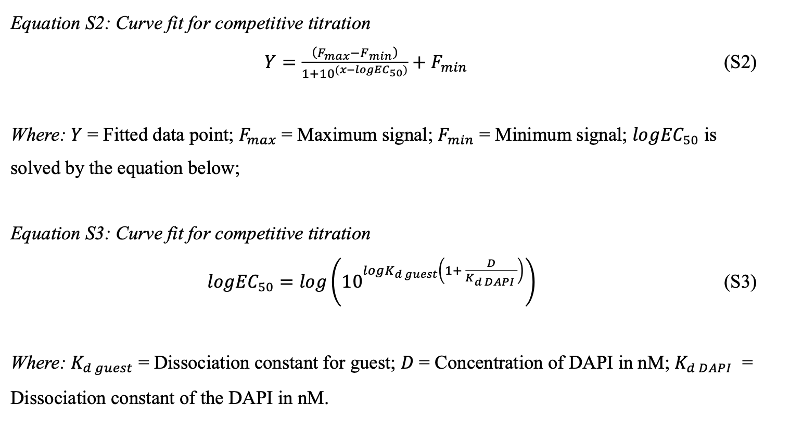
Reference
DOI: 10.1039/d2ob01487d
DOI 10.1074/jbc.M115.669333

