**Project Aim**

The main purpose of this ABM is to examine how changes to the food environment impact access to and purchasing of food. This model aims to support decision making at the local council level.

**Model Overview**

We model an abstract food environment in an urban setting to observe interactions between food outlets and households and how access and purchasing change over time. We use the five domains of access (affordability, accessibility, availability, acceptability and accommodation)1 to define key components of the food environment. In this iteration of the model affordability and accessibility are updated over time.

The model includes two classes of agents: households (HH) and food outlets. Households decide to either eat an at home meal or an out of home meal for three meals a day. The out of home meal is the equivalent of choosing a takeaway or fast-food option. Households also choose where and when to shop for groceries via visits to food outlets (Figure 1). The outcomes of these behaviours lead to the primary outcomes of the households: consumption of fruit and vegetables (FV), consumption of fast food (FF), and meals skipped.

The primary outcomes for food retail outlets are the visits and purchases made at the store. Food outlet agents sell either FV or FF and make an annual decision to remain open or close for business (Figure 2). Measures of both distance and density are considered for accessibility. New outlets can open based on purchasing behaviours of HH agents in a given neighbourhood, filling a gap (Figure 3).

We model interventions that affect accessibility and affordability of food may result in structural changes to the food environment and in turn change regular purchasing of different food types in the environment. Future iterations of the model will aim to incorporate a spatially explicit environment of Liverpool City Council as well as leveraging the other domains of access.

**Household agent properties and actions**

HH agents are characterised by several static state attributes: location, income, travel mode, number of people in household, shopping frequency, and neighbourhood (see Table 4 for more details). Additionally, HHs are intitialised with a measure of consumption of fruit and vegetables (servings) and fast food (meals) and are given a household budget as well. For this model, most of these data are estimates or randomised. In the next iteration, all HH data will be derived from national household surveys including spatially-explicit microsimulations generating individual data.

At initialisation, household agents create an access list of food outlets and update the access list of food outlets annually (Function 1). Household agents may perform 4 actions during a given timestep:

*Function 2: Decide to shop*

*Function 3: Choose FV Outlet or a FF Outlet*

*Function 4: Acquire FV from outlet*

*Function 5: Choose a food source for each meal or skip meal*

The population at this time mimics the size of four Liverpool wards as neighbourhoods (n=x). Four neighbourhoods, two low-income, one middle-income, and one higher income are abstracted. Households “sprout” randomly within a ward. Future model iteration will randomly assign locations along a spatially explicit road network in each neighbourhood (either ward or lower super output areas).

Additionally, every seven days, each household budget is replenished depending upon their predetermined budget (all households are initiated with a budget).

Figure 1. Household Flow Diagram of Actions, Purchasing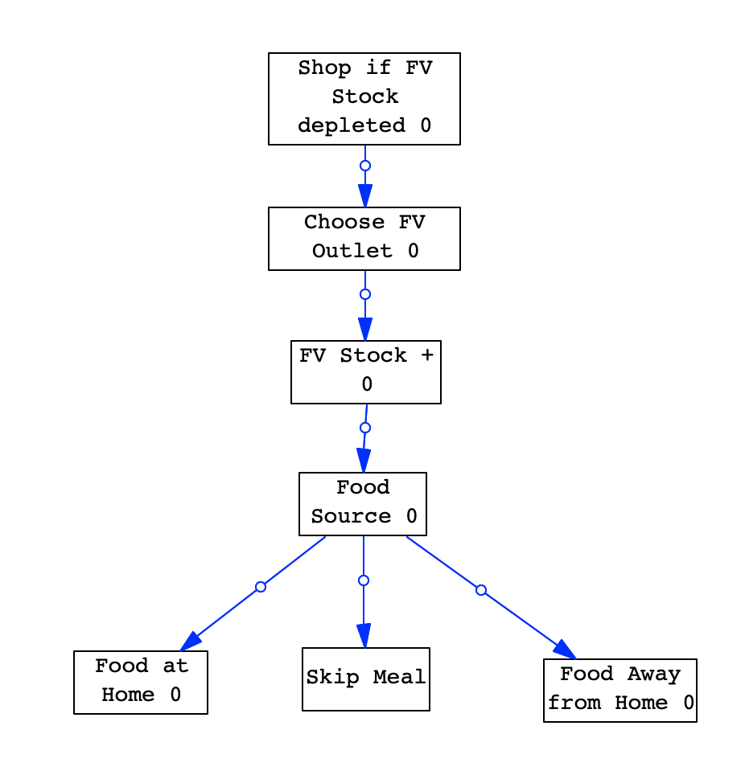

*F1. Identify accessible food outlets for shopping/access list (assign-shops)*

At initiation and then annually, HHs create two tables of shops (one of stores selling FV and one of stores selling fast-food meals). This is based on travel mode (access to car) and the distance to a given shop for a HH. If a HH does not have car access, the shop will be added to the HH access list if the shop is within 0.5 kilometers (estimated walking distance). In this model it is abstracted as a distance of ten. If a HH does have car access, the shop will be added to the HH access list if the shop is within 3 kilometers (a larger, car-accessible distance). Similarly, abstracted to five. If there are no shops within the assigned radius, then the two nearest shops are assigned, and distance calculated.

A preference score is calculated for each shop and added to the table. Each accessible store is given a rank based on the price and availability attribute of the store type. These assigned affordability and availability values are abstracted from research. For example, it is often that price is higher and availability lower at a corner store in relation to standard larger grocery outlets.[1]

|  |  |  |
| --- | --- | --- |
| *Table 1.* | | |
| ***Store Type*** | **Price** | **Availability** |
| *Discount* | 1 | 1 |
| *Corner* | 2 | 0 |
| *Medium* | 2 | 2 |
| *Large* | 1 | 2 |
| *Food Hub* | 0 | 1 |

A low-income household will prioritise price whereas households that are not low-income prioritise availability (see tables 2 and 3). These are referenced in the model as two matrices.

|  |  |  |  |  |
| --- | --- | --- | --- | --- |
| *Table 2.* | | | | |
| Low-Income Households Ranking | | Price | | |
| Low | Medium | High |
| Availability | High | 1 | 4 | 7 |
| Medium | 2 | 5 | 8 |
| Low | 3 | 6 | 9 |

|  |  |  |  |  |
| --- | --- | --- | --- | --- |
| *Table 3.* | | | | |
| High-Income Households Ranking | | Price | | |
| Low | Medium | High |
| Availability | High | 1 | 2 | 3 |
| Medium | 4 | 5 | 6 |
| Low | 7 | 8 | 9 |

*F2. Decide to shop*

Each HH agent is initialised with a household budget for store purchases. All HHs are asked whether they need to shop at the initiation of any tick. HHs decide to shop if the FV meal stock in the house is less than what can feed the HH in one day and if their budget is more than zero. If purchasing food stock, they choose from a store in their access list (Function 3).

*F3. Choose FV Outlet or FF Outlet*

Using the RND extension, a FV outlet is chosen by the household based on the rank score in the access table of each household. The function used returns one store choice drawn from a probability of the store being selected. This probability is based on a weight, the inverse of the stores rank and an element of randomness. The FF outlet is chosen randomly from the access list of FF outlets loaded in Function 1. These are both reported/stored and used in other functions (Function 2 and 5).

*F4. Acquire FV from outlet*

HHs attempt to acquire as many meals as necessary to feed the HH for 10 days. If, based on the price of the store and the HH budget, a household cannot afford meals for 10 days, they acquire whatever their budget allows.

Future iteration of this model will consider what proportions of a given meal is typically FV stock as measured from either NDNS or CANTAR data: A HH acquires a particular stock (measured in how many meals can be eaten from that stock) from each store and a proportion of how much of that is FV is measured based on price of store, cost to travel to store, and their budget at the time of purchase.

Food outlets increment store visit and store sales based on the amount purchased.

*F5. Choose a food source for each meal or skip meal*

Three times a day, the agent determines whether they will have food from home or food away from home. To do this, they calculate the probability of eating a meal away from home based on the density of accessible FF stores multiplied by a weight and the amount of stock they have at home. The weight has been sense checked at this moment but will be weighted based on a household survey in later iteration. If the probability is more than a random draw between 0 and 1 and the HH budget is more than 0, they will choose to have an FF meal. If not, they will consume a meal at home. If they do not have budget available, they will skip a meal.

If a HH chooses to eat a meal at home, they adjust both their number of FV meals and their FV stock which, in this model is 1:1 but will eventually be adjusted base on the average number of servings of FV consumed daily.

***Food Outlet Agents***

*See list of all Food Outlet Agent variables in Table 5. There are four total types of food outlet agents. Four types of food outlet agents selling fruit and veg:*

* *Large grocery stores*
* *Medium grocery stores*
* *Discount stores*
* *Corner stores*

*One type of food outlet sells fast food: Hot food takeaways. Future iterations will include food pantry models.*

Food outlet agents perform two actions (Figure 2):

1. Collect visits and purchases
2. Increase or decrease their prices
3. Decide to remain open or close

Based on input data, each neighbourhood will have a complete census of grocers, corner stores, and fast-food outlets. At this moment, we abstract four neighbourhoods, two low-income, one middle-income, and one higher-income.

Outlets collect the number of visits and purchases from HH shopping and calculate the annual total. This is reset every year. All food outlet agents except food pantries may decide to lower or increase their price and possibly close if a certain threshold is not met of HH agents visiting and purchasing. Annually, outlets check their earnings against the median earnings of their stop-type category multiplied by an adjustable threshold (one for opening outlets and one for closing outlets). If their earnings are above this number, they sprout in a patch in the neighbourhood where most of their shoppers live. If their earnings are below the calculated value, they first adjust their price. If the price cannot be further adjusted down (less than 1), they close.

For development: decide how price changes endogenously and how availability changes endogenously; suggestion is that as price goes up, availability goes down.

**Global Variables**

To understand the role that place plays, the model has a set of global variables of purchasing patterns/visits to stores for each neighbourhood. A neighbourhood is currently an abstracted ward in Liverpool. The next iteration will define neighbourhoods as geographically weighted average of an LSOA and its neighbours.

**Time**

Each time step represents one day and the model will aim to iterate over about 8 years to capture changes in the food environment and to be able to calibrate against existing data on store closures/openings.

**Key Input Data (notes)**

Key sources:

HH Microsimulation from the last 5 years of the National Diet and Nutritional Survey

Family Food Survey

Food safety standards data

Imported will be:

* Type (converted to fast food / not fast food)
* Grocery Store Type (Large grocery, Medium grocery, Discount, Corner, Food pantries/Community food hubs)
* LSOA (geographical area / neighbourhood)
* Deprivation classificiation of LSOA (1-10)

**Calibration (proposed)**

Open food outlets will need thresholds, use shops opening and closing every year to calibrate – examine a net effect and see how the model can mimic; other option is to have the baseline that then changes depending on scenario changes

|  |  |  |  |  |
| --- | --- | --- | --- | --- |
| *Table 4. Agent variables and parameters of Households* | | | | |
| **Parameter** | **Variable Type & Unit** | **Initialisation** | **Update** | **Main Role** |
| Household Income Designation | Categorical (low-income, not low-income) | Currently randomized based on neighbourhood type/designation.  Will be derived from census and the SMS estimates | No | Determines preference ranking for stores; designates household food budget; along with location, may designate certain groups for intervention in scenarios |
| Household Size | Continuous | Currently randomized; Derived from SMS estimates | No | Determine HH budget and FV goal for purchasing; outcome: calculation of HH meeting FV and FF consumption |
| Travel Mode | Categorical; car or no car | Currently randomized; Derived from population estimates (need to update this in the SMS) | No | Part of a calculation of access list |
| Household food budget | Numerical distributions for two groups: low-income HH and not low-income HH | Currently randomized based on income designation; will be simulated budget for model based on Family Food Survey 2019-2020 | Yes, every step | Determines amount of food-at-home meals HH can purchase |
| Location | Point | Based on Neighbourhood | No | Part of a calculation (Access radius/ likelihood to shop rating) |
| Access List (FV-access and FF-access) | List of shops within access radius | Calculation; will be measured based on travel mode and Euclidian distance to stores | Annually |  |
| Fast food density (ff-density) | Categorical (low, medium, high) | calculated | Annually |  |
| Food stock (FV-stock) | continuous | *not currently initialized, but may derive from estimates | Yes, every step |  |
| Out of home meals (ff-meals) | continuous | *not currently initialized, but may derive from estimates | Yes, every step |  |
| In home meals (fv-meals) | continuous | *not currently initialized, but may derive from estimates | Yes, every step |  |
| Skipped meals (meals-skipped) | continuous | Reported, not initialised | Yes, every step |  |

|  |  |  |  |  |
| --- | --- | --- | --- | --- |
| *Table 5. Agent variables and parameters of Food Outlets* | | | | |
| **Parameter** | **Variable Type & Unit** | **Initialisation** | **Update** | **Main Role** |
| Type (shop-type) | Categorical (Fast food/Fruit and Veg) | Derived from food safety standards data/scraped google data | No; or only in particular scenarios | Informs access tables |
| Category (category) | Categorical (4 types) | Derived from food safety standards data/scraped google data | No | Informs closure thresholds, availability, price |
| Location | Point | From food safety standards data | No | Access list |
| Price level | Categorical; high, medium, low | Store type | Only in particular scenarios |  |
| Availability | Categorical | Store type | Yes? As price increases and shop visits and/or earnings may decrease, availability decreases? | HH likelihood to shop rating |
| Number of visits/earnings (visits and earnings) | Numerical | Model-generated | Continuously | Probability to close/remain open (or possibly to change price) |
| Customer Origins | List | Model-generated | Yes | Where new shops sprout |

1. Penchansky, R. & Thomas, J. W. The concept of access: Definition and relationship to consumer satisfaction. *Med. Care* (1981). doi:10.1097/00005650-198102000-00001

2. Cummins, S. *et al.* Neighbourhood deprivation and the price and availability of fruit and vegetables in Scotland. *J. Hum. Nutr. Diet.* **23**, 494–501 (2010).

3. Black, C. *et al.* Measuring the healthfulness of food retail stores: Variations by store type and neighbourhood deprivation. *Int. J. Behav. Nutr. Phys. Act.* **11**, 1–11 (2014).

4. Black, C. *et al.* Variety and quality of healthy foods differ according to neighbourhood deprivation. *Heal. Place* **18**, 1292–1299 (2012).

5. Harmer, G., Jebb, S. A., Ntani, G., Vogel, C. & Piernas, C. Capturing the Healthfulness of the In-store Environments of United Kingdom Supermarket Stores Over 5 Months (January–May 2019). *Am. J. Prev. Med.* **61**, e171–e179 (2021).

1.