**MIKE P. CARCAGENTE** Blk 1 Lot 6 Phase 1 Kaakbay ni San Isidro Llano Caloocan City

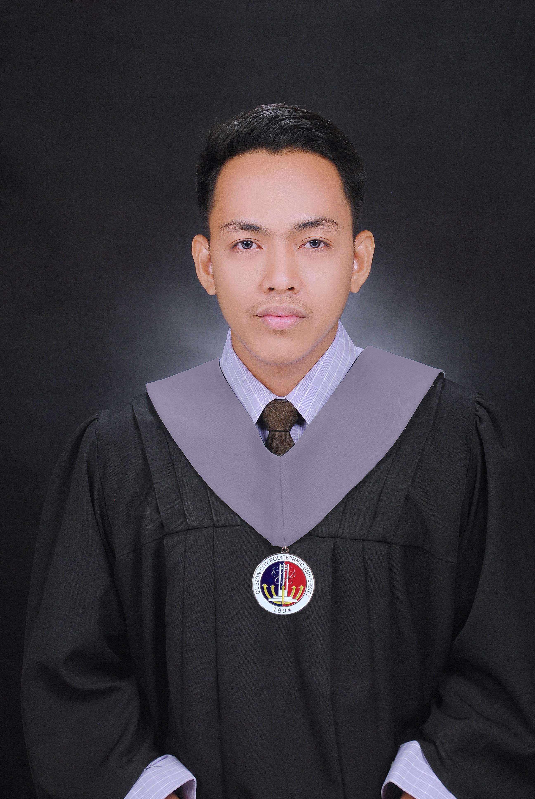

[mikecarcagente20@gmail.com](mailto:mikecarcagente20@gmail.com)

09568268560

**Objective:** Looking for a challenging role in a reputable organization to fully utilize my training and skills for the growth of the organization as well as to enhance my knowledge about new and emerging trends in the IT sector.

**Personal Skills:**

• Motivated and always willing to learn new things.

• Ability to follow instruction.

**Work Experience:**

**Web developer in Magellan Solutions (February 2018 – Current)**

* Responsible for designing, coding and modifying websites, from layout to function and according to a client's specifications.
* Have experienced in technical SEO.
* Have experienced in using google analytics and web master tool.
* Responsible for maintaining WP Sites
* Technical support site security issues
* Have experienced in AWS (Amazon Web Services)
* Have experienced in Database management
* Have experienced in Site migration
* Responsible for site optimization
* Have experience in LAMP Server setup

**IT Helpdesk in Bridge Southeast Asia (6 months).**

* Provide a centralized resource to answer questions, troubleshoot problems and facilitate solutions related to a company's processes, products and services.

**Trainings / Seminars**

**Youth Congress on Information Technology** SMX Convention Center September 29, 2016

**The Basic Python Development – Ground Gurus** (November 18, 2017)

**The Fundamentals of React Native Development** (November 25, 2017)

**Pre Professional Experience**

• IT Helpdesk Intern at Bestank Manufacturing Corporation.(2016-2017)

• IT Programmer Intern at Inteligente Publishing Inc. (2016-2017)

• IT Staff Intern at Expressions Company. (2012-2013)

**Education:**

**Bachelor of Science in Information Technology (S.Y 2013-2017)**Quezon City Polytechnic University 673 Quirino Highway, San Bartolome Novaliches, Quezon City, 1116 Metro Manila

**Vocational Course:** 1 year Programming Course (S.Y 2012-2013)

**REFERENCES:** Will be provided upon request.