



Splunk Plug-in Configuration Guide
ELXS-ALL-UD-18-0001

Table of Contents
1 Installing the Splunk Plug-in 3
1.1 Installing the Splunk Index Mapping Template 3
2 Configuring Mistral to use the Splunk Plug-in 5
2.1 Mistral Plug-in Configuration File 5
2.1.1 PLUGIN directive 5
2.1.2 INTERVAL directive 5
2.1.3 PLUGIN_PATH directive 5
2.1.4 PLUGIN_OPTION directive 6
2.1.5 END Directive 6
2.2 Plug-in Command Line Options 6
3 Mistral’s Splunk Document Model 8

Installing the Splunk Plug-in
Extract the Mistral plug-ins archive that has been provided to you in a location accessible to all potential execution hosts. Please make sure that you use the appropriate version of the plug-in for the architecture of the machine on which the plug-in will run.

In addition, if the Mistral Plug-ins package was obtained separately from the main Mistral product, please ensure that the version of the plug-in downloaded is compatible with the version of Mistral in use. Version 5.1.0 of the Splunk Plug-in as described in this document is compatible with all versions of Mistral compatible with plug-in API version 5. At the time of writing this is Mistral v2.11.2 and above.

The Splunk plug-in can be found in, for example:

<installation directory>/output/mistral_splunk_v5.1.0/x86_64/

for the 64 bit Intel compatible version, and in:

<installation directory>/output/mistral_splunk_v5.1.0/aarch32/

for the 32 bit ARM compatible version.

The plug-in must be available in the same location on all execution hosts in your cluster regardless of architecture.

Configuring an HTTP Event Collector End Point
Prior to using the Mistral Splunk plug-in HTTP Event Collector (HEC) must be enabled and an appropriate end point must be configured within Splunk.

The process for enabling HEC for the current version of Splunk (7.1.0 at the time of writing) is as follows.

HEC can be enabled by opening Settings → Data inputs, selecting “HTTP Event Collector” and then clicking the “Global Settings” button.

Configure HEC as appropriate for your environment however “All tokens” must be set to “enabled”.
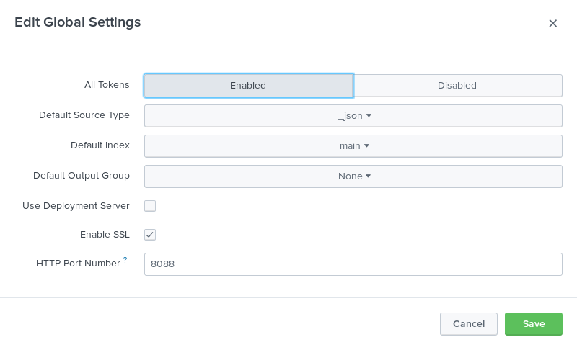
Once HEC has been enabled you must create a token for use with the Mistral Splunk plug-in by clicking the green “New Token” button.

Again most of the configuration can be set as appropriate to your environment. The Mistral Splunk plug-in does not use “indexer acknowledgement” so we recommend that the option to enable this feature is not set.

The plug-in writes data to HEC using JSON therefore we recommend that “Source type” be set to “Select → Structured → _json” however leaving this set to the default value of “Automatic” should also work.

Once configured the token value generated can be used with the Mistral Splunk Plug-in to push alert data into Splunk.

Configuring Mistral to use the Splunk Plug-in
Please see the Plug-in Configuration section of the main Mistral User Guide for full details of the plug-in configuration file specification. Where these instructions conflict with information in the main Mistral User Guide please verify that the plug-in version available is compatible with the version of Mistral in use and, if so, the information in the User Guide should be assumed to be correct.

Mistral Plug-in Configuration File
The Mistral plug-in configuration file is an ASCII plain text file containing all the information required by Mistral to use any OUTPUT or UPDATE plug-ins required. Only a single plug-in of each type can be configured.

Once complete the path to the configuration file must be set in the environment variable MISTRAL_PLUGIN_CONFIG. As with the plug-in itself the configuration file must be available in the same canonical path on all execution hosts in your cluster.

This section describes the specific settings required to enable the Splunk Plug-in.

PLUGIN directive
The PLUGIN directive must be set to “OUTPUT” i.e.

PLUGIN,OUTPUT

INTERVAL directive
The INTERVAL directive takes a single integer value parameter. This value represents the time in seconds the Mistral application will wait between calls to the specified plug-in e.g.

INTERVAL,300

The value chosen is at the discretion of the user, however care should be taken to balance the need for timely updates with the scalability of the Splunk installation and the average length of jobs on the cluster.

PLUGIN_PATH directive
The PLUGIN_PATH directive value must be the fully qualified path to the Splunk plug-in as described above i.e.

PLUGIN_PATH,<install_dir>/output/mistral_splunk_v5.1.0/x86_64/mistral_splunk

The PLUGIN_PATH value will be passed to /bin/sh for environment variable expansion at the start of each execution host job.

PLUGIN_OPTION directive
The PLUGIN_OPTION directive is optional and can occur multiple times. Each PLUGIN_OPTION directive is treated as a separate command line argument to the plug-in. Whitespace is respected in these values. A full list of valid options for this plug-in can be found in section 2.2 Plug-in Command Line Options.

As whitespace is respected command line options that take parameters must be specified as separate PLUGIN_OPTION values. For example, to specify the hostname the plug-in should use to connect to the Splunk server the option “-h hostname” or “--host=hostname” must be provided, this must be specified in the plug-in configuration file as:

PLUGIN_OPTION,-h
PLUGIN_OPTION,hostname

or
PLUGIN_OPTION,--host=hostname

Options will be passed to the plug-in in the order in which they are defined and each PLUGIN_OPTION value will be passed to /bin/sh for environment variable expansion at the start of each execution host job.

END Directive
The END directive indicates the end of a configuration block and does not take any values.

Plug-in Command Line Options
The following command line options are supported by the Splunk plug-in.

-e file, --error=file
Specify location for error log. If not specified all errors will be output on stderr and handled by Mistral error logging.

-h hostname, --host=hostname
The hostname of the Splunk server with which to establish a connection. If not specified the plug-in will default to “localhost”.

-i index_name, --index=index_name
The name of the index in which to store data, if not specified this will default to “main”.

-m octal-mode, --mode=octal-mode
Permissions used to create the error log file specified by the -e option.

-p number, --port=number
Specifies the port to connect to on the Splunk server host. If not specified the plug-in will default to “8088”.

-s, --ssl
Connect to the Splunk server via secure HTTP.

-t hash, --token=hash
The API endpoint token required to access the Splunk server. If hash is specified as “file:<filename>” the plug-in will attempt to read the token from the first line of <filename>.

-v var-name, --var=var-name
The name of an environment variable, the value of which should be stored by the plug-in. This option can be specified multiple times.

Mistral’s Splunk Document Model
This section describes how the Mistral Splunk Plug-in stores data within Splunk.

Documents are inserted into these indexes with the following labels and structure:

{
"rule": {
"scope",
"type",
"label",
"measurement",
"calltype",
"path",
"threshold",
"timeframe",
"size-min",
"size-max"
},
"job": {
"host",
"job-group-id",
"job-id"
},
"process": {
"pid",
"command",
"file",
"cpu-id",
"mpi-world-rank"
},
"environment": {
"var-name",
…
},
"value"
}

The Mistral Splunk Plug-in will insert documents as described in the following table.

Document Label | Description
rule.scope | Inserted as a text string, set to either “local” or “global” indicating the scope of the contract containing the rule that generated the log.
rule.type | Inserted as a text string, set to either “monitor” or “throttle” indicating the type of rule that generated the log.
rule.label | Inserted as a text string, copied from the log message LABEL field unchanged.
rule.measurement | Inserted as a text string, copied from the log message PATH field unchanged.
rule.calltype | Inserted as a text string, the list of call types specified in the log message CALL-TYPE field. The Mistral Splunk plug-in will always log compound types in alphabetical order.  E.g. if the log message listed call types as “read+write+seek” the plug-in will normalise this to “read+seek+write”.
rule.path | Inserted as a text string, copied from the log message SIZE-RANGE field unchanged.
rule.threshold | Inserted as a number, the rule limit as reported in the log message THRESHOLD field converted into the smallest unit for the measurement type.  For bandwidth rules this field will be bytes, for latency rules it is microseconds and for count rules the simple raw count.
rule.timeframe | Inserted as a number, the timeframe the measurement was taken over as reported in the log message THRESHOLD field, converted into microseconds.
rule.size-min | Inserted as a number, the lower bound of the operation size range as reported in the log message SIZE-RANGE field, converted into bytes.  If this field was set to “all” in the log message this value will be set to “0”.
rule.size-max | Inserted as a number, the upper bound of the operation size range as reported in the log message SIZE-RANGE field, converted into bytes.  If this field was set to “all” in the log message this value will be set to the maximum value of an “ssize_t”. This value is system dependent but for 64 bit machines this will typically be ﻿9223372036854775807.
job.host | Inserted as a text string, copied from the log message HOSTNAME field with any domain component removed.
job.job-group-id | Inserted as a text string, copied from the log message JOB-GROUP-ID field unchanged or “N/A” if this field is blank.
job.job-id | Inserted as a text string, copied from the log message JOB-ID field unchanged or “N/A” if this field is blank.
process.pid | Inserted as a number, copied from the log message PID field unchanged.
process.command | Inserted as a text string, copied from the log message  COMMAND-LINE field unchanged.
process.file | Inserted as a text string, copied from the log message FILE-NAME field unchanged.
process.cpu-id | Inserted as a number, copied from the log message CPU field unchanged.
process.mpi-world-rank | Inserted as a number, copied from the log message  MPI-WORLD-RANK field unchanged.
environment.var-name | Inserted as a text string. The string “var-name” will be replaced by an environment variable name as specified in a --var option. The value stored will be the value of this variable as detected when the plug-in is initialised.  If no --var options are specified the environment block will be omitted.
value | Inserted as a number, copied from the log message  MEASURED-DATA field converted into the smallest unit for the measurement type.  For bandwidth rules this field will be bytes, for latency rules it is microseconds and for count rules the simple raw count.

