E-COMMERCE TERRITORIAL TARGETING ANALYSIS

Geographic Opportunity Scoring for Medical Instruments
RapidMiner data preparation + Power BI territorial targeting concept
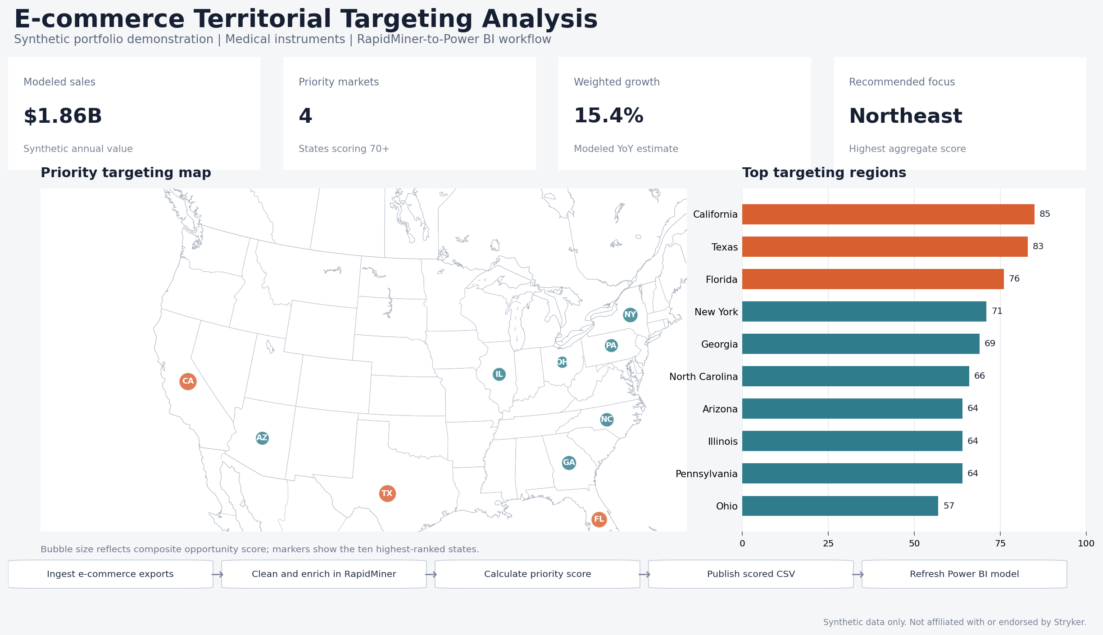
Project statement
Built a synthetic e-commerce targeting model that consolidates commercial and geographic signals, calculates a composite opportunity score, and translates the results into an interactive territorial-planning dashboard.

Independent demonstration only. No confidential Stryker data, actual sales performance, or official territory definitions were used.

1. Business Context and Solution
A practical analytics concept for prioritizing geographic markets and supporting territory design.

Business problem
E-commerce sales can reveal demand that is not fully visible through field activity alone. However, transaction exports, geographic reference data, market-potential indicators, and sales-territory assignments often reside in separate files. The analysis needs a repeatable way to standardize these sources, score opportunity consistently, and surface the result in a map that commercial teams can use.

Project objectives
- Consolidate state- or ZIP-level e-commerce activity into a governed geographic fact table.
- Identify higher-priority targeting regions using sales, order volume, growth, market potential, and current coverage.
- Provide a transparent scoring model that can be audited and adjusted by commercial stakeholders.
- Translate scored outputs into an interactive Power BI design for territory planning and whitespace analysis.

Solution architecture
1 | 2 | 3 | 4 | 5
Source data  Orders, revenue, ZIP, product family | RapidMiner  Clean, join, aggregate, normalize | Scoring model  Calculate priority and tier | Published file  Governed scored CSV or table | Power BI  Map, ranking, KPIs, drill-through

Portfolio deliverables
Interactive HTML dashboard, editable Word case study, shareable PDF, synthetic Excel data model, and import-ready CSV output.

2. Data Model and Priority Scoring
A transparent composite score converts multiple commercial signals into one targeting rank.

Core analytic grain
The demonstration model uses one row per state. A production implementation would typically move to ZIP5, customer account, or a defined market-basket grain, then roll results into sales territories.
Input | Definition | Weight | Role in score
E-commerce Sales | Synthetic annual revenue | 28% | Current commercial value
Online Orders | Synthetic transaction count | 20% | Demand volume
YoY Growth | Synthetic annual growth rate | 20% | Momentum
Market Potential | Modeled 0-100 opportunity index | 20% | Addressable opportunity
Whitespace | One minus modeled coverage | 12% | Underpenetrated market potential

Scoring logic
Composite formula
Priority Score = 100 × [0.28(Sales normalized) + 0.20(Orders normalized) + 0.20(Growth normalized) + 0.20(Market Potential / 100) + 0.12(Whitespace)]

Priority tiers and actions
Score band | Tier | Suggested action
72-100 | Highest | Prioritize digital campaigns and review field coverage
60-71 | High | Develop focused market plan and monitor conversion
45-59 | Moderate | Test targeted campaigns and reassess
0-44 | Low | Maintain baseline coverage and review quarterly
The weights are intentionally configurable. In a real commercial setting, the model should be calibrated with historical conversion, sales-rep capacity, channel mix, and market-access constraints.

3. Power BI Dashboard Design
The report structure supports both executive prioritization and analyst-level investigation.

Recommended page layout
- Top KPI cards: modeled sales, priority-market count, weighted growth, and recommended focus territory.
- Main map: state or ZIP choropleth colored by Priority Score, with territory boundary overlays where supported.
- Ranking panel: horizontal bar chart of states or markets by Priority Score.
- Detail table: sales, orders, growth, market potential, coverage, whitespace, score, and recommended action.
- Slicers: territory, priority tier, product family, customer segment, and reporting period.

Illustrative DAX measures
Measure | DAX concept
Modeled Sales | SUM(Scored_Data[E-commerce Sales])
Priority Markets | CALCULATE(DISTINCTCOUNT(Scored_Data[State Abbr]), Scored_Data[Priority Score] >= 70)
Weighted Growth | DIVIDE(SUMX(Scored_Data, Scored_Data[YoY Growth] * Scored_Data[E-commerce Sales]), [Modeled Sales])
Whitespace | 1 - AVERAGE(Scored_Data[Coverage])

Interaction design
- Selecting a state filters the ranking and detail table while displaying a market-profile tooltip.
- Territory slicers allow leaders to compare portfolio balance and identify overloaded or underdeveloped regions.
- A drill-through page can expose ZIP-level opportunity, target accounts, channel mix, and historical growth.
- The model can support scenario parameters to test alternative weights or coverage assumptions.
Production consideration
For accurate territorial boundaries, use governed ZIP-to-territory assignments and a supported polygon layer such as Azure Maps, ArcGIS for Power BI, or a certified custom shape map. Avoid treating state boundaries as a substitute for actual sales territories.

4. RapidMiner Workflow and Implementation Plan
RapidMiner provides a repeatable preprocessing and scoring layer before the Power BI refresh.
1. Ingest | Read transaction exports and geographic reference files.
2. Validate | Check schema, required fields, data types, nulls, and duplicate keys.
3. Standardize | Format ZIP5 as text, normalize product and segment labels, and derive dates.
4. Enrich | Join geography, territory, market potential, and commercial coverage.
5. Aggregate | Summarize sales and order activity to the selected geographic grain.
6. Normalize | Scale model inputs to comparable 0-1 ranges.
7. Score | Calculate the weighted Priority Score and assign a tier.
8. Publish | Write the scored output to a governed location for Power BI refresh.

Quality controls
- Reject records with missing geographic keys or invalid ZIP formats.
- Reconcile aggregated revenue and order counts back to the source export.
- Track unmatched geography and territory joins in an exception output.
- Version scoring weights and retain run metadata for reproducibility.
- Validate map totals against the scored source table after every refresh.

Portfolio value demonstrated
- Commercial analytics: translated transaction data into a prioritization framework.
- Data engineering: designed a repeatable cleansing, enrichment, aggregation, and publishing workflow.
- Geospatial analysis: connected opportunity signals to state and territory structures.
- Business intelligence: defined an interactive dashboard, measures, filters, and drill paths.
- Governance: documented assumptions, formulas, quality checks, and limitations.
Recommended next iteration
Replace synthetic state data with de-identified ZIP-level transactions, add account and product dimensions, calibrate weights against historical conversion, and validate the recommended territories with field leadership.

