Conversion of Team Nando Networks from Opendss to Pandapower

The team Nando's network infrastructure is modeled using OpendSS. The conversion of the files to Pandapower was achieved by utilizing the openDSS files for each component type. Each line is comprised of a distinct component, each of which possesses its own unique characteristics. The network presented (Network_1_Rural_SMR8) consists of buses, lines, SWER transformers, regulators, capacitors, and distribution substations. The loads are either residential or commercial.
Modeling
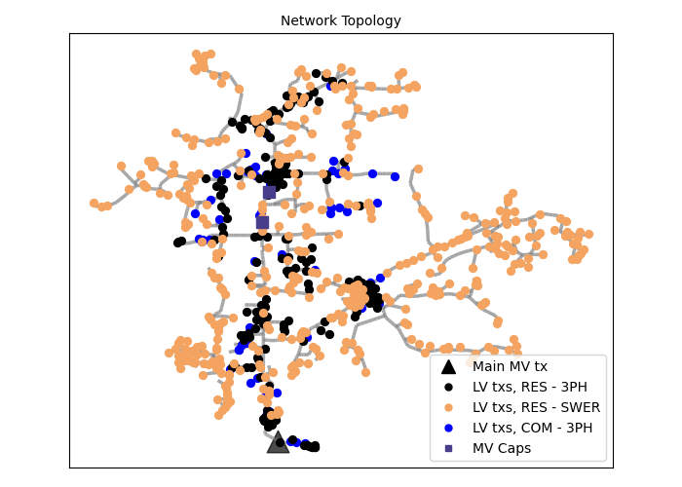Figure 1: Network 1 plot
- Buses: All MV buses are set to a nominal voltage of 22 kV, except the source bus, which is predefined at 66 kV. All LV buses are predefined at 0.4 kV.
- Lines and line codes: Lines are modeled according to the provided line codes. Any line with length < 0.001 km is replaced by a switch with the same bus-to-bus connection. This is required for pandapower power-flow convergence, since extremely small impedances (≈ < 0.001 Ω) can lead to numerical instability and non-convergence.
- Capacitors: In the time-series power-flow, capacitors are switched ON from 10:00 to 23:00.
- Regulators: Regulators are represented as two-winding transformers with tap control applied during the time-series simulation. The nominal ratio is 22/22 kV. Tap range is 17 positions with 1.25% step size, with the neutral position at 0 (tap positions −8 to +8). The controller voltage target is 1.04 pu with a deadband of ±0.01 pu. This differs from the OpenDSS model where the voltage target is 1 pu.
- SWER transformers: SWER transformers are modeled as two-winding transformers with nominal ratio 22/22 kV, consistent with the balanced (three-phase equivalent) model used. This differs from the original OpenDSS network configuration, which included 22/12.7 kV SWER transformers.
- Distribution substations: Distribution transformers are modeled as two-winding transformers with nominal ratio 22/0.4 kV, using off-load tap settings with 5 positions and 2.5% step size; the nominal (neutral) position is 3. This differs from the original OpenDSS network configuration, which included transformers with nominal voltage ratios of 22/0.433 kV and 12.7/0.23 kV.
- Primary substation: The external grid (slack) is defined at 1.04 pu
These adjustments were introduced in order to facilitate the transition from single-phase representations to a three-phase equivalent modeling framework and to improve the agreement between the two simulation environments and reduce the observed deviations.

Transformer Parameters
- Pandapower Transformer Parameters:
vk_percent = relative short-circuit voltage
vkr_percent = real part of relative short-circuit voltage
pfe_kw = iron losses in kW
i0_percent = open loop losses in percent of rated current
shift_degree= angle shift over the transformer
- OpenDSS Transformer Parameters:
%loadloss = Percent Losses at rated load
%noloadloss = Percent No load losses at nominal voltage
xhl = percent reactance high-to-low
conns = connection of this winding
- Conversion:
vk_percent = xhl
vkr_percent = %loadloss
pfe_kw = (%noloadloss/100) * sn_mva/1000
i0_percent = 0.1
shift_degree = 0º for conns=[Wye Wye] or 30º for conns=[Delta Wye]
Line Parameters
- Pandapower Line Parameters:
r_ohm_per_km = line resistance in ohm per km
x_ohm_per_km = line reactance in ohm per km
c_nf_per_km = line capacitance (line-to-earth) in nano Farad per km
max_i_ka = maximum thermal current in kilo Ampere
- OpenDSS Line Parameters:
r1 = positive-sequence resistance, ohms per unit length
x1 = positive-sequence reactance, ohms per unit length
b1 = positive-sequence capacitance, microS per unit length
normamp = normal ampacity, amps
- Conversion:
r_ohm_per_km = r1
x_ohm_per_km = x1
c_nf_per_km ​= ​[(b1*10⁻⁶ ) / km_per_unit]*(10⁹/2*π*50)
max_i_ka = normamp / 1000

Timeseries Powerflow
In the resulting circuit, the loads are applied and the load shapes are mapped in the same way as in the opendss file of Team Nando. The analysis that followes is for the 15 January 2014, the day of the
year with highest demand (resolution of 30 minutes).
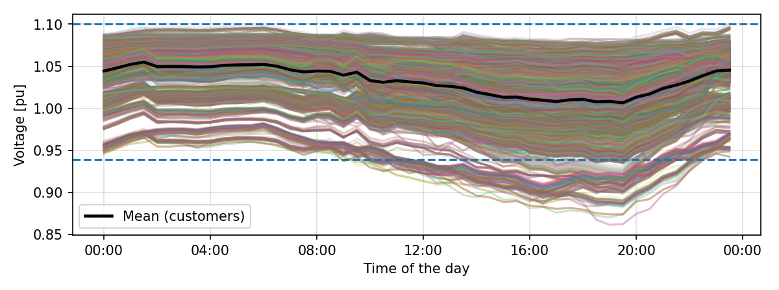Figure 2: Voltage plot of all costumer busses for the 15 January 2014

Metrics and Comparison of Pandapower-Opendss
- Customer Voltages: For a random customer bus, the waveform of voltage over time for one day is presented below.
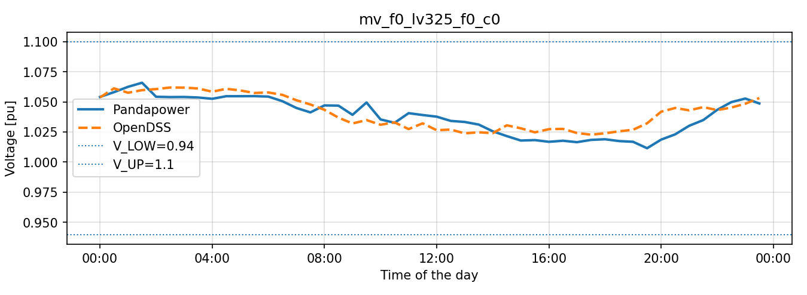
The global Mean Absolute Percentage Error is 1.8143.
The max deviation is 13.292567 %.
- Low-Voltage Transformer Utilization: For a random Transformer, the waveform of loading_percent over time for one day is presented below.
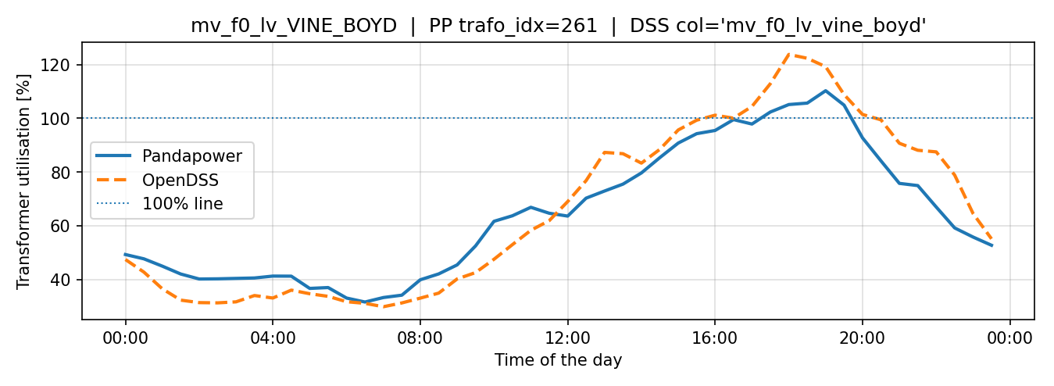
The overall mean absolute difference is 6.1673 percentage points.
This deviation is oriented to the transition from single-phase transformer representations to a three-phase equivalent modeling framework.
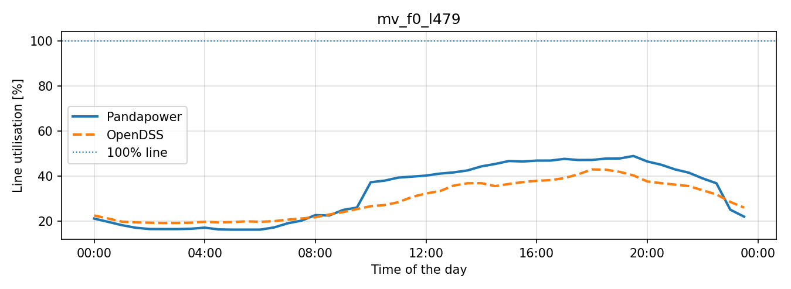
- MV Line Utilization: For a random MV line, the waveform of loading_percent over time for one day is presented below.
The overall mean absolute difference is 1.2506 percentage points.

