Upon starting FileGetMain.java displays a list of menu options and hotkeys

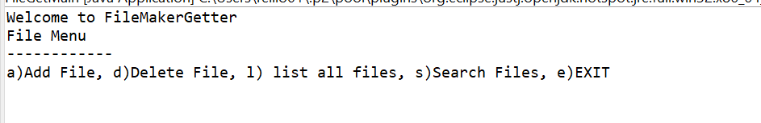

Press “a” to add a file. Press enter.

FileGetMain.java prompts for a file name

Enter a file name to create a file. Press enter

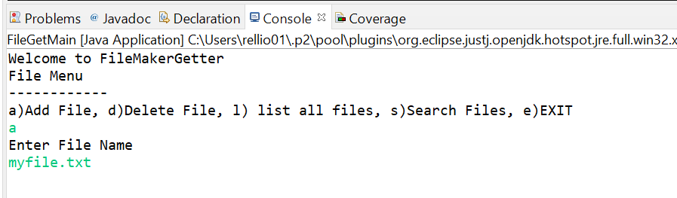

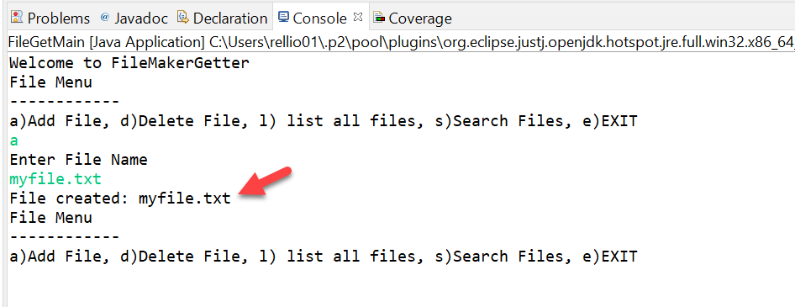

Result: A new file gets creted under ./myfiles:

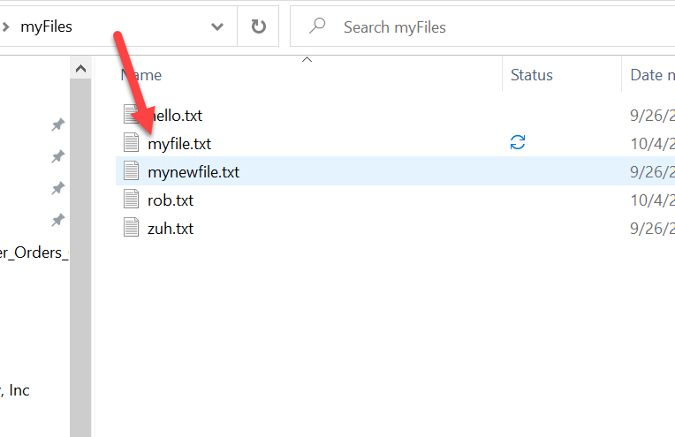

Press “l” + enter to list all files in ./myfiles

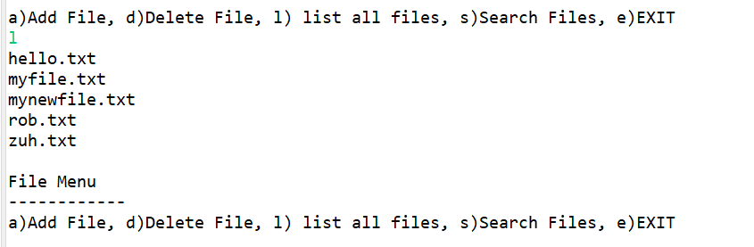

Press “d” enter to delete a file

FileGetMain.java prompts for a file name

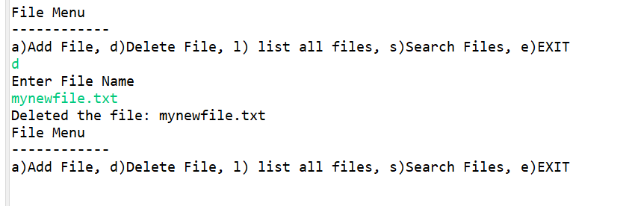

Result: file gets deleted from ./myfile directory

Press s + enter button

FileGetMain.java prompts for a file name. enter a random string (which will not be found)

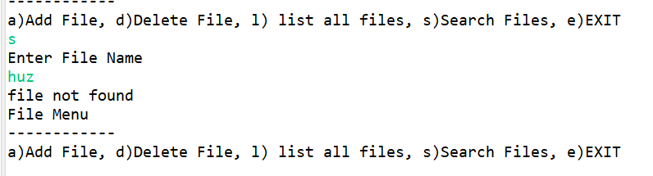

Press “e” + enter to end the program.