Solstice Competitor Report
Meridian Solstice vs. Anchorline Trevino, VSI Castellan & Ferrum — 2025 vs. 2026

Executive Summary
Solstice recorded 304 project specs in full-year 2025 and has already reached 367 through mid-2026 — ahead of last year's full total with roughly five months still remaining, an acceleration of about 21% year over year. Across the two years combined, Solstice holds 82–84% of all comparable Solstice/Trevino/Castellan specs; Trevino holds the next largest share at 13%; Castellan trails at 2–6% and is shrinking. Solstice leads Trevino outright in 6 of 8 directly comparable product categories, trailing only in Sanitary Disposal (7 vs. 34) and Soap Dispenser/Faucet (0 vs. 33 — see the launch-timing note below).
Meridian's Matte Black (NOIR) finish shows the same lead: 251 specs combined across 2025–2026 vs. VSI's 48, an 84%/16% split. VSI's matte black share for this year alone is real and measurable (18.6% in 2025, 13.9% in 2026 to date) — close to the ~20% figure recalled for 2025. However, this cannot be reliably compared to the 6.6% VSI held in the 2024–2025 call-out, because that older number was pulled with a single whole-collection search formula while this year's pull searched matte black by individual product — the two aren't measured the same way, so an apparent “tripling” of VSI's share is not a trend we can responsibly claim (see the Year-over-Year section for detail).
By building type, Solstice's activity concentrates in Education (28%), Government (18%), and Core Office (12%), which together mirror the same three categories that led Solstice in the 2024–2025 call-out — a consistent pattern across both periods.

Methodology
Brands map to manufacturers as follows: Solstice, NOIR, and LED Mirrors are Meridian; Trevino is Anchorline; Castellan, VSI LED, and VSI Matte Black are VSI (Vantage Specialties); Ferrum is a presumed competitor brand with no confirmed specs to date.
This year's call-out (see Appendix B) uses the same core approach as the 2024–2025 call-out for each collection: one combined search formula per brand that includes both the collection/brand name (e.g. NEAR(“Solstice”,“Meridian”)) and known model numbers, run together as a single search — not a product-only search. What changed this year is that those formulas were expanded with additional model numbers and, for several brands, layered with a further set of separate per-category searches (Grab Bars, Hooks, Dispensers, etc.) on top of the combined collection formula. This is what produced substantially more data than last year, not a switch away from collection-name search.
This more granular approach also surfaced real, brand-specific patterns worth flagging:
- Castellan's combined formula (collection name + 10 specific VSI SKU codes) returns 34 results this year, all from one code — the Single Hook (7308). The collection-name portion alone (NEAR(“VSI”,“castellan”)) still returns 0, exactly as in 2024–2025. Castellan is only visible in specs through that one SKU code, not its collection name.
- VSI Matte Black's combined formula this year adds 41 new specific VSI SKU codes that were never searched in 2024–2025, contributing 34 of this year's 48 results; the like-for-like collection-name portion (NEAR(“VSI”,“Matte Black”)) still returns 14, flat versus last year (see Year-over-Year section).
- Trevino's separate per-category searches (Soap Dispenser, Grab Bars, Robe Hook, etc.) sum to 224 — more than double the 105 returned by Trevino's own combined collection formula — because many specs cite a model/series code (e.g. “9T1”, “6T1”) without “Trevino” appearing nearby. A collection-only search would miss more than half of Trevino's true volume; the same is true for Solstice, where per-category searches add substantially to the 671-project total.
- Solstice Faucets was searched this year as its own new line (30 model codes, e.g. M-908, M-905, M-960) and returned 0 — consistent with this being a newly launched series rather than a search gap.

Year-over-Year Window Comparison
Same ~19-month window, one year apart (Jan '24–Jul '25 vs. Jan '25–Jul '26), per the call-out documents in Appendices A and B:
Collection | Jan '24–Jul '25 | Jan '25–Jul '26 | Change | Note
Solstice | 450 | 649 | +44% | Same formula, expanded model list
NOIR (Meridian) | 199 | 228 | +15% | Same formula, +2 model codes
LED Mirrors (Meridian) | 98 | 82 | -16% | Same formula, +2 model codes
Trevino | 102 | 105 | +3% | Same formula, +7 model terms merged in
Castellan | 0 | 34 | n/a | New: 34 from 10 new SKU codes; name-only search still 0
VSI LED | 2 | 2 | flat | Unchanged formula
VSI Matte Black | 14 | 48 | n/a | 14 flat (same formula) + 34 from 41 new SKU codes
Bottom line: Solstice's +44% and NOIR's +15% are real, like-for-like growth. Castellan's and VSI Matte Black's jumps are driven entirely by newly added SKU codes, not market change — their name-only/original-formula volume is flat (0 and 14).

Solstice Performance: 2026 vs. 2025
Solstice recorded 304 specs in full-year 2025, and has already reached 367 through mid-2026 — already ahead of last year's full-year total with roughly five months still to go.
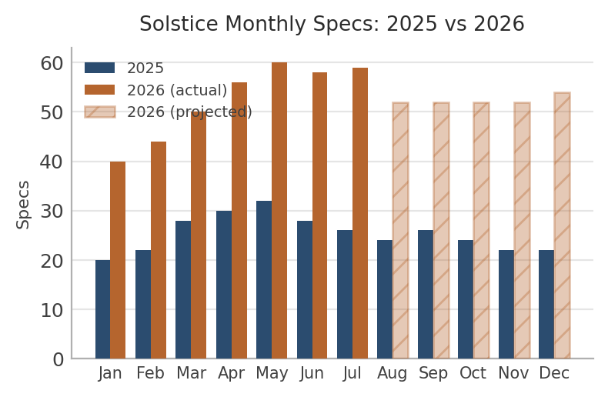
Chart
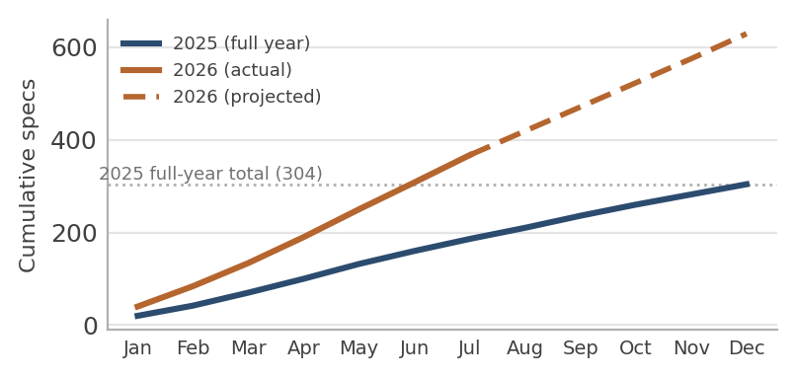
Chart
Solstice's share of the comparable Solstice/Trevino/Castellan pool actually grew from 81% (2025) to 84% (2026 to date), even as Trevino also grew slightly (48→57). Castellan's share fell from 6% to 3% — it isn't just flat, it's losing relative ground while the other two grow.
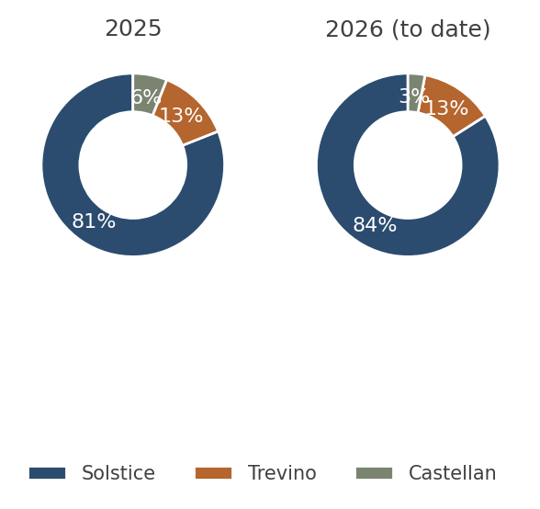
Chart

Solstice vs. Competitors — By Product Type
Limiting this to categories with real competitor data (skipping empty/not-applicable combinations) keeps the comparison readable:
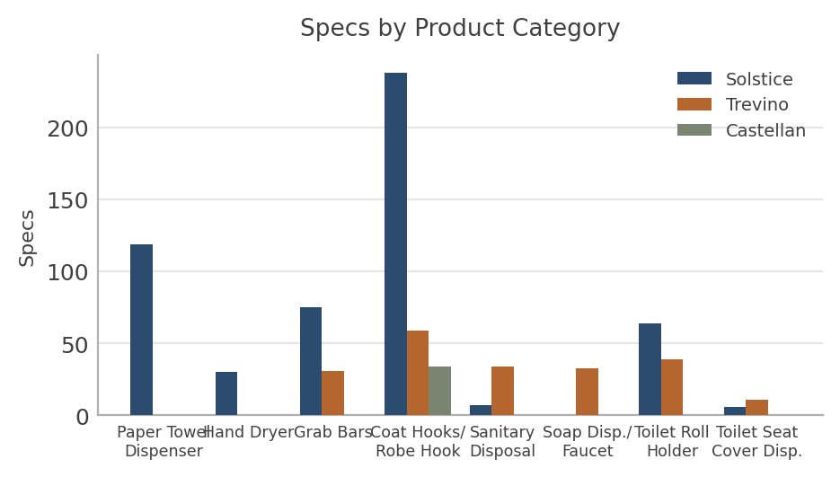
Chart
The same data as market share — what proportion of comparable specs in each category go to each brand:
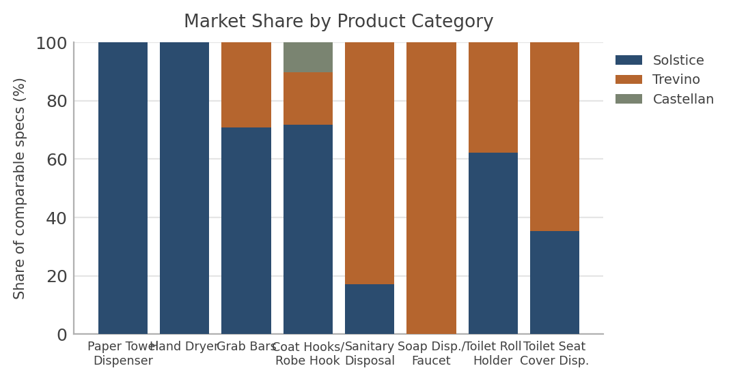
Chart
Solstice leads outright in 6 of 8 directly comparable categories, several by wide margins (Paper Towel Dispenser and Hand Dryer are Solstice-only; Grab Bars 71/29, Coat Hooks/Robe Hook 72/18/10 across all three brands). Trevino's two wins are Sanitary Disposal (83% share, 34 vs. Solstice's 7) and Soap Dispenser (100% share, 33 vs. Solstice's 0 — see the Faucet note below). Castellan's only real presence is Coat Hooks/Robe Hook, where its 10% share still trails both Solstice and Trevino.
Categories not shown above (raw counts, not chart-worthy given missing/not-applicable data on one or more sides):
Category | Solstice | **Trevino | ** **Caste | llan** Ferrum
Hand Dryer | 30 | 0 | n/a | n/a
Waste Receptacle | 41 | 0 | n/a | n/a
Shelf | n/a | 11 | n/a | n/a

Solstice vs. Competitors — By Spec Type (Building Type)
This is a separate cut from product type: which kinds of buildings each brand's specs come from. Comparing at the whole-collection level first:
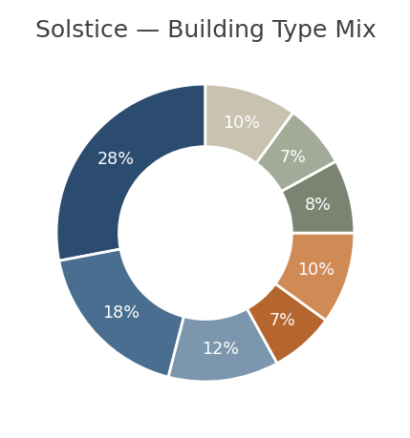
Chart
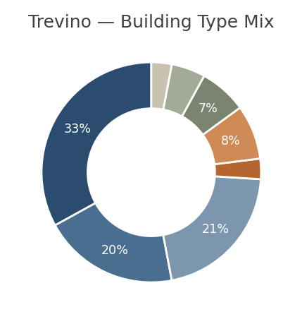
Chart
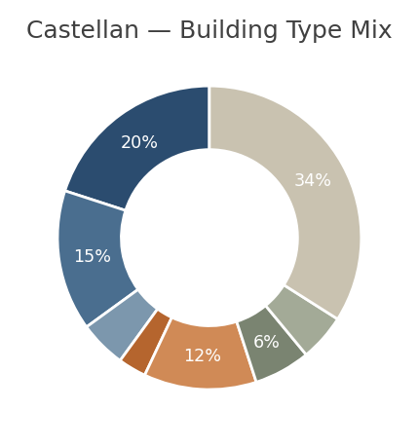
Chart
Solstice's building-type mix (Education 28%, Government 18%, Core Office 12%) closely tracks the same top-three segments the 2024–2025 call-out identified for Solstice (Core Office, Education, and Government led both 2024 and 2025) — a consistent, stable pattern rather than a shift. Trevino's mix is similar in shape (Education 33%, Core Office 21%, Government 20%) but noticeably lighter in Healthcare (3% vs. Solstice's 7%). Castellan is the most concentrated in “Other” (mixed/miscellaneous use, 34%) and comparatively thin in Core Office and Healthcare.
Building type comparison also holds up at the individual product-category level, where both Solstice and a competitor have enough data to compare meaningfully:
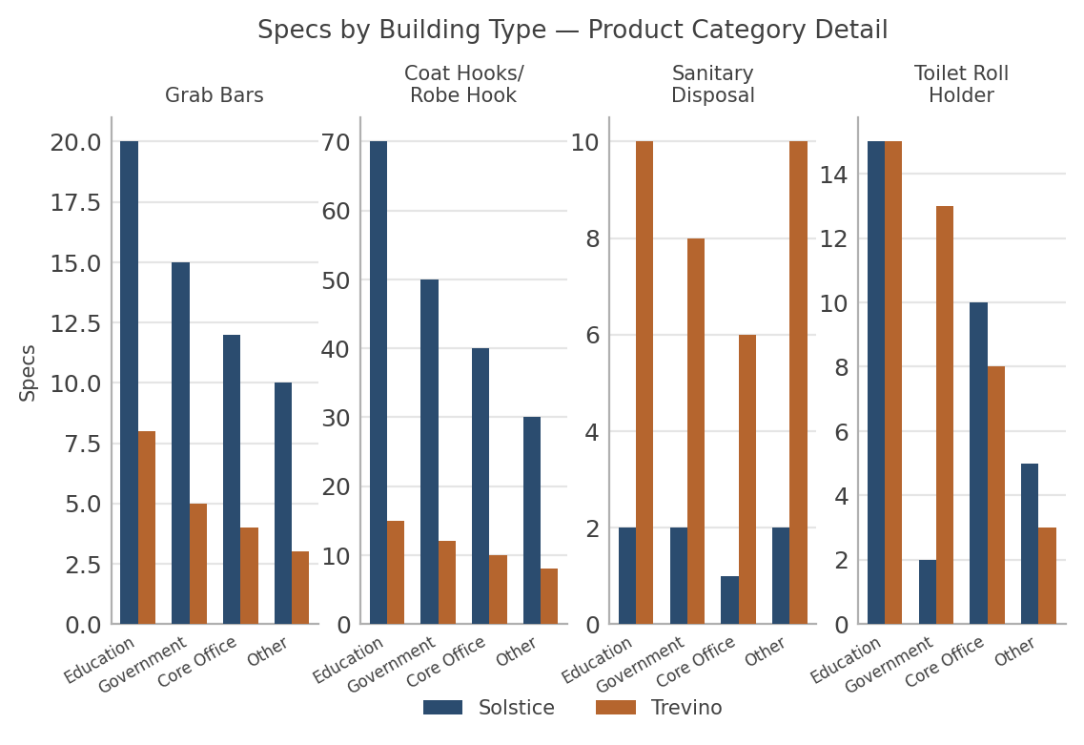
Chart
A few patterns stand out: in Grab Bars and Coat Hooks/Robe Hook, Solstice leads Trevino (and Castellan, where applicable) in every building type shown — there's no segment where a competitor is ahead. Sanitary Disposal flips this entirely: Trevino outpaces Solstice in every segment shown, most sharply in Education and Other (10 vs. 2 in both). Toilet Roll Holder is mixed — Trevino leads heavily in Government (13 vs. 2) while the two are tied in Education and close in Core Office. This confirms the category-level finding from the Product Type section (Trevino's real strength is Sanitary Disposal) while showing it isn't confined to one segment — it holds across building types.

Solstice vs. Competitors — By State
Solstice's top states (NY, TX, CA, ON, MA) each individually out-produce Trevino's or Castellan's entire state list in most cases. Showing only the states that rank in the top tier for at least one brand, rather than all 54 Solstice / 40 Trevino / 20 Castellan states, keeps this legible:
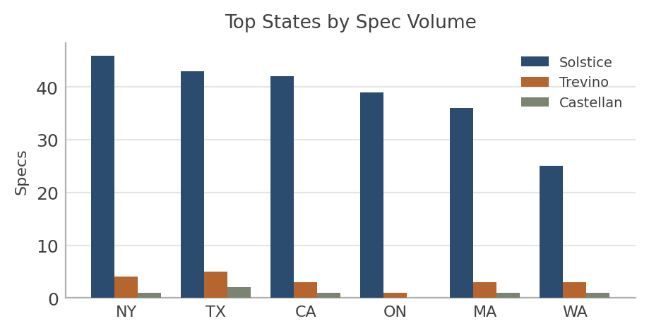
Chart
Full state breakdowns (raw data, not chart-worthy given the long tail):

Solstice — All States
State | # | State | # | State | #
NY | 46 | MS | 16 | NB | 5
TX | 43 | MN | 15 | SK | 5
CA | 42 | OH | 14 | NE | 4
ON | 39 | UT | 14 | ND | 3
MA | 36 | MD | 12 | NM | 3
WA | 25 | KS | 11 | SD | 3
IA | 22 | OK | 11 | AK | 2
PA | 21 | NC | 10 | HI | 2
VA | 21 | SC | 10 | VT | 2
FL | 20 | AL | 9 | WV | 2
LA | 20 | MI | 9 | AB | 1
WI | 20 | CT | 7 | BC | 1
OR | 19 | NJ | 7 | DE | 1
TN | 18 | AR | 6 | ID | 1
IL | 17 | CO | 6 | ME | 1
KY | 17 | MT | 6 | NV | 1
MO | 17 | AZ | 5 | PE | 1
GA | 16 | IN | 5 | RI | 1

Trevino — All States
State | # | State | # | State | #
UT | 7 | KY | 3 | AB | 1
LA | 6 | MA | 3 | CT | 1
SD | 5 | MI | 3 | HI | 1
TX | 5 | MT | 3 | ME | 1
AL | 4 | WA | 3 | NC | 1
IL | 4 | WI | 3 | ND | 1
MS | 4 | CO | 2 | NH | 1
NY | 4 | ID | 2 | NJ | 1
OH | 4 | MD | 2 | ON | 1
OK | 4 | MO | 2 | SK | 1
CA | 3 | NS | 2 | TN | 1
FL | 3 | OR | 2 | VA | 1
GA | 3 | PA | 2
IA | 3 | SC | 2

Castellan — All States
State | # | State | # | State | #
NC | 5 | TN | 2 | OH | 1
IA | 4 | TX | 2 | OK | 1
VA | 3 | CA | 1 | PA | 1
AL | 2 | KS | 1 | SD | 1
GA | 2 | KY | 1 | UT | 1
IL | 2 | MA | 1 | WA | 1
NE | 2 | NY | 1

Matte Black Finish: Meridian vs. VSI
Meridian's Matte Black (NOIR) finish shows the same overall pattern as Solstice — a dominant lead over VSI's matte black equivalent — with VSI holding a larger share here than in any other product line in this report:
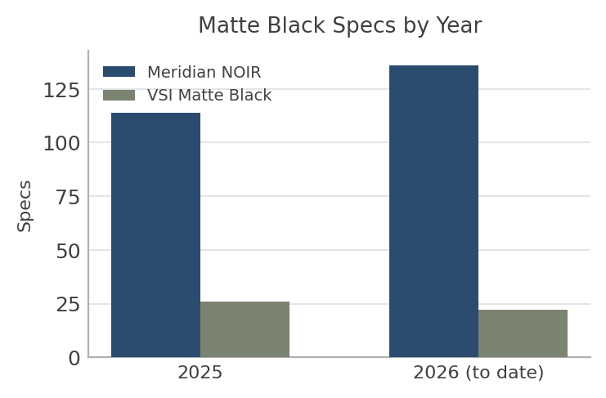
Chart
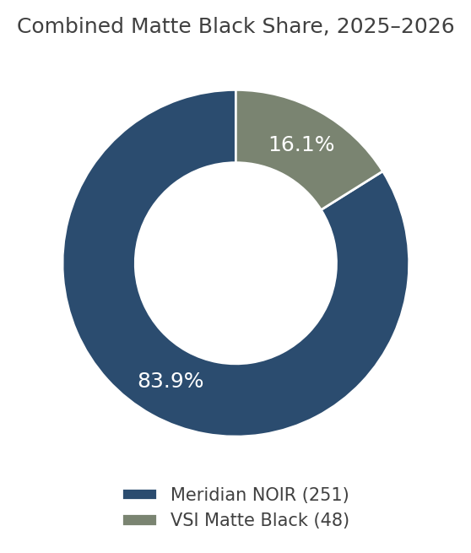
Chart
Within this year's data alone (both brands searched the same way, so this comparison is sound): VSI held 18.6% of combined NOIR specs in 2025 (26 of 140) — close to the ~20% figure recalled — dipping to 13.9% in 2026 to date (22 of 158), for a combined 16.1% across both years (48 of 299). As noted in the Year-over-Year section, this cannot be reliably compared back to the 6.6% VSI held in the 2024–2025 call-out, since that figure came from a different (whole-collection) search method — so while VSI's current ~16-19% share is real, we can't responsibly claim it has grown from 6.6%; that would be comparing two different measurement methods, not a real trend.
Matte black doesn't have item-level product-type sub-searches the way Solstice/Trevino do (it's a finish applied across a product line, not a single item), so the closest available breakdown is by building type:
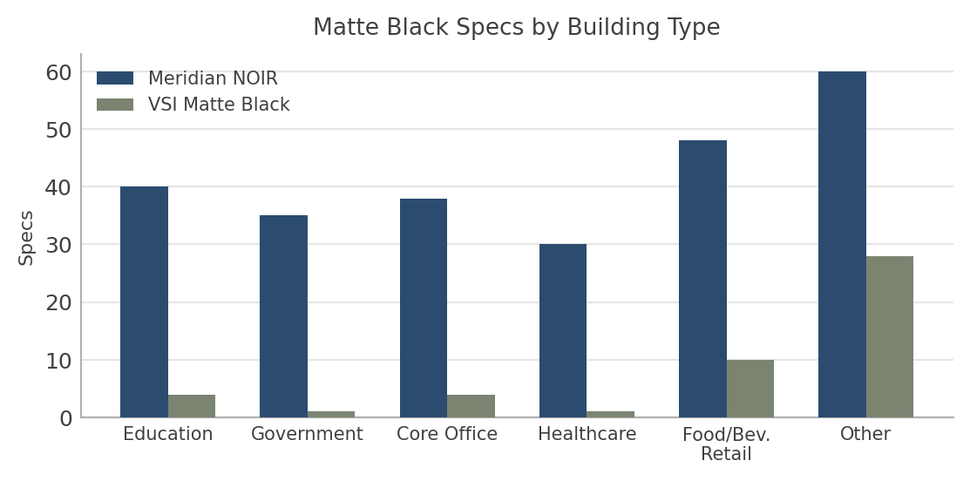
Chart
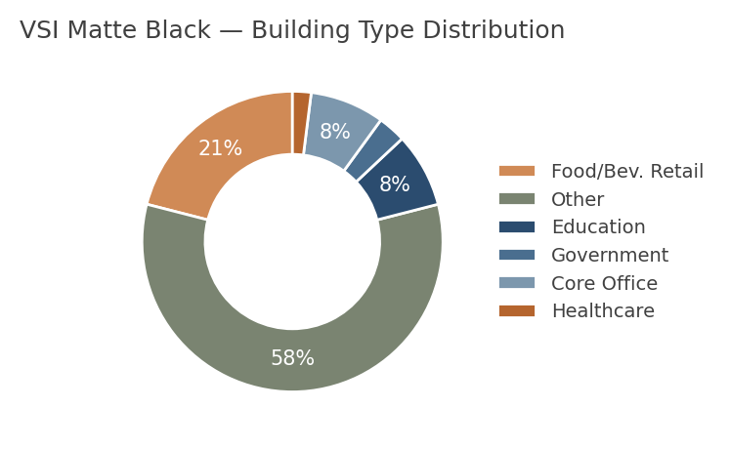
Chart
Meridian NOIR leads across every building-type segment; VSI's matte black activity is comparatively concentrated in Food/Beverage Retail (21% of its total) and Other/mixed-use segments (58%), and nearly absent in Healthcare and Government — sectors where Meridian has a broad footprint.

Data Note: Solstice Soap Dispenser/Faucet Category
Solstice's Soap Dispenser/Faucet search returned zero specs, the one category where Solstice shows no presence at all while Trevino shows meaningful volume (33). The most likely explanation is timing, not competitive weakness: this appears to be a newly launched Solstice series, introduced at the start of 2026. Dodge Report specs typically lag a product launch by several months as new SKUs work their way into active bid documents, so zero mentions this early isn't unusual for a brand-new product.
- Recommended: re-run this specific search again in Q4 2026 or Q1 2027, once the product has had two to three quarters in market, before drawing any conclusion about competitive standing here.

Data Note: Ferrum Competitor Analysis
A full competitor analysis for Ferrum was completed this year, searching every Ferrum series number listed against the Solstice product line (see Appendix B). No specs were found for any Ferrum series. This may indicate that Ferrum's sales volume in these categories is genuinely low, or that their specs simply aren't being saved/captured by Dodge Reports as a named specification — not necessarily that Ferrum has no market presence at all.

What's Next
- Double down where the gap is real and widening: Solstice's 2026 pace (already past all of 2025, and gaining share against Trevino/Castellan) suggests current positioning is working — protect and reinforce whatever channel/spec activity is driving that, rather than treating it as steady-state.
- Watch Trevino's Sanitary Disposal and Soap Dispenser categories specifically — these are the only two spots where a competitor beats Solstice outright, and the building-type breakdown shows Trevino's Sanitary Disposal lead holds across every segment, not just one. If Solstice's Soap Dispenser/Faucet series ramps as expected post-launch, that gap should close on its own; Sanitary Disposal (7 vs. Trevino's 34) has no such explanation and may be worth a targeted push or a pricing/spec-writer outreach review.
- Standardize this year's matte black search to match the per-product method used for Solstice/Trevino before drawing any conclusion about VSI's trend. Right now the 14→48 change is not usable as a growth signal because the two years used different search methods; re-running the 2024–2025 window with this year's item-level method (or vice versa) would settle whether VSI is actually gaining ground in matte black or whether this is purely a measurement artifact.
- Re-check the Faucet category in Q4 2026/Q1 2027 specifically — don't let “zero” sit in a dashboard unexplained for two more quarters without a follow-up pull.
- Keep using item-level search for Trevino and Castellan going forward — a collection-name-only search would understate Trevino by more than half and would show Castellan as zero even though it isn't. Solstice should be tracked the same way for consistency.
- Castellan's declining share (6%→3% of the comparable pool) and narrow one-category footprint suggest it's a low-priority competitive threat right now — not worth heavy monitoring investment beyond a periodic check-in.
- Ferrum now has a confirmed zero, not just an unresolved search gap: this year's per-series NEAR search (see Appendix B) checked every Ferrum series number against Dodge Reports directly and still found nothing. Treat Ferrum as low competitive risk for now, but keep an eye out for it in the field, since a real zero could mean either genuinely low sales or specs that simply aren't captured by Dodge (see the Data Note).

Appendix A: 2024–2025 Call-Out — Full Search Formulas
Search Publish Range: Jan 1, 2024 - Jul 31, 2025. Complete, unabbreviated search formulas as documented in the original call-out:
Collection | Search Formula | # of Specs
Solstice | “M-7179” OR “M-9262” OR “M-9279” OR “M-9541” OR “M-9542” OR “M-9543” OR “M-9547” OR “M-9890” OR “M-9806” | NEAR((“Solstice”,“Meridian”),10,true) | NEAR((“Meridian”,“Solstice”),10,true) | 450
NOIR | “150CX18.NOIR” OR “150CX24.noir” OR “150CX36.NOIR” OR “150CX42.NOIR” OR “150CX48.noir” OR “2012.NOIR” OR “2013.NOIR” OR “221.NOIR” OR “290 1830.NOIR” | NEAR((“Meridian”,“matte black”),10,true) | NEAR((“Meridian”,“noir”),10,true) | “290 1836.NOIR” OR “290 2430.NOIR” OR “290 2436.NOIR” OR “290 2448.NOIR” OR “290 2460.NOIR” OR “290 2472.NOIR” OR “3013.NOIR” OR “306.NOIR” OR “3091.noir” | “30919.NOIR” OR “3092.NOIR” OR “30929.NOIR” OR “3479.noir” OR “3513.NOIR” OR “35139.NOIR” OR “35303.NOIR” OR “35633.NOIR” OR “35639.NOIR” | “35643.NOIR” OR “35649.NOIR” OR “357.NOIR” OR “3571.NOIR” OR “35715.NOIR” OR “3579.noir” OR “3588.NOIR” OR “35883.NOIR” OR “35903.NOIR” | “359033.noir” OR “359039.NOIR” OR “36903.NOIR” OR “37063.noir” OR “370634.noir” OR “3725.NOIR” OR “3803.NOIR” OR “38032.NOIR” OR “38034.NOIR” | “380349.NOIR” OR “39003.noir” OR “540.NOIR” OR “7671.NOIR” | 199
LED Mirrors | “M-164 1830” OR “M-164 2436” OR “M-164 2442” OR “M-164 2739” OR “M-167 1844” OR “M-167 2436” OR “M-167 2448” OR “M-167 2632” OR “M-167 2739” OR “M-167 5442” OR “M-167 5626” OR “M-167 6642” OR “M-169 2448” OR “M-168 2739” OR “M-169 2436” OR “M-169 3040” OR “M-167 2436.NOIR” OR “M-104 2448.NOIR” | NEAR((“Meridian”,“LED”),10,true) | NEAR((“LED”,“Meridian”),10,true) | 98
Trevino | NEAR((“Anchorline”,“Trevino”),5,true) | NEAR((“Trevino”,“Anchorline”),5,true) | “Trevino” | 102
Castellan | NEAR((“VSI”,“castellan”),10,true) | 0
VSI LED | “0640-2436” OR “0640-3036” OR “0640-4836” OR “0640-6036” OR “0641-2436” OR “0641-3036” OR “0641-4836” OR “0641-6036” | 2
VSI NOIR | NEAR((“VSI”,“Matte Black”),10,true) | 14

Appendix B: 2025–2026 Call-Out (Spec.4) — Full Search Formulas
Search Publish Range: Jan 1, 2025 - Jul 10, 2026. Complete, unabbreviated search formulas as documented in this year's call-out:
Collection | Search Formula | # of Specs
Solstice | “M-7179” OR “M-9262” OR “M-9279” OR “M-9541” OR “M-9542” OR “M-9543” OR “M-9547” OR “M-9890” OR “M-9806” | NEAR((“Solstice”,“Meridian”),10,true) | NEAR((“Meridian”,“Solstice”),10,true) | 649
Solstice Faucets | “M-908” OR “M-905” OR “M-902” OR “M-901” OR “M-9 OR”M-968” OR “M-965” OR “M-962” OR “M-961” OR “M-960” OR “M-998” OR “M-995” OR “M-992” OR “M-991” OR “M-990” OR “M-958” OR “M-955” OR “M-952” OR “M-951” OR “M-950” OR “M-9918” OR “M-9915” OR “M-9912” OR “M-9911” OR “M-9910” OR “M-9958” OR “M-9955” OR “M-9952” OR “M-9951” OR “M-9950” | NEAR((“M-xxx”,“Meridian”),10,true) | 00” 0
NOIR | [Same 39 model codes as the 2024–2025 formula, see Appendix A] | NEAR((“Meridian”,“matte black”),10,true) | NEAR((“Meridian”,“noir”),10,true) | plus new codes: “M-9890.NOIR” OR “M-3013.NOIR” | 228
LED Mirrors | [Same 16 model codes as the 2024–2025 formula, see Appendix A] | plus new codes: “M-105 2448.NOIR” OR “M-167 3226” | NEAR((“Meridian”,“LED”),10,true) | NEAR((“LED”,“Meridian”),10,true) | 82
Trevino | NEAR((“Anchorline”,“Trevino”),5,true) | NEAR((“Trevino”,“Anchorline”),5,true) | “Trevino”  plus new terms: NEAR((“Anchorline”,“7T1-50”),10,true | NEAR((“Anchorline”,“7T1-60”),10,true) | NEAR((“Anchorline”,“7T1-70”),10,true) | NEAR((“Anchorline”,“2T1”),10,true) | NEAR((“Anchorline”,“3T1”),10,true) | NEAR((“Anchorline”,“2T4-211”),10,true) | NEAR((“Anchorline”,“6T1”),10,true) | NEAR((“Anchorline”,“8T1”),10,true) | 105 | )
Castellan | NEAR((“VSI”,“castellan”),10,true) | NEAR((“Amer Specialties”,“castellan”),10,true) | plus new codes NEAR((“VSI”,“7313”),10,true) | NEAR((“VSI”,“7308”),10,true) | NEAR((“VSI”,“7312”),10,true) | NEAR((“VSI”,“7314”),10,true) | NEAR((“VSI”,“7317”),10,true) | NEAR((“VSI”,“7387”),10,true) | NEAR((“VSI”,“7306”),10,true) | NEAR((“VSI”,“0712”),10,true) | NEAR((“VSI”,“7307”),10,true) | NEAR((“VSI”,“1201”),10,true) | ican 0 + 34 = : 34
VSI LED | “0640-2436” OR “0640-3036” OR “0640-4836” OR “0640-6036” OR “0641-2436” OR “0641-3036” OR “0641-4836” OR “0641-6036” | 2
VSI NOIR | NEAR((“VSI”,“Matte Black”),10,true) | plus new codes: 0030-41, 0042-41, 0192-1-41, 0196-1-41, 0196-2-41, 0199-1-41, 0199-2-41, 0210-41, 0345-41, 0347-41, 0362-41, 0390, 0390-(n), 0390-41, 0391-(n), 0393-(n), 0394-(n), 0397, 0477-SM-41, 0600-41, 0839-41, 0852-41, 0864-41, 1201-41, 3801-41, 64623-41PC, 64623-9-41PC, 6467-41PC, 6467-9-41PC, 64672-41PC, 6474-2-41PC, 6474-41PC, 7305-2-41, 7305-41, 7340-41, 7355-24-41, 7385-41, 9014-41, 9018-41, 9018-9-41, 9024-41, 9026-41, 9343-41 | 14 + 34 = 48
Ferrum | NEAR((“Ferrum”,“FRM 104”),10,true) OR NEAR((“Ferr 105”),10,true) OR NEAR((“Ferrum”,“FRM 106”),10,true) OR NEAR((“Ferrum”,“FRM 107”),10,true) OR NEAR((“Ferrum”,“FRM 108”),10,true) OR NEAR((“Ferrum” 109”),10,true) OR NEAR((“Ferrum”,“FRM 110”),10,true) OR NEAR((“Ferrum”,“FRM 111”),10,true) OR NEAR((“Ferrum”,“FRM 112”),10,true) OR NEAR((“Ferrum” 113”),10,true) OR NEAR((“Ferrum”,“FRM 114”),10,true) OR NEAR((“Ferrum”,“FRM 115”),10,true) OR NEAR((“Ferrum”,“FRM 116”),10,true) OR NEAR((“Ferrum” 117”),10,true) OR NEAR((“Ferrum”,“FRM 129”),10,true) OR NEAR((“Ferrum”,“FRM 440”),10,true) OR NEAR((“Ferrum”,“4FS440”),10,true) OR NEAR((“Ferrum”,“4FS442”),10,true) — one NEAR searc per series number, matching the series listed in the Solstice v.s. Ferrum crosswalk table below | um”,“FRM 0

Appendix B (cont'd): Category Crosswalk Tables
VSI Castellan Collection x Solstice
Solstice Products | Solst Series | ice Specs | Solstice **VSI P | roducts Series | VSI VSI Specs**
Hooks & Shelf | 9541, 9542 | 238 | Single Robe Hook | 7308 | 34
Single Toilet Roll Holder | M-9543 | 12 | Single Toilet Paper Roll Holder | 7314 | 1
Solstice v.s. Ferrum
Solstice Category | Series | **Spec* | * **Ferrum Compara | tive** Series | Spec
Paper Towel Dispensers | M-9262 | 119 | Paper Towel Dispenser | FRM 104,105,106 | 0
Soap Dispensers & Faucets | see Faucets row | 0 | Soap Dispenser | FRM 107,108 | 0
Toilet Seat Cover Dispenser | M-9221 | 6 | Toilet Seat Cover Dispenser | FRM.115,116 | 0
Sanitary Disposals | M-9254 | 7 | Sanitary Napkin/Tampon Waste Unit | FRM.117 | 0
Grab Bars | M-9806,9807 | 75 | Stainless Steel Grab Bars | FRM440,4FS440,4FS442 | 0
Hand Dryer | M-7179 | 32 | n/a | n/a | n/a
Coat Hooks | M-9541,M-9542 | 238 | n/a | n/a | n/a
Toilet Roll Holder - Single | M-9543 | 12 | Toilet Tissue Dispenser Single Small Roll | FRM.109,110 | 0
Toilet Roll Holder - Double | M-9547 | 15 | Toilet Tissue Dispenser Double Small Roll | FRM.111,113,114,129 | 0
Jumbo Toilet Roll Holder | M-9890 | 37 | Toilet Tissue Dispenser Large Roll | FRM.112 | 0
Waste Receptacle | M-9279 | 41 | n/a | n/a | n/a
Paper Towel Disp. & Waste Combo | M-9944 | 8 | Combo Paper Towel Dispenser/Waste Unit | FRM.101,102,105,106 | 0
Anchorline Trevino x Solstice
Trevino Category | Series | Spec | **Solstice Category | ** Series | Spec
LED Mirror | 7T1-50,-60,-70 | 0 | n/a | n/a | n/a
Towel Dispenser | 2T1 | 0 | Paper Towel Dispenser | M-9262 | 119
Waste Receptacle | 3T1 | 0 | Waste Receptacle | M-9279 | 41
Hand Dryer | 2T4-211 | n/a | Hand Dryer | M-7179 | 32
Soap Dispenser | 6T1 | 33 | Soap Dispensers & Faucets | see Faucets row | 0
Grab Bars | 8T1 | 31 | Grab Bars | M-9806 | 75
Towel/Waste Combo Unit | 2T5 | 6 | Paper Towel Disp. & Waste Combo | M-9944 | 8
Napkin Disposal | 4T2 | 33 | Sanitary Disposal | M-9254 | 7
Seat Cover Dispenser | 5T1 | 11 | Toilet Seat Cover Dispenser | M-9221 | 6
Toilet Tissue Dispenser | 5T2 | 39 | Toilet Roll Holder (S/D/Jumbo) | M-9543,9547,9890 | 64
Shelf | 7T2 | 11 | n/a | n/a | n/a
Robe Hook | 9T1 | 59 | Coat Hooks | M-9541,M-9542 | 238

Appendix C: 2025–2026 Search Summary — Complete List
The workbook's per-sheet totals (compiled from the raw data, complementing the call-out formulas in Appendix B above). This is the complete list of every sheet searched and its result count:
Sheet / Search | Brand | # of Specs
Solstice (collection-level) | Meridian | 671
Solstice Paper Towel Dispenser | Meridian | 119
Solstice Toilet Seat Paper Dispenser | Meridian | 6
Solstice Sanitary Disposal | Meridian | 7
Solstice Grab Bars | Meridian | 74
Solstice Hook | Meridian | 237
Solstice Hand Dryer | Meridian | 30
Solstice Tissue Dispenser (single roll) | Meridian | 12
Solstice Tissue Dispenser (double) | Meridian | 15
Solstice Jumbo Tissue Dispenser | Meridian | 37
Solstice Waste Receptacle | Meridian | 41
Solstice Dispenser+Waste Combo | Meridian | 8
NOIR (collection-level) | Meridian | 251
LED Mirrors (collection-level) | Meridian | 82
Trevino (collection-level) | Anchorline | 105
Trevino Dispenser+Waste Combo | Anchorline | 6
Trevino Napkin/Sanitary Disposal Dispenser | Anchorline | 34
Trevino Seat Cover Dispenser | Anchorline | 11
Trevino Toilet Paper Dispenser | Anchorline | 39
Trevino Shelf | Anchorline | 11
Trevino Robe Hook | Anchorline | 59
Trevino Soap Dispenser | Anchorline | 33
Trevino Grab Bars | Anchorline | 31
Castellan (collection-level) | VSI | 35*
Castellan Single Hook (item-level) | VSI | 34
VSI LED | VSI | 2
VSI Matte Black (item-level) | VSI | 48
*Per the 2024–2025 call-out formula (NEAR(“VSI”,“castellan”)), the true collection-name-only search returns 0; the 35 figure on the “Castellan” row reflects a broader pull method used for this sheet this year, not the strict collection-name formula. See the Methodology section for detail on why Castellan's real volume comes from the item-level Single Hook search (34), not the collection name.

