IST 363

# Lab 10

## react 1

1. paste screenshot here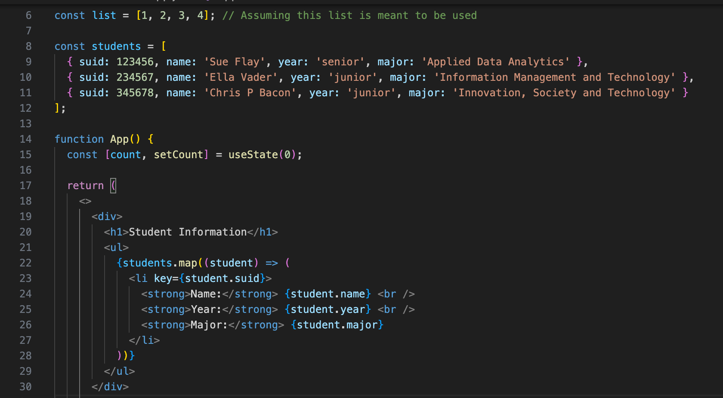

2. paste screenshot here

3. paste screenshot here

6. write brief answers to the questions below

a. React is a JavaScript library for building user interfaces. It is used to build single-page applications and allows us to create reusable UI components. Components are independent and reusable bits of code. They serve the same purpose as JavaScript functions, but work in isolation and return HTML. They are basically like functions that return HTML elements.

b. It tells the difference between an HTML tag and a component instance

c. JSX is an extension of JavaScript used in React but does a lot of similar HTML functions. JSX is compiled into JavaScript functions while HTML attributes are replaced with React syntax

d. class is already a defined word in JavaScript, so React uses className to propelry render CSS classes

e. you wrap them in {}

f. it makes code easier to read and reuse. Every reasoning for usage can be categorized and better understood

g. if a component becomes too large or takes on too much. It is helpful to divide everything up per what its concern is

h. Yes, they can each behave differently if you render it with different props

i. it uses controlled components for form elements, and manage the value of them using the component’s state. That way, React controls the form data