

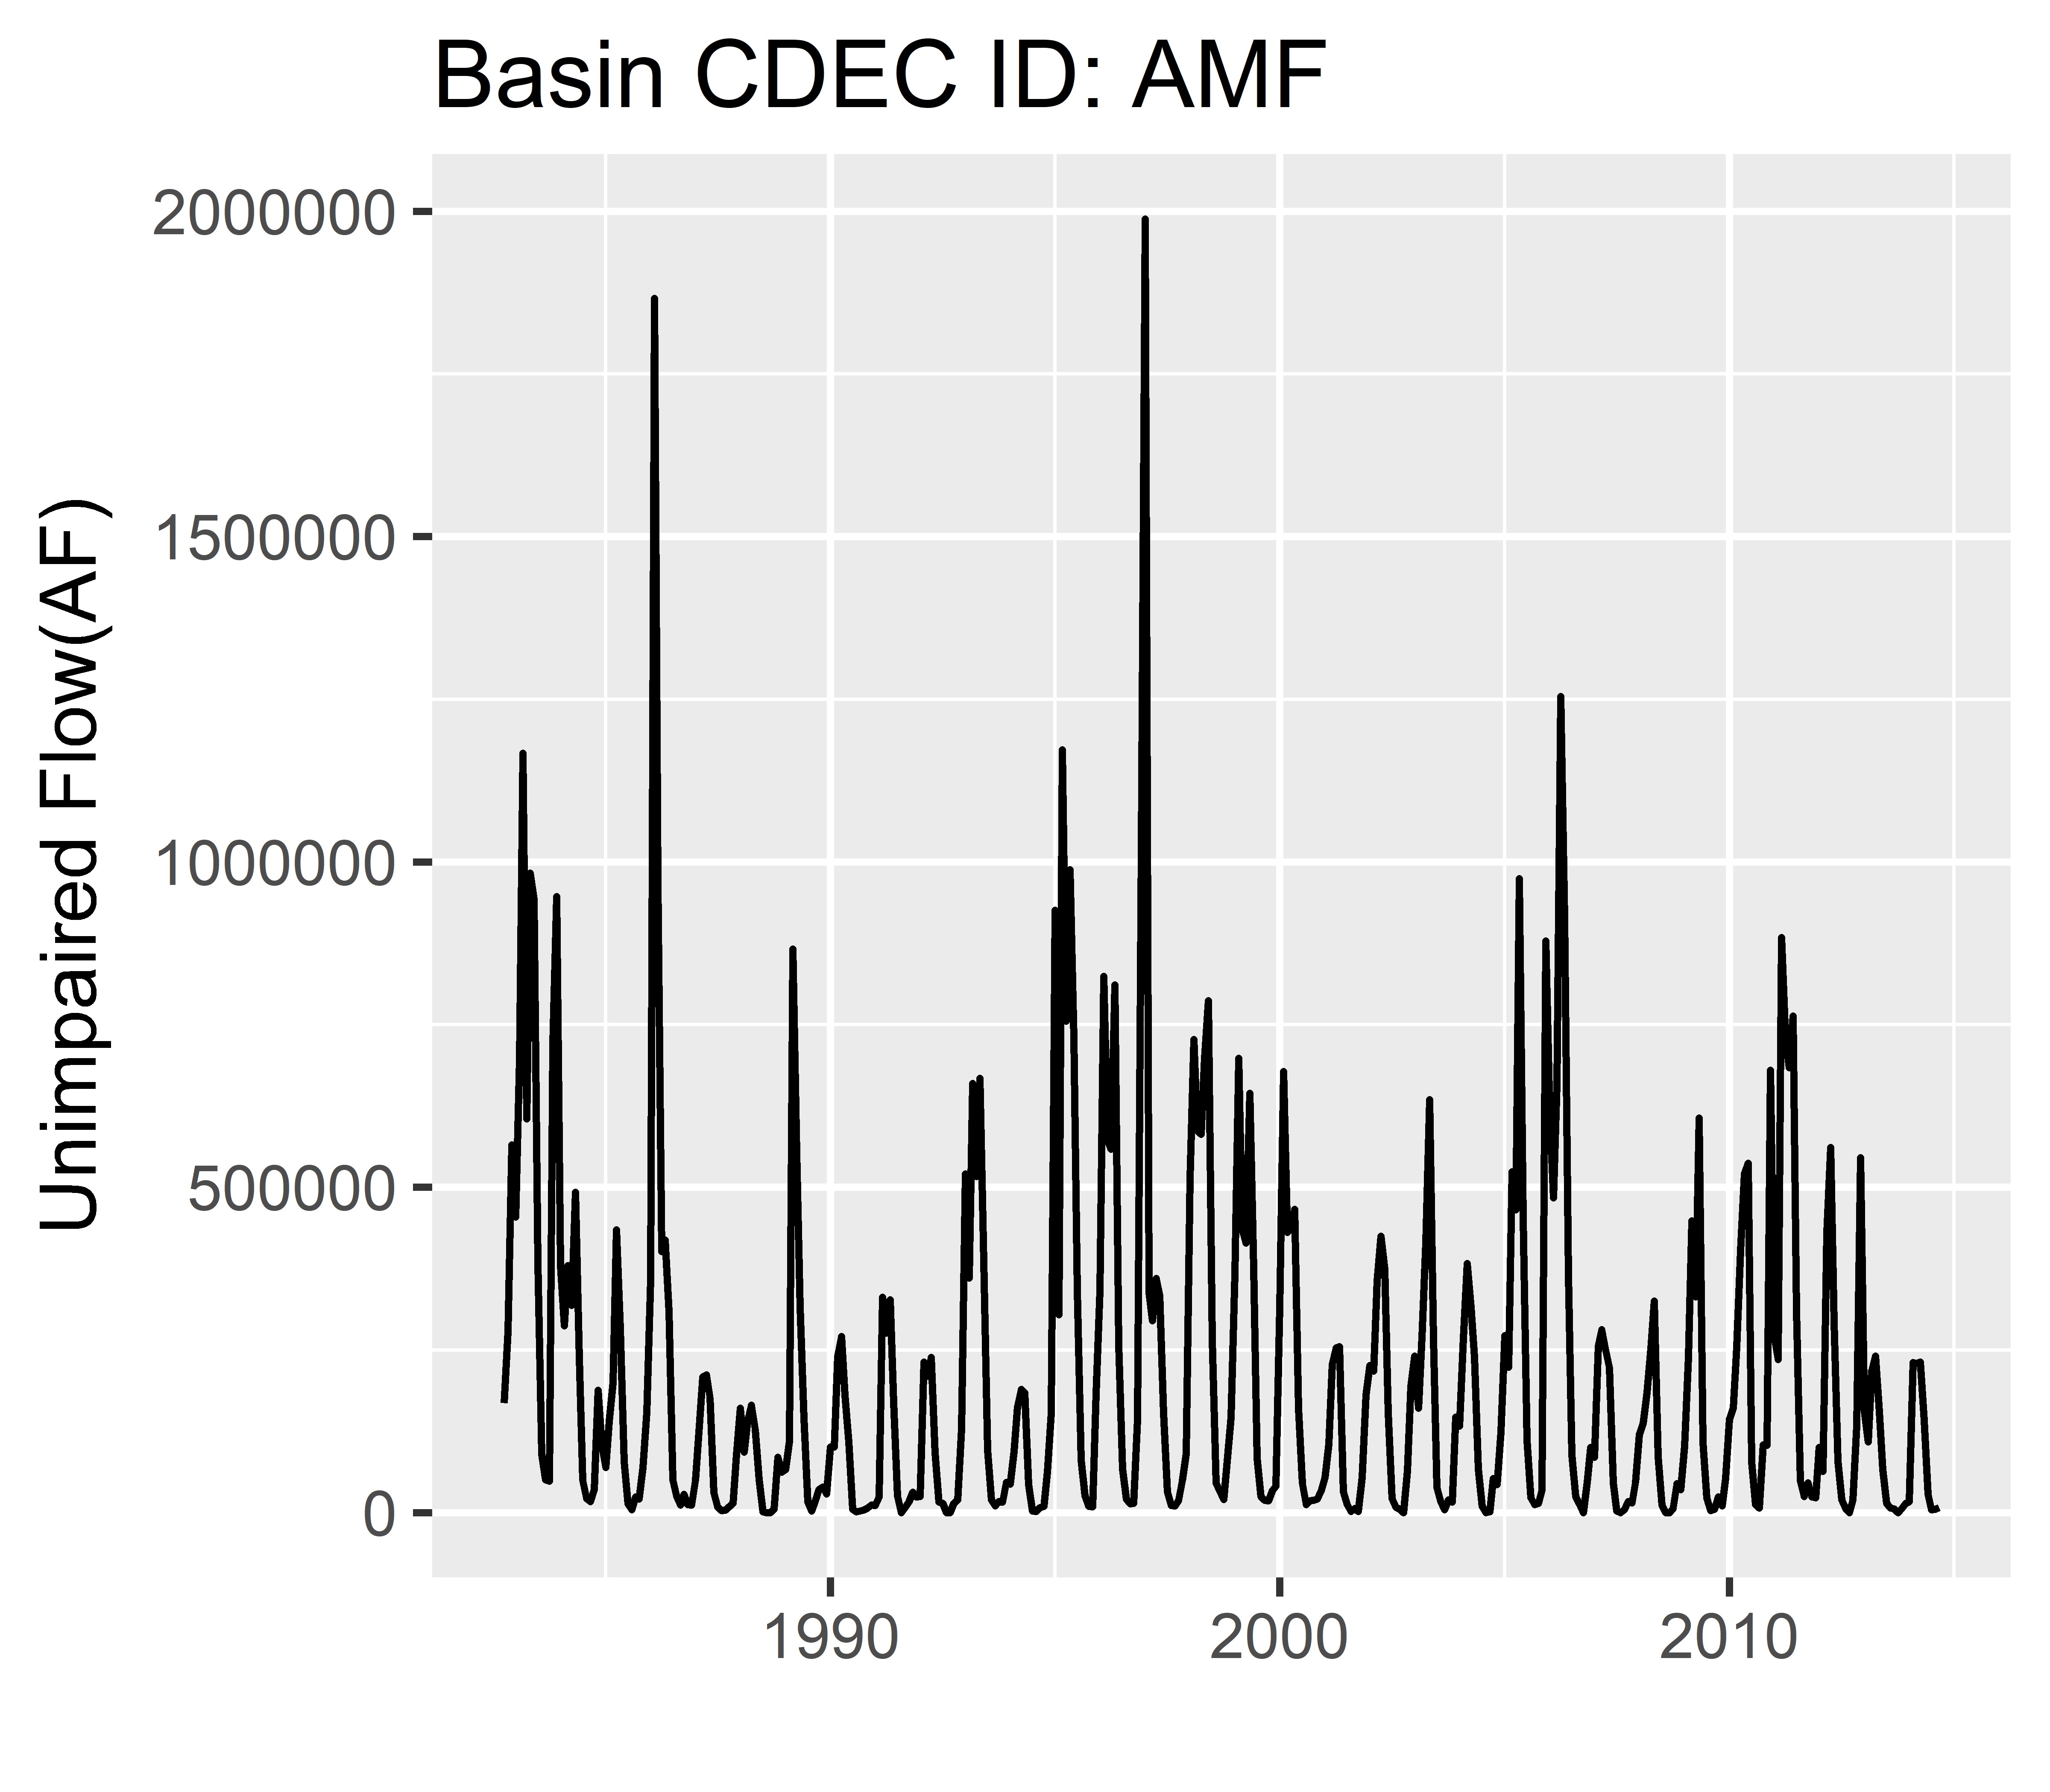

*temporal*

1

2

4

3

*hierarchical*

*spatial*

flow

time