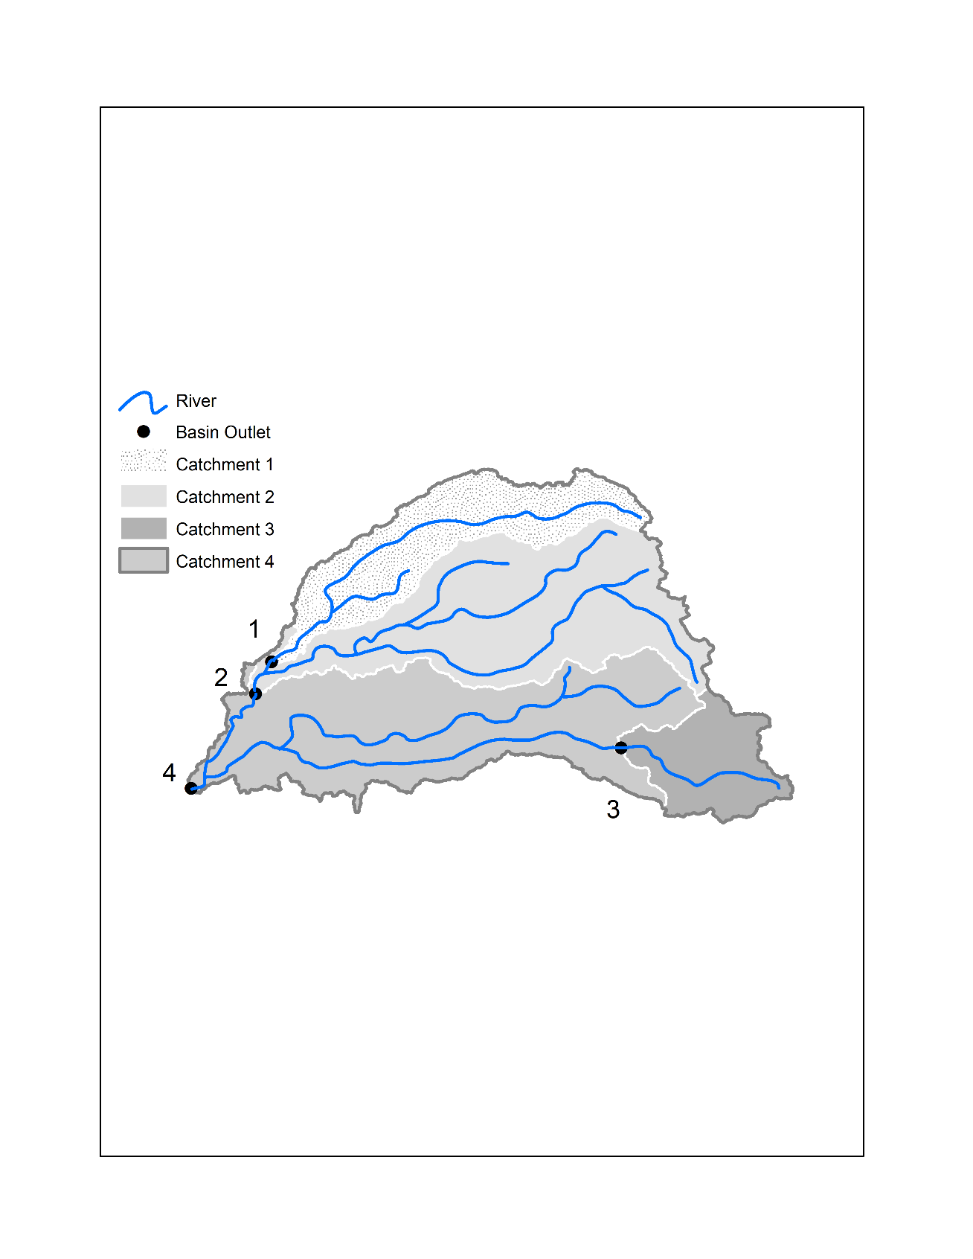

spatial

grouping

1

2

4

3

hierarchical

flow

time

temporal

