

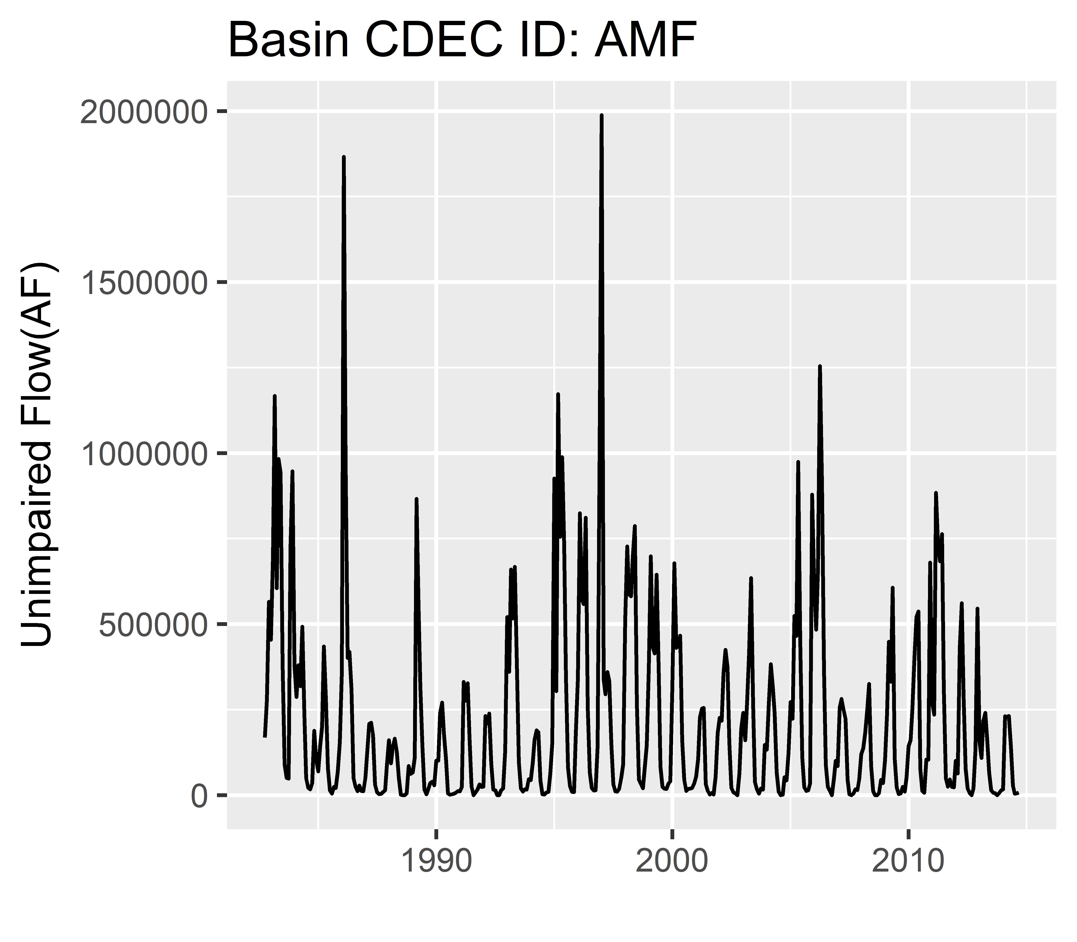

***temporal***

1

2

4

3

***hierarchical***

***spatial***

***grouping***

flow

time