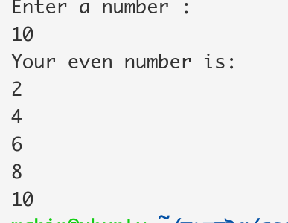
Even Number:
#!/bin/bash
echo "Enter a number : "
read num
echo "Your even number is: "
for((i=1;i<=num;i++))
do
out=$(( $i % 2 ))
if [ $out -eq 0 ]
then
echo $i
fi
done

Sumation:
#!/bin/bash
echo "Enter number: "
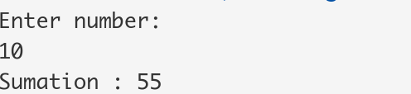
read num
sum=0
for ((i=1;i<=num;i++))
do
sum=$((sum+i))
done
echo "Sumation : $sum"

Reverse string :
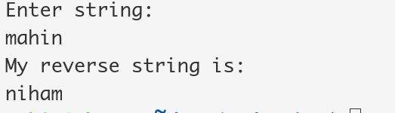
#!/bin/bash
echo "Enter string: "
read str
echo "My reverse string is: "
echo $str | rev

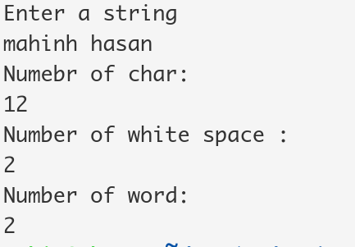
Number of char ,space word:
#!/bin/bash
echo "Enter a string"
read str
echo "Numebr of char: "
echo -n $str | wc -c
echo "Number of white space : "
echo grep -o "" <<< $str | wc -w
echo "Number of word: "
echo -n $str | wc -w

Student Grade:

read -p "Please enter number of subject: " num

if [ $num -gt 60 ]
then
echo "First Division"
elif [ $num -le 60 && $num -gt 50 ]
then
echo "Second Divison"
elif [ $num -le 50 && $num -gt 40 ]
then
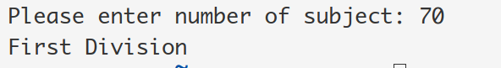
echo "Thid Division"
else
echo "Fail"

fi

Shell comand using grep:
