# Pebcak

### Hayden Anderson, Michael Elliott, Albert Morgan, Alex Ruef

<http://web.engr.oregonstate.edu/~morgaalb/cs340-project/public/>

### 1. Introduction

Pebcak enterprise is the Internet service provider that works for you! We have created a website that allows our customers to pick and choose the Internet plan that works best for them. Customers are also empowered with the ability to update their account information to insure that their excellent Internet service continues.

### 2. Detailed Functionality & Requirements

This section describes the business rules and the requirements of the application in detail.

**Business rules**

* 1. Customers must log in before being able to view any details about their plans or billing
  2. Customers must be able to add new billing information when logged in
  3. Customers must be able to change the billing of a plan when logged in
  4. Customers must be able to add and remove plans when logged in
  5. Customers may have 0 or many plans
  6. Customers may have 0 or many billing methods
  7. Customers may not sign up for the same plan twice
  8. Each plan must have exactly one customer and exactly one billing method
  9. Employees must login before viewing customer information or adding new plans
  10. You do not need to log in to view all of the ISP’s plans or compare them to their

competitors

* 1. Competitor plans must be associated with exactly one competitor
  2. Competitors may have multiple plans

### 3. Database Design

## ER Diagram of Database

## https://lh4.googleusercontent.com/3w9HO6mTZBbHVA2S81MaCqgbSPWr7-FPzeHl34iQYC3BD6nYKxe5qKtkcqDqbdQ-UNG5DHjhycdjThVzp_4cfuS_n8BqVksiGDlk7Q82QWlxBgNFqLob6PlCewodoFekKwLif8LDXrY

## Relation Schema

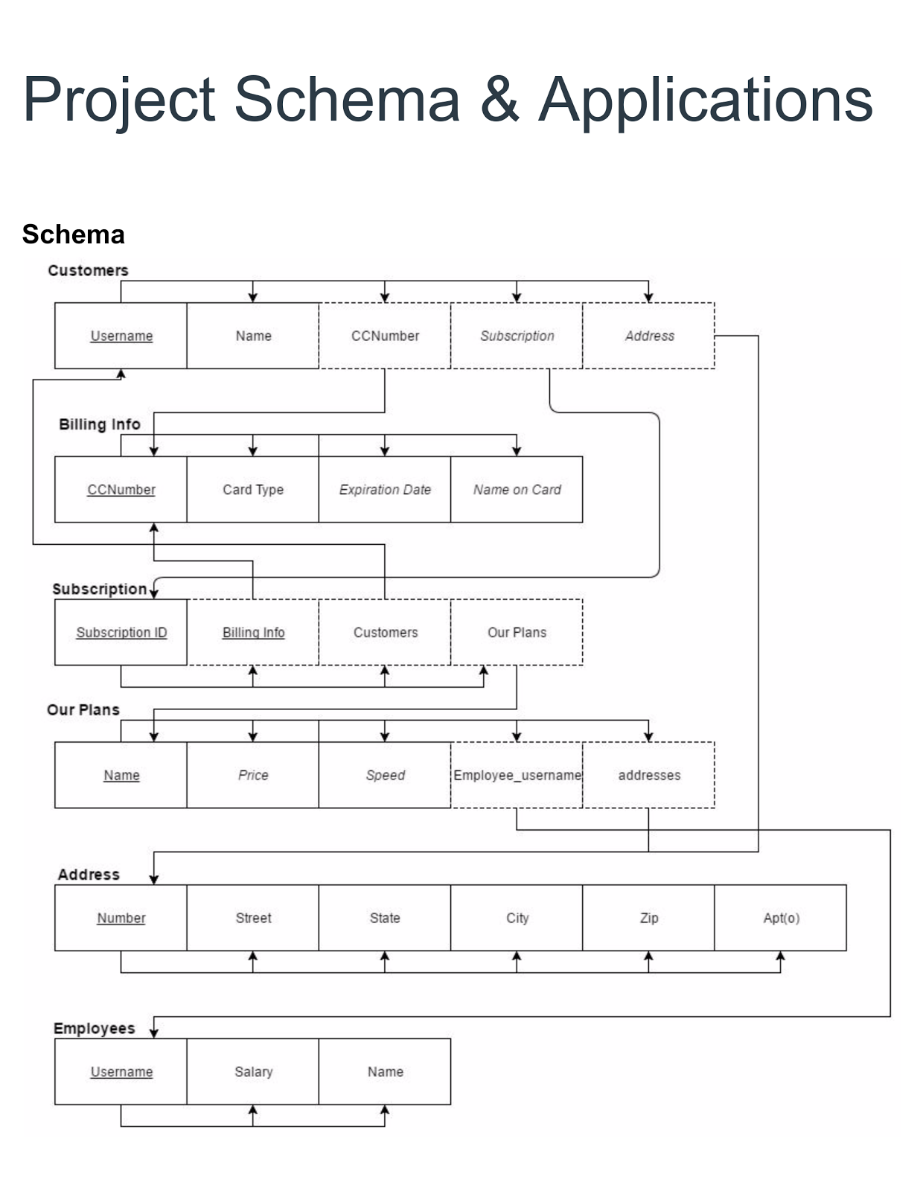

## Database Tables



DROP TABLE IF EXISTS Employee;

CREATE TABLE Employee (

id INT AUTO_INCREMENT NOT NULL,

username VARCHAR(255) UNIQUE NOT NULL,

pass_hash BINARY(60) NOT NULL,

salary INT,

name VARCHAR(255),

PRIMARY KEY (id)

) ENGINE=InnoDB, CHARACTER SET=UTF8;



DROP TABLE IF EXISTS Address;

CREATE TABLE Address (

id INT AUTO_INCREMENT NOT NULL,

num INT NOT NULL,

street VARCHAR(255) NOT NULL,

apt_no INT,

city VARCHAR(255) NOT NULL,

state CHAR(2) NOT NULL,

zip DECIMAL(5) NOT NULL,

PRIMARY KEY (id)

) ENGINE=InnoDB, CHARACTER SET=UTF8;



DROP TABLE IF EXISTS Customer;

CREATE TABLE Customer (

id INT AUTO_INCREMENT NOT NULL,

username VARCHAR(255) UNIQUE NOT NULL,

pass_hash BINARY(60) NOT NULL,

name VARCHAR(255) NOT NULL,

address_id INT,

PRIMARY KEY (id),

FOREIGN KEY (address_id) REFERENCES Address(id) ON DELETE SET NULL

) ENGINE=InnoDB, CHARACTER SET=UTF8;



DROP TABLE IF EXISTS Billing_Info;

CREATE TABLE Billing_Info (

id INT AUTO_INCREMENT NOT NULL,

cc_number DECIMAL(16) NOT NULL,

cc_type VARCHAR(255) NOT NULL,

expiration_date DATE NOT NULL,

name VARCHAR(255) NOT NULL,

user_id INT NOT NULL,

PRIMARY KEY (id),

FOREIGN KEY (user_id) REFERENCES Customer(id) ON DELETE CASCADE

) ENGINE=InnoDB, CHARACTER SET=UTF8;



DROP TABLE IF EXISTS Subscription;

CREATE TABLE Subscription (

plan_id INT,

address_id INT,

billing_id INT,

customer_id INT,

PRIMARY KEY (plan_id, address_id),

FOREIGN KEY (billing_id) REFERENCES Billing_Info(id) ON DELETE CASCADE,

FOREIGN KEY (customer_id) REFERENCES Customer(id) ON DELETE CASCADE,

FOREIGN KEY (address_id) REFERENCES Address(id) ON DELETE CASCADE

) ENGINE=InnoDB, CHARACTER SET=UTF8;



DROP TABLE IF EXISTS Plan;

CREATE TABLE Plan (

id INT AUTO_INCREMENT NOT NULL,

name VARCHAR(255),

price DECIMAL(9, 2),

speed INT,

added_by INT,

PRIMARY KEY (id),

FOREIGN KEY (added_by) REFERENCES Employee(id) ON DELETE SET NULL

) ENGINE=InnoDB, CHARACTER SET=UTF8;



DROP TABLE IF EXISTS Address_Plans;

CREATE TABLE Address_Plans (

plan_id INT NOT NULL,

address_id INT NOT NULL,

PRIMARY KEY (plan_id, address_id),

FOREIGN KEY (plan_id) REFERENCES Plan(id) ON DELETE CASCADE,

FOREIGN KEY (address_id) REFERENCES Address(id) ON DELETE CASCADE

) ENGINE=InnoDB, CHARACTER SET=UTF8;

### 4. Website Design

Discuss the design of your website.

## Website Layout

## Databases wireframe.pngUser Interface

**Home page**

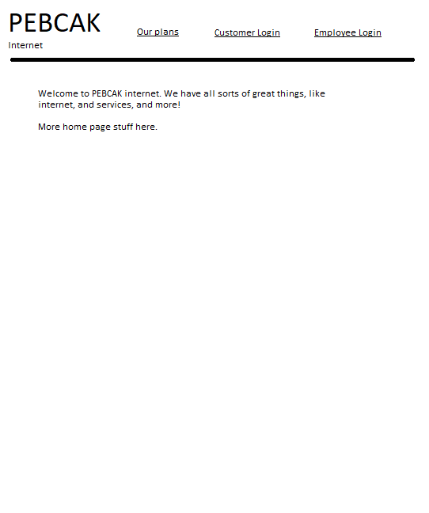

Our homepage allows users to login and access the rest of the site.

**Customer login page**

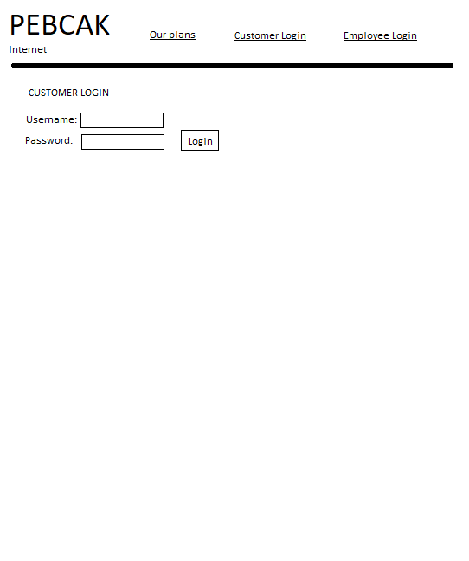

Customers can use this page to login and gain access to their account and plan pages.

**Employee login**

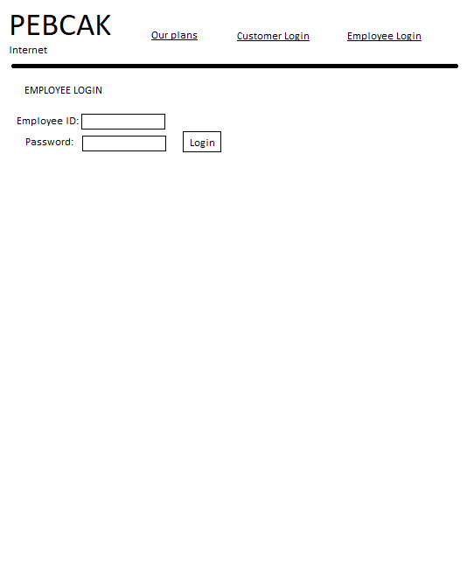

Allows employees to login and access plans.

**Plans page**

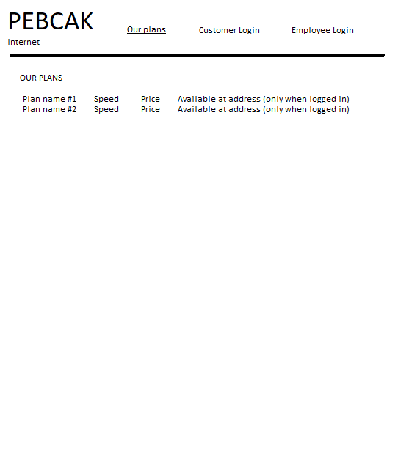

Shows plans to users and employees who are logged in.

**Subscribe page**

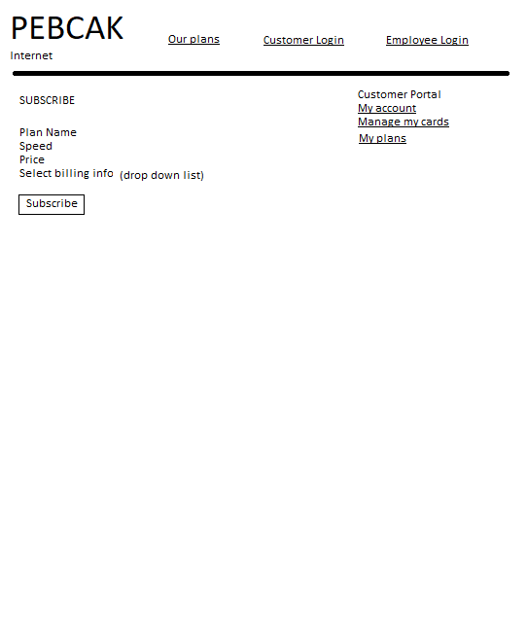

Allows users to subscribe to an Internet plan of their choosing.

## User Manual or Help page

We have included a help page which can be found here: <http://web.engr.oregonstate.edu/~morgaalb/cs340-project/public/help.php>

### 5. Application Implementation

* Describe your use of HTML/PHP/CSS/JavaScript/….
* Discuss your SQL queries
* Which of your application requirements the DBMS provides.

### 6. Evaluation

Explain the steps that you have taken to test your application. To test the usability of your application have friends/classmates perform a task to using your application then evaluate their ability to complete it.

### 7. Future Work & Lessons Learned

What additional functionalities do you plan to implement beyond this class? What challenges have you run into during the design, implementation, and testing of your application? How did you address these issues? What would you do differently next time?

***Appendix – Team Report*** *If you worked in a team summarize the division of labor.*