Hayden Anderson,
Michael Elliott,
Albert Morgan,
Alex Ruef

CS 340

Juli Schutfort

10 May 2017

Project Database

DROP TABLE IF EXISTS Employee;

CREATE TABLE Employee (
id INT AUTO_INCREMENT NOT NULL,
username VARCHAR(255) UNIQUE NOT NULL,
pass_hash BINARY(60) NOT NULL,
salary INT,
name VARCHAR(255),
PRIMARY KEY (id)
) ENGINE=InnoDB, CHARACTER SET=UTF8;

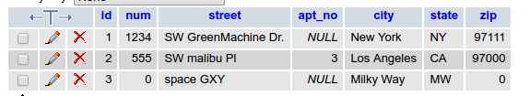
DROP TABLE IF EXISTS Address;

CREATE TABLE Address (
id INT AUTO_INCREMENT NOT NULL,
num INT NOT NULL,
street VARCHAR(255) NOT NULL,
apt_no INT,
city VARCHAR(255) NOT NULL,
state CHAR(2) NOT NULL,
zip DECIMAL(5) NOT NULL,
PRIMARY KEY (id)
) ENGINE=InnoDB, CHARACTER SET=UTF8;

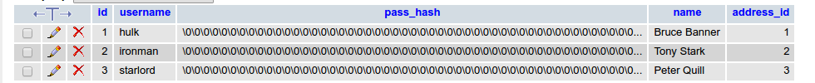
DROP TABLE IF EXISTS Customer;

CREATE TABLE Customer (
id INT AUTO_INCREMENT NOT NULL,
username VARCHAR(255) UNIQUE NOT NULL,
pass_hash BINARY(60) NOT NULL,
name VARCHAR(255) NOT NULL,
address_id INT,
PRIMARY KEY (id),
FOREIGN KEY (address_id) REFERENCES Address(id) ON DELETE SET NULL
) ENGINE=InnoDB, CHARACTER SET=UTF8;

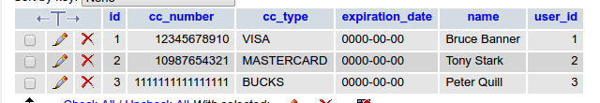

DROP TABLE IF EXISTS Billing_Info;

CREATE TABLE Billing_Info (
id INT AUTO_INCREMENT NOT NULL,
cc_number DECIMAL(16) NOT NULL,
cc_type VARCHAR(255) NOT NULL,
expiration_date DATE NOT NULL,
name VARCHAR(255) NOT NULL,
user_id INT NOT NULL,
PRIMARY KEY (id),
FOREIGN KEY (user_id) REFERENCES Customer(id) ON DELETE CASCADE
) ENGINE=InnoDB, CHARACTER SET=UTF8;

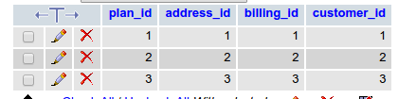
DROP TABLE IF EXISTS Subscription;

CREATE TABLE Subscription (
plan_id INT,
address_id INT,
billing_id INT,
customer_id INT,
PRIMARY KEY (plan_id, address_id),
FOREIGN KEY (billing_id) REFERENCES Billing_Info(id) ON DELETE CASCADE,
FOREIGN KEY (customer_id) REFERENCES Customer(id) ON DELETE CASCADE,
FOREIGN KEY (address_id) REFERENCES Address(id) ON DELETE CASCADE
) ENGINE=InnoDB, CHARACTER SET=UTF8;

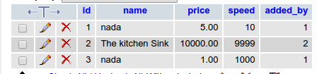

DROP TABLE IF EXISTS Plan;

CREATE TABLE Plan (
id INT AUTO_INCREMENT NOT NULL,
name VARCHAR(255),
price DECIMAL(9, 2),
speed INT,
added_by INT,
PRIMARY KEY (id),
FOREIGN KEY (added_by) REFERENCES Employee(id) ON DELETE SET NULL
) ENGINE=InnoDB, CHARACTER SET=UTF8;

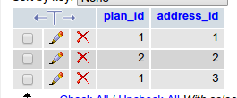
DROP TABLE IF EXISTS Address_Plans;

CREATE TABLE Address_Plans (
plan_id INT NOT NULL,
address_id INT NOT NULL,
PRIMARY KEY (plan_id, address_id),
FOREIGN KEY (plan_id) REFERENCES Plan(id) ON DELETE CASCADE,
FOREIGN KEY (address_id) REFERENCES Address(id) ON DELETE CASCADE
) ENGINE=InnoDB, CHARACTER SET=UTF8;

