Hayden Anderson,
Michael Elliott,
Albert Morgan,
Alex Ruef

CS 340

Juli Schutfort

26 May 2017

Project SQL
Procedures and Triggers:

DELIMITER $$
CREATE PROCEDURE checkValidState (s CHAR(2))
BEGIN
IF s NOT IN ('AK', 'AL', 'AR', 'AZ', 'CA', 'CO', 'CT', 'DE', 'FL', 'GA', 'HI', 'IA', 'ID', 'IL', 'IN', 'KS', 'KY', 'LA', 'MA', 'MD', 'ME', 'MI', 'MN', 'MO', 'MS', 'MT', 'NC', 'ND', 'NE', 'NH', 'NJ', 'NM', 'NV', 'NY', 'OH', 'OK', 'OR', 'PA', 'RI', 'SC', 'SD', 'TN', 'TX', 'UT', 'VA', 'VT', 'WA', 'WI', 'WV', 'WY') THEN
SIGNAL SQLSTATE '45000'
SET MESSAGE_TEXT = 'That is not a valid state.';
END IF;
END;
$$

CREATE TRIGGER triggerAddressState
BEFORE UPDATE ON addresses
FOR EACH ROW CALL checkValidState(NEW.st);

DELIMITER $$
CREATE PROCEDURE UpdateAddressPlan(planId INT, addNum INT, addStreet VARCHAR(255), addAptNo INT, addCity VARCHAR(255), addSt CHAR(2), addZip DECIMAL(5)

BEGIN

DECLARE @addressId INT

IF NOT EXISTS(SELECT * FROM Address WHERE num = @addNum AND street = @addStreet AND (@addAptNo IS NULL OR apt_no = @addAptNo) AND city = @addCity AND state = @addSt AND zip = @addZip) THEN INSERT INTO Address (num, street, apt_no, city, state, zip) VALUES (@addNum, @addStreet, @addAptNo, @addCity, @addSt, @addZip)

SET @addressId = (SELECT * FROM Address WHERE num = @addNum AND street = @addStreet AND (@addAptNo IS NULL OR apt_no = @addAptNo) AND city = @addCity AND state = @addSt AND zip = @addZip)

INSERT INTO AddressPlans (plan_id, address_id) VALUES (@planId, @addressId)

END
$$

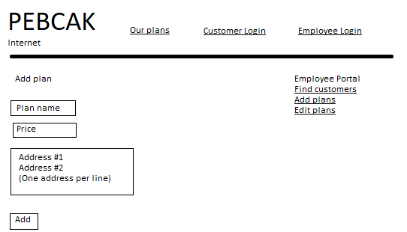
// Inserts a new plan into the database.
INSERT INTO Plan (name, price, speed, added_by)
VALUES $planName, $planPrice, $planSpeed, $employeeId

// For every plan in the plan box:
call UpdateAddressPlan($newPlanId, $addressNum, $addressStreet, $addressAptNo, $addressCity, $addressState, $addressZip)
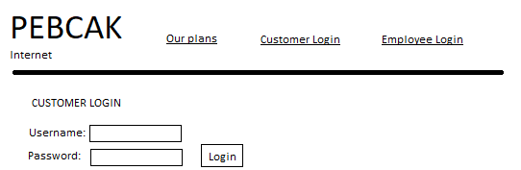
// Grabs customer data
SELECT * FROM Customers
WHERE username=@Username
AND PASSWORD(@Password)=password
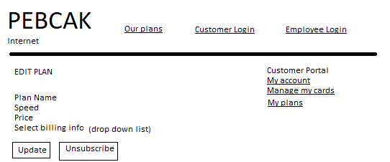
// Gets Billing Info for a specific user and updates their subscriptions based on
// new billing info input
SELECT *
FROM Billing_Info
WHERE user_id = $customerId

UPDATE Subscription
SET billing_id = $newBillingId
WHERE plan_id = @planId
AND customer_id = $customerId

DELETE FROM Subscription
WHERE plan_id = $planId
AND address_id = $addressId
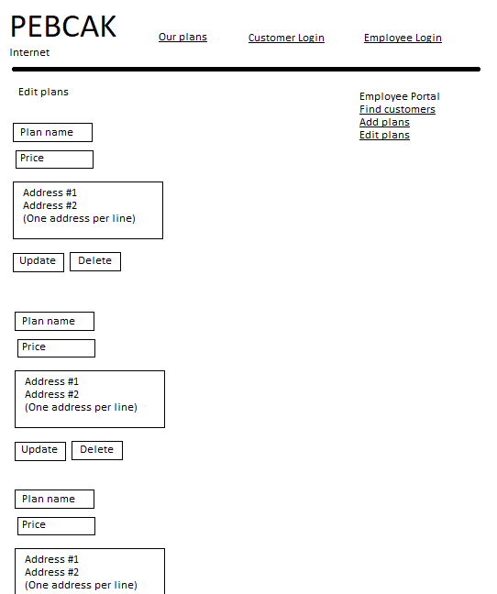
// Allows employees to update the various plan details.
UPDATE Plan
SET name=$planName,price=$planPrice,speed=$planSpeed
WHERE id=$planId

// For every plan in the plan box:
call UpdateAddressPlan($planId, $addressNum, $addressStreet, $addressAptNo, $addressCity, $addressState, $addressZip)
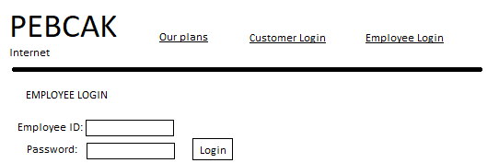
// Checks whether an employee exists with the appropriate password
SELECT * FROM Employee
WHERE username=$username
AND password=PASSWORD($password)
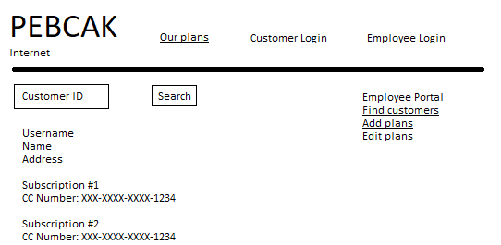
// Gives customer information to an employee.
// Shows the username, name, address, and all of the billing options for a
// customer
SELECT c.username, c.name, a.num, a.street, a.apt_no, a.city, a.state, a.zip
FROM Customer c
LEFT JOIN Address a
ON c.address_id = a.id
WHERE c.id = $customerId

SELECT p.name, b.cc_number FROM
Customer c
LEFT JOIN Subscription s
ON c.id = s.customer_id
LEFT JOIN Plan Billing_Info b
ON s.billing_id = b.id
LEFT JOIN Plan p
ON s.plan_id = p.id
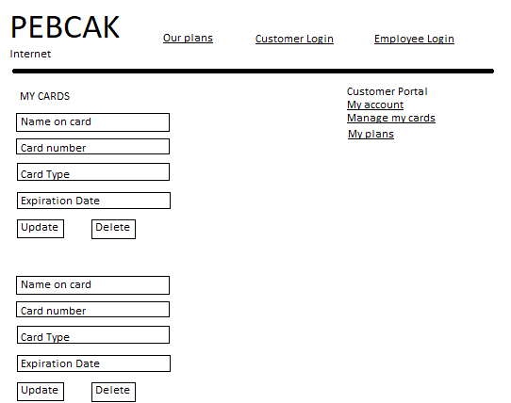
// Shows a customer all of the cards they have entered into the database.
// Allows the customer to edit details on any card.
SELECT *
FROM Billing_Info
WHERE user_id = $user_id

UPDATE Billing_Info
SET name = $name, cc_number=$number, cc_type=$type, expiration_date=$exp
WHERE id=$cardId

DELETE FROM Billing_Info
WHERE id=$cardId
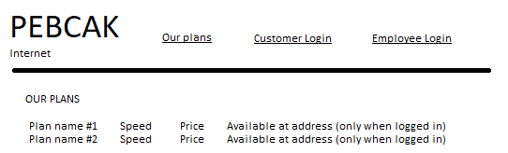
// Shows all plans to non-logged in users.
SELECT * FROM Plans

// When logged in:
// Shows all plans, and whether that plan is available at the user’s address.
SELECT p.name, p.price, p.speed, CASE WHEN ap.address_id IS NULL THEN 'Available' ELSE 'Unavailable' AS availability
FROM Plan p
LEFT JOIN Address_Plans ap
ON p.id = ap.plan_id
WHERE ap.address_id = (SELECT address_id FROM Customer WHERE id = $customerId)

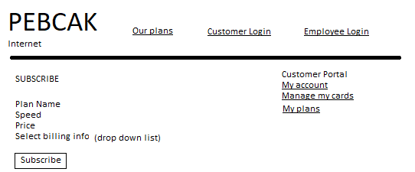
// Shown to the customer after they click on a plan to subscribe to it.
// Shows the details of the plan they selected, and retrieved all of
// that customer’s billing options so they can select one.
SELECT * FROM Billing_Info
WHERE customer_id = $customerId

INSERT INTO Subscription (plan_id, billing_id, customer_id)
VALUES ($planId, $billingInfo, $customerId)

