TRASH HORSE
SMART WASTE SORTING SYSTEM
TECHNICAL PROJECT REPORT
Technology for Recycling and Automated Separation
of Household Waste Horse
Project Authors
Mohammadreza Kermani | Ilia Bakhshayesh
Educational Institution
[School Name]
Field of Study
Computer Science / Network and Software
Project Supervisor
[Supervisor Name]
Date
[Submission Date]

Abstract
Waste management and recycling are important challenges in modern society. One difficulty in the recycling process is separating different types of waste into appropriate categories. Manual waste sorting requires human involvement and can be time-consuming.
This project, named TRASH HORSE, aims to develop a smart waste sorting system that combines computer vision, machine learning, and embedded hardware to automate parts of the waste separation process.
The system uses a Raspberry Pi 3 as its main processing unit. A camera captures images of waste objects, and a machine learning model processes these images to identify their categories. The classification model, developed using Google's machine learning technology and trained by Ilia Bakhshayesh, is deployed in TensorFlow Lite format to enable local inference on the Raspberry Pi.
After classification, Python software processes the predictions and controls two servo control channels through the Raspberry Pi GPIO interface. The servo mechanisms direct recognized waste categories toward their corresponding collection positions.
The software is developed using Python and several libraries, including OpenCV, NumPy, TensorFlow Lite, and GPIO Zero.
This project demonstrates the integration of computer vision, machine learning, embedded Linux, electronics, and mechanical control in a practical automated system.
Keywords: Raspberry Pi, Python, Computer Vision, TensorFlow Lite, OpenCV, GPIO, Servo Motor, Waste Classification, Automation.

Contents
Abstract 2
1. Introduction 5
1.1 Background 5
1.2 Project Description 5
1.3 Project Motivation 5
2. Project Objectives 5
3. Project Overview and Scope 6
3.1 General Operation 6
3.2 Classification Categories 6
4. Hardware Requirements 6
4.1 Raspberry Pi 3 6
4.2 SG90 Servo Motors 7
4.3 Breadboard and Electrical Connections 7
4.4 Camera 7
4.5 Hardware Summary 8
5. Software and Technologies 8
5.1 Python 8
5.2 OpenCV 8
5.3 TensorFlow Lite 8
5.4 NumPy 9
5.5 GPIO Zero 9
5.6 pigpio 9
5.7 Software Summary 9
6. System Architecture 10
6.1 General Architecture 10
6.2 System Workflow 10
6.3 Image Processing 10
6.4 Classification Process 11
6.5 Prediction Consistency Mechanism 11
7. Implementation 11
7.1 Software Development Environment 11
7.2 Servo Initialization 11
7.3 Model Initialization 12
7.4 Camera Initialization 12
7.5 Image Processing and Inference 12
7.6 Servo Control Logic 12
7.7 Resource Management 13
8. Testing and Evaluation 13
8.1 Hardware Testing 13
8.2 Software Testing 13
8.3 Classification Testing 14
8.4 Complete System Testing 14
9. Challenges and Solutions 14
9.1 Servo Motor Instability 14
9.2 Image Processing Compatibility 14
9.3 Prediction Stability 15
9.4 Hardware and Software Integration 15
10. Team Contributions 15
10.1 Mohammadreza Kermani 15
10.2 Ilia Bakhshayesh 15
10.3 Collaborative Work 15
11. Limitations and Future Improvements 16
11.1 Additional Sorting Categories 16
11.2 Classification Reliability 16
11.3 Mechanical Improvements 16
11.4 Performance Optimization 16
11.5 User Interface 16
11.6 System Monitoring 16
12. Conclusion 16
13. References 17
14. Appendix 17
Appendix A – Software Implementation 17
Appendix B – Project Documentation 17
Appendix C – Project Ownership and AI Declaration 18
Project Ownership 18
Artificial Intelligence Declaration 18
Machine Learning Model 18
Project Name 18

1. Introduction

1.1 Background
Waste separation is an important part of effective recycling systems. Different materials, such as paper, plastic, metal, and glass, require different recycling processes.
In conventional waste collection systems, separation is frequently performed manually or through specialized industrial equipment.
Recent developments in computer vision and machine learning have created opportunities to automate waste recognition and sorting using relatively affordable hardware.
Embedded computers, such as the Raspberry Pi, make it possible to implement these technologies in compact systems without requiring a full desktop computer.

1.2 Project Description
TRASH HORSE is an automated waste recognition and sorting project designed to identify waste categories using a camera and a machine learning model.
The project combines two main technological areas:
- Artificial Intelligence and Computer Vision: recognizing waste objects from camera images.
- Embedded Systems and Electronics: controlling mechanical components according to classification results.
The Raspberry Pi acts as the central processing unit, coordinating communication between the camera, classification software, and servo motors.
The system is designed to reduce the amount of manual work required during waste separation.

1.3 Project Motivation
The main motivation behind this project was to explore how software and hardware technologies can work together to solve a practical environmental problem.
Rather than developing a purely software-based application, the team aimed to create a physical prototype capable of interacting with its environment.
The project also provided an opportunity to gain practical experience in Linux, Python programming, machine learning, electronics, and hardware integration.

2. Project Objectives
The primary objective is to develop a prototype capable of recognizing waste objects and directing them toward appropriate collection positions.
The specific objectives include:
- Developing a machine learning-based waste classification system.
- Deploying the trained model on a Raspberry Pi 3.
- Capturing images using a connected camera.
- Processing images using OpenCV and NumPy.
- Executing the classification model locally using TensorFlow Lite.
- Controlling servo motors through the Raspberry Pi GPIO interface.
- Integrating software and hardware into a unified system.
- Testing the reliability of classification and mechanical control.

3. Project Overview and Scope

3.1 General Operation
The system follows a sequence of operations:
- A waste object is presented to the camera.
- The camera captures an image.
- OpenCV processes the image and prepares it for classification.
- The TensorFlow Lite interpreter executes the machine learning model.
- The model produces a classification result.
- The program collects multiple consecutive predictions.
- If four consecutive predictions agree, the software determines the appropriate sorting action.
- The corresponding servo motor moves to its assigned position.
- After the movement, the servo returns to its neutral position.

3.2 Classification Categories
The software currently defines five classification labels:
Category | Description
NTO | Non-trashable object
Metal | Metal waste
Plastic | Plastic waste
Paper | Paper waste
Glass | Glass waste

The classification model can identify these five categories. However, the current mechanical implementation only performs servo movements for Metal, Plastic, and Paper.
Glass and NTO currently produce classification messages without activating a sorting mechanism. This distinction is important when evaluating the implemented functionality.

4. Hardware Requirements
The project combines an embedded computer, electronic components, and mechanical actuators.

4.1 Raspberry Pi 3
The Raspberry Pi 3 is the main processing unit of the system.
It is responsible for:
- Running the operating system.
- Executing the Python application.
- Processing camera images.
- Running the TensorFlow Lite model.
- Managing GPIO communication.
- Controlling the servo motors.
The Raspberry Pi was selected because of its relatively small size, low power consumption, Linux compatibility, and GPIO capabilities.
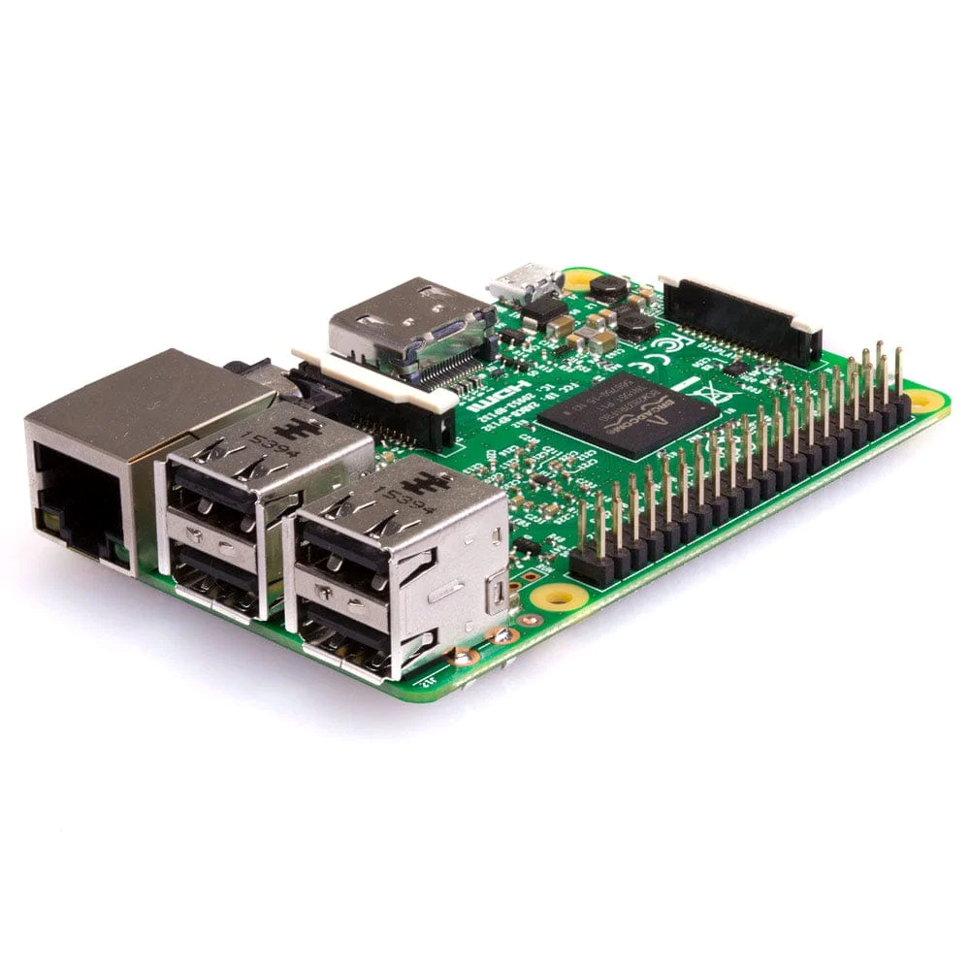Figure 1. Raspberry Pi 3 single-board computer.

4.2 SG90 Servo Motors
The project uses two servo control channels to operate the mechanical sorting mechanism. The servo motors receive control signals from the Raspberry Pi and move to specified angular positions.
The software uses the AngularServo class from GPIO Zero to control their positions.
Servo | GPIO Pin | Physical Pin
Servo 1 | GPIO18 | Pin 12
Servo 2 | GPIO19 | Pin 35

The servo positions used by the program include 0°, 90°, and 180°. The 90° position is used as the neutral position in the control routine.
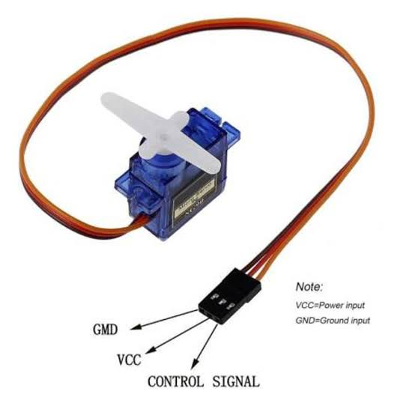
Figure 2. SG90 micro servo motor.

4.3 Breadboard and Electrical Connections
A breadboard and jumper wires are used to establish the required electrical connections between the Raspberry Pi and the servo control circuits.
The servo motors require an appropriate power supply. An external power source is used to provide servo power.
A common ground connection between the external power supply and the Raspberry Pi is necessary to establish a shared electrical reference for the control signals.
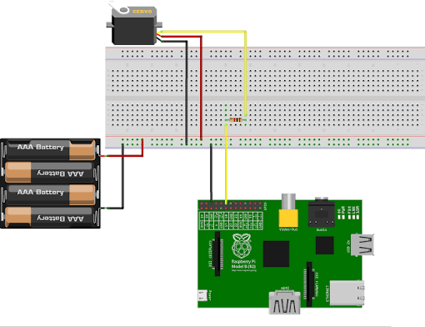Figure 3. Illustrative breadboard and electronic connections.

4.4 Camera
A camera is connected to the Raspberry Pi to capture images of waste objects. The camera provides the input data required by the machine learning model.
The software accesses the camera using OpenCV's VideoCapture interface.
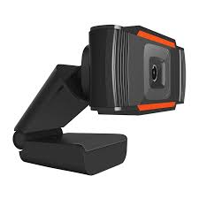Figure 4. Camera module used for image acquisition.

4.5 Hardware Summary
Component | Function
Raspberry Pi 3 | Main processing unit
Camera | Image acquisition
SG90 servo motors | Mechanical movement
Breadboard | Circuit prototyping
Jumper wires | Electrical connections
External power supply | Servo power

5. Software and Technologies
The TRASH HORSE system uses several software technologies to combine computer vision, machine learning, and embedded hardware control.

5.1 Python
Python is the primary programming language used in the project. It coordinates the different software components, including camera communication, image preprocessing, model inference, and servo motor control.
Python was selected because of its extensive ecosystem of libraries for artificial intelligence, computer vision, and hardware programming.

5.2 OpenCV
OpenCV (Open Source Computer Vision Library) is used for camera communication and image processing.
Its main responsibilities include:
- Accessing the connected camera.
- Capturing image frames.
- Converting images from BGR to RGB color format.
- Resizing images according to the machine learning model's input dimensions.
OpenCV provides the image data required by the classification model.

5.3 TensorFlow Lite
TensorFlow Lite is the machine learning inference framework used by the project.
The classification model, named TRASH HORSE, is provided in the .tflite format. The model was trained by Ilia Bakhshayesh using Google's machine learning technology.
TensorFlow Lite allows the model to execute directly on the Raspberry Pi without requiring an external cloud-based inference service.
The program uses the TensorFlow Lite Interpreter to:
- Load the model file.
- Allocate the required tensors.
- Retrieve input and output information.
- Receive processed image data.
- Execute model inference.
- Retrieve classification predictions.
This approach enables local image classification on the embedded device.

5.4 NumPy
NumPy is used for numerical calculations and image data manipulation.
Its functions support:
- Expanding image dimensions.
- Converting image data into numerical arrays.
- Applying normalization and quantization transformations.
- Finding the highest-scoring classification result.
NumPy provides the numerical operations needed to prepare images and interpret model outputs.

5.5 GPIO Zero
GPIO Zero is the Python library used to control the Raspberry Pi GPIO interface.
The project uses its AngularServo class to control the angular positions of the servo motors. The software creates two independent servo objects connected to GPIO18 and GPIO19.
The motors are controlled by assigning angular values to their respective objects.

5.6 pigpio
The project uses PiGPIOFactory as the GPIO Zero pin factory. This backend provides the servo control interface used by the application.
It is configured when creating the servo objects, allowing the application to use the pigpio-based GPIO control system. The required pigpio service and compatibility must be maintained in the operating system environment.

5.7 Software Summary
Technology | Application
Python | Main programming language
OpenCV | Camera communication and image processing
TensorFlow Lite | Machine learning inference
NumPy | Numerical calculations and array manipulation
GPIO Zero | Servo motor control
pigpio | GPIO control backend
Raspberry Pi OS | Embedded operating system

6. System Architecture

6.1 General Architecture
The system consists of three major functional layers:
1. Image Acquisition Layer
The camera captures images of waste objects. OpenCV retrieves the frames and prepares the image data.
2. Classification Layer
The TensorFlow Lite interpreter processes the prepared image and generates a classification result.
3. Hardware Control Layer
The Python application evaluates the classification results and determines whether a servo motor should move.

6.2 System Workflow
The complete processing pipeline can be represented as follows:
Camera Input
↓
OpenCV Image Processing
↓
Image Resizing and Normalization
↓
TensorFlow Lite Inference
↓
Classification Result
↓
Four-Prediction Consistency Check
↓
Sorting Decision
↓
GPIO Servo Control
↓
Mechanical Sorting Action

6.3 Image Processing
The input image is initially captured in BGR format by OpenCV. The program converts it into RGB format because the model expects RGB image data.
The image is then resized according to the input dimensions obtained from the TensorFlow Lite model. The image is expanded into a batch of one image and converted into a numerical representation.
Normalization and quantization are applied according to the model's input parameters. This process ensures that the image is prepared in the format expected by the model.

6.4 Classification Process
The TensorFlow Lite interpreter executes the classification model. The model produces numerical output values representing its predictions.
The program identifies the index of the highest-scoring output using NumPy's argmax function. This index is then mapped to the corresponding category name through a predefined classification list.

6.5 Prediction Consistency Mechanism
Instead of immediately responding to every individual prediction, the program collects four consecutive classification results. The system checks whether all four results are identical.
If they agree, the corresponding sorting action is selected. If they disagree, the current group of predictions is discarded and a new group begins.
This mechanism is intended to reduce reactions to individual inconsistent predictions.

7. Implementation

7.1 Software Development Environment
The main application is developed in Python and runs on the Raspberry Pi. The program integrates image acquisition, machine learning inference, and hardware control in a single application.
The main software dependencies include:
- OpenCV
- NumPy
- TensorFlow
- GPIO Zero
- pigpio

7.2 Servo Initialization
At the beginning of the main function, the program initializes the pigpio pin factory. Two AngularServo objects are created: the first servo is connected to GPIO18, and the second servo is connected to GPIO19.
Both servos are configured with a minimum angle of 0° and a maximum angle of 180°.
The pulse-width parameters are configured as follows:
- Minimum pulse width: 0.0005 seconds.
- Maximum pulse width: 0.0025 seconds.
After initialization, the program moves both servos to their neutral positions.

7.3 Model Initialization
The TensorFlow Lite model is loaded using the Interpreter class. The program allocates the model's tensors and retrieves its input and output information.
The input dimensions and quantization parameters are obtained dynamically from the model. This allows the application to prepare image data according to the model's configuration rather than relying entirely on hardcoded image dimensions.

7.4 Camera Initialization
OpenCV's VideoCapture function is used to access the camera. The camera index is supplied as a function argument.
If the camera cannot be opened, the program displays an error message and closes the initialized hardware resources.

7.5 Image Processing and Inference
The application continuously reads camera frames. Classification inference is performed at intervals of approximately 0.5 seconds.
Before inference, the frame is:
- Converted from BGR to RGB.
- Resized to the model's input dimensions.
- Expanded into a batch.
- Converted and normalized.
- Quantized according to the model's input parameters.
The prepared image is passed to the TensorFlow Lite interpreter. After inference, the output tensor is retrieved and converted using the output quantization parameters. The highest-scoring category is selected as the prediction.

7.6 Servo Control Logic
The servo control function receives a servo object and a target angle.
It performs the following operations:
- Moves the servo to the requested angle.
- Waits for two seconds.
- Returns the servo to 90°.
- Waits for another two seconds.
The sorting logic currently uses the following mapping:
Classification | Servo | Target angle
Metal | GPIO18 servo | 0°
Plastic | GPIO19 servo | 0°
Paper | GPIO19 servo | 180°
Glass | No movement | Not implemented
NTO | No movement | Not implemented

This mapping represents the current software implementation.

7.7 Resource Management
The application includes a try/finally structure to manage resources.
When the program exits or encounters an error during the main processing loop, the cleanup section releases:
- The camera.
- OpenCV windows.
- Both servo objects.
- The pigpio pin factory.
This helps prevent hardware resources from remaining unnecessarily occupied after the application terminates.

8. Testing and Evaluation
Testing is an important part of evaluating the performance and reliability of an embedded system. The project requires testing at both the individual component level and the complete system level.

8.1 Hardware Testing
Hardware testing focuses on verifying the electrical connections and mechanical components.
Test | Expected Result | Actual Result
Raspberry Pi startup | Successful startup | [Record result]
GPIO18 output | Correct servo control | [Record result]
GPIO19 output | Correct servo control | [Record result]
External servo power | Stable motor operation | [Record result]
Common ground | Reliable control signals | [Record result]
Camera connection | Successful image capture | [Record result]

8.2 Software Testing
Software testing focuses on the application's ability to execute the classification and control procedures.
Test | Expected Result | Actual Result
Model loading | Successful model initialization | [Record result]
Camera access | Continuous frame acquisition | [Record result]
Image preprocessing | Correct input preparation | [Record result]
Model inference | Classification output | [Record result]
Prediction consistency | Four matching predictions detected | [Record result]
Program termination | Hardware resources released | [Record result]

8.3 Classification Testing
Each classification category should be tested using multiple representative objects. The results should be recorded to evaluate the model's performance.
Category | Number of Tests | Correct Predictions | Accuracy
Metal | [ ] | [ ] | [ ]
Plastic | [ ] | [ ] | [ ]
Paper | [ ] | [ ] | [ ]
Glass | [ ] | [ ] | [ ]
NTO | [ ] | [ ] | [ ]

Accuracy can be calculated using:
Accuracy = (Correct Predictions / Total Tests) × 100
Actual test results should be entered after performing the experiments.

8.4 Complete System Testing
The final testing stage evaluates the interaction between the camera, machine learning model, Python application, and servo motors. The objective is to verify that a recognized category results in the appropriate mechanical action.

9. Challenges and Solutions
During the development process, several technical challenges were encountered.

9.1 Servo Motor Instability
One of the challenges occurred during servo motor operation. The servos sometimes moved irregularly or failed to respond consistently.
After examining the electrical connections, it was discovered that the external power supply's ground was not connected to the Raspberry Pi's ground.
The problem was addressed by connecting the grounds of both power systems. This established a common electrical reference for the servo control signals.

9.2 Image Processing Compatibility
Machine learning models require input images with specific dimensions, color formats, and numerical representations.
To address this, the software retrieves the required input dimensions and quantization parameters directly from the TensorFlow Lite interpreter. OpenCV and NumPy are then used to prepare the image data.

9.3 Prediction Stability
Individual classification results may occasionally differ because of changes in object position, lighting, or camera conditions.
To reduce the effect of individual inconsistent predictions, the program collects four consecutive predictions and checks whether they agree before performing a sorting action.

9.4 Hardware and Software Integration
Another important challenge was coordinating the image classification process with the physical servo mechanisms.
The software needed to translate classification results into appropriate mechanical actions. This was addressed by implementing a control function that receives a servo object and a target angle. The classification logic then selects the appropriate servo and position.

10. Team Contributions
The project was developed collaboratively by Mohammadreza Kermani and Ilia Bakhshayesh. Responsibilities were divided according to the different technical areas of the system.

10.1 Mohammadreza Kermani
Primary responsibilities:
- Raspberry Pi configuration and setup.
- Linux operating system and environment management.
- Python application development and integration.
- GPIO configuration.
- Servo motor control and testing.
- Electronic connections and hardware integration.
- Communication between software and physical components.

10.2 Ilia Bakhshayesh
Primary responsibilities:
- Machine learning model development.
- Training the TRASH HORSE classification model.
- Image processing implementation.
- Development and integration of classification functionality.

10.3 Collaborative Work
Both team members contributed to the overall development and integration of the project. The software and hardware components were brought together to create a unified waste sorting prototype.

11. Limitations and Future Improvements
Although the current implementation demonstrates the integration of machine learning and embedded hardware, several improvements can be considered.

11.1 Additional Sorting Categories
The current classification model recognizes five labels, but the mechanical system does not yet provide a dedicated sorting action for every category. Future development could include mechanical sorting positions for Glass and additional waste categories.

11.2 Classification Reliability
The classification system could be improved through additional training data, better image diversity, and more extensive testing under different lighting conditions.

11.3 Mechanical Improvements
The mechanical sorting mechanism could be redesigned to improve reliability, positioning accuracy, and overall durability.

11.4 Performance Optimization
The software could be optimized to reduce unnecessary processing and improve inference performance on the Raspberry Pi.

11.5 User Interface
A future version could include a graphical interface displaying:
- Camera output.
- Current classification.
- Servo status.
- Number of processed objects.
- System operating status.

11.6 System Monitoring
Additional monitoring features could be implemented to detect camera failures, servo errors, and unexpected system behavior.

12. Conclusion
TRASH HORSE demonstrates how machine learning, computer vision, embedded Linux, and electronics can be combined to develop a practical automated waste sorting prototype.
The project uses a Raspberry Pi 3 as its central processing unit, OpenCV for camera communication and image processing, TensorFlow Lite for machine learning inference, and GPIO Zero with pigpio for servo control.
One of the main achievements of the project is the integration of a trained classification model with physical hardware. Rather than simply identifying objects on a computer screen, the system uses classification results to control mechanical components.
The development process also provided practical experience in Linux system configuration, Python programming, electronic circuit connections, image processing, machine learning deployment, and hardware-software integration.
Although the current implementation has limitations, particularly regarding the mechanical handling of all classification categories, it establishes a foundation for further development.
TRASH HORSE represents an interdisciplinary engineering project that demonstrates the potential of accessible computing technologies in addressing practical environmental challenges.

13. References
The following official documentation and resources provide technical information about the technologies used in this project.
- Python Software Foundation. Python Documentation. https://docs.python.org/3/
- OpenCV. OpenCV Documentation. https://docs.opencv.org/
- Google. TensorFlow Lite Documentation. https://www.tensorflow.org/lite
- NumPy Developers. NumPy Documentation. https://numpy.org/doc/
- Raspberry Pi Foundation. Raspberry Pi Documentation. https://www.raspberrypi.com/documentation/
- GPIO Zero. GPIO Zero Documentation. https://gpiozero.readthedocs.io/
- pigpio. pigpio Library Documentation. http://abyz.me.uk/rpi/pigpio/
- TowerPro. SG90 Micro Servo Motor Specifications. [Insert the exact manufacturer datasheet used.]

14. Appendix

Appendix A – Software Implementation
The main application is written in Python and integrates the following components:
- Camera acquisition through OpenCV.
- Image preprocessing using OpenCV and NumPy.
- Machine learning inference through TensorFlow Lite.
- Prediction evaluation.
- Servo motor control using GPIO Zero and pigpio.
The source code is maintained by the project authors, Ilia Bakhshayesh and Mohammadreza Kermani.

Appendix B – Project Documentation
The following materials should accompany the report:
- Photograph of the Raspberry Pi 3.
- Photograph of the servo motors.
- Illustrative electrical connection diagram.
- Screenshot of the software running on the Raspberry Pi.
- Actual photographs of the completed prototype.
- Demonstration video of the sorting process.

Appendix C – Project Ownership and AI Declaration

Project Ownership
The source code and project implementation are the property of Ilia Bakhshayesh and Mohammadreza Kermani.

Artificial Intelligence Declaration
Artificial intelligence tools were used as supplementary learning and educational assistance during the development process. The project was developed through the authors' own programming, experimentation, hardware integration, and technical work. It was not generated as a fully automated AI-written project.

Machine Learning Model
The TRASH HORSE classification model was developed using Google's machine learning technology and trained by Ilia Bakhshayesh.

Project Name
TRASH HORSE stands for:
Technology for Recycling and Automated Separation
of Household Waste Horse

