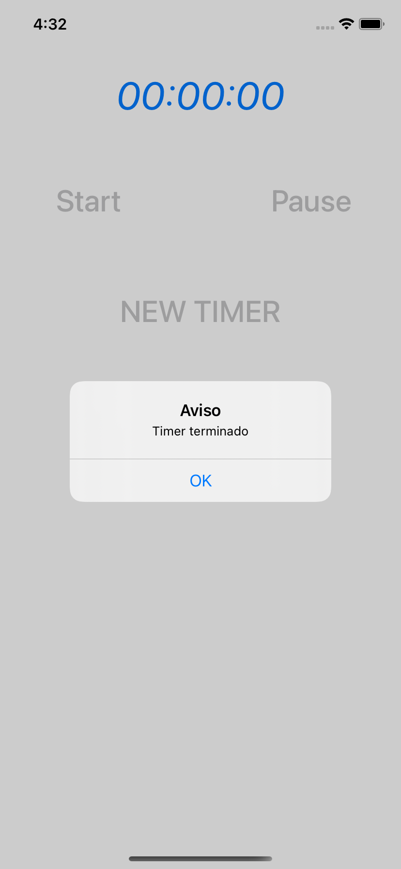

<https://github.com/elliot-21/registroUsuarios>

<https://github.com/elliot-21/networksocial>

