Victor MAYAUD
Elliot MAYAUD

Micro-Expression Recording Protocol

-Setup and Background Preparation:

Position subjects in front of a white background. Ensure a distance of 30-40 cm between the subjects and both cameras (the event camera and the RGB camera).

-Lighting Adjustment:

Adjust the lighting to minimize shadows and highlight facial features effectively. The goal is to ensure even illumination across the subject’s face to capture micro-expressions clearly.

-Instruction of Micro-Expression Task:

Assign a specific micro-expression to the subject prior to recording. Instruct the subject to maintain a neutral facial expression initially and then perform the assigned micro-expression.

-Camera Synchronization:

Place a piece of paper in front of both cameras to synchronize them and mark the start of the video recording.

-Recording Initiation:

Begin recording simultaneously on both cameras. Remove the paper after a 2-second countdown to ensure that both cameras start recording the video at the same time.

-Cue for Micro-Expression:

After 5 seconds from the start of the recording, signal the subject by raising a hand. This is the cue for the subject to perform the designated micro-expression.

-Termination of Recording:

End the recording after 10 seconds.

Images:

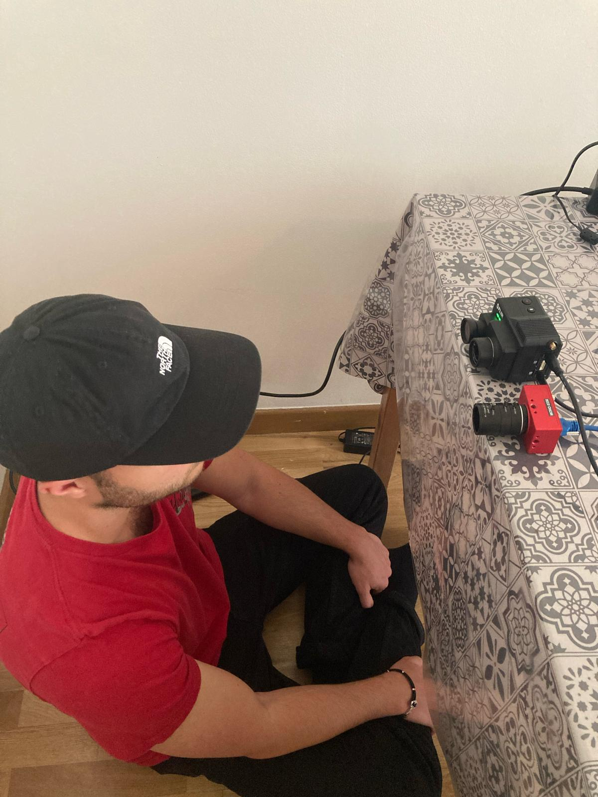
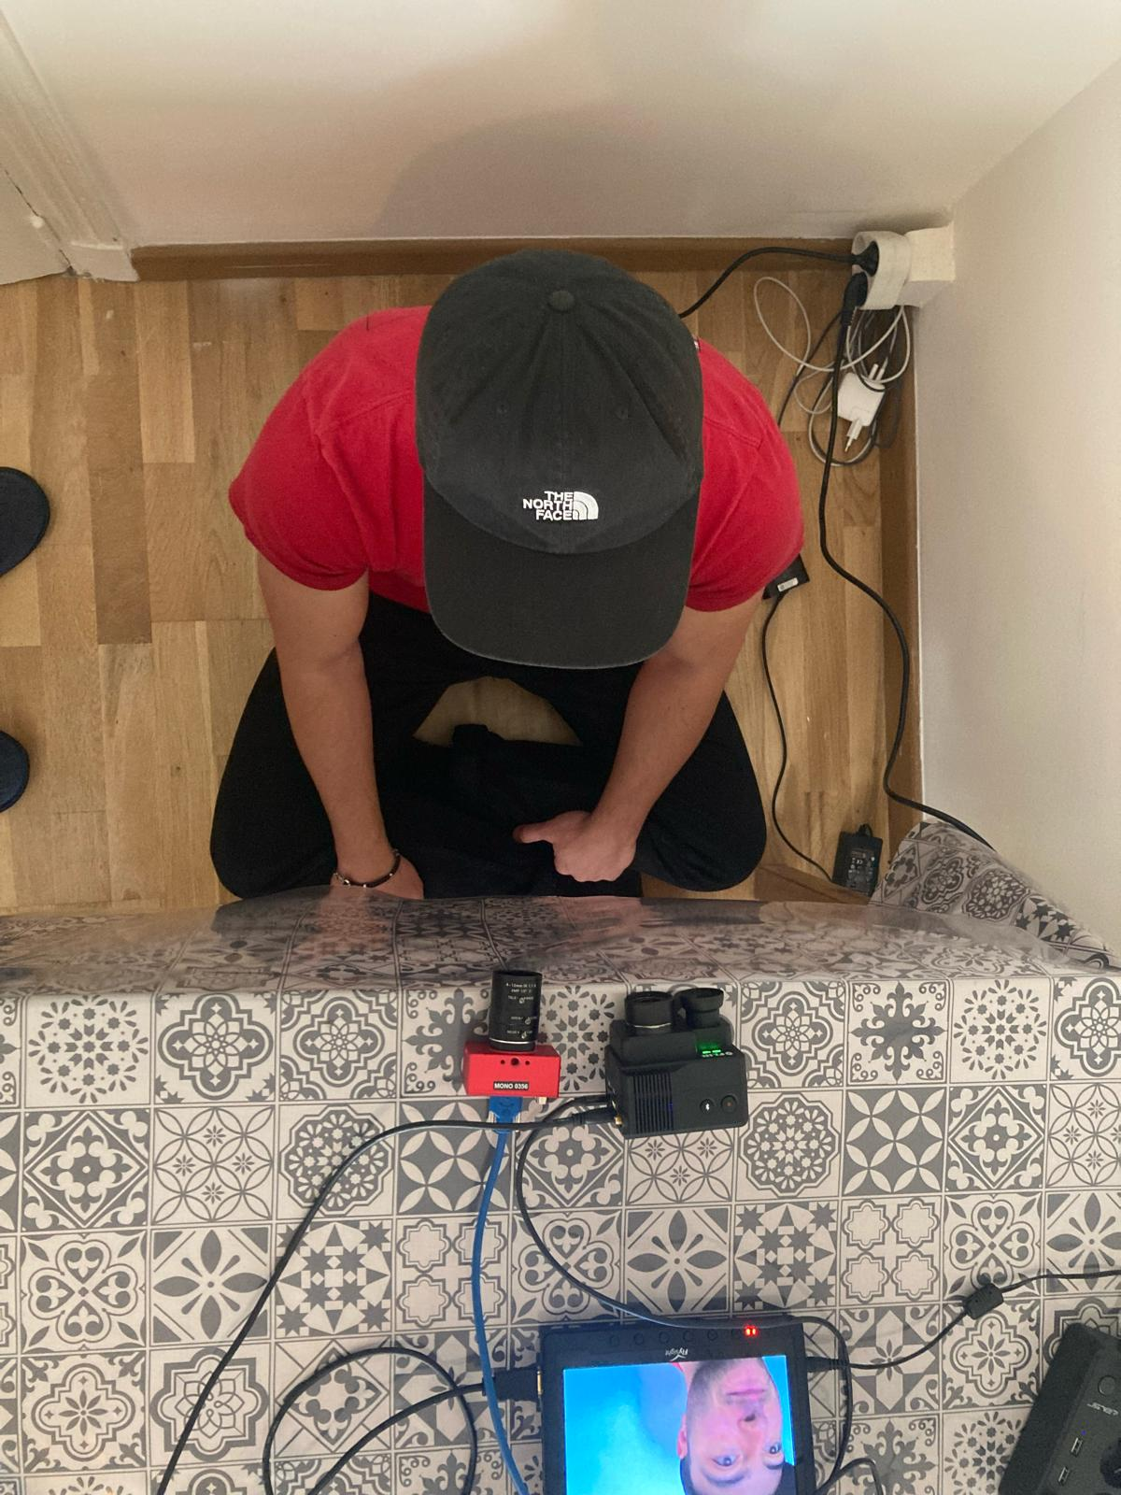

Principal Facial movement: Open mouth, frown, raise eyebrows… ( nose wrinkle...)

