“A Well Thought-Out Englilsh Paper”
by: Kyle “The Yellow Dart” Smith

Since maybe like the Middle Ages, there have been many differing opinions about

hustle and bustle. This cannot be denied. It is my intention to sit down and play video

games for several hours.

First, moving around quickly, and with purpose, is a true sign of character.

Secondarily, bustle(e.g. hustle) yields more product for the working types. “Hustle and

bustle are like my right and left arms,” said Li’l Spicy in his famous “Hustle and Bustle

Are Like My Right and Left Arms” speech. Webster’s defines bustle as “excited and

often noisy activity; a stir.” A stir, indeed. Finally, sometimes gross stuff can be funny.

In conclusion, I, “The Yellow Dart,” think I have done a great job illustrating the

many differing opinions about hustle and bustle, may they both rest in peace. Also, I

think Strong Bad should decrease The Cheat’s allowance.

“Eating One Battery”
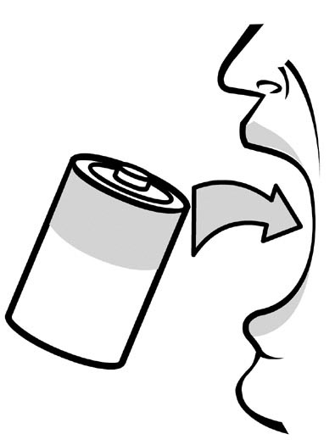
fig. 1

“Eating Five Batteries” 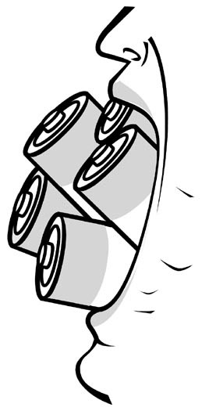
fig. 2

