Debuggin probability

Check that subframe cropping is working as intended:

Aram Ellipse:

**2020 EDL**

100 x 19 km

348.8 °E, 7.869 °N

93° <= Az <= 116° (CW from North)

As plotted in ellipse evaluator:

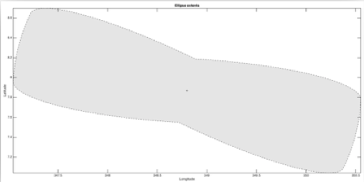

Subframe extracted during evaluateAzCore:

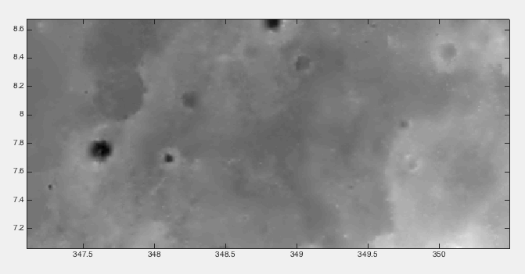

Matches area covered by ellipses plotted over similarly scaled MOLA in Arc:

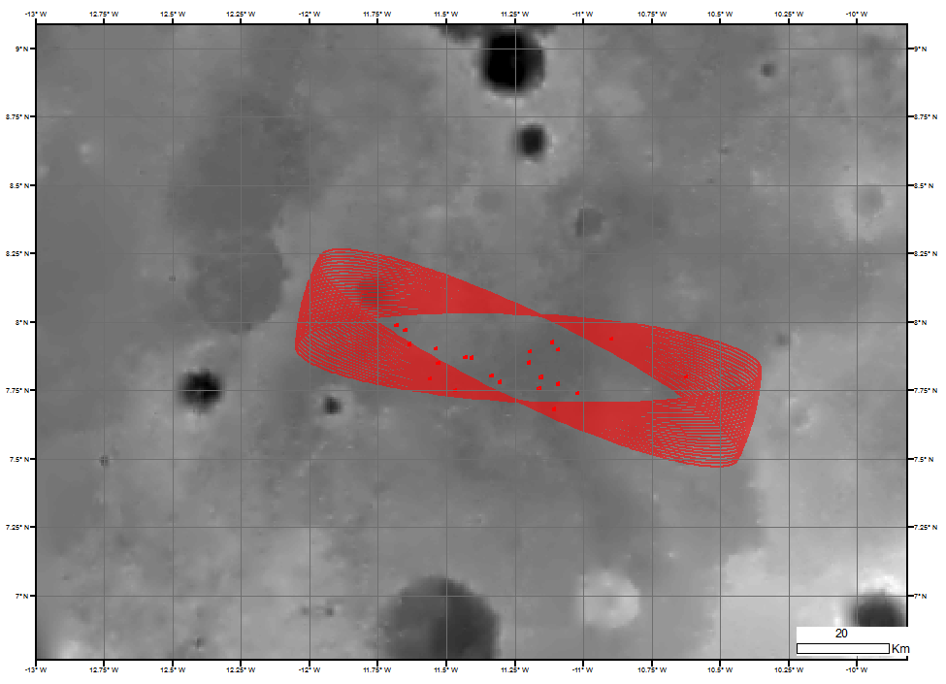

**Appears to work as intended.**

However:

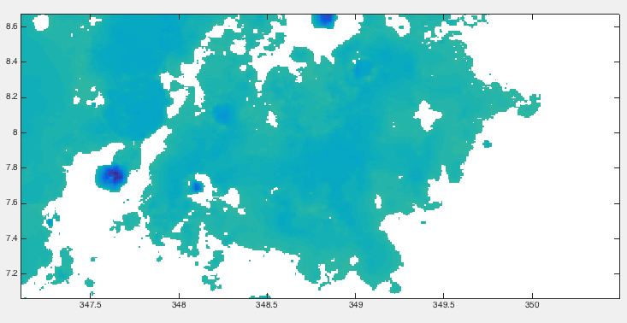

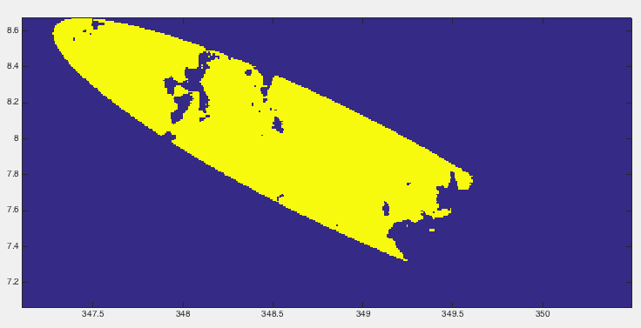

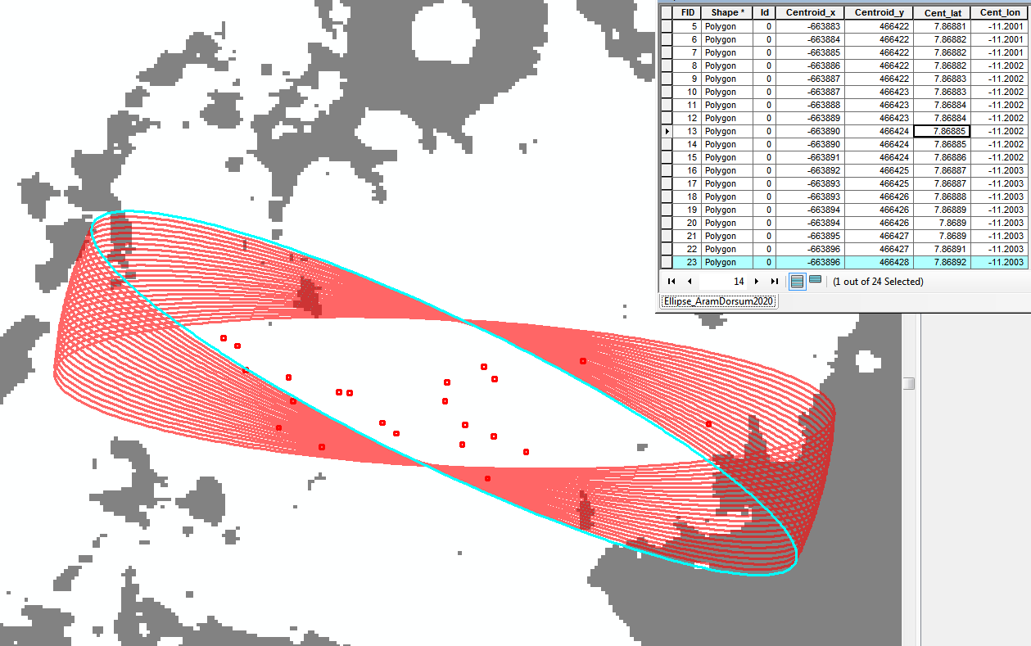

**Elllipse is not in correct position! Why not?**

Are the map-projected coordinates of the centroid the same?

Arc: -663896, 466438

Matlab: 20675014.49612921 (-663880), 464967.6479579408

16 m off in longitude, 1470.4 m off in latitude!

But perhaps the shapes are different too?

Need a way to load ellipse from shape file. Shapefile coordinates MUST be held in Lambert equal area cylindrical.