Degeneration and Identity Collapse:
Two Failure Modes of Multi-Agent LLM Debate at 7B Scale
Elliott Leow, Shivam Aarya
Independent Research

Abstract
Multi-agent debate—where multiple LLM instances iteratively discuss a problem—is widely used to improve reasoning, with groupthink cited as the primary risk. We study convergence dynamics in multi-agent debate using two open-weight 7B instruction-tuned models (OLMo-3-7B-Instruct and Qwen-2.5-7B-Instruct) across 250 debate sessions. We find that neither model produces the sustained productive disagreement assumed by the debate literature. Instead, we observe two distinct failure modes: OLMo-3 degenerates into repetitive gibberish by round 3–5, while Qwen-2.5 converges to token-for-token identical outputs in 57% of sessions—even at standard sampling temperature (0.7) with heterogeneous persona prompts.
Task openness is the primary moderator of identity collapse: convergence rates range from 83% for highly constrained tasks (ethical dilemmas, startup ideation) to 17% for open-ended creative tasks, with a monotonic gradient across five task types. Temperature, persona configuration, and instruction-level forcing functions have negligible effects. The shared conversational context acts as an attractor so strong that it overrides sampling stochasticity entirely—when noise temporarily breaks the identity lock, agents snap back to identical outputs within one round.
These findings suggest that multi-agent debate at 7B scale does not produce the dynamic disagreement its proponents assume. Practitioners deploying debate with open-weight models should expect either degeneration or convergence, not productive diversity.

1. Introduction
Multi-agent debate has emerged as a popular technique for improving LLM reasoning. Du et al. (2023) showed that debating agents outperform single models on mathematical and strategic tasks. Liang et al. (2023) demonstrated benefits across broader reasoning domains. The core assumption is that multiple agents maintain productive disagreement—challenging errors, offering alternatives, and iteratively refining positions.
The primary concern in this literature is groupthink: agents converging too quickly on a shared (potentially wrong) answer (Wynn et al., 2025; Janis, 1972). This has motivated interventions including diverse personas, heterogeneous decoding parameters, and structured disagreement protocols.
We test a more basic question: do 7B-scale open-weight models sustain coherent multi-turn debate at all? Prior work on multi-agent debate primarily uses frontier models (GPT-4, Claude) where sustained conversation is reliable. As open-weight models become the preferred deployment target for cost and privacy reasons, understanding their debate dynamics becomes practically important.
We run 250 debate sessions across two model families (OLMo-3-7B-Instruct and Qwen-2.5-7B-Instruct), five task types, two persona configurations, forcing function conditions, and a temperature gradient. Our findings are:
- (1) OLMo-3 cannot sustain multi-turn debate. It degenerates into repetitive text by round 3–5 under all conditions, including greedy decoding.
- (2) Qwen-2.5 sustains coherent conversation but exhibits identity collapse: 57% of sessions produce token-for-token identical outputs from both agents, even at temperature 0.7.
- (3) Task openness is the primary moderator. Structured tasks collapse in 83% of sessions; creative tasks resist collapse (17%). Temperature, personas, and forcing functions are secondary or irrelevant.
- (4) Neither model produces sustained productive disagreement—the regime that multi-agent debate requires to function as intended.

2. Related Work

2.1 Multi-Agent LLM Debate
Du et al. (2023) introduced multi-agent debate for mathematical and strategic reasoning using ChatGPT and GPT-4. Liang et al. (2023) extended the approach with structured communication protocols. Chan et al. (2024) applied debate to evaluation. Critically, these studies use frontier-scale models. Whether their findings transfer to smaller open-weight models—increasingly the deployment target—has not been tested.

2.2 Convergence and Groupthink
Wynn et al. (2025) showed that multi-agent debate can decrease accuracy when models prioritize peer consensus over critical evaluation. Xiong et al. (2025) found that sycophancy causes "disagreement collapse" in debate. Cemri et al. (2025) developed a failure taxonomy for multi-agent systems. Our work identifies two failure modes specific to 7B-scale models that prevent debate from functioning at all.

2.3 Multi-Turn Degeneration
Multi-turn degeneration—where LLM output quality degrades over extended conversations—is a recognized challenge. Performance drops of 39% between single-turn and multi-turn settings have been documented across models including GPT-4o and Claude (Hong et al., 2025). Our finding that OLMo-3 degenerates within 3–5 rounds of debate is consistent with this literature but more severe than previously reported, possibly because debate generates more diverse context than typical multi-turn QA.

2.4 Convergence in Collaborative LLM Tasks
Parfenova (2025) found emergent convergence in multi-agent LLM annotation, where groups of LLMs converge lexically and semantically. Our identity collapse finding extends this: in debate settings, convergence can be total (token-for-token identical outputs) when tasks provide sufficient structure. The task-openness gradient we observe may explain why Parfenova found strong convergence in annotation (structured) while other studies report diversity in open-ended generation.

3. Methods

3.1 Models
We test two open-weight 7B instruction-tuned models from different organizations and training pipelines: OLMo-3-7B-Instruct (AI2, December 2025) and Qwen-2.5-7B-Instruct (Alibaba, 2025). Both are loaded in float16 precision on a single NVIDIA RTX 3090 (24GB VRAM). We chose these models because (a) they represent different training methodologies, (b) their open weights enable mechanistic analysis, and (c) 7B is a common deployment scale for cost-sensitive applications.

3.2 Debate Protocol
Each session involves two agents discussing a topic across 10 rounds, generating up to 512 tokens per turn with chain-of-thought prompting ("Think step by step, then give your argument"). Under the sequential condition, agent_0 responds first, then agent_1 responds having seen agent_0's output. Both agents see the full conversation history.

3.3 Experimental Conditions
Task Types (5): Startup ideation, policy design, creative problem-solving, ethical dilemma, and research question. These span a gradient from structured (ethical dilemma: constrained solution space) to open-ended (creative problem-solving: unconstrained).
Persona Configurations (2): Homogeneous (identical "helpful assistant" prompts) and heterogeneous ("bold creative thinker" vs. "careful analytical thinker").
OLMo-3 Experiments (n = 135): 50 core sessions (5 tasks × 2 configs × 5 reps), 60 forcing function sessions (consensus + evaluation pressure × 2 configs × 3 tasks × 5 reps), 25 temperature gradient sessions (5 temperatures × 5 reps).
Qwen-2.5 Experiments (n = 115): 30 core sessions (5 tasks × 2 configs × 3 reps), 60 forcing function sessions (consensus + evaluation pressure × 2 configs × 3 tasks × 5 reps), and 25 temperature gradient sessions (5 temperatures × 5 reps). Temperature 0.7 for core and forcing experiments, varied for gradient.

3.4 Metrics
We measure convergence at multiple levels:
- Exact Match Rate: Fraction of round pairs where both agents produce token-for-token identical text. This captures identity collapse—the strongest form of convergence.
- Text Similarity: Pairwise SequenceMatcher ratio (character-level edit similarity) between agent responses. Captures surface-level convergence on a 0–1 scale, where 1.0 indicates identical text. We use character-level rather than embedding-based similarity because identity collapse produces exact string matches that embedding similarity would saturate on.
- Degeneration Detection: We flag rounds where either agent produces text with a top single-word frequency exceeding 30%, indicating repetitive degeneration.
- Convergence Round: The first round at which agents produce identical or near-identical (similarity > 0.95) outputs, if ever.

4. Results

4.1 OLMo-3: Universal Degeneration
OLMo-3-7B-Instruct cannot sustain multi-turn debate. Across all 135 sessions—including greedy decoding, varied temperatures (0.1–1.0), and instruction-level forcing functions—70% of sessions show repetitive degeneration by round 5. Under greedy decoding, degeneration begins at round 2–3. Agents fall into different repetitive loops (e.g., agent_0: "the most. Could be the most. Could be the most." vs. agent_1: "These These mechanisms These These models These These"), producing an artifactual divergence pattern.
Sampling actually delays degeneration: temperature 0.7 sessions degenerate around round 5–6 versus round 2–3 for greedy. Randomness breaks incipient repetition loops, extending coherent conversation by 2–3 rounds. However, no temperature setting prevents degeneration entirely within 10 rounds.
All OLMo-3 convergence/divergence metrics are confounded by degeneration. We report them for completeness but draw no conclusions about debate dynamics from this model.
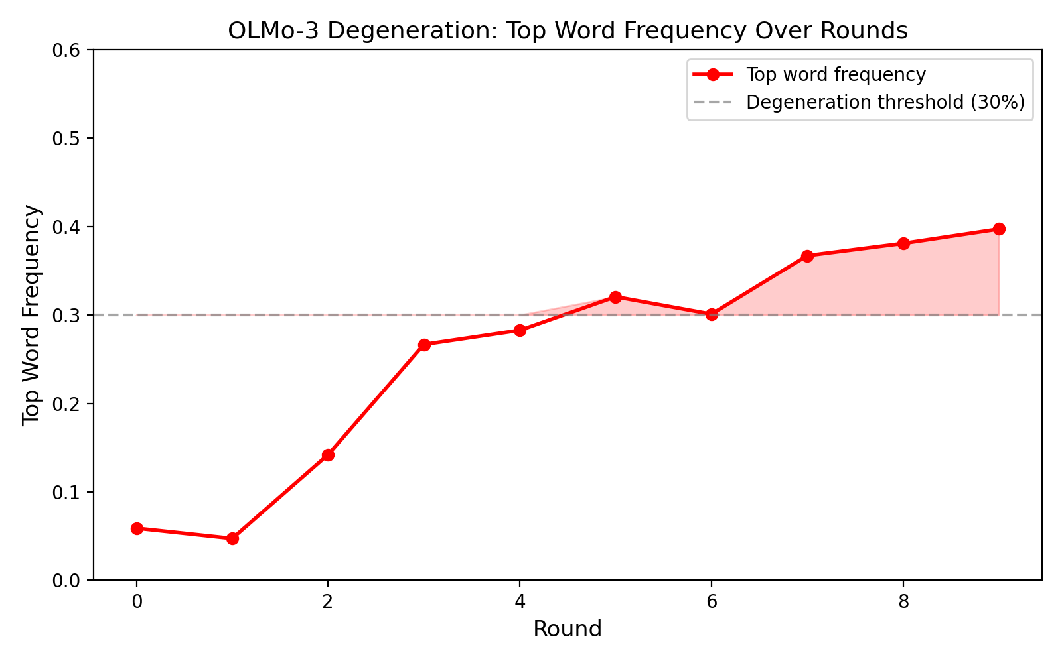
Figure 4. Mean top single-word frequency across rounds (OLMo-3, n = 135 sessions). Red region indicates degeneration threshold (>30%).

4.2 Qwen-2.5: Identity Collapse
Qwen-2.5-7B-Instruct produces coherent, non-degenerate text through all 10 rounds in every session. However, 17 of 30 sessions (57%) converge to token-for-token identical outputs by rounds 7–9. Of late-round turn pairs (rounds 7–10), 54 of 90 (60%) are exact string matches, with another 5 near-identical. Only 31 of 90 late-round pairs show genuinely different text.
This identity collapse occurs at standard sampling temperature (0.7)—meaning the shared conversational context is so constraining that it overrides token-level sampling stochasticity entirely. When sampling noise temporarily breaks the identity lock (a session hitting similarity = 1.0 at round 3, dropping to 0.05 at round 4), agents snap back to identical outputs within one round. The conversation history functions as a deterministic attractor.
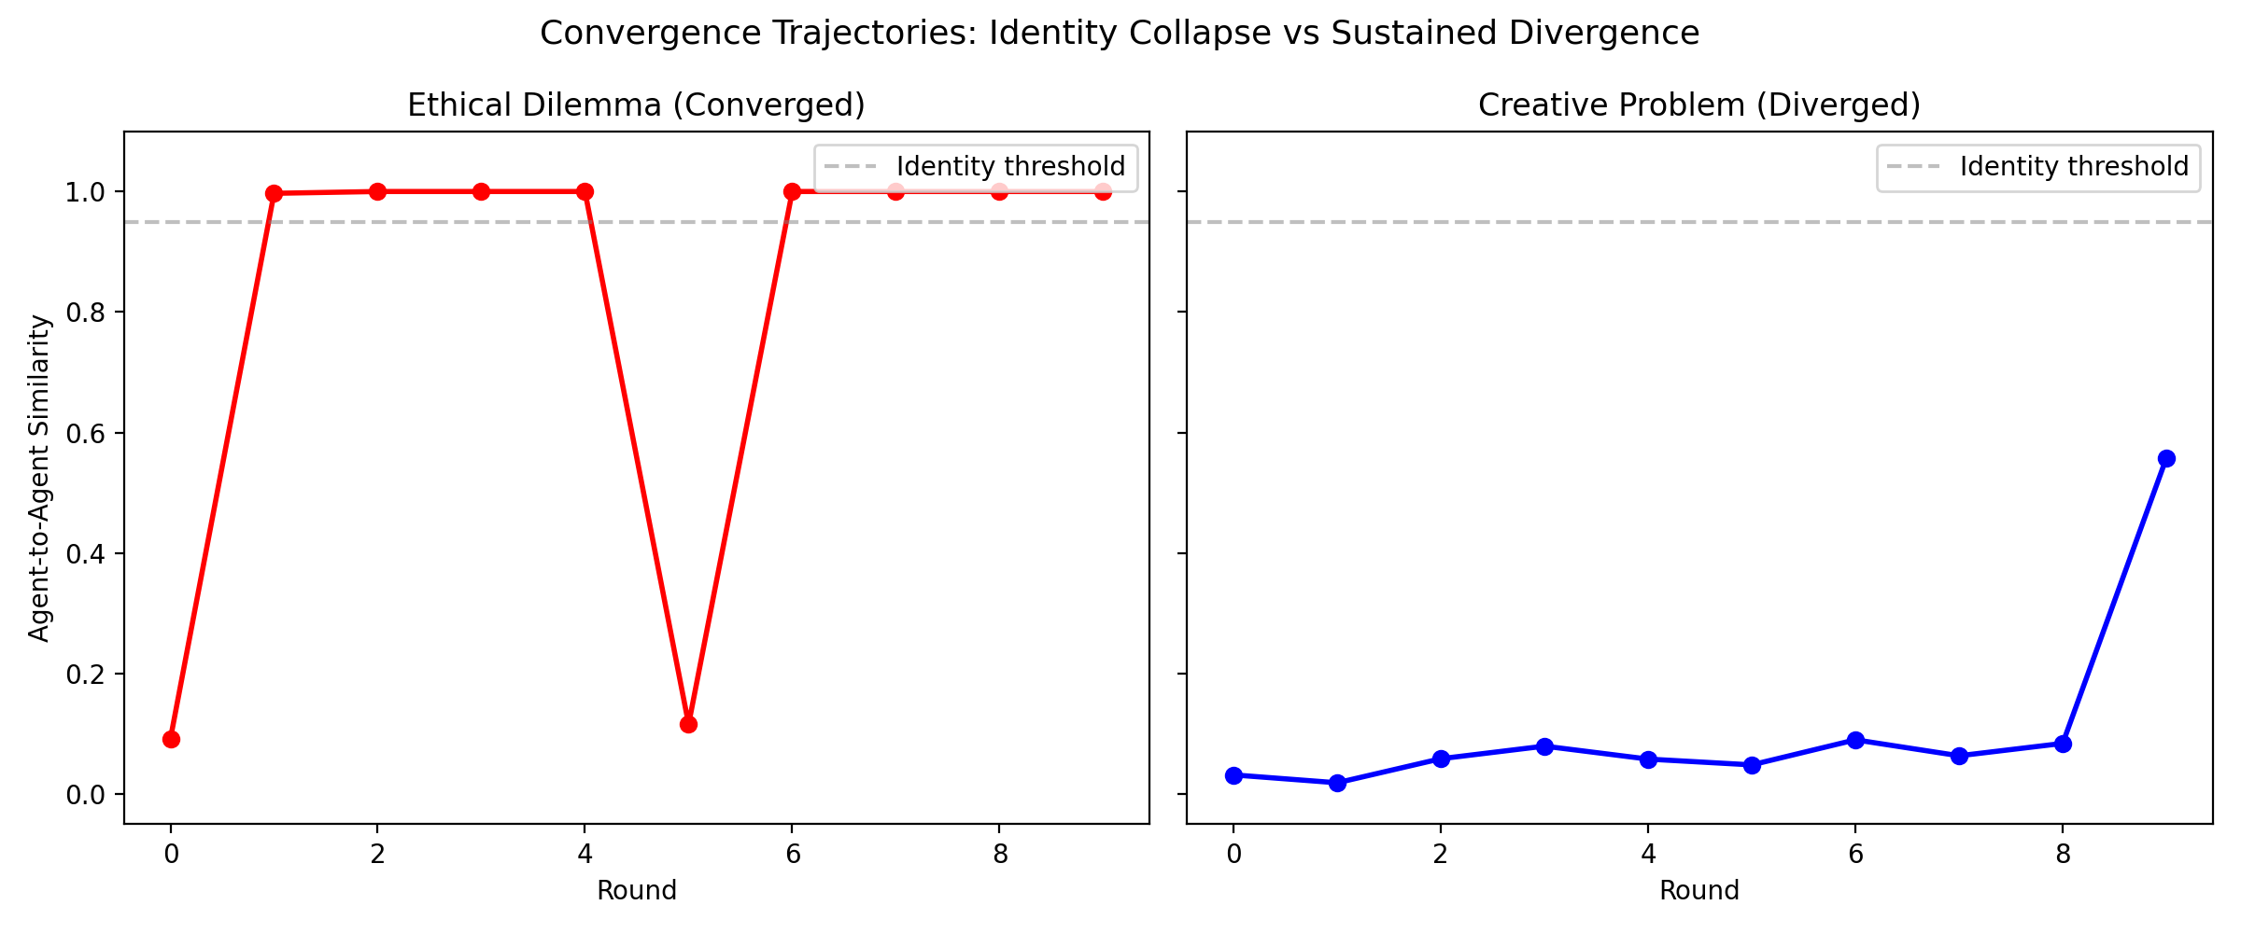
Figure 2. Convergence trajectories for representative sessions. Left: ethical dilemma (identity collapse with snap-back at round 5). Right: creative problem (sustained divergence). Y-axis: SequenceMatcher ratio.

4.3 Task Openness Determines Convergence
The strongest predictor of identity collapse is task type, ordered by solution-space constraint:
Task Type | Converge Rate | Avg Late Similarity | Solution Space
Ethical dilemma | 5/6 (83%) | 0.958 | Highly constrained
Startup ideation | 5/6 (83%) | 0.957 | Moderately constrained
Research question | 4/6 (67%) | 0.853 | Moderate
Policy design | 2/6 (33%) | 0.770 | Moderately open
Creative problem | 1/6 (17%) | 0.597 | Highly open

Table 1. Identity collapse rate by task type (Qwen-2.5, n = 30 sessions). Structured tasks with constrained solution spaces collapse in the majority of sessions. Creative tasks with open solution spaces partially resist collapse.

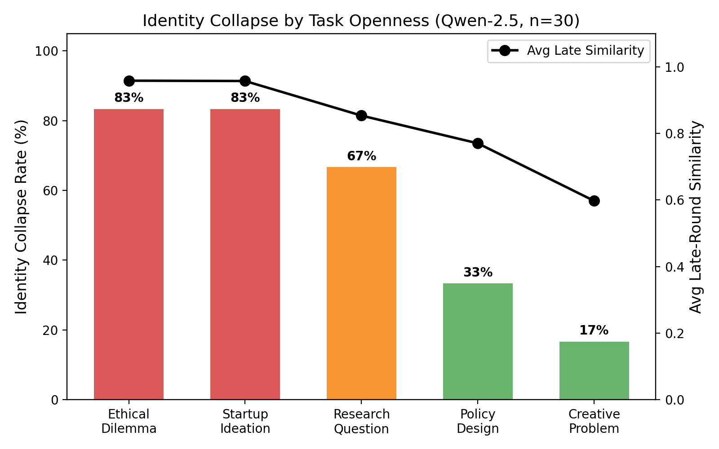
Figure 1. Identity collapse rate and average late-round similarity by task type (Qwen-2.5, n = 30 core sessions).

The gradient is monotonic: as tasks become more open-ended, both convergence rate and endpoint similarity decrease. This suggests that the conversation history acts as an attractor whose strength depends on the constraint of the solution space. Structured tasks provide few valid response regions, making it easy for shared context to funnel both agents to the same output. Creative tasks provide many valid regions, giving agents enough room to maintain distinct outputs despite shared context.

4.4 Personas and Forcing Functions Are Ineffective
Heterogeneous persona prompts ("bold creative thinker" vs. "careful analytical thinker") delay identity collapse by approximately one round (mean convergence round 3.5 vs. 2.7 for homogeneous) but do not prevent it: 8 of 14 heterogeneous sessions (57%) still collapse, versus 9 of 15 homogeneous (60%).
On Qwen-2.5 (where data is not confounded by degeneration), neither forcing function meaningfully changes identity collapse rates relative to baseline (57%). Consensus instruction produces 47–60% convergence across configurations (avg similarity 0.807–0.852), and evaluation pressure produces 47–73% convergence (avg similarity 0.782–0.911). All values fall within the range of baseline variation. Neither consensus mandates nor evaluation pressure break the shared-context attractor.
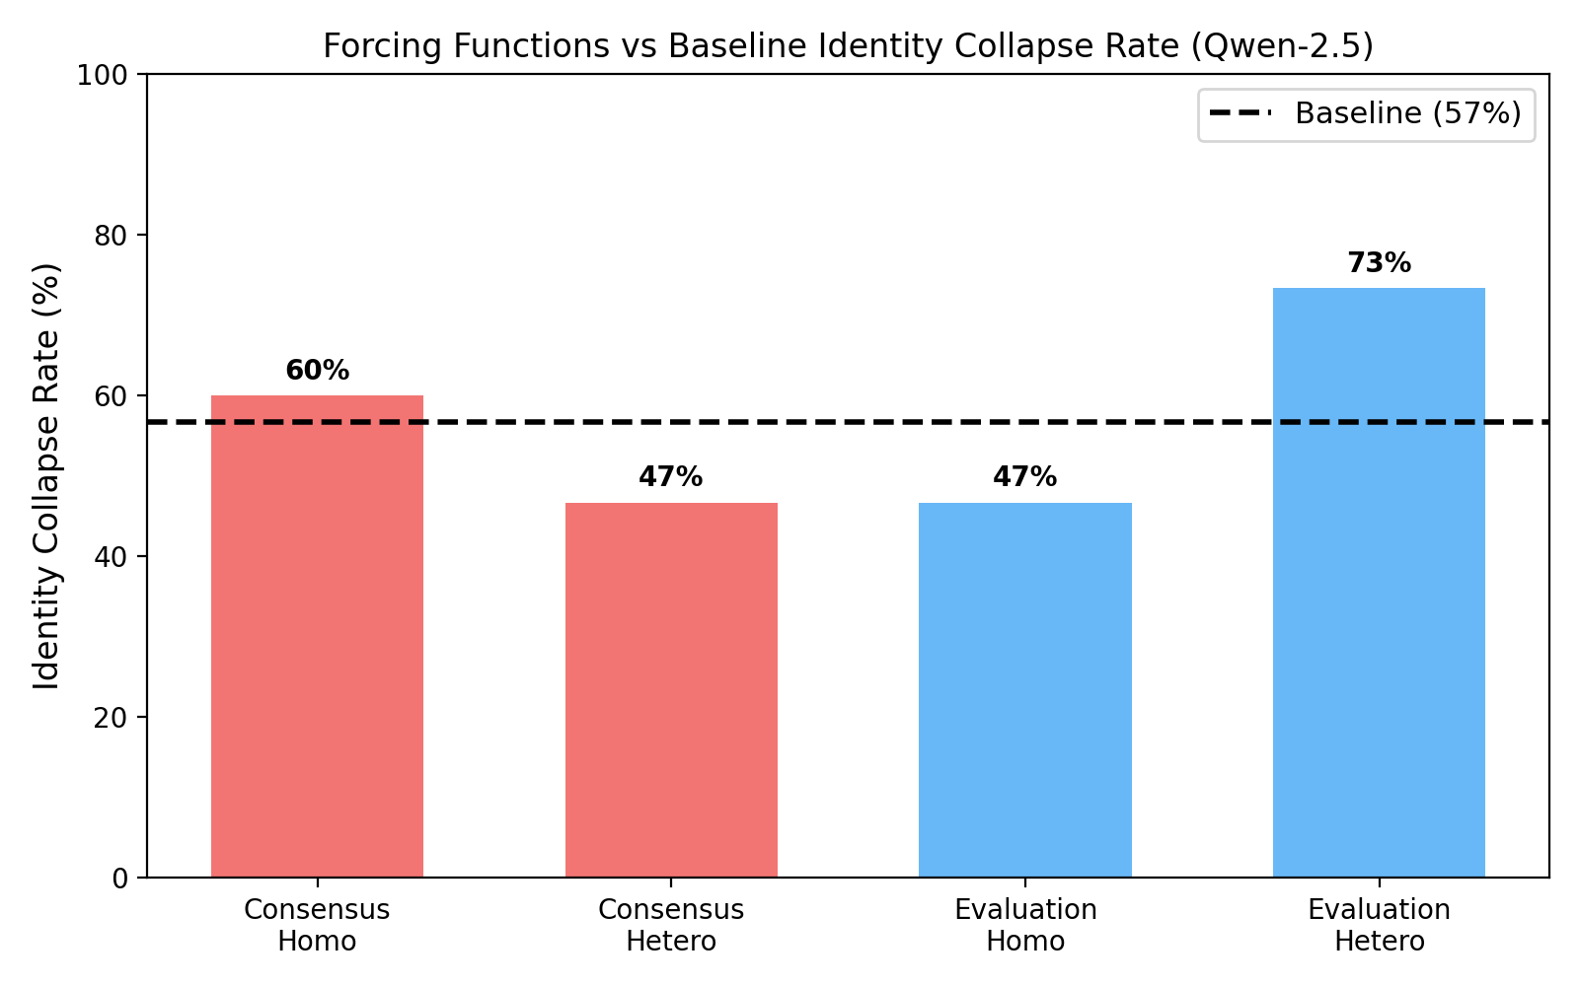
Figure 5. Identity collapse rate by forcing function condition (Qwen-2.5, n = 15 per condition). Dashed line: baseline rate (57%). No condition significantly differs from baseline.

4.5 Temperature Goldilocks Zone
The Qwen-2.5 temperature gradient reveals a non-monotonic relationship between temperature and identity collapse. Contrary to the naive expectation that lower temperature produces more convergence:
Temperature | Converge Rate | Avg Similarity | Interpretation
0.0 (greedy) | 3/5 (60%) | 0.910 | Positional differences preserved
0.1 | 3/5 (60%) | 0.725 | Low noise, some differentiation
0.3 | 5/5 (100%) | 0.999 | Goldilocks: noise smooths position
0.5 | 5/5 (100%) | 1.000 | Goldilocks: total identity collapse
1.0 | 2/5 (40%) | 0.763 | High noise overcomes attractor

Table 2. Temperature gradient on Qwen-2.5 (n = 5 per temperature). Moderate temperatures (0.3–0.5) produce 100% identity collapse. Both greedy decoding and high temperature partially resist.

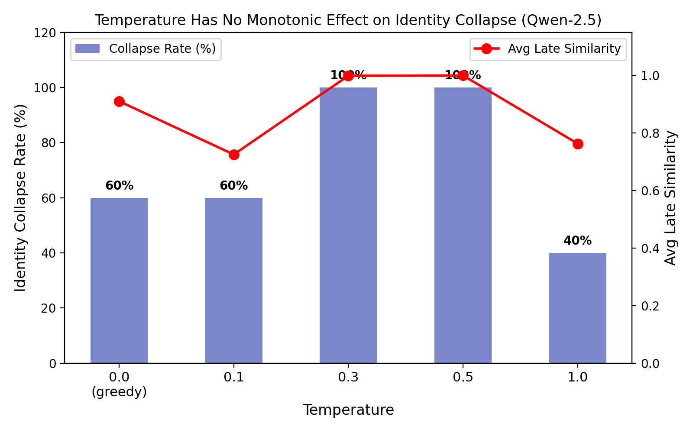
Figure 3. Temperature gradient (Qwen-2.5, n = 5 per temperature). Moderate temperatures maximize identity collapse. The non-monotonic pattern is suggestive at this sample size.

Moderate temperatures (0.3–0.5) maximize identity collapse: 100% of sessions converge with average similarity ≥0.999. Both extremes partially resist. Under greedy decoding, the two agents respond from slightly different conversational positions (agent_0 goes first); deterministic decoding preserves these small positional differences. Under high temperature (1.0), sampling noise is large enough to explore genuinely different output regions despite shared context.
The moderate-temperature sweet spot exists because the noise is sufficient to smooth over small positional differences between agents (rounding both to the same attractor) but insufficient to escape the attractor entirely. This is a form of stochastic resonance: moderate noise amplifies the shared-context attractor rather than disrupting it.

5. Discussion

5.1 Two Failure Modes, One Underlying Cause
Both failure modes—degeneration and identity collapse—may share a common cause: the overwhelming influence of shared conversational context. In multi-agent debate, both agents read the same conversation history, which grows to dominate their input by round 5–10. This shared context pushes both agents toward similar internal representations.
In OLMo-3, this manifests as degeneration: the model cannot maintain coherent generation under the pressure of long, shared context. In Qwen-2.5, it manifests as identity collapse: the model generates coherent text but produces identical outputs because the shared context leaves insufficient room for differentiation. The difference is in model robustness to long context, not in the underlying dynamic.

5.2 Why Identity Collapse Overrides Sampling
The most surprising finding is that identity collapse produces token-for-token identical outputs at temperature 0.7. Standard sampling should introduce per-token variation. The explanation is that by round 3–5, the shared context is so constraining that the model's logit distribution is effectively peaked on a single token sequence—the "correct" continuation given the conversation so far. Temperature-based sampling from a near-degenerate distribution produces the same output.
The temperature gradient reveals a subtler picture. Moderate temperatures (0.3–0.5) produce the strongest convergence—100% identity collapse—while both greedy and high temperature partially resist. This is a form of stochastic resonance: moderate noise smooths over the small positional differences between agents (who respond in different order) without providing enough perturbation to escape the shared-context attractor. Greedy decoding preserves positional differences deterministically; high temperature overcomes the attractor through brute-force exploration.
The snap-back phenomenon supports this interpretation. When sampling noise temporarily produces a different output (breaking the identity lock), the next round's shared context —now including the divergent turn—still points both agents back to the same continuation. The attractor is robust to single-round perturbations.

5.3 Task Openness as the Key Variable
The clean gradient from 83% convergence (ethical dilemma) to 17% (creative problem-solving) identifies task openness as the primary variable determining debate dynamics. This has a simple mechanistic interpretation: the model's output distribution, conditioned on shared context, has lower entropy for structured tasks (fewer valid continuations) than for creative tasks (many valid continuations). Identity collapse occurs when this conditional entropy is low enough that sampling cannot produce different outputs.
This connects to Parfenova's (2025) finding of convergence in multi-agent annotation (a structured task) and suggests a general principle: multi-agent LLM systems converge when the task constrains the valid output space, and diverge when it does not. The question is not "do agents converge?" but "how open is the task?"

5.4 Implications for Multi-Agent System Design
Our findings have practical implications for deploying multi-agent debate with open-weight models:
- Multi-agent debate at 7B scale does not produce productive disagreement on structured tasks. If the goal is to elicit diverse reasoning paths for factual or analytical problems, 7B models will likely converge to identical outputs. This directly limits the applicability of debate-based reasoning (Du et al., 2023) at this scale.
- The groupthink concern is moot at 7B scale—not because agents maintain productive disagreement, but because they collapse to something worse than groupthink: identity. Groupthink implies shared conclusions with potentially different reasoning. Identity collapse means no diversity of any kind.
- Personas and instruction-level interventions are insufficient. Different persona prompts delay collapse by one round but do not prevent it. Effective interventions may require architectural changes: partial context sharing, forced output diversity constraints, or simply larger models.
- Model selection matters more than any experimental variable we tested. The difference between OLMo-3 (degeneration) and Qwen-2.5 (identity collapse) is larger than any within-model manipulation.

5.5 Limitations
We test only two model families at 7B scale. Frontier models (GPT-4, Claude) likely exhibit different dynamics—the debate literature's positive results with these models are not challenged by our findings. Our results speak specifically to the 7B open-weight deployment scenario.
Qwen-2.5 core experiments use n = 3 replications per cell; forcing function experiments use n = 5. While the task-openness gradient is clear and monotonic, interaction effects may emerge at larger scale. We report embedding similarity and exact match rates; an LLM-as-judge metric for concept-level agreement would address the gap between surface similarity and opinion alignment.
All tasks are open-ended discussion prompts. Factual QA with verifiable ground truth—the setting where Du et al. (2023) showed debate benefits—may produce different dynamics, as the correct answer provides a natural attractor distinct from the shared-context attractor we observe.

6. Future Work
The most important extension is testing frontier models (GPT-4o, Claude, Llama-3-70B) to determine whether identity collapse is a 7B-scale phenomenon or a general property of shared-context debate. A model-scale gradient (7B, 13B, 30B, 70B) would identify the threshold at which productive disagreement becomes possible.
Architectural interventions—partial context sharing (each agent sees only its own previous responses plus a summary of the partner's), output diversity constraints (penalizing similarity to the partner's previous turn), and explicit disagreement prompting—could break the identity collapse attractor.
The task-openness gradient should be quantified more precisely using a continuous measure of solution-space entropy rather than our qualitative ordering. Factual tasks with verifiable ground truth would test whether the correct answer can compete with the shared-context attractor.

7. Conclusion
We studied multi-agent debate dynamics at 7B scale across 250 sessions and found two failure modes: degeneration (OLMo-3) and identity collapse (Qwen-2.5). Neither model produces the sustained productive disagreement that multi-agent debate requires. The shared conversational context acts as an attractor that overrides persona differentiation, instruction-level forcing functions, and—most surprisingly—is amplified by moderate sampling temperature through a stochastic resonance effect.
Task openness is the primary moderator: convergence rates follow a monotonic gradient from 83% for constrained tasks to 17% for creative tasks. This suggests a general principle: multi-agent convergence dynamics are determined primarily by the constraint of the solution space, not by decoding parameters or prompt engineering.
For practitioners: multi-agent debate with 7B open-weight models does not work as advertised on structured tasks. The productive disagreement shown in the literature with frontier models does not transfer to this scale. Effective multi-agent reasoning at 7B may require architectural innovations beyond the standard shared-context debate protocol.

Transparency Note
This paper was produced through a multi-agent AI research collaboration. The research process involved multiple false starts and falsified narratives:
- (1) Our initial experiments (78 sessions) were inadvertently run on a 1B base model rather than the intended 7B instruct model, producing results that appeared to show universal divergence. All results were discarded upon discovery.
- (2) The 1B-base results supported a "stochastic divergence" narrative—that sampling noise compounds through conversational feedback loops to produce universal divergence. This narrative was falsified when proper instruct models showed the opposite pattern (identity collapse).
- (3) A "consensus paradox" (consensus instructions increasing divergence) was identified in the 1B-base data but did not replicate with instruct models.
- (4) A hidden-state "invisible groupthink" finding was falsified by a shared-context baseline.
We report this process because the falsified narratives are instructive: each was internally consistent and compelling, and each was wrong. The final findings emerged only through systematic replication, model auditing, and willingness to restart from scratch.

References
Cemri, M., Pan, M. Z., Yang, S., et al. (2025). Why do multi-agent LLM systems fail? arXiv:2503.13657.
Chan, C., Chen, W., Su, Y., et al. (2023). ChatEval: Towards better LLM-based evaluators through multi-agent debate. arXiv:2308.07201. ICLR 2024.
Du, Y., Li, S., Torralba, A., Tenenbaum, J. B., & Mordatch, I. (2023). Improving factuality and reasoning in language models through multiagent debate. arXiv:2305.14325.
Holtzman, A., Buys, J., Du, L., Forbes, M., & Choi, Y. (2020). The curious case of neural text degeneration. ICLR 2020. arXiv:1904.09751.
Hong, J., Byun, G., & Kim, S. (2025). Measuring sycophancy of language models in multi-turn dialogues. arXiv:2505.23840. EMNLP 2025 Findings.
Janis, I. L. (1972). Victims of Groupthink. Houghton Mifflin.
Liang, T., He, Z., Jiao, W., et al. (2023). Encouraging divergent thinking in large language models through multi-agent debate. arXiv:2305.19118.
Parfenova, A., et al. (2025). Emergent convergence in multi-agent LLM annotation. arXiv:2512.00047. EMNLP BlackboxNLP 2025.
Python Software Foundation. difflib — Helpers for computing deltas. Python Standard Library.
Riedl, C. (2025). Emergent coordination in multi-agent language models. arXiv:2510.05174.
Sharma, M., et al. (2024). Towards understanding sycophancy in language models. ICLR 2024. arXiv:2310.13548.
Wang, Y., et al. (2024). Sycophancy in large language models: Causes and mitigations. arXiv:2411.15287.
Wynn, A., Satija, H., & Hadfield, G. (2025). Talk isn't always cheap: Understanding failure modes in multi-agent debate. arXiv:2509.05396. ICML MAS Workshop 2025.
Xiong, K., et al. (2025). Peacemaker or troublemaker: How sycophancy shapes multi-agent debate. arXiv:2509.23055.

