[Document title]

[Draw your reader in with an engaging abstract. It is typically a short summary of the document. When you’re ready to add your content, just click here and start typing.]
  - [Document subtitle]

Table of Contents
1.1 PROJECT OBJECTIVES 2
1.2 PROJECT SCOPE DOCUMENT 3
1.3 PROJECT QUALITY PLAN 4
1.4 Work Breakdown Structure (WBS) 5
1.5 Network Planning and Scheduling 6
1.6 Critical Path Analysis 7
1.7 Resource Estimation 8

1.1 PROJECT OBJECTIVES
The 3 clear measurable project objectives ME and my IT PROJECT MANAGEMENT TEAM came up with are:
- Specific & Measurable: Develop and deploy the operational Smart Service Portal web and mobile application within 8 months, achieving at least 95% system uptime and automated routing for all municipal service requests (water leaks, electricity faults, refuse collection, billing queries).
- Achievable & Relevant: Integrate directly with existing municipal billing and customer databases to enable real-time tracking, SMS/email notifications, and geo-location mapping for fault reporting.
- Time-Bound: Fully complete system testing, user training, deployment, and handover to the municipal IT operations team within the stipulated 8-month schedule.

1.2 PROJECT SCOPE DOCUMENT
- Project Description: Implementation of the City of Johannesburg Smart Service Portal (SSP) to replace fragmented communication channels (call centers, walk-in offices, emails, paper-based forms) with a unified digital platform.
- In-Scope Items: Web and mobile application development, user authentication, online logging and tracking of service requests, automated routing to relevant departments, SMS/email notifications, integration with municipal billing databases, real-time dashboards and analytics for management, and geo-location features for fault reporting.
- Out-of-Scope Items: Upgrades to internal municipal back-end core billing servers beyond API integration points, physical hardware replacements for municipal offices, and field worker mobile device procurement.
- Key Deliverables: Approved Project Scope Document, WBS, Project Quality Plan, Network Diagram & Schedule, Functional SSP Web/Mobile App, Testing Reports, and Final Project Handover Report.
- Project Constraints: Fixed 8-month delivery deadline mandated by Gauteng Provincial Government; strict adherence to municipal IT security standards and budget allocation.
- Assumptions: Stakeholders will promptly review and approve deliverables; municipal database APIs will be accessible for integration testing; adequate development and testing staff will remain assigned throughout the project lifecycle.

1.3 PROJECT QUALITY PLAN
1.3 Project Quality Plan (10 Marks)
- Quality Objectives: Ensure zero critical software defects upon release, 99.9% data integrity during billing integration, and high usability scores (minimum 85% satisfaction rating from citizen trial users).
- Quality Standards to be Applied: ISO/IEC 25010 (Software Product Quality), ISO 9001 (Quality Management), Web Content Accessibility Guidelines (WCAG 2.1) for usability, and municipal cybersecurity standards.
- Quality Assurance (QA) Activities: Regular peer code reviews, sprint retrospective meetings, milestone reviews, and compliance audits against ISO standards.
- Quality Control (QC) Measures: Automated unit testing, integration testing, software security penetration testing, user acceptance testing (UAT), and inspection of deliverables against acceptance criteria.
- Roles and Responsibilities: Palesa (Software Development Lead) ensures code quality; Maggie (Testing Lead) executes QA/QC protocols; Beth (Project Manager) oversees overall adherence to the Quality Plan.

1.4 Work Breakdown Structure (WBS)
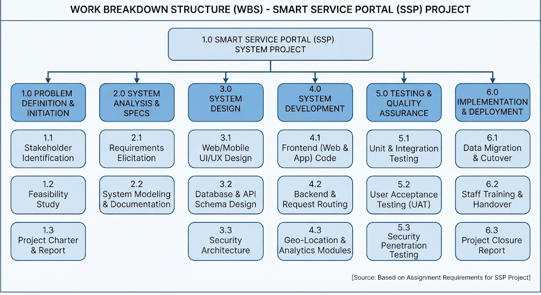

1.5 Network Planning and Scheduling
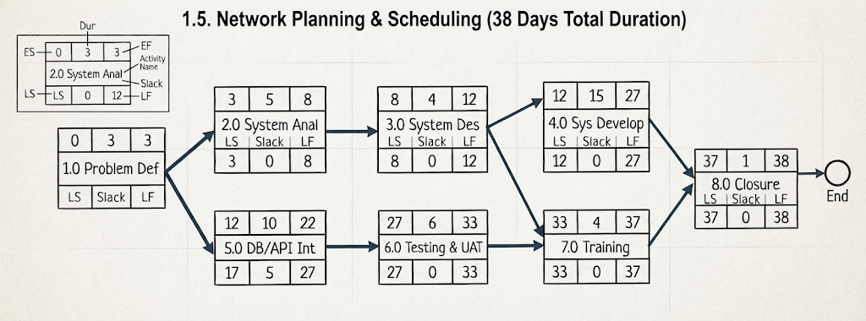

1.6 Critical Path Analysis
Path Calculations & Total Durations
- Path 1 (Top / Main Route):
  - Activities $1.0→2.0→3.0→4.0→6.0→7.0→8.0$
  - Calculation: $3+5+4+15+6+4+1=38\text{ days}$ (Zero slack / Total float)
- Path 2 (Alternative / Database Integration Route):
  - Activities $1.0→2.0→3.0→5.0→6.0→7.0→8.0$
  - Calculation: $3+5+4+10+6+4+1=33\text{ days}$ (Has 5 days of total slack)
Critical Path Identification
- Critical Path: $1.0→2.0→3.0→4.0→6.0→7.0→8.0$
- Total Duration: 38 working days
- Analysis: The path containing the system development task (Activity 4.0) determines the overall project duration. Because Activity 5.0 (Database & API Integration) has a total float of 5 days, any delay on the critical path will directly extend the 38-day completion timeline, whereas delays on non-critical paths up to 5 days will not impact the final deadline.

1.7 Resource Estimation
Human Resources
- 1. Problem Definition & Initiation (Activity 1.0):
  - Project Manager (Betty) to lead stakeholder interviews and charter finalization.
  - Systems Analyst (jimmy) to gather initial municipal requirements and business needs.
- 2. System Analysis & Design (Activities 2.0 & 3.0):
  - Lead Software Architect (Tylil) to design system architecture, UI/UX mockups, and database schemas.
  - Systems Analyst (Jimmy) to map existing manual workflows to digital functional specifications.
- 3. System Development & Integration (Activities 4.0 & 5.0):
  - Frontend Developer (Elliot) to build responsive web viewports and mobile user interfaces.
  - Backend Integration Engineer (Jordan) to program API endpoints linking to municipal billing and customer databases.
- 4. Testing, Deployment & Closure (Activities 6.0, 7.0 & 8.0):
  - Quality Assurance / Testing Leads (Magret and Rigby) to execute unit tests, security scans, and UAT sessions.
  - Project Manager (Betty) and IT Support Staff to manage user training, system cutover, and final project handover.
Technical Resources
- 1. Problem Definition & Initiation (Activity 1.0):
  - Documentation tools (Microsoft Word, Google Workspace) for drafting the Project Charter and Problem Definition report.
  - Collaborative scheduling software for initial milestone mapping.
- 2. System Analysis & Design (Activities 2.0 & 3.0):
  - Modeling and diagramming software (Microsoft Visio, draw.io) for building Work Breakdown Structures and Use Case diagrams.
  - UI design toolkits (Figma or Adobe XD) for sketching wireframes.
- 3. System Development & Integration (Activities 4.0 & 5.0):
  - Integrated Development Environments (IDEs) such as Visual Studio Code and Git version control repositories.
  - Cloud development servers and database management tools (SQL Server Management Studio / Oracle database tools) for backend coding.
- 4. Testing, Deployment & Closure (Activities 6.0, 7.0 & 8.0):
  - Automated testing software and security scanning toolkits (Selenium, Postman for API testing).
  - Staging and production cloud server environments, alongside multi-device test hardware (iOS/Android smartphones) for mobile validation.

