FabulousFormMaker

Plug-in

*User Manual*

Comp412



***TABLE OF CONTENTS***

**About This Book**

The FabulousFormMaker Plug-in User Manual explains how to use the plugin on any Content Management System

**Intended Audience**

This information is intended for anyone who wants to build their own forms without any knowledge of coding or programming. The information in this document is written for non-experienced WordPress users . For more information on WordPress, see <https://wordpress.org/>.

**Technical Support**

For any technical queries, suggestions or more information, you may contact FabulousFormMaker Plugin Technical Support through email:

**Email support**: support@ellytronic.media

# Introduction

Many users require easy creation of forms. FabulousFormMaker plugin offers users an advantage to create their own custom forms with the use of text boxes, password fields, drop down select boxes, radio boxes, and checkboxes and text areas.

This user manual explains basic know how of using FabulousFormMaker with WordPress.

## Steps to create form from FabulousFormMaker Plugin

a. Settings,

b. Form Editor,

c. Your form so far

# 1. Settings

User can login to their wp-admin portal after successful installation of the FabulousFormMaker Plugin. User can see their dashboard. Follow the below steps:

1. Navigate to Plugins
2. Click on Installed Plugins
3. Activate FabulousFormMaker.
4. Navigate to Contact Form (Note: User will be able to see their Custom Contact Form)

**Possible Operations:**

1. ***Address the contact form to the following name:*** User can enter the name in the textbox.
2. ***Send the contact form to this email address:*** User can enter the email address of the person who will receive the form.
3. Click on Save Settings will save the entry made to the above fields with the message on top as *“Settings Updated”*. (Please refer to the screenshot for same)

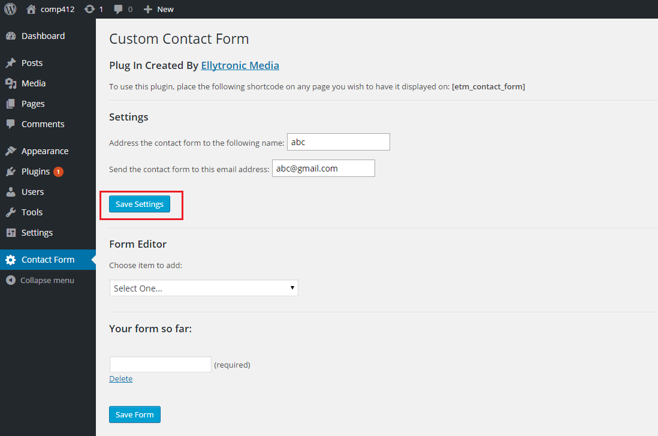

1. User can change the settings in ***Address the contact form to the following name*** text field and ***Send the contact form to this email address*** text field and click on Save Settings.
2. To verify if the above entries has been saved, user can navigate to any other tab and come back to ‘Contact Form’ Page to see their settings have been saved.

# 2. Form Editor

After entering necessary information in Settings, user can create the form by choosing fields from the drop down list.

1. Choose item to add in the contact form
2. Click on the drop down list
3. User can choose any of the six options (Single-Line Text Box, Selection Box, Large Text Box, Password Text Box, Radio Box (Choose one Option Style), Check Boxes (Choose Multiple Option Style).
4. User has the ability to delete any of the option.

**Possible Operations**:

**1. Single-Line Text Box**

1. Select Single-Line Txt Box option from the drop down list. (Please refer to the screenshot below)

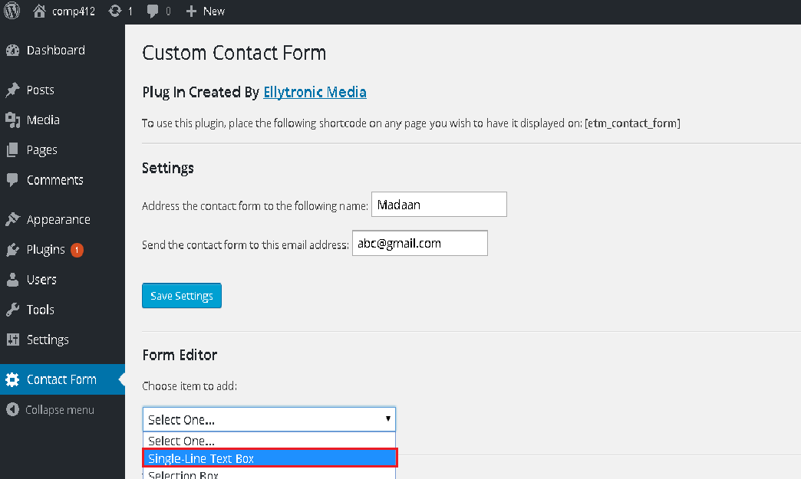

1. On selection of Single-Line Text Box option, user can add ‘Text to print before this single line text box:’ making this field as ‘Required’ (a check box), ‘Finish this element and add to form’ or ‘Cancel adding this element’. (Please refer to the screenshot below)

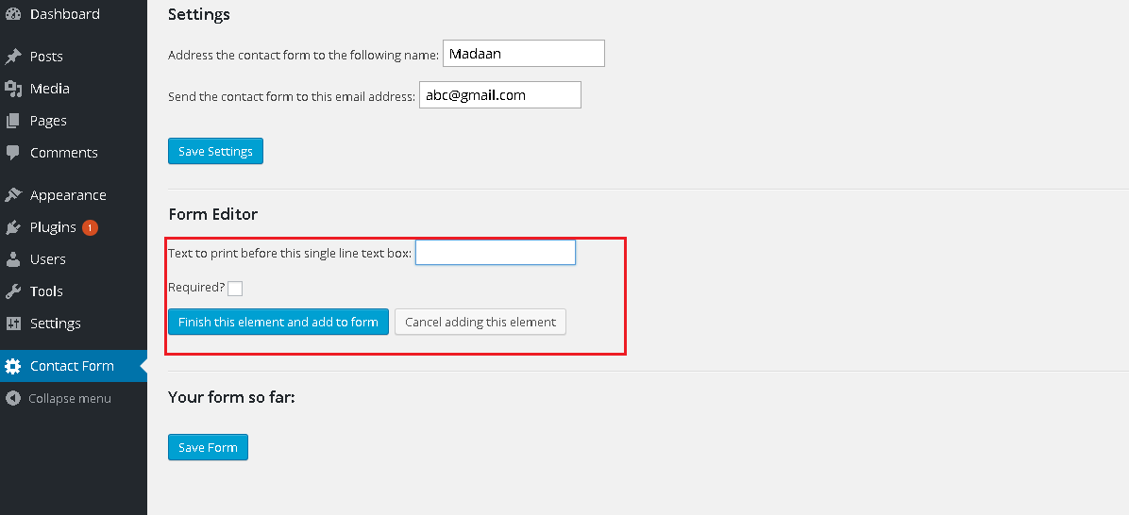

1. If user selects ‘Required’ check box, then this text box becomes required field in the contact form.
2. User can ‘Finish this element and add to form’ or user can ‘Cancel adding this element’ in the form.
3. For example user selects on ‘Required’ and clicks on ‘Finish this element and add to form’.

**2. Selection Box**

1. User selects ‘Selection Box’ option from the drop down list.
2. User can add entry in ‘Text to print before this dropdown select box’, make a field ‘Required’ or not required, add options to the ‘Next select box option’, ‘Your Select Box So Far’ displays the options, ‘Finish this element and add to form’ or ‘Cancel adding this element’.
3. For example user selects names the selection box field as ‘Age’, makes it a required field, with selection as 10, 20 etc and clicks on “Finish this element and add to form’. (Please refer to the screenshot below).

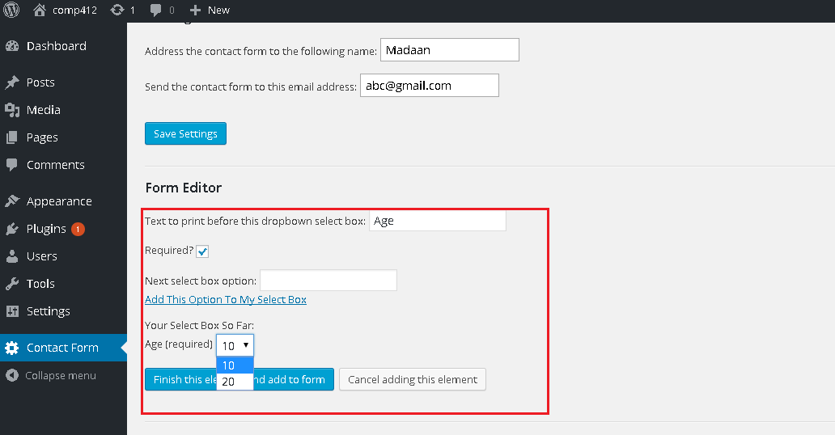

**3. Large Text Box**

1. User selects ‘Large Text Box’ option from drop down list.
2. On selection of Large Text Box option, user can add ‘Text to print before this large text box:’ making this field as ‘Required’ (a check box)or not required, ‘Finish this element and add to form’ or ‘Cancel adding this element’.
3. For example, user adds name to ‘Text to print before this large text box’, keeping the field as not required and ‘Finish this element and add to form’. (Please refer to the screenshot below)

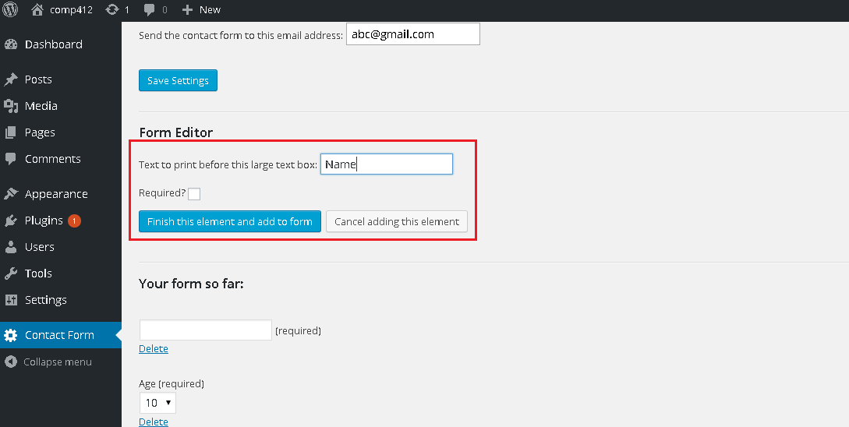

**4. Password Text Box**

1. User selects ‘Password Text Box’ option from drop down list.
2. On selection of Password Text Box option, user can add ‘Text to print before this password style box:’ making this field as ‘Required’ (a check box)or not required, ‘Finish this element and add to form’ or ‘Cancel adding this element’.
3. For example, user adds name to ‘Text to print before this password style box’, keeping the field as required and ‘Finish this element and add to form’. (Please refer to the screenshot below)

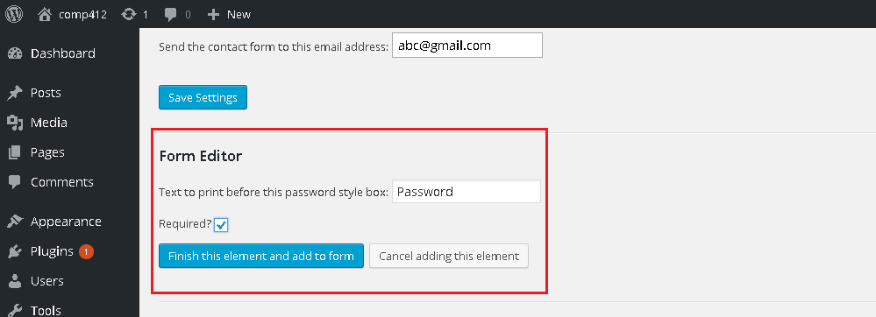

**5. Radio Box**

1. User selects ‘Radio Box’ option from drop down list.
2. On selection of ‘Radio Box’ option, user can add ‘Text to print before this list of choices:’, make this field as ‘Required’ or not ‘Required’, ‘Label for this choice’, ‘Finish this element and add to form’ or ‘Cancel adding this element’.
3. For example, user can add entry to ‘Text to print before this list of choices’, keeping the field as not required, ‘Label for this choice, click on ‘Add this Option To My List’. Once user add option to my list, ‘Option Added’ message is displayed. ‘Your list so far’ is shown with radio button. Click on ‘Finish this element and add to form’.

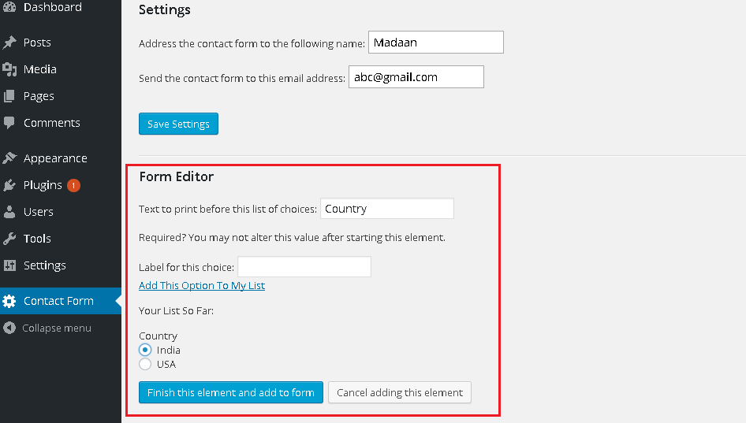

**6. Check Boxes**

1. User selects ‘Check Boxes’ option from drop down list.
2. On selection of ‘Check Boxes’ option, user can add ‘Text to print before this list of choices:’, make this field as ‘Required’ or not ‘Required’, ‘Label for this choice’, ‘Finish this element and add to form’ or ‘Cancel adding this element’.
3. For example, user can add entry to ‘Text to print before this list of choices’, keeping the field as ‘Required’, ‘Label for this choice’, click on ‘Add this Option To My List’. Once user add option to my list, ‘Option Added’ message is displayed. ‘Your list so far’ is shown with check boxes. Click on ‘Finish this element and add to form’.

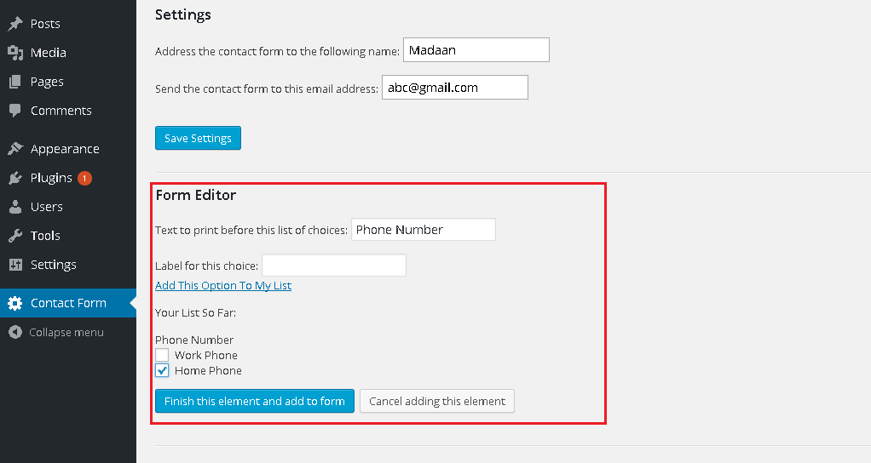

# Your form So Far

Form looks like below after following the selection above and click on ‘Save Form’

