DryWall Toolbox
Product Detail Page UI/UX Design System
Production build specification • Desktop reference: product-detail-mockup1.png
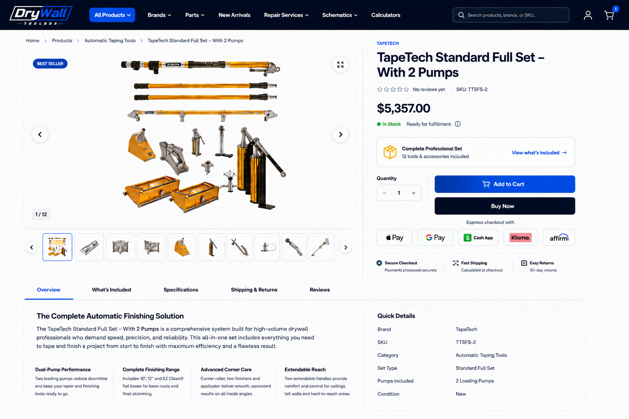
Purpose. Define the visual tokens, responsive geometry, component contracts, interaction states, content rules, accessibility requirements, and implementation acceptance criteria required to reproduce the approved PDP consistently across tool sets, variable products, simple products, parts, and accessories.

1. Architecture
The PDP is a frontend presentation composition over canonical commerce data. The approved visual system must not create parallel authority for product identity, pricing, stock, variations, cart, checkout, fulfillment, or payment eligibility.
Concern | Authority / owning layer | PDP responsibility
Presentation, responsive layout, gallery, controls | frontend/ | Render canonical data; own interaction and accessibility only.
Product, variation, price, cart, checkout | WooCommerce | Source commerce state; never duplicate it client-side as authoritative state.
Inventory / fulfillment / tracking | Veeqo via backend contracts | Display only backend-authorized availability/fulfillment claims.
Catalog identifiers / taxonomy / media / compatibility | products/ + DTB APIs | Render canonical identifiers and relationships.
Checkout orchestration / domain rules / integrations | DTB MU Plugins | Preserve existing checkout and event-ledger workflow.
Payment methods | Payment provider | Render only methods eligible for the active checkout/session.

2. Reference geometry
The supplied 1536×1024 mockup is the visual source of truth for this document. Measurements below are normalized implementation targets, not claims about existing repository CSS.
Region | Desktop target
Viewport design reference | 1536 × 1024
Global content max width | ≈ 1416 px; centered; 56–64 px outer gutters at 1536 px
Header height | ≈ 70–72 px
Breadcrumb band | ≈ 48 px from header baseline to PDP content
Hero grid | ≈ 58% media / 42% purchase; 28–36 px column gap
Media stage | Aspect ratio ≈ 1.53:1; white surface; 1 px cool-neutral border; 10–12 px radius
Thumbnail rail | 56–68 px tile height; 8–12 px gaps; active tile uses 2 px blue outline
Section navigation | Single horizontal row; 52–58 px height; active underline 2 px
Overview grid | ≈ 60% editorial description / 40% quick details

3. Design tokens
Token | Value / rule | Usage
--dtb-navy-950 | #06152D to #071630 | Global header, Buy Now, highest-contrast brand surfaces
--dtb-blue-600 | #0B57E3 to #0D5BEA | Primary CTA, links, active navigation, focus accents
--dtb-green-600 | #08A43A | Verified in-stock state only
--text-strong | #071630 | Titles, price, major headings
--text-body | #172A49 | Body and secondary product information
--text-muted | #64748B | Metadata, helper text
--border | #DCE4EF | Cards, thumbnails, separators
--surface | #FFFFFF | Primary page surface
--surface-subtle | #F8FAFD | Only where a differentiated neutral surface is needed
--radius-sm | 6 px | Variant buttons, quantity controls, thumbnails
--radius-md | 10–12 px | Gallery and restrained cards
--shadow-float | 0 4px 14px rgba(7,22,48,.10) | Carousel arrow / floating controls only

4. Typography system
Role | Desktop | Weight / behavior
Brand eyebrow | 11–12 px | 700; uppercase; blue; letter spacing .03em
Product H1 | 30–36 px / 1.05–1.12 | 700–750; max 2–3 lines
Price | 30–34 px | 700–750; tabular numerals preferred
Section heading | 18–22 px | 700
Body | 14–16 px / 1.5–1.65 | 400–500; readable line length
Metadata | 12–13 px | 500; muted
Control label | 12–13 px | 600–700
Button | 14–15 px | 650–700

5. Desktop component specification

5.1 Header and breadcrumb
Retain the existing DTB global header language: deep navy, left-aligned brand mark, primary navigation, right-aligned search/account/cart. The PDP must begin beneath the header with a low-emphasis breadcrumb. Breadcrumbs are navigational, not decorative; truncate long terminal labels without creating horizontal overflow.

5.2 Product media gallery
The media column is the visual anchor. Use a large white stage with contain-fit imagery and substantial breathing room. Product photography must never be cropped merely to fill the frame.
Element | Required behavior
Main image | object-fit: contain; centered; stable aspect ratio; no layout shift between images.
Carousel arrows | Circular white floating controls; subtle shadow; 40–44 px target; keyboard operable.
Image counter | Small neutral label such as 1 / 12; bottom-left.
Expand / zoom | Top-right floating control; opens accessible lightbox/fullscreen view.
Thumbnail rail | Uniform tiles; active = blue outline; keyboard focus distinct from selected state.
Badges | Only factual merchandising states backed by data. Avoid decorative badge proliferation.

5.3 Purchase panel
The purchase panel is visually dense but not card-heavy. It remains on the white page surface and uses hierarchy, spacing, and thin separators rather than nested panels.
Order | Element | Build rule
1 | Brand | Blue uppercase eyebrow; link to canonical brand route when available.
2 | Product title | Strong H1; preserve canonical product name.
3 | Reviews + SKU | Compact metadata row; no fake rating; zero-review state must remain explicit.
4 | Price | WooCommerce-authoritative. Do not render a crossed-out regular price when it equals the active price.
5 | Stock / fulfillment | Semantic status. Fulfillment copy only when sourced from the proper backend authority.
6 | Tool-set summary | Conditional. Compact bordered row with set count and link to What's Included. Omit for normal products.
7 | Variation controls | Conditional. Label + explicit option buttons/selectors; selected, unavailable, hover and focus states.
8 | Quantity + Add to Cart | Quantity occupies a compact fixed-width control; Add to Cart is the dominant blue CTA.
9 | Buy Now | Full-width navy secondary accelerated action; must use the existing checkout contract.
10 | Express methods | Provider marks only when eligible; consistent optical sizing.
11 | Service assurances | Three restrained text groups separated by vertical rules; icons optional, not required.

5.4 Section navigation
The approved visual language is text-only navigation. No tab icons. Labels are conditional by product type. Tool sets may expose Overview, What's Included, Specifications, Shipping & Returns, Reviews. Standard products normally use Description, Specifications, Reviews unless additional canonical content exists.

5.5 Overview / description
Do not render the description as a generic bullet list or a stack of decorative feature cards. The approved pattern is retailer-style editorial copy: one strong merchandising headline, one concise descriptive paragraph, then a restrained four-column feature strip using typography and thin vertical separators. Feature icons are intentionally excluded.
Overview element | Rule
Headline | Benefit-led, product-specific; 18–22 px; one line where practical.
Lead paragraph | 2–4 sentences; max readable width ≈ 680–760 px.
Feature strip | 3–4 concise feature columns; heading + 1–2 sentence explanation; no bullets; no pictograms.
Quick Details | Right-side structured key/value table; factual attributes only; avoid duplicate prose.
Vertical balance | Description and Quick Details begin on the same baseline; content density should visually balance both columns.

5.6 What's Included — tool sets only
For kits and sets, included equipment is a first-class product contract. The top purchase panel links to this section. The section should present canonical included items, quantities and identifiers without turning the page into an oversized card grid. Prefer compact rows or a disciplined image/list composition.

5.7 Specifications
Specifications are structured product facts, not marketing prose. Use a clean two-column definition/table treatment. Hide empty attributes. Preserve units and canonical identifiers. Variation-specific values update only when the selected variation legitimately changes the attribute.

6. Product-type composition rules
Product type | Hero/purchase differences | Lower-content differences
Tool set / kit | Show compact Complete Set summary and What's Included link. | Overview + What's Included + Specifications + Shipping & Returns + Reviews.
Variable product | Variation selection is required before enabled purchase actions when WooCommerce requires it. | Description + Specifications + Reviews; selected variation may update factual specs.
Simple product | No variation UI. Quantity + Add to Cart immediately available if purchasable. | Description + Specifications + Reviews.
Replacement part | Compatibility may be more important than merchandising features. | Description + Compatibility + Specifications + Reviews when canonical compatibility exists.
Out of stock / unavailable | Disable purchase path according to commerce state; show factual availability message. | Do not hide product information solely because purchasing is unavailable.

7. Responsive system
Breakpoint intent | Layout
≥ 1280 px | Full two-column hero; 56–64 px page gutters; purchase panel may use sticky positioning within hero bounds.
1024–1279 px | Two-column hero with tighter gap and reduced H1/media sizing; maintain purchase hierarchy.
768–1023 px | Prefer stacked media then purchase panel unless available width preserves controls without compression.
< 768 px | Single column; gallery first; purchase information second; horizontally scrollable thumbnail rail; no desktop sticky panel.
Mobile CTA | Optional bottom purchase bar only after original CTA leaves viewport; respect safe-area inset and do not obscure content.

8. Interaction and state matrix
State | Required UI behavior
Loading | Reserve geometry for gallery/title/price; avoid content jump. Skeletons must match final dimensions.
Variation unselected | Purchase action communicates required selection; never silently choose a variation unless product contract defines a default.
Variation unavailable | Option remains understandable but non-selectable; announce unavailable state accessibly.
Adding to cart | Disable duplicate submission, show progress, preserve quantity/variation identity.
Add success | Update canonical cart state and cart count; provide non-blocking confirmation.
Add failure | Inline actionable error; preserve user's selections.
Image failure | Use deterministic product-media fallback; preserve gallery dimensions.
Zero reviews | Display truthful zero-review state; no filled stars or fabricated rating.
Keyboard focus | Visible high-contrast focus ring on every interactive control.

9. Production build guidance
This specification is intentionally visual and implementation-oriented. Reproduce the approved reference through reusable layout primitives and product-type conditions rather than page-specific positioning or one-off styling.
Area | Build direction
Layout | Use intrinsic Grid/Flexbox composition. Keep the desktop hero as a balanced media/purchase split and allow each column to shrink without overflow.
Spacing | Use the tokenized spacing system consistently; do not compensate for misalignment with arbitrary margins or absolute offsets.
Media | Preserve a stable gallery stage and thumbnail geometry across image counts and aspect ratios.
Purchase controls | Keep variation selection, quantity, Add to Cart, Buy Now and express methods in one predictable vertical sequence.
Lower content | Use the approved text-only navigation and balanced editorial/Quick Details composition. Tool-set-only content remains conditional.
Responsive behavior | Reflow the same component system rather than maintaining separate desktop and mobile markup.

10. Visual quality rules
The approved interface is restrained, product-led and retailer-grade. Visual hierarchy should come from proportion, typography, whitespace and alignment—not decorative UI.
Use | Avoid
Large, clean product imagery | Decorative image frames or heavy shadows
Strong title and price hierarchy | Competing oversized labels and badges
Text-only section navigation | Icons inside section tabs
Restrained feature statements with separators | Cheesy feature icons or pictograms
One dominant blue Add to Cart action | Multiple equally dominant CTAs
Factual stock, shipping and product information | Generic or unsupported trust claims
Compact neutral borders and modest radii | Nested card-on-card layouts and excessive pill shapes
Retailer-style description copy | Marketing copy formatted as long bullet lists

11. Visual fidelity checklist
Area | Reference target
Page shell | Centered wide desktop composition with consistent left/right gutters and no wasted horizontal space.
Hero balance | Gallery remains the visual anchor while the purchase column has enough width for the full product title, price and controls.
Gallery | Large contain-fit image, understated border, floating arrows, image count and compact thumbnail rail.
Purchase hierarchy | Brand → title → reviews/SKU → price → availability → conditional product configuration → quantity/CTAs → express checkout → service information.
Tool-set treatment | Only sets/kits receive the compact Complete Professional Set row and What’s Included navigation.
Standard-product treatment | No set summary; use product options/variations only when the product requires them.
Overview | Editorial headline and paragraph on the left, restrained feature statements below, Quick Details aligned on the right.
Typography | Navy high-contrast headings, blue accents, restrained metadata and consistent numeric price emphasis.
Borders/radii | Thin cool-neutral borders and modest 6–12 px radii; shadows reserved for floating controls.
Responsive | No clipped content or horizontal page overflow; components reflow without changing commerce meaning.

12. Build sequence
• Inspect the current PDP route, component tree, gallery, purchase controls, product options and lower-content implementation before changing behavior.
• Establish the shared page shell, spacing, typography, color, border and radius tokens used by the approved mockup.
• Rebuild the media gallery to the approved proportions and interaction layout.
• Rebuild the purchase column while preserving existing product, variation, cart and checkout behavior.
• Replace the current lower content presentation with the approved text-only navigation, retailer-style overview and Quick Details composition.
• Add conditional compositions for tool sets, variable products, simple products and replacement parts without duplicating the PDP.
• Tune tablet and mobile reflow from the same component tree.
• Perform visual comparison against the supplied reference at desktop width, then verify representative products from every supported product type.

13. Deliverable definition
The finished PDP should reproduce the supplied mockup as a reusable DryWall Toolbox product-detail system—not as a single hard-coded TapeTech page. The visual language, hierarchy and geometry remain consistent while product-specific modules appear only when supported by the product being rendered.

