Identifying Players by Betting Tolerance in Texas Holdem Poker
Nicholas Larsen, Jun Zhang, Rob Rochwick

I. Introduction
Poker is a game of imperfect information. In such games each player only knows a particular subset of the complete parameters of game play. In poker, the knowledge available to each player is the cards they have. The unknown information in poker is the cards their opponents are have. Professional poker players use many tactics to aid their decision making from strategy to statistics to psychology. Usually these tactics are used to determine what cards their opponents have. Once the opponent’s cards are known, the optimal play can be made.

In almost every poker strategy, one of the most important parameters is the evaluation of a player’s own hand. In many cases, this can be the most dominate factor, namely when the hand a player has is either the best hand possible or the worst hand possible at any given moment of action. The action a player makes with a given hand evaluation can be represented by a set of tolerances. A tolerance is the threshold an evaluation must be greater than to bring about a certain action. A set of tolerances (one for each possible action) can be used to describe how a player will act in every situation.

If the tolerances of a player can be correctly evaluated, it would be possible for their opponent to narrow down the range of hands their opponents have without knowing the specific cards they hold. This project will try to create a system to identify player tolerances and make accurate guesses as to who each player is from a set of possible players.

II. Overview
1. Can a poker AI beat a human player?
Due to the imperfect nature of poker, many speculate that computer AI cannot out perform human players. Here is a look at why some people feel this way.

There are two main approaches to creating poker AI agents: odds calculators and opponent modelers. Odds calculators evaluate the hand they have against the set of all possible hands and make a move based on the chance they believe they have of winning. For example, if and odds calculator decided it had a 60% chance of winning the hand it might call, but if had a 70% chance, it would raise. If it calculated that it had less than a 60% chance to win, it would either check or fold if another player had bet to it. Skeptics of this system say that depending on the computer’s move, it is possible to determine the exact cards it is holding based on its own evaluation of its chance to win. At this point, the player would know have perfect information and be able to make the optimal move. In the long run this would result in the human winning. The other type of computer AI is an opponent modeler. This type of agent attempts to determine what it will take to make the most money in any given hand by trying to force its opponents into difficult decisions. Pattern finding is key to almost every opponent modeler. Take for example that after playing 100 hands against human player X, the computer finds that the human will fold 80% of the time when player X checks and the another player bets. Then regardless of the computers own hand evaluation, it would bet if checked to by player X, thus forcing player X into a difficult decision, which is profitable for the computer. Again human skeptics feel this system can be broken by playing a certain way to falsely train the AI agent for a large enough set of hands until a point in which they can play the opposite making back their lost money plus profit. Some also believe that correct opponent modeling cannot be done in a reasonable number of hands. In casino poker, it is rare that anyone may play another person more than a couple hundred hands in their lifetime. If the computer AI cannot correctly model their opponents in a short enough time, they will not have the chance to make up losses in the long run because the long run is only a few hundred hands.

2. Poker game play
Poker starts by deciding who will be the dealer first, and assigning them as the button. The player to the left of the dealer then puts in money equaling half of the betting limit (known as the small blind), and the player two seats left of the dealer put in money equaling the full betting limit (known as the big blind). Two cards are dealt to each player so that no other player knows which cards any other player has. A betting round now takes place. In a betting round, the player directly to the left of the dealer has the option to bet or check (a bet of $0). The amount of money this player places into the pot is called the action. Each player who has not folded must call this action, raise it, or fold. The action continues going clockwise around the table until all players have placed an equal amount into the pot, or folded. Then a card is burned and three cards are dealt face up (called the flop). These cards are called community cards and every player can use them. Another betting round now takes place. After the betting completed, another card is burned and one more is turned face up, and there is another round of betting. One last card is burned and the next added to the community cards. The last betting round now takes place. At this point, all players who have not folded turn their cards face up and the winner is decided. Whoever has the best hand wins all the money in the pot, and if there is a tie, the pot is split equally amongst the winners.

The most successful poker player is determined by who has the highest small bets won per hand ratio.

The System
This system is broken into two major components: the tolerance poker players and the watcher, who will watch the tolerance players compete and try to guess who each player is from a set of possible players.

- Tolerance players
Tolerances determine the move a player will make based on the evaluation of the cards it has. There are 6 tolerances in limit Texas Holdem poker: call, bet and raise for both pre-flop and post-flop. There are 2 hand evaluation functions, one for pre-flop and one for post-flop. This is because prior to the flop, a player only has two cards, and not the 5 required to make the full set of poker hands.

The evaluation of any hand is a number related to the overall strength of a particular hand in the set of all possible hands. To evaluate pre-flop value, the values of each of the two cards are squared and then the squares added together and then further increased by 25. The extra 25 was added to help the move making algorithm run on a single set up as opposed to creating 2 separate move making functions (one for pre-flop and one for post-flop). Though a hand ranking based on expected value may provide a more accurate description of real life play, this method was chosen to keep the testing simple.

Post-flop evaluation is the strength of the hand by name (e.g. one pair, three of a kind) in the set of possible hand names.

To define players, values were assigned for each of the 6 tolerances in many different ways. Aggressive players and passive players can be defined by lowering or raising the tolerances for any player. Also, a player can be set to play passively pre-flop and very aggressive post-flop or vice versa. Static tolerance players are players whose tolerances do not change during game play. Static tolerance players were used in this project.

- The watcher
The point of the watcher is to identify random players from a set of possible players. To do this, the watcher will observe a set number of hands, learning the tolerances of each player as they play.

The watcher will only make modifications to the tolerances of players if it sees their cards. Any player who folds does not have to show their cards and at the end the watcher will make no changes to the believed tolerances of that player. To learn the tolerances, the watcher keeps track of the lowest tolerance it sees the player make for a specific action (bet, raise or call). Since the tolerances of these players don’t change, keeping track of the lowest will eventually converge on the actual tolerance value for each possible action.

To make a guess of whom a specific player is, the tolerances that have been learned during play are compared against the tolerances for all possible players. Comparing the tolerance sets of an unknown player and a possible player is a three step process. In the first step, the percent error from each specific tolerance is recorded for bet, raise and call pre-flop, and post-flop. The second step averages the pre-flop errors and the post-flop errors. The third step averages the results for pre-flop and post-flop together into a single percent possibility of being that possible player. After comparing against all possible players, the player with the lowest percent difference is the guess made.

Implementation and results
- The setup
Fifteen static tolerance players were created with varying levels of aggressiveness pre-flop and post-flop. Two sets of these players (players 1 and 5 and players 10 and 11) were created to be nearly the same to see if the watcher could differentiate the two. The betting limits were set at $2 bets and $2 raises for every betting round with a maximum of three raises per round. At the beginning of run, a new table is created and the seating chart for the table is randomly generated with five players from the set of all possible players. Then the button is randomly chosen and play begins.

As each player makes a move, the watcher is told the player who made the move and what the move was (raise, bet, call, check or fold). If at the end of the hand, the player is still in the hand and shows their cards, the watcher back tracks through the hand, updating the hand evaluation at each point and updating tolerances if necessary. Once the user defined number of hands has completed, the total win/loss of each player is displayed and the watcher’s guess for each player is displayed.

- The results
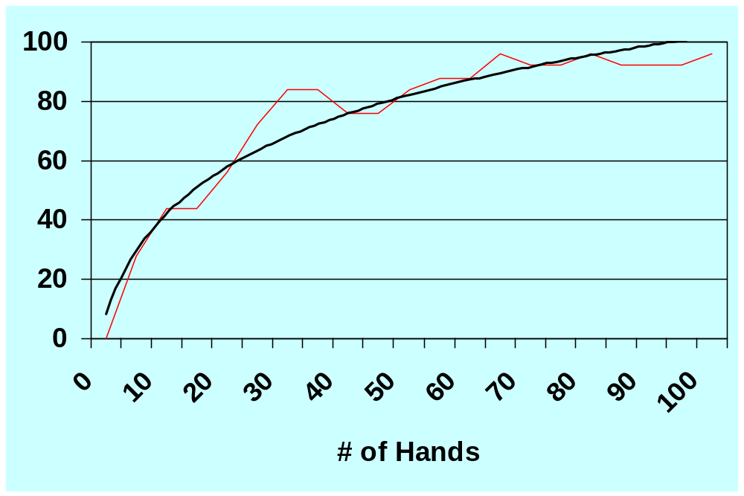The watcher was able to correctly approximate the tolerances of each player in a small number of hands on the average. Player identification percentages were taken after watching different amounts of hands starting at 5 and ranging all the way to 100 in increments of 5. Each amount of hands was run 100 times, keeping track of the percent correct guesses along the way. The red line shows the actual recorded data and the black line is the trend line of the recorded data.

The data shows that this system can correctly identify static tolerance players 85% of the time in as few as 35 hands. After seeing 60 or more hands, the system is 92% correct on the average. This means that at a table of 9 players, this system could correctly identify 8 of the players.

No independent tests were run specifically setting the closely related players at the table together. The tests were run 100 times at each number of hands watched (e.g. watching 10 hands and making guesses 100 times before moving up to watching 15 hands). Since the players were chosen at random, the pairing of these players most likely happened on a significant number of occasions. Because of this assumption, combined with the results around 60 hands or more, it is also assumed the system was able to tell the pairs apart at least half the time. More specific tests would need to be run to verify this.

Conclusion
This system attempts to opponent model by identifying player tolerances for every action available in a poker betting round. Using opponent modeling this system was able to correctly identify most players at a shorthanded table in as few as 35 hands. If the long run duration of these players is 200 hands, then this system would be able to make the most optimal move for 80% of the hands it plays in that duration.

When only watching a small number of hands (roughly 15 or less), often the system would return that all players were the same player. The player it chose was the player whose tolerances were set so that it would only begin the hand with pocket aces. This is due to the fact that often the watcher would not see any cards from a specific player for the duration of the test. Changing this to choose a more common opponent could produce better results.

This system does not handle changing player styles however, so the claim that it can win in the long run against player who change their style has not been addressed. This system has viable applications however, against new players specifically, who typically make decisions based on how good their hand is against all possible hands for a situation. Against such players, this system could them be modified, possibly using a mini-max search, to find the path leading to the largest payoff, which is the point of poker.

Future Research
Dynamic Tolerance Players. Static tolerance players were used in this project for simplicity and tested for the purpose of determining if the system could work. Creating players who tolerances change based on variables such as table position, tilt meter (winning or losing a large pot), number of players involved in the hand and pot size could make players act in a more realistic manner.

Player Agent. One of the next steps is to create a player that takes information derived by the watcher and use it in a minimax algorithm to determine the optimal way to proceed in the hand to achieve the highest expected value for each given hand.

Play Frequency Modifications. It could be possible to begin changing tolerances based on the average number of hands a player plays without the knowledge of seeing that players cards rather than assuming they only play aces preflop just because no cards were ever shown down from a particular player. This could help reduce the number of hands needed to identify tougher opponents.

Player Assumptions. A percent difference from a particular player could be set up to draw an assumption about who a particular player is before having complete information. This would provide a player agent to make more accurate/profitable plays after watching a smaller number of hands. This could also be useful to identify a player’s style in a substantially smaller number of hands than watching a particular move happen repeatedly. This could prove to be the biggest advancement in the system.

