Organic Campaign Content Package
Weeks 1–2 | August 31–September 13, 2026
Two website articles • Twelve social posts • Platform-ready image assets
Campaign direction: Protect What Matters → Know Before We Clean

Campaign window: August 31–September 13, 2026
Week 1 theme: Protect What Matters
Week 2 theme: Know Before We Clean
Brand promise: We protect what matters most.
Primary service area language: San Antonio, Boerne and New Braunfels
Primary CTA: Schedule online at https://www.aladdincleans.com/locations/schedule-online/ or call 210-736-1821.

Publishing Notes
- Use short sentences, clear language and active voice.
- Educate before asking for business.
- Do not add discounts, coupons, “specials,” lowest-price language or urgency tactics.
- Confirm links, phone number, service availability and operational details immediately before scheduling.
- Generated editorial images do not depict actual Aladdin employees or customers. Do not identify the people shown or pair them with a testimonial.
- Two assets use current Aladdin-owned website photography: September 7 and September 11.
- Sundays are reserved for comment response, FAQ capture and optimization. No public Sunday post is included.

WEBSITE ARTICLE 1

Why Trust Is Part of the Service—Not an Extra
Recommended publication date: Thursday, September 3, 2026
Suggested slug: /why-trust-is-part-of-property-care/
SEO title: Why Trust Matters in Home Property Care | Aladdin
Meta description: Before a property-care visit, know what builds trust: clear communication, trained professionals, careful preparation and accountable follow-through.
Primary keyword: trusted property care San Antonio
Secondary keywords: professional carpet cleaning San Antonio; local cleaning and restoration company; what to expect from carpet cleaning
Excerpt: Inviting a service professional into your home requires more than comparing equipment or prices. Here are the signs of a property-care company that respects your home, explains the work and earns your confidence.
Categories: Blog; Residential Services; Carpet Cleaning
Featured image: images-ready/04-sep03-trust-blog-featured.jpg
Featured image alt text: Property-care professional listening to a homeowner during a pre-service walkthrough in a bright San Antonio home.
When you schedule care for your carpet, rugs, upholstery or floors, you are making a decision about more than a surface.
You are deciding who will enter your home. Who will handle the things your family uses every day. Who will explain what they see, recommend a sensible plan and follow through on what they promise.
That is why trust is not an extra feature of professional property care. Trust is part of the service itself.

Trust Starts Before the Appointment
A professional experience should begin before a technician arrives at your door.
You should know who you are contacting, what the next step will be and how the company will communicate with you. A helpful team will ask about your concerns instead of jumping straight to a price or a one-size-fits-all answer.
They may ask:
- What surface or item needs attention?
- Are there spots, odors, wear or previous repairs?
- Are there pets, children or special scheduling needs in the home?
- Is the item valuable, handmade or sentimental?
- What result matters most to you?
These questions are not unnecessary delays. They help the company understand the property and prepare for a useful first conversation.

A Professional Visit Should Feel Clear and Respectful
Every home is different, but a trustworthy service visit usually includes the same basic habits.

1. A clear introduction
You should know who has arrived and why they are there. The technician should be prepared to listen before beginning the work.

2. A walkthrough
The technician should review the areas of concern with you. This is the time to point out a recurring spot, a delicate rug, a high-traffic path or anything else that may affect the care plan.

3. An explanation
Professional expertise should make the process easier to understand. You should hear what the technician recommends, why that approach fits the material and what expectations are realistic.

4. Protection for the home
Good preparation is visible. Depending on the service, that may include walk-off mats, corner guards, careful hose placement, furniture protection or other steps that help protect the surrounding space.

5. A final review
Before the visit ends, you should understand what was completed, how to care for the area afterward and whether any concern requires a different or additional solution.
These habits may appear simple. Together, they show respect for the customer, the home and the work.

Expertise Should Sound Like an Explanation
Customers should not have to become cleaning technicians before making a confident decision.
A knowledgeable professional can explain the difference between options in plain language. For example, Aladdin offers more than one carpet-cleaning method because different conditions call for different approaches. A heavily soiled carpet may call for a deep hot-water cleaning process, while a low-moisture encapsulation method may be appropriate in another setting.
The same principle becomes even more important with specialty rugs. Construction, fibers, dyes, condition and previous repairs can all affect how a rug should be evaluated and cared for.
Expertise is not about using the most technical words. It is about helping you understand the recommendation without pressure.

Five Questions to Ask Before You Book
You can learn a great deal about a property-care company by asking five straightforward questions.
1. How will you evaluate the material before beginning?
The answer should involve inspection and listening—not an automatic method.
2. Who will be working in my home?
Ask about training, certification and the company’s service standards.
3. How will you protect the surrounding space?
Preparation should be part of the process.
4. What should I expect during and after the service?
A professional should explain timing, access, drying or after-care considerations that apply to the job.
5. What happens if I have a concern afterward?
Accountability matters. You should know how feedback and follow-up are handled.
Save these questions before your next service call. The answers can help you compare more than price.

Local Experience Creates Accountability
Aladdin has served San Antonio and surrounding communities since 1956. Today, the company serves customers through locations in San Antonio, Boerne and New Braunfels and provides residential, commercial, rug-care and restoration services.
History alone does not earn trust. What matters is how that experience appears in today’s customer interaction: prepared people, clear recommendations, careful work and accountable follow-through.
That is the standard we work to protect on every visit.

Start With a Conversation
If you have a question about carpet, rugs, upholstery, floors or another part of your property, you do not need to diagnose the problem before calling.
Tell us what you are seeing. We will help you understand the next step.
Schedule an assessment online: https://www.aladdincleans.com/locations/schedule-online/
Call Aladdin: 210-736-1821

Recommended Internal Links
- About Aladdin: https://www.aladdincleans.com/about/
- Carpet cleaning: https://www.aladdincleans.com/residential-services/carpet-cleaning/
- Professional area rug cleaning: https://www.aladdincleans.com/oriental-rugs/rug-cleaning/
- Schedule online: https://www.aladdincleans.com/locations/schedule-online/

WEBSITE ARTICLE 2

One Cleaning Method Does Not Fit Every Surface
Recommended publication date: Thursday, September 10, 2026
Suggested slug: /why-cleaning-methods-depend-on-the-surface/
SEO title: Why Cleaning Methods Depend on the Surface | Aladdin
Meta description: Carpet, rugs, upholstery, wood, tile and stone need different care. Learn what professionals evaluate before recommending a cleaning method.
Primary keyword: professional cleaning methods San Antonio
Secondary keywords: carpet cleaning methods; professional area rug cleaning; upholstery and floor care; property-care assessment
Excerpt: The right care plan starts with the material—not the machine. Learn what a professional evaluates before recommending a method for carpet, rugs, upholstery, tile, stone or wood.
Categories: Blog; Residential Services; Carpet Cleaning; Oriental Rugs
Featured image: images-ready/10-sep10-method-blog-featured.jpg
Featured image alt text: Professional inspecting the transition between wall-to-wall carpet and a patterned area rug while a homeowner observes.
A carpet, a handwoven rug, an upholstered chair, a hardwood floor and a natural-stone surface may all collect soil and show wear.
That does not mean they should be cared for in the same way.
Professional property care begins by understanding the material in front of us. The right question is not, “Which machine do we use every time?” The right question is, “What does this surface need?”

The Material Comes Before the Method
Before recommending a cleaning approach, a trained professional considers several factors.

Material and construction
Carpet fibers behave differently from upholstery fabric. A machine-made area rug may require a different plan than a handmade or antique rug. Natural stone, sealed tile, hardwood and grout each respond differently to moisture, agitation and cleaning products.

Condition
Normal soil, a recurring spot, worn fibers, loose seams, dye instability, previous repairs and surface damage can change what is appropriate—and what result is realistic.

Use and location
A family room with pets and daily foot traffic has different priorities than a lightly used guest room or a commercial hallway. Access, furniture, ventilation and the way the space must remain in use can also affect the plan.

Moisture and drying needs
Some methods use more water for deep rinsing. Others are designed around lower moisture and faster drying. Specialty rugs may require controlled washing and drying outside the home.

The customer’s goal
Appearance may be the most visible concern, but it is not always the only one. Odor, a recurring spot, soil, texture, maintenance timing or preparation for a move may be part of the conversation.
The assessment brings these factors together.

Carpet: More Than One Professional Option
Aladdin offers different carpet-cleaning methods because carpet conditions and spaces vary.
Hot-water cleaning can provide a deep, restorative cleaning for heavily soiled carpet. The process uses hot water and a cleaning solution to flush the carpet fibers and extract soil.
Encapsulation cleaning is a lower-moisture approach that can be useful for sticky soils and situations where a faster-drying method is appropriate. The process surrounds soil particles so they can be removed from the carpet.
The recommendation should follow an analysis of the carpet—not a preference for using the same process everywhere.

Area and Oriental Rugs Need Specialty Judgment
An area rug is not simply a removable piece of carpet.
Its fibers, dyes, foundation, fringe, construction, age and previous repairs can affect the safest approach. Valuable or handmade rugs may also carry history and meaning that cannot be replaced.
Aladdin’s professional rug-care process begins with a detailed inspection. Rugs are then cared for in a controlled facility through steps that address dry soil, washing, rinsing, moisture removal, drying, grooming and final inspection.
Aladdin operates South Texas’ only fully automated rug-cleaning facility. The process is handled by trained rug-care specialists and is designed to give specialty rugs the controlled care they need.

Upholstery, Wood, Tile and Stone Have Their Own Rules
Upholstery fabrics vary in fiber, construction, color stability and manufacturer guidance. The material should be evaluated before moisture or a cleaning product is introduced.
Wood floors may show residue, wear or finish concerns that cannot be solved by treating the surface like tile.
Tile and grout can collect soil differently, while natural stone may be vulnerable to etching or other damage that looks like dirt but is not removed through ordinary cleaning.
This is why an experienced property-care company should be willing to say when a surface needs a different process, a repair or a more specialized evaluation.

What a Useful Assessment Should Cover
Before work begins, you should understand:
- What material or construction is being evaluated
- Which conditions may affect the result
- What method is recommended and why
- How the surrounding area will be protected
- What preparation is needed from you
- What timing, drying or after-care considerations apply
- Which expectations are realistic
You should also have the opportunity to point out previous treatments, recurring problems or anything particularly valuable or sensitive.

Questions Make the Care Plan Better
If you are not sure what type of carpet, rug, upholstery or floor you have, that is all right. You do not need to arrive with the technical answer.
Start with what you know:
- Where is the concern?
- When did you first notice it?
- Has anything already been used on the area?
- Is the item handmade, antique, repaired or especially valuable to you?
- How is the room or property used?
Those details help a professional choose the right next step.

Let the Surface Lead the Recommendation
The most professional answer is not always the fastest answer. It is the answer that respects the material, explains the reasoning and protects what matters to the customer.
If you would like help evaluating carpet, rugs, upholstery, tile, stone, wood or another part of your property, start with a conversation.
Schedule an assessment online: https://www.aladdincleans.com/locations/schedule-online/
Call Aladdin: 210-736-1821

Recommended Internal Links
- Carpet cleaning methods and process: https://www.aladdincleans.com/residential-services/carpet-cleaning/
- Professional area rug cleaning: https://www.aladdincleans.com/oriental-rugs/rug-cleaning/
- Upholstery cleaning: https://www.aladdincleans.com/residential-services/upholstery-cleaning/
- Tile and grout care: https://www.aladdincleans.com/residential-services/tile-grout-cleaning-repair-services/
- Schedule online: https://www.aladdincleans.com/locations/schedule-online/

SOCIAL CONTENT — WEEK 1

POST 1 — Monday, August 31
Theme: Five questions before booking property care
Channels: Facebook and Instagram
Format: Saveable carousel; supplied image serves as the cover
Asset: images-ready/01-aug31-trust-checklist-feed.jpg

Asset size: 1080 × 1350
Alt text: Homeowner greeting a professional property-care technician wearing shoe covers and holding a tablet at the front door.
Suggested cover overlay: 5 Questions to Ask Before You Book Property Care

Carousel Copy
1. How will you evaluate the material before beginning?
2. Who will be working in my home?
3. How will you protect the surrounding space?
4. What should I expect during and after the service?
5. What happens if I have a concern afterward?
Final slide: Compare more than price. Choose clear answers, careful preparation and accountable follow-through.

Facebook / Instagram Caption
Before you invite a company into your home, ask more than, “How much will it cost?”
Ask how the material will be evaluated. Ask who will arrive. Ask how the surrounding space will be protected. Ask what to expect after the work is complete.
Clear answers help you compare the people, process and care behind the price.
Save these five questions before your next property-care appointment—and send us the question you would add to the list.
#AladdinCleans #SanAntonioHomes #PropertyCare #CleaningExperts
CTA: Save the checklist and share a question.
Production note: Generated editorial image; do not identify the people shown as employees or customers.

POST 2 — Tuesday, September 1
Theme: Professional care begins before the equipment comes inside
Channels: Instagram Reel and Facebook
Format: 15–20 second Reel; supplied image is the cover
Asset: images-ready/02-sep01-professional-preparation-reel-cover.jpg
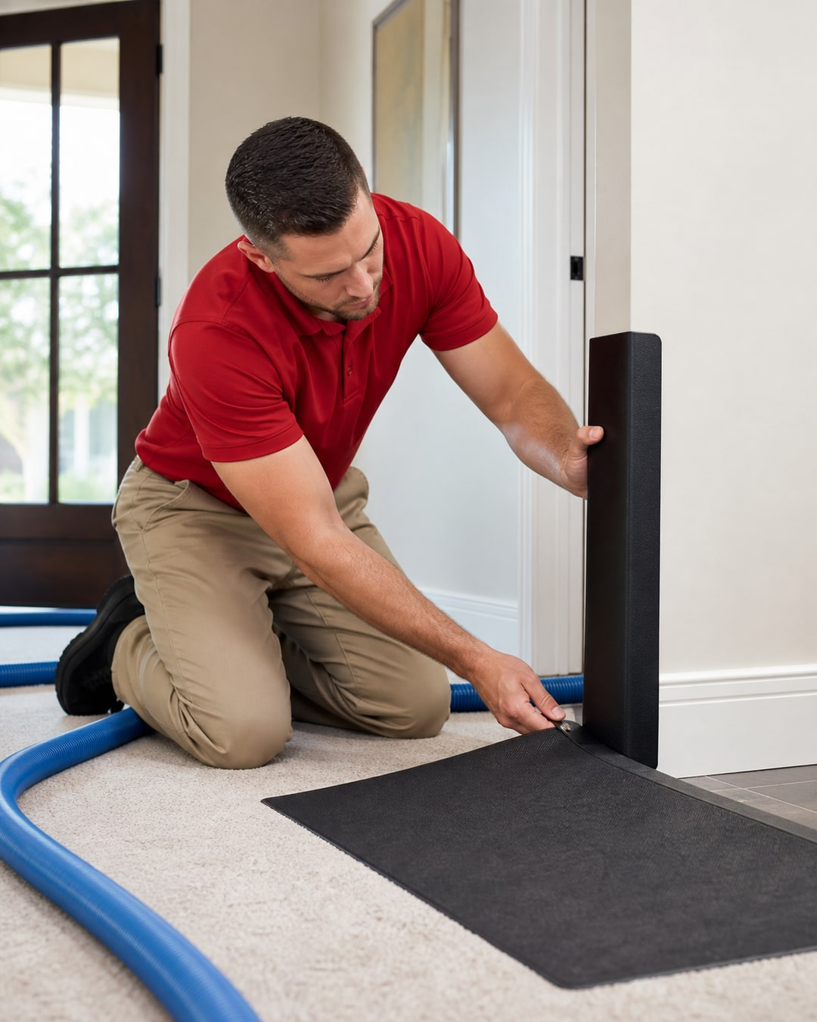
Asset size: 1080 × 1350
Alt text: Property-care technician carefully positioning a corner guard and walk-off mat before bringing a service hose into a home.
Suggested cover overlay: Professional Care Starts Before the Machine

Reel Shot List and On-Screen Copy
- 0–3 sec: Technician places walk-off mat. Protect the entry.
- 3–7 sec: Corner guard is positioned. Protect the home.
- 7–11 sec: Technician puts on shoe covers. Prepare with care.
- 11–15 sec: Walkthrough with homeowner. Explain the plan.
- 15–18 sec: Clean process detail. Then begin the work.

Caption
The service does not begin when the machine turns on.
It begins with preparation: listening to the customer, reviewing the space, protecting entryways and corners, and explaining what will happen next.
Those details are not extras. They are part of caring for the home.
What is one sign that tells you a service professional respects your property?
#AladdinCleans #ProfessionalCare #SanAntonioHomes #CustomerExperience
CTA: Comment with the service detail that matters most.
Production note: Film real Aladdin preparation steps for the Reel. Use the generated image only as the cover.

POST 3 — Wednesday, September 2
Theme: What earns your trust?
Channels: Instagram and Facebook Stories
Format: Question sticker; use the same background across the sequence
Asset: images-ready/03-sep02-trust-question-story.jpg
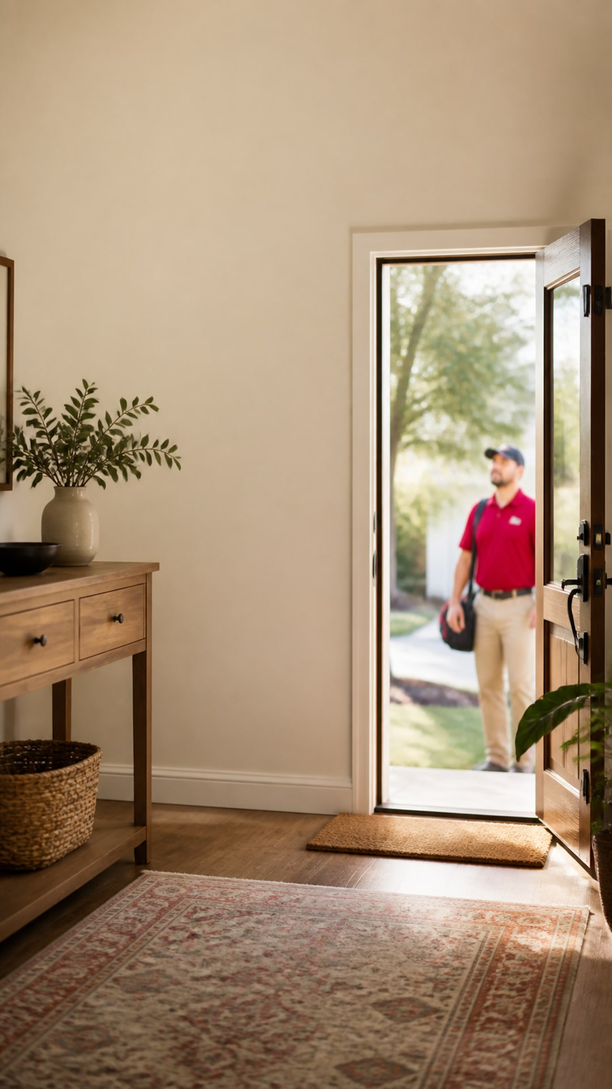
Asset size: 1080 × 1920
Alt text: Warm home entry with a professional service technician waiting outside the open door.

Story Sequence
- Frame 1 overlay: Inviting someone into your home requires trust.
- Frame 2 overlay: What matters most when you choose a property-care company?
- Sticker: Question box — Tell us what earns your trust.
- Frame 3 follow-up: Reshare common answers with We’re listening. We’ll answer the top themes this week.
CTA: Submit an answer.
Production note: Keep text inside the center safe zone and away from the technician at lower right.

POST 4 — Thursday, September 3
Theme: Website article launch — trust is part of the service
Channels: Facebook and LinkedIn
Format: Link post
Asset: images-ready/04-sep03-trust-blog-featured.jpg
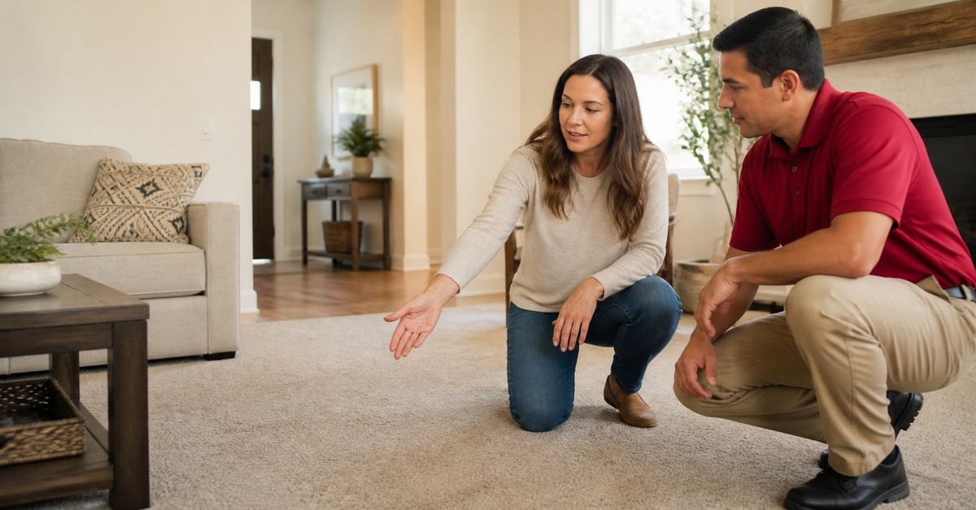
Asset size: 1200 × 628
Alt text: Property-care professional listening as a homeowner points out an area of carpet during a pre-service walkthrough.
Link: Publish article first, then replace with the live article URL.

Facebook Caption
When you schedule care for your home, you are choosing more than a cleaning method.
You are choosing who will enter the property, listen to your concerns, explain the recommendation and protect the surrounding space.
Our new guide covers five questions to ask before booking—and the professional habits that should be visible before, during and after a visit.
Read: Why Trust Is Part of the Service—Not an Extra
CTA: Read and save the five questions.

LinkedIn Caption
Trust is not a soft benefit in property care. It is an operating standard.
Clear communication, trained people, protection for the property, realistic expectations and accountable follow-through all shape the customer’s experience of the work.
We have outlined the questions homeowners and property managers can ask before choosing a service partner.
Read: Why Trust Is Part of the Service—Not an Extra
#CustomerExperience #PropertyCare #SanAntonioBusiness
Production note: Generated editorial image; do not identify the people shown as employees or customers.

POST 5 — Friday, September 4
Theme: Since 1956, one relationship at a time
Channels: Facebook, Instagram and Google Business Profile
Format: Photo story
Asset: images-ready/05-sep04-local-legacy-feed.jpg
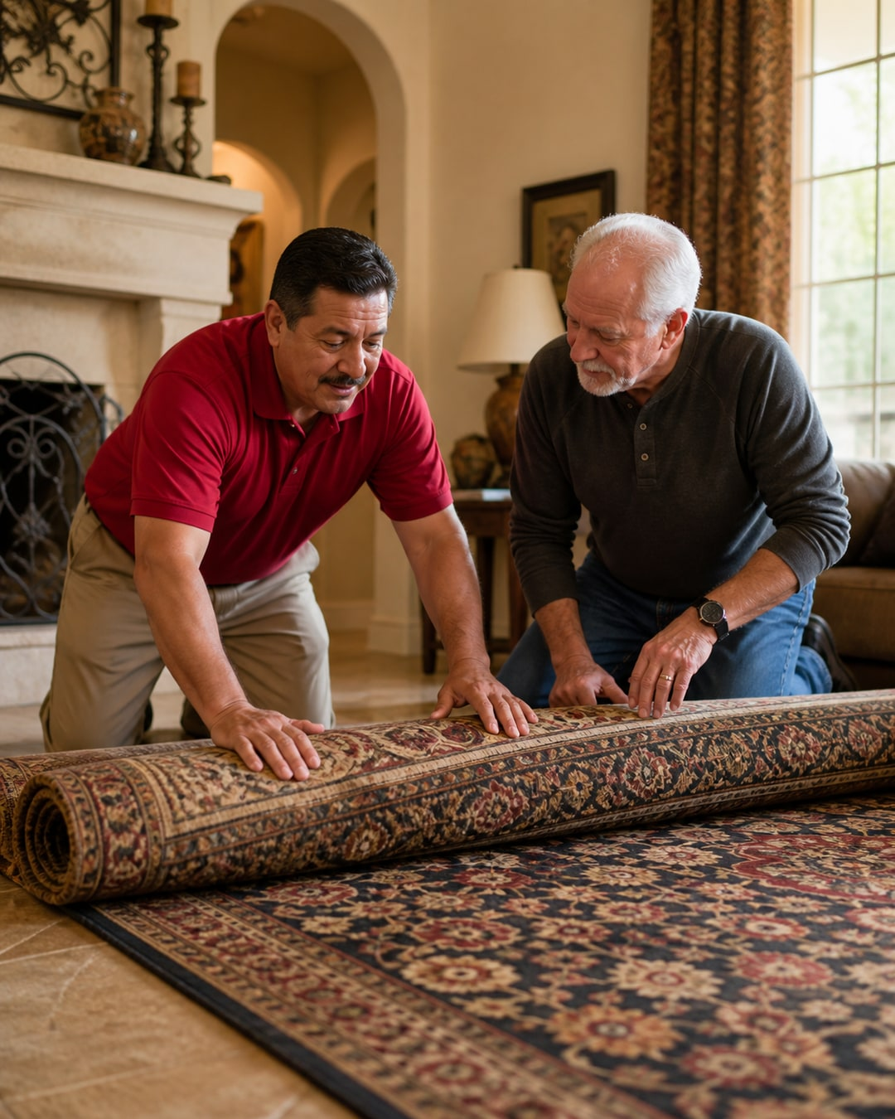
Asset size: 1080 × 1350
Alt text: Professional and homeowner carefully examining and rolling a patterned area rug together in a warm living room.
Suggested overlay: Serving Our Communities Since 1956

Facebook / Instagram Caption
Aladdin has served San Antonio and surrounding communities since 1956.
That history matters because it creates a responsibility: listen carefully, explain the work, respect the property and earn the relationship again on every visit.
Today, we serve homeowners and businesses in San Antonio, Boerne and New Braunfels with residential care, specialty rug services, commercial care and restoration support.
What does great local service look like to you?
#AladdinCleans #SanAntonio #Boerne #NewBraunfels #SupportLocal

Google Business Profile Caption
Serving San Antonio and surrounding communities since 1956 means earning trust one relationship at a time. Aladdin provides residential, commercial, specialty rug and restoration services from locations in San Antonio, Boerne and New Braunfels. Tell us what great local service means to you.
CTA: Join the conversation.
Production note: Generated editorial image. It is not a customer story or testimonial.

POST 6 — Saturday, September 5
Theme: Which service detail matters most?
Channels: Instagram Stories
Format: Two native poll frames
Asset: images-ready/06-sep05-experience-poll-story.jpg
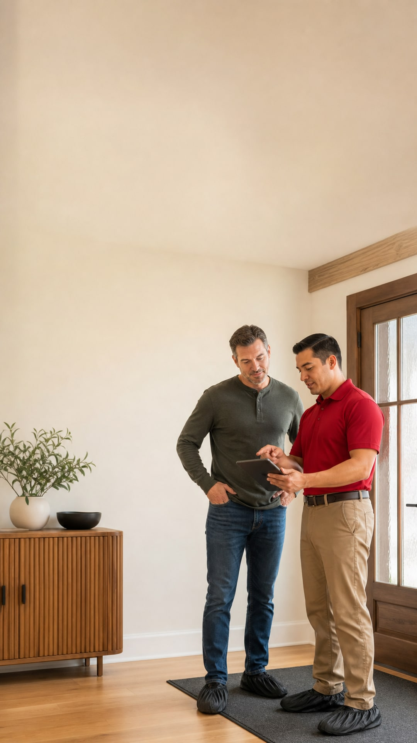
Asset size: 1080 × 1920
Alt text: Homeowner and property-care professional reviewing a plan on a tablet near a protected entryway.

Story Sequence
- Frame 1 overlay: Which builds more confidence before the work begins?
- Poll: A clear explanation / Careful preparation
- Frame 2 overlay: Which matters more after the visit?
- Poll: Helpful follow-up / Easy communication
- Frame 3 overlay: We’ll share what our community chose next week.
CTA: Vote in both polls.
Production note: Place poll stickers in the open upper portion of the image.

SOCIAL CONTENT — WEEK 2

POST 7 — Monday, September 7
Theme: Labor Day appreciation
Channels: Facebook, Instagram and Google Business Profile
Format: Facility and fleet photo
Asset: images-ready/07-sep07-labor-day-facility-and-fleet.jpg
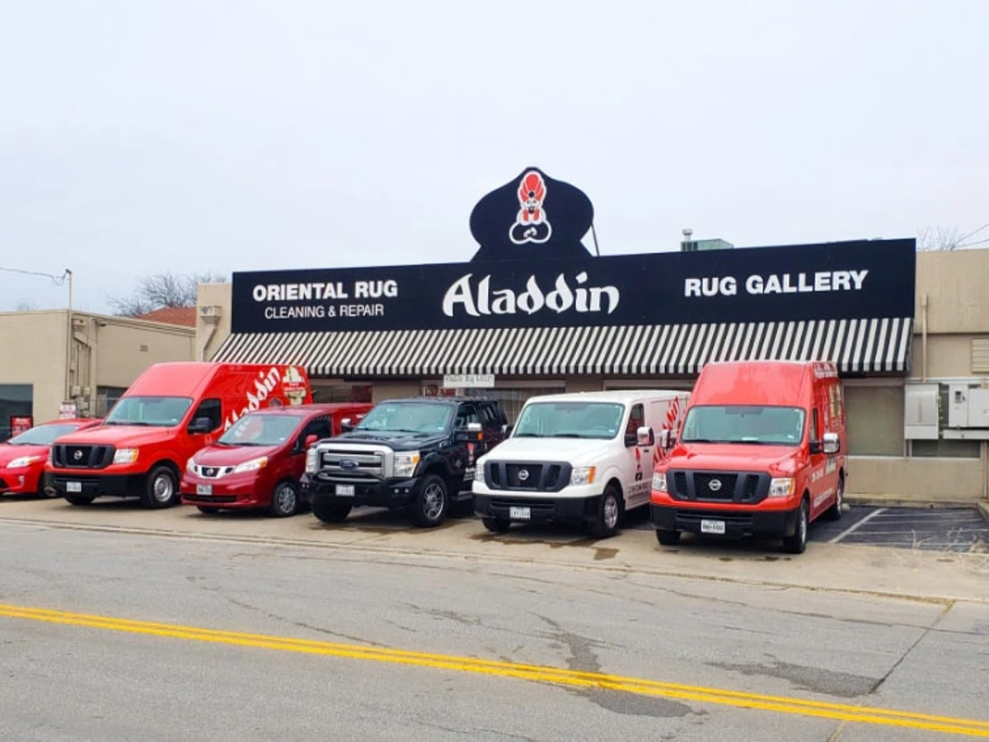
Asset size: 1200 × 900
Alt text: Aladdin Cleaning and Restoration facility and red, white and black service vehicles in San Antonio.

Caption
Today, we are grateful for the people behind the work.
The technicians who prepare carefully. The rug-care specialists who notice the small details. The customer-service team that keeps communication moving. The operations team that helps every visit stay on track.
Labor Day is a good moment to recognize the care, judgment and craftsmanship that cannot be reduced to a machine or a checklist.
Thank you to the Aladdin team—and to working people throughout San Antonio, Boerne and New Braunfels.
#LaborDay #AladdinCleans #SanAntonioBusiness #SkilledProfessionals
CTA: Join us in thanking the people behind the work.
Production note: This is an existing Aladdin website image, selected instead of an AI-generated staff image so the post does not depict fictitious employees.

POST 8 — Tuesday, September 8
Theme: The right method starts with an inspection
Channels: Instagram Reel and Facebook
Format: 15–20 second Reel; supplied image is the cover
Asset: images-ready/08-sep08-method-starts-with-inspection-reel-cover.jpg
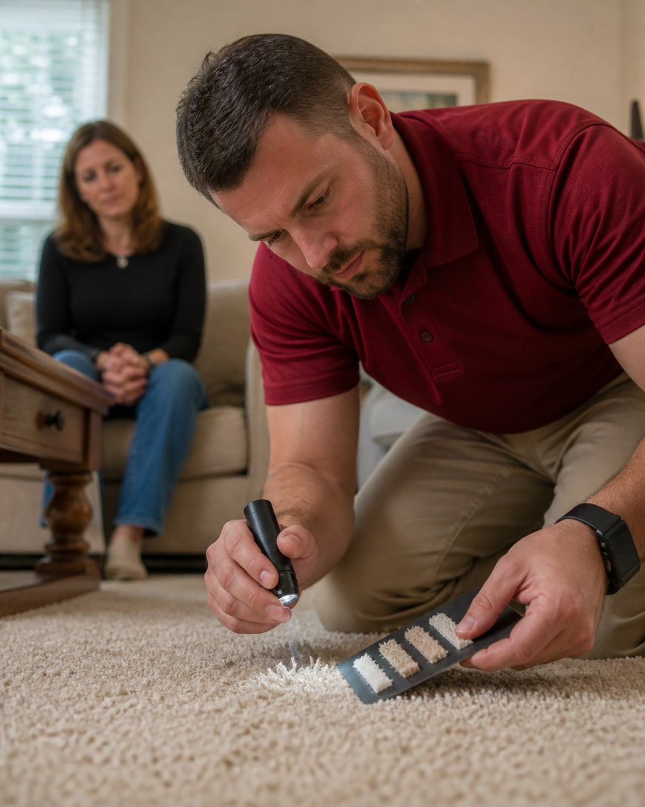
Asset size: 1080 × 1350
Alt text: Property-care professional closely inspecting carpet fibers with a light and fiber samples while a homeowner observes.
Suggested cover overlay: The Right Method Starts With an Inspection

Reel Shot List and On-Screen Copy
- 0–3 sec: Close-up of carpet or fabric. Start with the material.
- 3–7 sec: Technician inspects condition. Look at construction and wear.
- 7–11 sec: Customer points out concern. Listen to the history.
- 11–15 sec: Technician explains recommendation. Choose the method.
- 15–18 sec: Final detail. Then set clear expectations.

Caption
The right care plan starts with an inspection—not an assumption.
Material, construction, condition, previous treatments and the way a space is used can all affect the recommendation.
That is why a professional should be able to explain not only what method is recommended, but why it fits the surface in front of them.
What would you want explained before the work begins?
#AladdinCleans #CleaningExperts #PropertyCare #SanAntonioHomes
CTA: Ask what your technician will evaluate first.
Production note: Film a real Aladdin inspection for the Reel. Use the generated image as the cover.

POST 9 — Wednesday, September 9
Theme: What do you want explained before service?
Channels: Instagram and Facebook Stories
Format: Question sticker
Asset: images-ready/09-sep09-pre-service-question-story.jpg
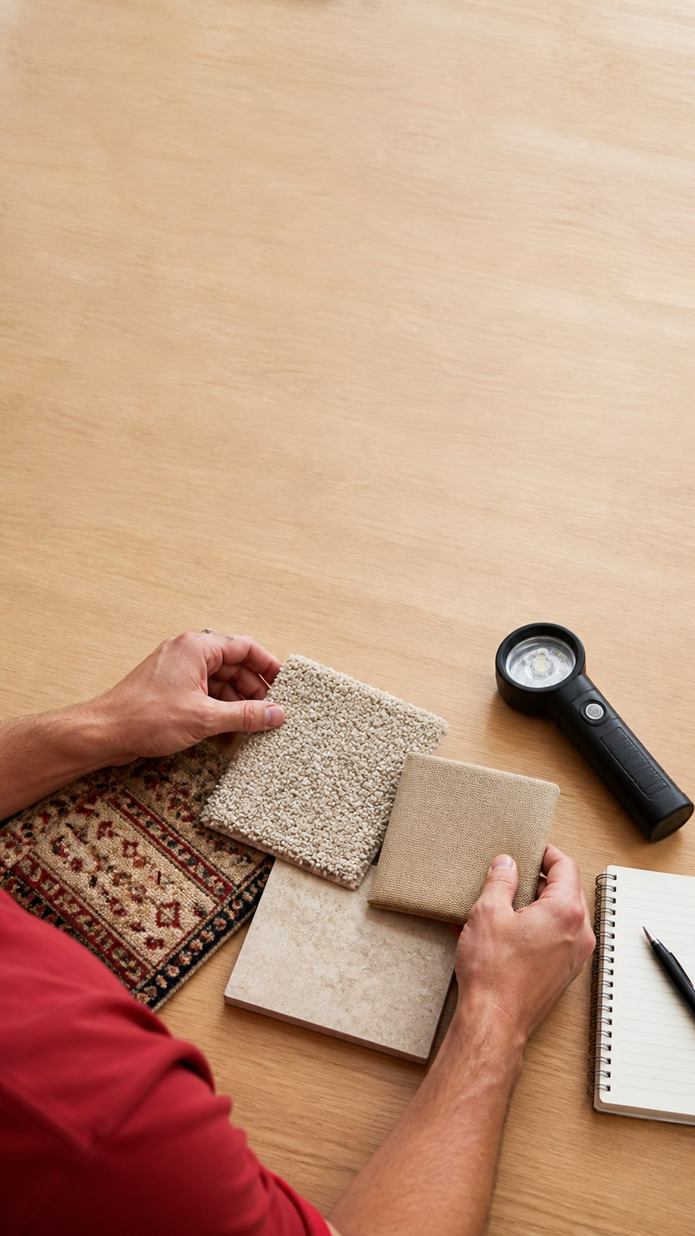
Asset size: 1080 × 1920
Alt text: Professional hands comparing samples of carpet, upholstery, rug and tile beside an inspection light and notebook.

Story Sequence
- Frame 1 overlay: A good recommendation should be understandable.
- Frame 2 overlay: What would you like explained before a service begins?
- Question sticker: Ask Aladdin
- Prompt ideas at bottom: Method • Drying • Pets • Furniture • Preparation
- Frame 3 follow-up: We’ll answer the most common questions in plain language.
CTA: Submit a question.
Production note: Use black or deep-red type in the open wood area; keep text away from the materials.

POST 10 — Thursday, September 10
Theme: Website article launch — one method does not fit every surface
Channels: Facebook and LinkedIn
Format: Link post
Asset: images-ready/10-sep10-method-blog-featured.jpg
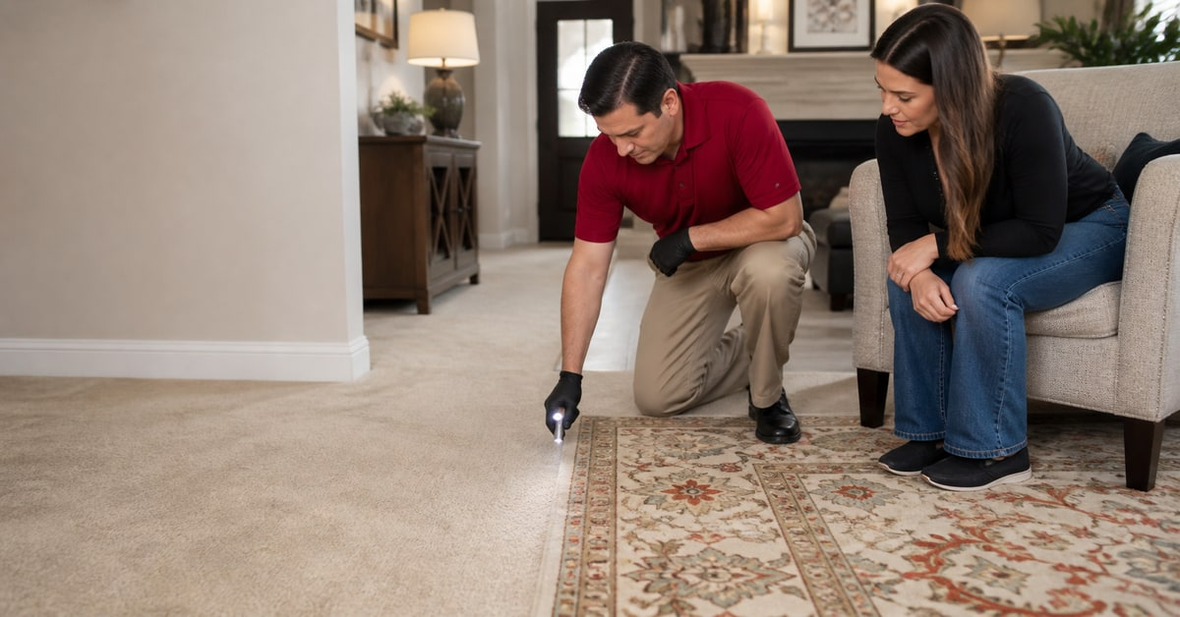
Asset size: 1200 × 628
Alt text: Professional examining the transition between wall-to-wall carpet and an area rug while a homeowner watches.
Link: Publish article first, then replace with the live article URL.

Facebook Caption
A carpet, an area rug, an upholstered chair and a stone floor may all need care—but they do not need the same care.
The material, construction, condition, use and drying needs should guide the recommendation.
Our new guide explains what a professional evaluates before selecting a method for carpet, rugs, upholstery, wood, tile or stone.
Read: One Cleaning Method Does Not Fit Every Surface
CTA: Read the guide and send us your surface-care question.

LinkedIn Caption
Process discipline begins with resisting the one-size-fits-all answer.
In residential and commercial property care, the material, condition, traffic, access and operational needs should guide the method. A useful recommendation explains those factors in plain language and sets realistic expectations.
Our latest guide outlines what an assessment should cover.
Read: One Cleaning Method Does Not Fit Every Surface
#PropertyManagement #CustomerExperience #ProfessionalServices
Production note: Generated editorial image; do not identify the people shown as employees or customers.

POST 11 — Friday, September 11
Theme: Proof needs context
Channels: Facebook, Instagram and Google Business Profile
Format: Process photo; future carousel can add a permissioned real before-and-after
Asset: images-ready/11-sep11-proof-needs-context-process-photo.jpg
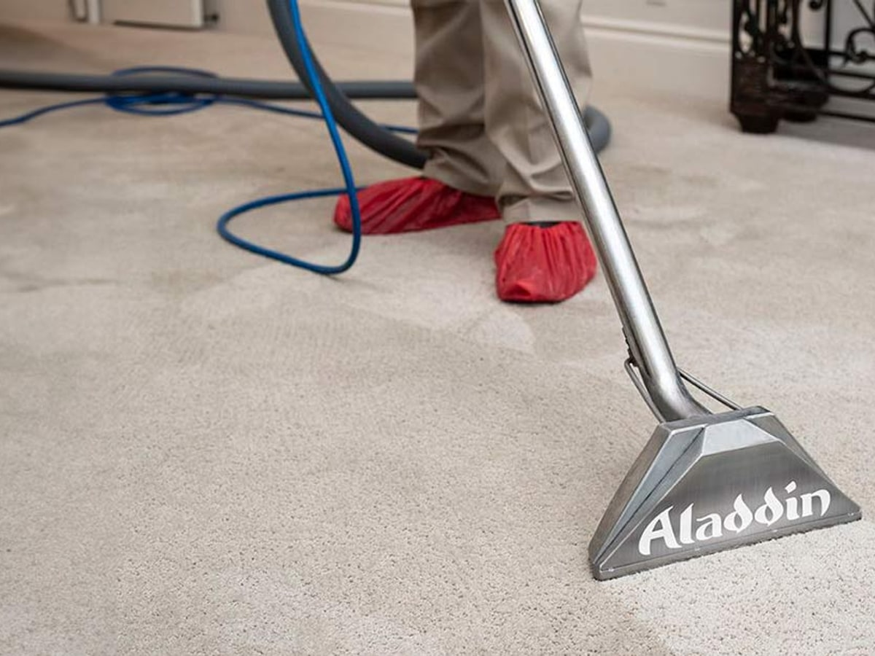
Asset size: 1200 × 900
Alt text: Aladdin carpet-cleaning extraction tool being used on neutral carpet while the technician protects footwear.
Suggested overlay: A Useful Result Includes the Why

Facebook / Instagram Caption
Before-and-after photos can be helpful—but only when you know what you are seeing.
A useful result includes context:
- What material was treated?
- What was the starting condition?
- Which method was selected, and why?
- What expectations were discussed?
- Was the customer’s permission confirmed?
Professional proof should help customers understand the process. It should not promise that every surface or condition will respond in exactly the same way.
Have a similar concern? Start with an evaluation and a conversation about what may be possible.
#AladdinCleans #ProfessionalCare #CleaningProcess #SanAntonioHomes

Google Business Profile Caption
A good before-and-after needs context. Material, starting condition, method and realistic expectations all matter. Aladdin’s certified cleaning specialists evaluate the surface and recommend appropriate options before the work begins. Have a concern? Start with an assessment.
CTA: Ask what may be possible for your property.
Production note: This is an existing Aladdin website process image. Add a real, permissioned before-and-after only when the job details and customer approval are available.

POST 12 — Saturday, September 12
Theme: Choose the next Ask Aladdin topic
Channels: Instagram Stories
Format: Poll / quiz sequence
Asset: images-ready/12-sep12-ask-aladdin-topic-poll-story.jpg
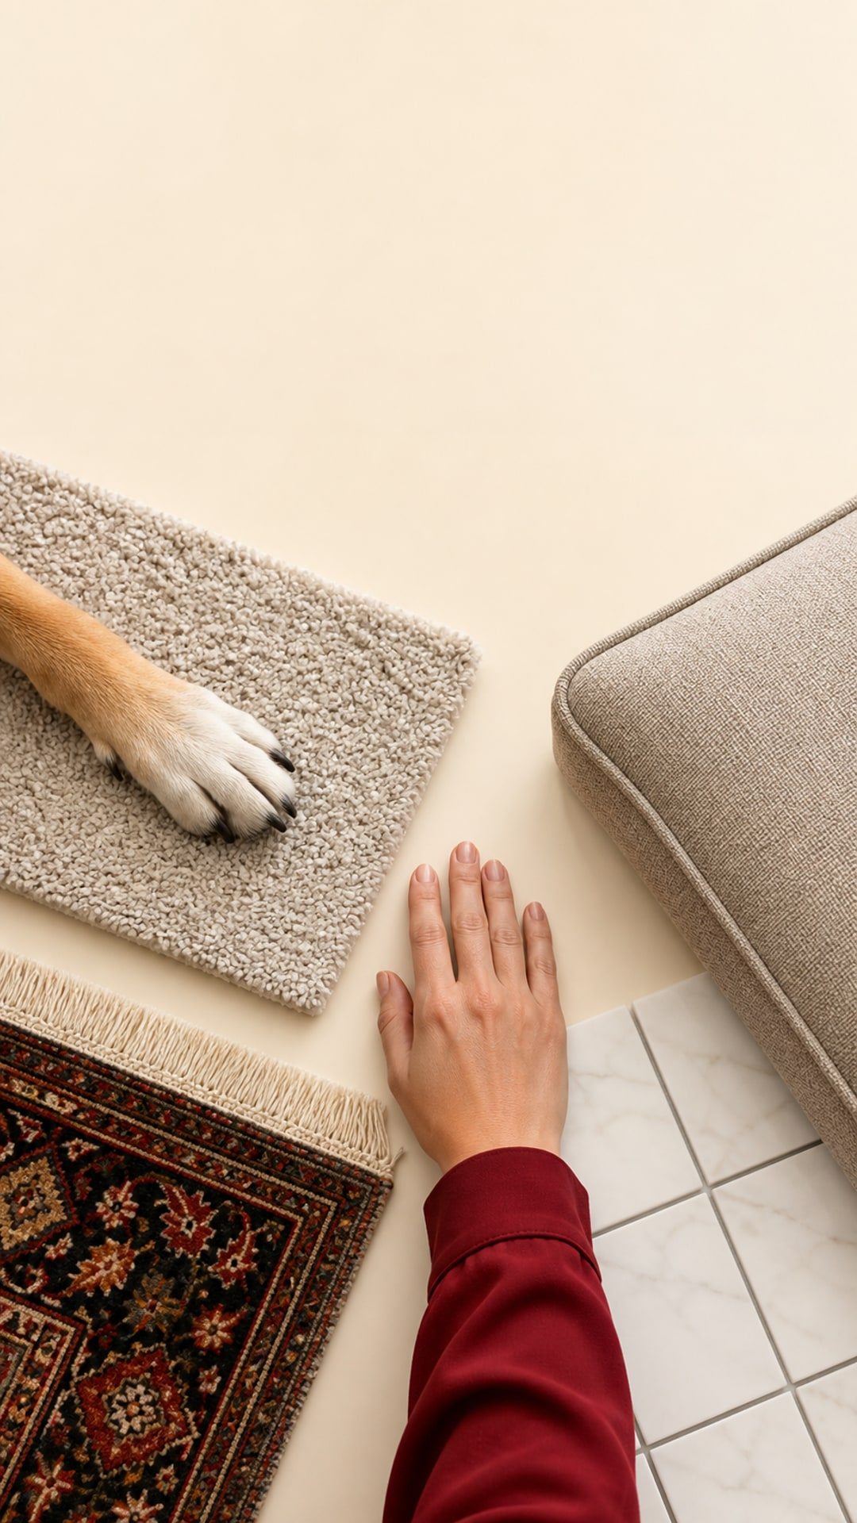
Asset size: 1080 × 1920
Alt text: Overhead arrangement of a pet paw on carpet, upholstery, a patterned rug and tile surrounding a professional’s hand.

Story Sequence
- Frame 1 overlay: Which topic should Ask Aladdin answer next?
- Poll 1: Pet accidents / Upholstery care
- Frame 2: Reuse image with a tighter crop.
- Poll 2: Rug spills / Tile & grout
- Frame 3 overlay: We’ll build the winning topic into an upcoming expert post.
CTA: Vote in both rounds.
Production note: Keep stickers in the open upper area. Do not add service or health claims to the visual.

COMMUNITY MANAGEMENT — BOTH SUNDAYS

Sunday, September 6
- Reply to every substantive comment and Story response.
- Record the words customers use when describing trust.
- Reshare the strongest Week 1 item to Stories.
- Identify one unanswered question for Week 2.

Sunday, September 13
- Answer remaining method and material questions without diagnosing from photos.
- Route active service needs to the confirmed phone or scheduling page.
- Compare saves, shares, replies and link clicks across both weeks.
- Repurpose the strongest educational idea in Week 3.

FINAL PRE-PUBLISH CHECK
Before publishing each item, confirm:
1. Does it build trust?
2. Does it demonstrate expertise through useful explanation?
3. Does it reinforce a professional customer experience?
4. Does it position Aladdin as a complete property-care expert?
5. Does it sound like an experienced, respected local company?
6. Are every claim, link, service, date, phone number and image permission current?
7. Does any generated person risk being mistaken for a named employee, customer or testimonial source?

