The user opens the application to a new game.

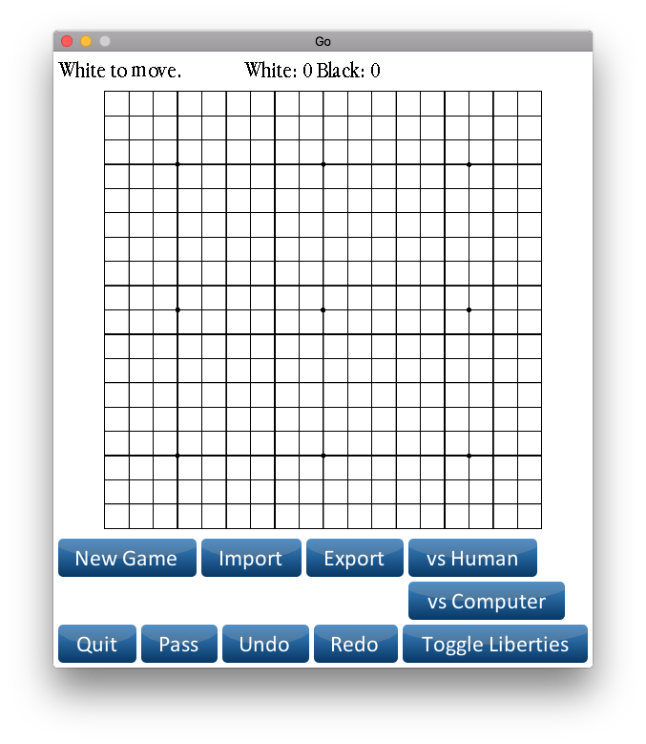

Two humans can play each other to get to this state.

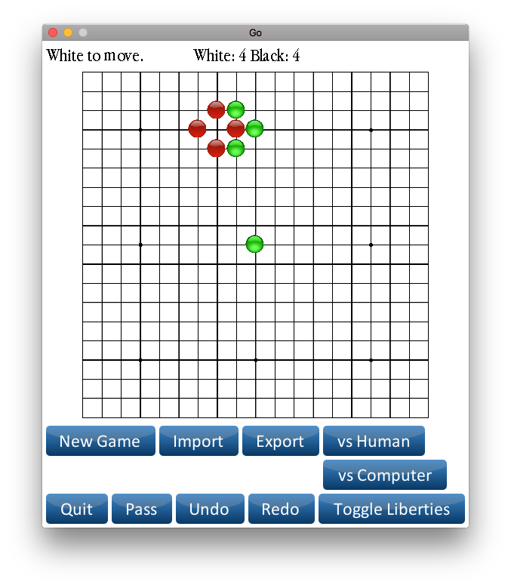

The opponent can then take the other player’s piece.

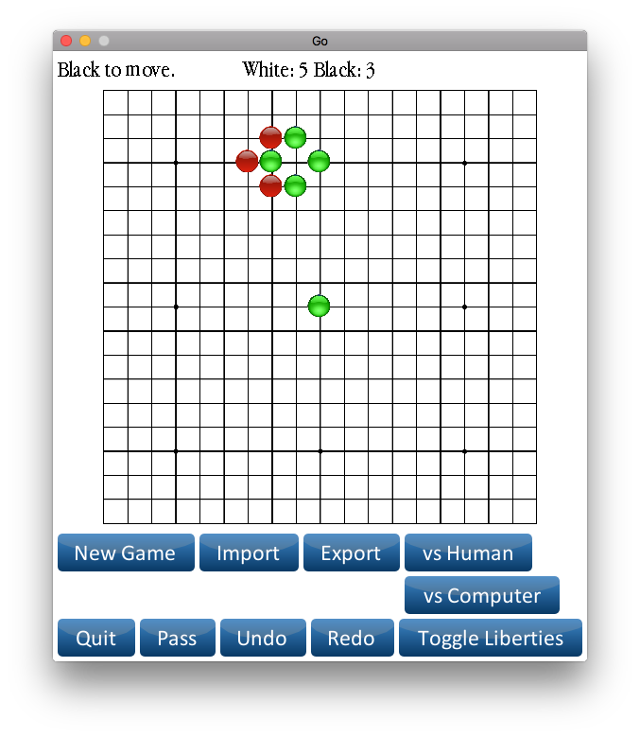

The user can undo the previous move and redo if needed.

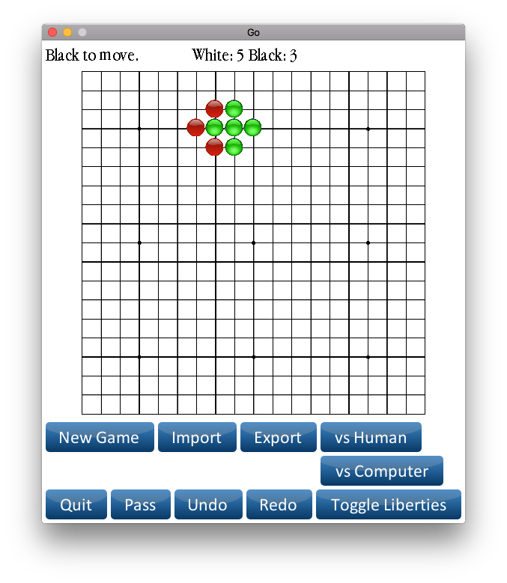

The user can toggle liberties to examine the board.

