Suicide Rates in New Zealand

Exploring associations with social
and economic factors

Report 2: Social Explanations for Suicide in New Zealand

Authors:
Dr Stuart Ferguson

Associate Professor Tony Blakely and Bridget Allan, Department of Public Health, Wellington School of Medicine and Health Sciences, University of Otago, New Zealand

Dr Sunny Collings, Department of Psychological Medicine, Wellington School of Medicine and Health Sciences, University of Otago, New Zealand

Published in December 2005 by the
Ministry of Health
PO Box 5013, Wellington, New Zealand
ISBN 0-478-29657-6 (Book)
ISBN 0-47828381-4 (Internet)
HP 4114
This document is available on the Ministry of Health’s website:
http://www.moh.govt.nz


Preface

Social and epidemiological explanations for New Zealand’s suicide trends to 1999
This paper is one of a suite of six reports that the Ministry of Health commissioned from the Wellington School of Medicine and Health Services between 2001 and 2004. The suite of reports, explore a range of possible social and epidemiological explanations, analyses and evidence about New Zealand’s suicide trends . Due to a three-year time lag in coroner statistics being available, most of the reports address suicide trends up to 1999.

National suicide prevention strategy
The suite of reports aims to inform discussion on the New Zealand’s proposed national suicide prevention strategy: A Life Worth Living: New Zealand Suicide Prevention Strategy.

Report no. | Topic | Author/s | Title
1 | Literature review (2002) | Caroline Maskill  Ian Hodges  Velma McLellan  Dr Sunny Collings | Explaining Patterns of Suicide: A selective review of studies examining social, economic, cultural and other population-level influences
2 | Review of routine data (2002) | Stuart Ferguson  Assc Prof Tony Blakely  Bridget Allan  Dr Sunny Collings | Suicide Rates in New Zealand: Exploring associations with social and economic factors
3 | Māori (2004) | Dr Paul Hirini  Dr Sunny Collings | Whakamomori: He whakaaro, he korero noa. A collection of contemporary views on Māori and suicide
4 | New Zealand–Finland comparison (2003) | Assc Prof Philippa Howden-Chapman  Dr Simon Hales  Dr Ralph Chapman  Dr Ilmo Keskimaki | The Impact of Economic Recession on Youth Suicide: A comparison of New Zealand and Finland
5 | Data analysis from the New Zealand Census–Mortality Study (2004) | Dr Sunny Collings  Assc Prof Tony Blakely  June Atkinson  Jackie Fawcett | Suicide Trends and Social Factors in New Zealand 1981–1999: Analyses from the New Zealand Census-Mortality Study
6 | Summary of reports 1–5 (2004) | Dr Sunny Collings  Assc Prof Annette Beautrais | Suicide Prevention in New Zealand: A contemporary perspective

Acknowledgements

The project as a whole was overseen by a multidisciplinary advisory group whose members also contributed directly to the development of this study: Dr Rees Tapsell, Associate Professor Philippa Howden-Chapman, Associate Professor Annette Beautrais, and Mr Don Smith.

Disclaimer

This report was prepared under contract to the New Zealand Ministry of Health. The copyright in this report is owned by the Crown and administered by the Ministry. The views of the authors do not necessarily represent the views or policy of the New Zealand Ministry of Health. The Ministry makes no warranty, express or implied, nor assumes any liability or responsibility for use of or reliance on the contents of this report.

A similar version of this report was published by the Department of Public Health, Wellington School of Medicine and Health Services in August 2003, ISBN 0-473-09821-0.

Contents
Preface iii
Acknowledgements iv
Disclaimer iv
Executive Summary viii
Introduction 1
Objectives and methodology of report 1
1 Gender 3
Key trends and observations 3
2 Age Group 8
Key trends and observations 8
3 Ethnicity 11
Key trends and observations 12
4 Marital Status 15
Key trends and observations 15
5 Unemployment 17
Key trends and observations 17
6 Spatial Factors 19
Key trends and observations 19
7 Labour-Force Participation 22
Key trends and observations 22
8 The Economic Business Cycle 24
Key trends and observations 24
9 Income Inequality 28
Key trends and observations 28
10 Availability of Means to Commit Suicide 30
Key trends and observations 30
11 Crime, Violence and Homicide 32
Key trends and observations 32
12 Fertility 35
Key trends and observations 35
13 Immigration 36
Key trends and observations 36

List of Tables
Table 1.1: Comparison of New Zealand’s age-standardised suicide rate (per 100,000 population) with selected OECD countries, by sex, 1995 7
Table 2.1: Comparison of New Zealand’s age-specific suicide rates with selected other OECD countries, 1995 10
Table 3.1: Comparison between specific ethnic groups and the rest of the population, New Zealand and selected other countries 13
Table 6.1: Age-standardised suicide rates for District Health Boards (DHBs), pooled rates, 1988−99 20
Table 10.1: Percentage of suicides using four common methods, 1977 and 1996 31
Table 11.1: Rate of recorded offences, by category, 1994−2001 33

List of Figures
Figure 1.1: Age-standardised rates of suicide in New Zealand, by sex, 1948−99 3
Figure 1.2: Age-specific rates of suicide, 15−24-year-olds, by sex, 1949−98 4
Figure 1.3: Age-specific rates of suicide, 25−44-year-olds, by sex, 1949−98 5
Figure 1.4: Age-specific rates of suicide, 45−64-year-olds, by sex, 1949−98 5
Figure 1.5: Age-specific rates of suicide, aged 65+ years, by sex, 1949−98 6
Figure 2.1: Age-specific rates of suicide, 15−24, 25−44, 45−64 and 65+ years, 1949−98 8
Figure 2.2: Age-specific rates of suicide, 15−19, 20−29 and 30−39-year-olds, 1949−98 9
Figure 2.3: Comparison of New Zealand’s age-specific suicide rates with those of Finland and Germany, 1995 10
Figure 3.1: Suicide rates, by ethnicity, 1978−99 11
Figure 3.2: Māori age-standardised rates of suicide, by sex, 1978−98 12
Figure 3.3: Age-specific rates of suicide, 15−29-year-olds, by ethnicity, 1978−99 13
Figure 4.1: New Zealand marriage rate and suicide rate, 1980−99 15
Figure 4.2: Scatter plot of selected OECD countries: suicide rate and divorce rates, 1995 16
Figure 5.1: Unemployment rate and age-standardised suicide rate, by sex, 1951−99 17
Figure 5.2: Unemployment rate and age-specific suicide rate, 15−24 and 25−34-year-olds, 1986−99 18
Figure 6.1: Age-standardised suicide rates for District Health Boards (DHBs), pooled rates, 1988−99 19
Figure 7.1: Labour-force participation rate (LFPR) and suicide rates, by sex, 1951−99 22
Figure 8.1: Gross domestic product (GDP) per capita and age-standardised suicide rate, 1955−98 24
Figure 8.2: Gross domestic product (GDP) per capita and suicide rate, 15−24 and 25−44-year-old age groups, 1955−98 25
Figure 8.3: Gross domestic product (GDP) per capita and Māori age-standardised suicide rate, 1988−99 26
Figure 8.4: Percentage change in gross domestic product (GDP) per capita and age-specific suicide rate, 25−44 and 45−64-year-old age groups, 1957−97 27
Figure 9.1: Two ratios of income inequality (50/10 and 75/25) and age-standardised suicide rate, 1982−98 28
Figure 9.2: Ratio of income inequality (75/25) and age-specific suicide rates (15−24 and 25−44-year-olds), 1982−98 29
Figure 9.3: Ratio of income inequality (75/25) and age-specific suicide rates (45−64-year-olds and 65+), 1982−98 29
Figure 10.1: Suicide by hanging, males and females, 1977−96 30
Figure 11.1: Overall rate of offences and age-standardised suicide rate, 1970−2001 32
Figure 11.2: Overall rate of offences and age-specific suicide rate, 15−24-year–olds, 1970−99 33
Figure 11.3: Scatter plot of selected OECD countries: suicide rates and prisoner rates, 1995 34
Figure 12.1: Total fertility rate and age-standardised suicide rate, 1962−99 35
Figure 13.1: Rate of long-term inward migration and age-standardised suicide rates, by sex, 1979−99 36

Executive Summary
This report provides a condensed overview of New Zealand data of social and economic factors that might be associated with suicide trends 1948–1999. Due to a three-year time lag in coroner statistics being available, this report contains suicide data up to 1999.

Overall, two conclusions can be drawn from this report.
- The dramatic variation in trends of age-specific suicide rates over time in New Zealand, and between countries, raises the possibility of social factors as important drivers of suicide rates. Put another way, it is difficult to see how individual-level risk factors (eg, psychiatric illness) could vary sufficiently rapidly over time (especially 1970s–1990s) to give rise to such rapidly changing suicide rates.
- There are possible associations of some social indicators (eg, fluctuations in gross domestic product, unemployment rates) with suicide rates. However, these associations are not statistically significant at the 95 percent level.

Introduction

Objectives and methodology of report
The objective of this report is to provide a condensed overview of patterns, trends and differences in social factors that might be associated with suicide. These include differences over time, between countries and regions, and across demographic categories.

A selective review of the sociological literature in the first report in this suite generated a number of factors with possible associations with suicide (Maskill et al 2005). Where routine data of adequate quality were readily available for these factors, a descriptive analysis was done.

Table of sources
The following table lists the variables suggested by the Report 1 selective literature review and either the main source of data we used for the analysis or the reason the variable was omitted from the series of analyses.

Variables suggested in selective literature review (Report 1) | Main data source used/reason for not using variable
Gender | New Zealand Health Information Service
Age and the life-cycle | New Zealand Health Information Service
Ethnic minority and indigenous groups | New Zealand Health Information Service
Household composition | Statistics New Zealand
Fertility | Statistics New Zealand
Spatial factors | New Zealand Health Information Service
Migration | Statistics New Zealand
Education | Analysed using New Zealand Census−Mortality Study data and reported in Collings et al 2005 (Report 5 in this suite)
Religion | Insufficient data to generate an adequate time series
Income inequality | M Mowbray, Distribution and Disparity: New Zealand household incomes, Ministry of Social Policy, Wellington, 2001
Specific occupations | Insufficient data
Unemployment | Statistics New Zealand
Labour-force participation | Statistics New Zealand
Economic cycles | Statistics New Zealand
Availability of suicide methods | New Zealand Health Information Service
Temporal, seasonal and climatic factors | Data not readily available
War and political events | Insufficient data
Crime, homicide and violence | New Zealand Police Service
Quality and availability of mental health services | Substandard quality of available data

All figures presented relating to suicide rates are based on data obtained from the New Zealand Health Information Service (NZHIS). The sources of other data are noted below each figure and/or in the notes at the end of the report. Unless otherwise noted, all figures present New Zealand-specific data.

Timeframes and associations of data
This report was prepared in 2002. At that time the available data on suicide in New Zealand extended from 1948 to 1999. The 1999 data was the most recent available. Obviously it would be preferable to have the most recent data to add to the data series, but at the time of printing this would only have brought us up to 2002. However, given that the purpose of this report was to examine in a descriptive way the long-term patterns of association between social factors and suicide rates, we think there is still considerable value in presenting this material.

Note that this report only describes apparent associations between variables. Such associations do not necessarily represent causality, but they do suggest possible worthwhile areas for further enquiry. The primary objective of this report is not to rigorously analyse the validity of any particular association using statistical, time-series analyses and other methodologies. Rather, and as stated above, the objective is to provide a rapid overview of patterns, trends and differences in social factors that might be associated with suicide.

Limited statistical tests
We have used visual plots to provide this overview. We have not attempted to rigorously test and probe any associations suggested in this report. That said, we have elected to present a few basic statistical tests in some chapters. These statistical tests are of time-series data and tend to be under-powered due to the absence of very long periods of data, during which suicide rates fall and rise many times and social conditions wax and wane. Most of the times-series analyses are for 40 to 50 years – the equivalent of conducting statistical tests on a sample size of 40 to 50 observations. Therefore, these tests must be interpreted cautiously as they may not be statistically significant when indeed there was an underlying association to a 90 percent level. . Note that if we had been able to use the suicide data up until 2002 (the two extra years of data available at the time of printing), the effect of the increase in sample size on statistical power would have been very small.

1 Gender
In most developed countries, males tend to have higher rates of suicide than females. New Zealand data shows that the male rate of suicide increased rapidly during the 1980s, largely due to an increase in suicide by young males. During the 1990s this increase levelled off, although New Zealand still has one of the highest male suicide rates in the OECD, and rates in the
25−44-year-old cohort were still increasing in the late 1990s. The male:female suicide ratio in New Zealand started decreasing in the 1990s because of an increased use of more lethal methods by women.

Figure 1.1: Age-standardised rates of suicide in New Zealand, by sex, 1948−99
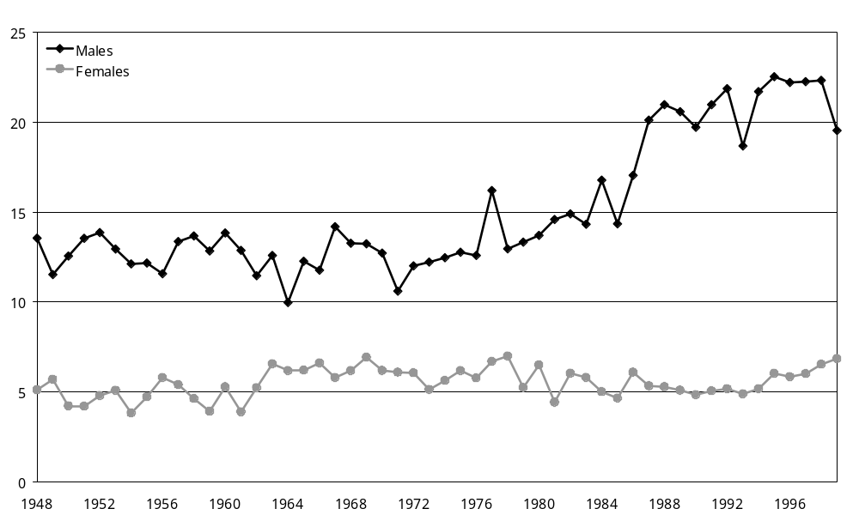
Note: Rates are standardised to the Segi world population.

Key trends and observations
- The overall rate of suicide for males has been increasing since the 1970s while the rate for females has stayed reasonably constant.
- Male suicide rates are higher than female suicide rates in all age groups (Figures 1.2 to 1.5).
- The ratio between the male rate and the female rate changes with time and with age group. Among youth, the male:female ratio increased in New Zealand due to a rapid increase in male suicide rates from the mid-1970s, although it has reduced somewhat since the early 1990s. Conversely, the male:female ratio among 45−64-year-olds has been relatively stable over the last 50 years. The overall male:female ratio has reduced in the 1990s, however, as younger females choose increasingly more lethal methods by which to attempt suicide.
- New Zealand’s suicide rates do not compare favourably with other OECD countries. The female and overall rates are roughly in the middle of the OECD range but the male rate is among the highest of the selected OECD countries (Table 1.1). Note that a comparison of age-standardised rates between countries obscures marked differences between age groups (see next chapter).

Figure 1.2: Age-specific rates of suicide, 15−24-year-olds, by sex, 1949−98
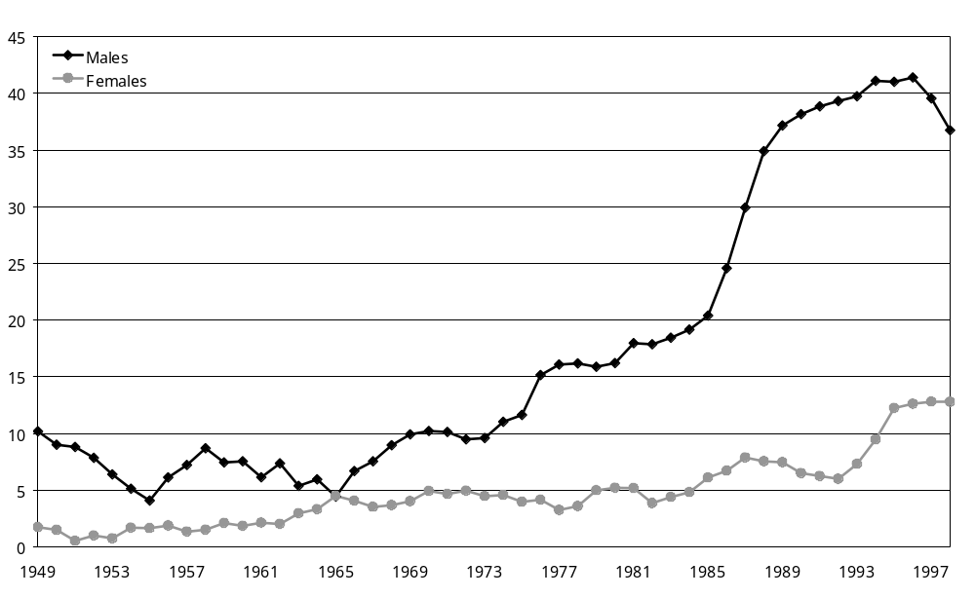
Note: The three-year smoothed rate is used for the age-specific rate.

Figure 1.3: Age-specific rates of suicide, 25−44-year-olds, by sex, 1949−98
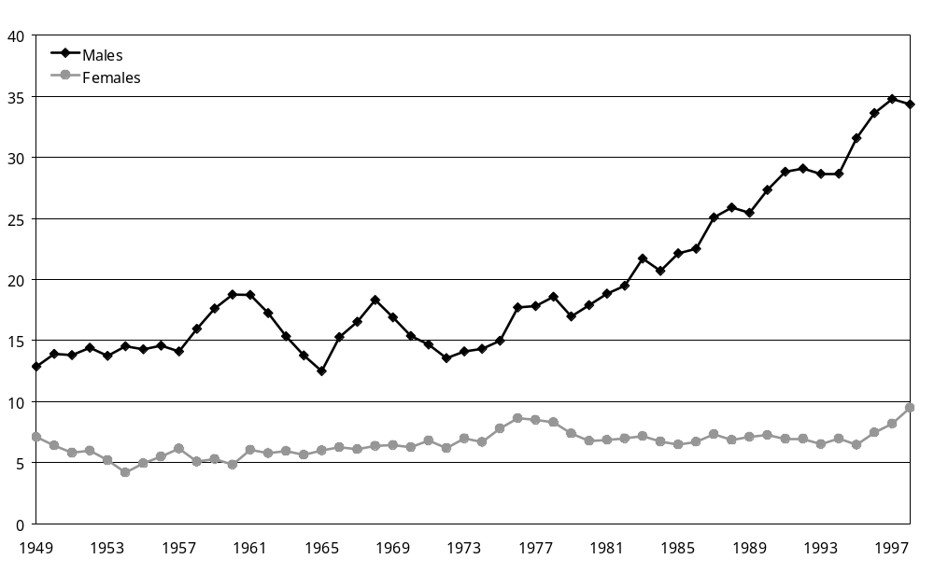
Note: The three-year smoothed rate is used for the age-specific rate.

Figure 1.4: Age-specific rates of suicide, 45−64-year-olds, by sex, 1949−98
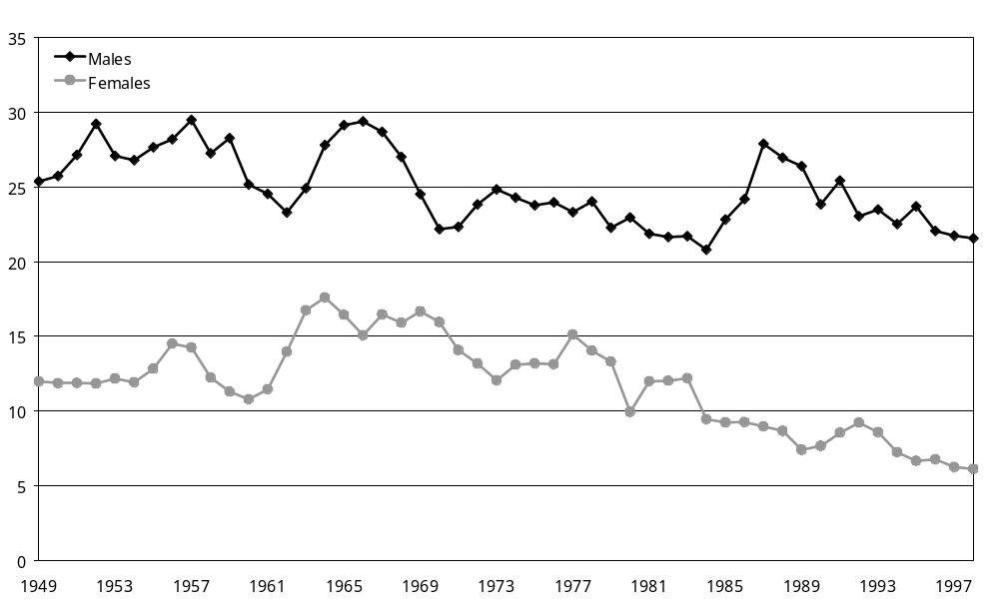
Note: The three-year smoothed rate is used for the age-specific rate.

Figure 1.5: Age-specific rates of suicide, aged 65+ years, by sex, 1949−98
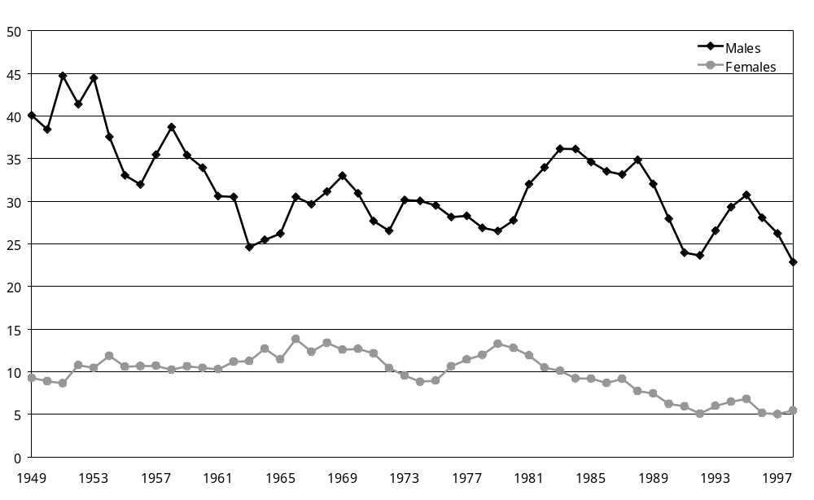
Note: The three-year smoothed rate is used for the age-specific rate.
General source: New Zealand Health Information Service (NZHIS)

Table 1.1: Comparison of New Zealand’s age-standardised suicide rate (per 100,000 population) with selected OECD countries, by sex, 1995
 | Suicide rate (per 100,000 population)
 | Males | Females | Total
Finland | 43.4 | 11.8 | 27.2
Austria | 34.2 | 11.0 | 22.2
France | 30.4 | 10.8 | 20.6
Denmark | 24.2 | 11.2 | 17.7
Japan | 23.4 | 11.3 | 17.4
Germany | 23.2 | 8.7 | 16.0
New Zealand | 24.3 | 6.4 | 15.4
Sweden | 21.5 | 9.2 | 15.4
Poland | 24.3 | 4.7 | 14.3
Canada | 21.5 | 5.4 | 13.5
Australia | 19.0 | 5.1 | 12.1
United States | 19.8 | 4.4 | 11.9
Ireland | 17.9 | 4.6 | 11.3
Korea | 14.5 | 6.7 | 10.6
Netherlands | 13.1 | 6.5 | 9.8
Portugal | 12.2 | 4.4 | 8.3
Spain | 12.5 | 3.7 | 8.1
Greece | 5.9 | 1.2 | 3.6
Source: World Health Organization, 2001 Mental health project on suicide prevention. Live Your Life. Data available on: http://www.who.int/mental_health/Topic_Suicide/suicide1.html.

2 Age Group
In most developed countries suicide rates peak for men in old age and in women during late old age. New Zealand suicide rates, however, do not follow this pattern. Since the 1980s New Zealand has consistently had one of the highest youth suicide rates (especially for young males) in the OECD.

Figure 2.1: Age-specific rates of suicide, 15−24, 25−44, 45−64 and 65+ years, 1949−98
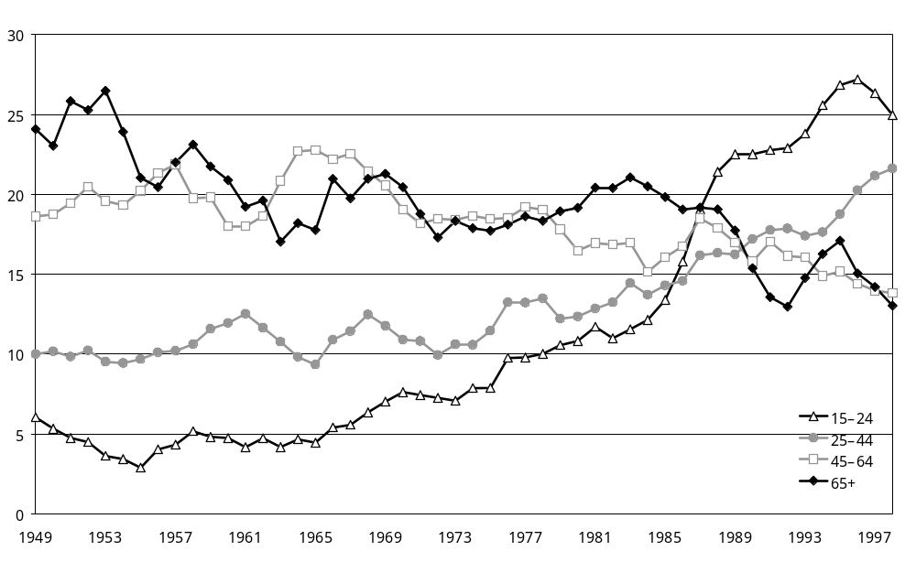
Note: The three-year smoothed rate is used for the age-specific rate.

Key trends and observations
- Prior to the mid-1970s, suicide rates were higher in older adults. In the mid-1980s there was a cross-over and in the 1990s younger people had higher suicide rates (Figures 2.1 and 2.2).
- Conventional categories of age used in routine reports (eg, 15−24, 25−44, 45−64 and 65-plus years, as shown in Figure 2.1) hide the fact that the highest suicide rates during the 1990s occurred among 20−29-year-olds (Figure 2.2). Suicide rates among 15−19 and 30−39-year-olds were also high during the 1990s (Figure 2.2).
- There has been an alarming increase in the rates of suicide among 15−29-year-olds in the last 20 years. While suicide rates for 30−39-year-olds have approximately doubled over the last 50 years, suicide rates for both 15−19 and 20−29-year-olds have increased more rapidly and overtaken those for 30−39-year-olds. These increases are mainly driven by a dramatic increase in the suicide rates of males in those age groups (Figures 1.2 and 1.3). Youth suicide rates began to fall in 1996. Provisional data for 2000 (not presented in this report) suggests a continued downturn in youth suicide.
- In contrast to the rate for younger people, the male and female suicide rates for older adults (45−64 and 65-plus age groups) have been decreasing in the last 20 years (Figures 1.4 and 1.5). The rate of this decrease has been similar for both males and females.
- New Zealand’s age-specific suicide rates in 1995 were consistently higher than those for most other OECD countries in the younger age groups (5−14, 15−24 and 25−34 years) and average for the older age groups. In New Zealand, age-specific suicide rates were highest in the younger age groups; in most other countries the rates were highest in the middle to older age groups (Table 2.1). This difference can be clearly seen in Figure 2.3 comparing New Zealand with Finland and Germany.

Figure 2.2: Age-specific rates of suicide, 15−19, 20−29 and 30−39-year-olds, 1949−98
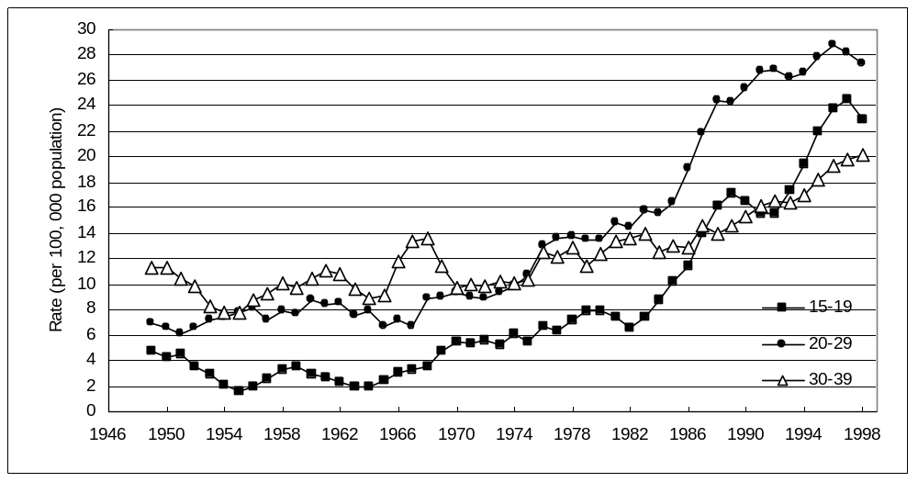

Note: The three-year smoothed rate is used for the age-specific rate.
General source: NZHIS

Table 2.1: Comparison of New Zealand’s age-specific suicide rates with selected other OECD countries, 1995
 | Suicide rate (per 100,000 population)
 | 5−14 | 15−24 | 25−34 | 35−44 | 45−54 | 55−64 | 65−74 | 75+
Finland | 0.6 | 22.8 | 33.0 | 44.0 | 43.4 | 43.8 | 28.1 | 23.3
Austria | 0.8 | 15.0 | 20.8 | 25.2 | 27.9 | 28.9 | 33.2 | 57.1
Germany | 0.1 | 4.7 | 9.4 | 15.8 | 28.8 | 32.6 | 34.4 | 45.9
Sweden | 0.4 | 9.4 | 13.8 | 21.0 | 23.0 | 20.9 | 19.4 | 27.0
New Zealand | 1.1 | 28.7 | 21.0 | 16.2 | 17.5 | 13.9 | 17.5 | 16.4
Canada | 1.1 | 15.0 | 18.0 | 19.2 | 18.5 | 15.1 | 12.1 | 12.2
Australia | 0.2 | 14.6 | 18.7 | 15.9 | 14.7 | 13.7 | 11.8 | 16.0
Netherlands | 0.3 | 6.8 | 10.6 | 14.2 | 12.7 | 12.9 | 14.0 | 15.1
Portugal | 0.2 | 4.4 | 6.8 | 6.2 | 10.3 | 11.9 | 16.9 | 23.1
Poland | 1.1 | 9.9 | 15.1 | 22.9 | 25.2 | 21.6 | 17.8 | 14.9
United Kingdom | 0.1 | 6.7 | 10.6 | 11.4 | 9.3 | 7.9 | 7.5 | 9.2
Greece | 0.0 | 2.6 | 4.4 | 3.6 | 4.3 | 4.2 | 4.8 | 8.2
Note: The table is sorted by overall national suicide rates for 1995.
Source: World Health Organization, 2001 Mental health project on suicide prevention. Live Your Life. Data available on: http://www.who.int/mental_health/Topic_Suicide/suicide1.html.

Figure 2.3: Comparison of New Zealand’s age-specific suicide rates with those of Finland and Germany, 1995
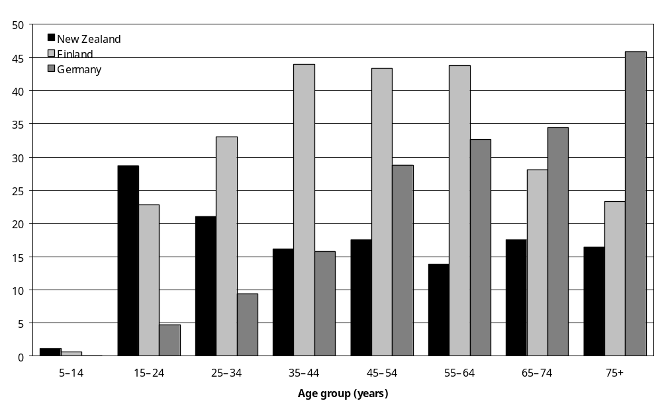
Source: World Health Organization, 2001 Mental health project on suicide prevention. Live Your Life. Data available on: http://www.who.int/mental_health/Topic_Suicide/suicide1.html.

3 Ethnicity
Indigenous populations tend to have higher suicide rates than non-indigenous populations. The steep rise in young indigenous people’s suicide rates, particularly in countries such as Canada, the USA, Australia and New Zealand, has paralleled the general increase in youth suicide rates that these countries have experienced over recent decades. In general, male suicide rates exceed those of females, although exceptions have been found in some developing countries.

There are major problems in accurately enumerating Māori and Pacific mortality rates. This inaccuracy is due to different recording of ethnicity in mortality and census data sets. The linkage of census and mortality data in the New Zealand Census−Mortality Study (NZCMS) allows correction for this numerator−denominator bias. All suicide rates by ethnicity presented in this section use NZCMS adjustment factors to correct for numerator−denominator bias.

New Zealand data shows that the Māori suicide rate was similar to the non-Māori rate up till the mid-1990s, after which the Māori rate was greater. As with the general population, Māori male suicide rates are consistently higher than Māori female rates.

Figure 3.1: Suicide rates, by ethnicity, 1978−99
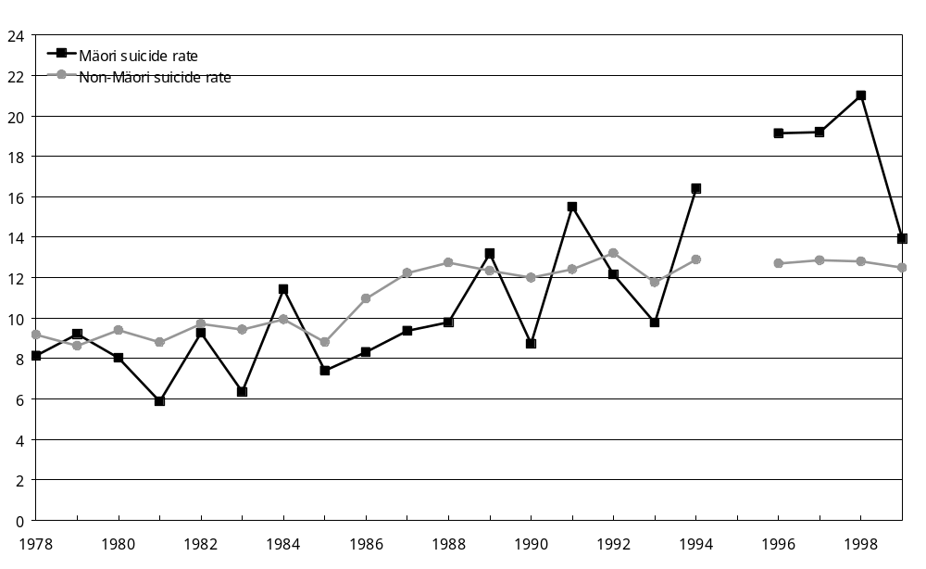
Notes: Rates are standardised to the Segi world population. The Māori and non-Māori rates are adjusted for misclassification of Māori deaths (also known as numerator−denominator bias) based on findings from the New Zealand Census−Mortality Study.
General source: NZHIS

Key trends and observations
- The Māori suicide rate was similar to the non-Māori rate up until the mid-1990s, after which the Māori rate was greater (Figure 3.1). This pattern is similar for both males and females.
- As with the general population, Māori male suicide rates are consistently higher than female rates. Both male and female rates have been increasing in the last 20 years although they appear to be falling in the late 1990s (Figure 3.2).
- The higher suicide rate of Māori compared to non-Māori since the 1990s is mainly due to particularly high suicide rates among 15−29-year-old Māori (see Figure 3.3).
- The higher suicide rate for New Zealand’s indigenous population (Māori) compared to the non-indigenous population is similar to the relationship between indigenous groups and the rest of the population in Australia and the USA (Table 3.1).

Figure 3.2: Māori age-standardised rates of suicide, by sex, 1978−98
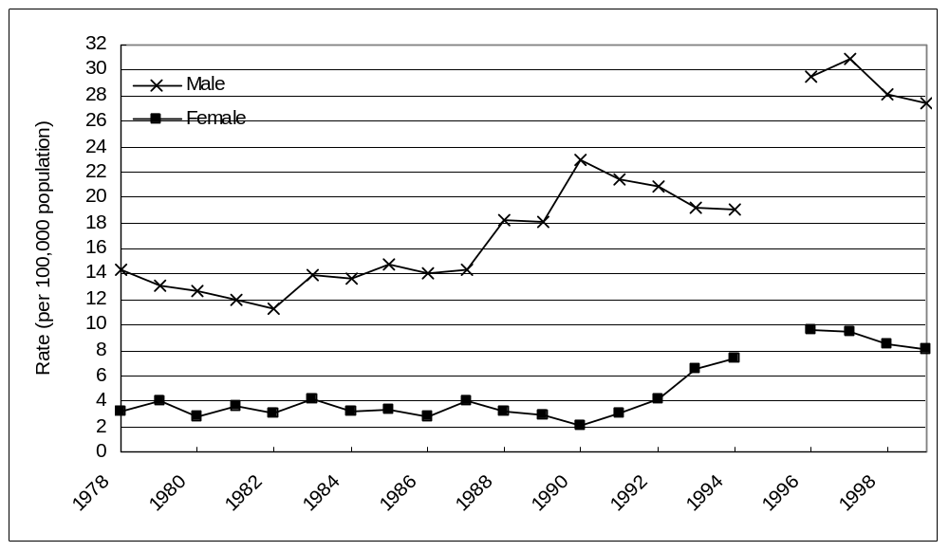
Notes: Rates are adjusted three-year smoothed rates, standardised to the Segi world population. The Māori and non-Māori rates are adjusted for misclassification of Māori deaths (also known as numerator−denominator bias) based on findings from the NZCMS.

Figure 3.3: Age-specific rates of suicide, 15−29-year-olds, by ethnicity, 1978−99
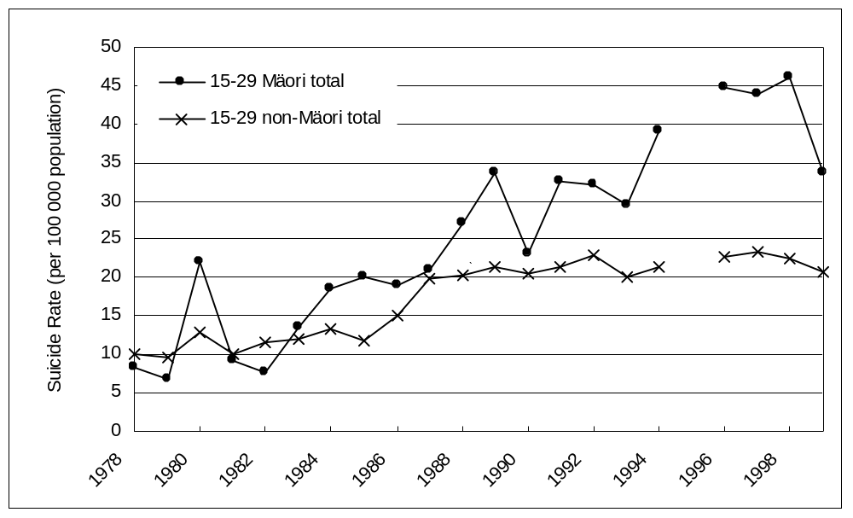

Note: Rates standardised to the Segi world population and adjusted for numerator−denominator bias.
General source: NZHIS

Table 3.1: Comparison between specific ethnic groups and the rest of the population, New Zealand and selected other countries
Country and ethnic group | Suicide rate (per 100,000)
Country and ethnic group | 1994 | 1995 | 1996
New Zealand
Māori | 16.4 | – | 19.1
Non-Māori | 12.9 | – | 12.7
United States of Americaª
Hispanic | 7.2 | 7.2 | 6.7
Black | 7.1 | 6.9 | 6.6
American Indians and Alaska native | 14.2 | 12.2 | 13.0
All Americans | 11.2 | 11.2 | 10.8
Australia^{b}
Aboriginal | – | 15.0 | –
Non-Aboriginal | – | 12.2 | –
Notes:
a Age-adjusted death rates. Source: Center for Disease Control, National Center for Health Statistics: Health, United States, 1998. www.cdc.gov/nchs/hus.htm
b Rates are calculated from South Australia, Western Australia and Northern Territory states only. Rates shown are age standardised using the 1991 Australian population. Source: Australian Bureau of Statistics. Aboriginal rates are likely to be underestimated due to numerator−denominator bias.

General note
Given that the under-reporting of indigenous people’s suicides appears to be a universal problem, the discrepancy between indigenous and non-indigenous suicide rates is likely to be even greater than suggested. In this report we have adjusted for the undercounting of Māori suicide deaths using adjustment ratios from the New Zealand Census−Mortality Study, which anonymously and probabilistically links census and mortality records.

4 Marital Status
Much research has shown that marital status is strongly associated with suicide at the level of individuals. Data on suicide rates by marital status over time is not available. The NZCMS allows times-series comparison of suicide rates by marital status. These analyses are presented in Report 5 of this suite of reports (Collings et al 2005).

All that can be presented in this report are basic comparisons of suicide rates by trends in marital status. Interpretation of the comparisons in this section should therefore be guarded.

Figure 4.1: New Zealand marriage rate and suicide rate, 1980−99
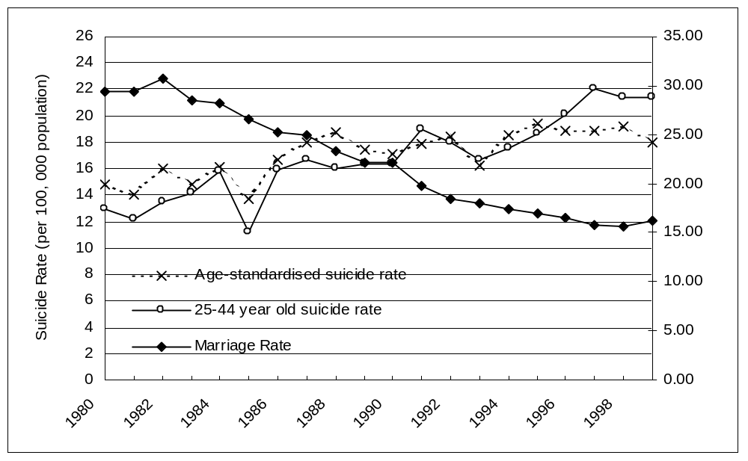
Notes: Marriage rate is per 1000 mean not-married population aged 16 years and over. The proportion of adult population married would be a more appropriate measure, but insufficient data was available for such a comparison. Suicide rate is standardised to 2001 population age-specific suicide rate, and for 25−44-year-olds.

Key trends and observations
- Over the last 20 years the overall marriage rate has been decreasing while the divorce rate has been gradually increasing. The combination of these factors has led to a gradual decrease in the percentage of adults who are married (from 56.1 percent in 1986 to 52.1 percent in 1996).
- Overall, there does not appear to be a strong trend for changes in the marriage rate to be related to changes in the overall suicide rate (Figure 4.1).
- Looking at OECD countries in 1995 there appears to be an association, with higher divorce rates being related to higher rates of suicide (Figure 4.2).
- The causal importance of these associations is unclear.
Figure 4.2: Scatter plot of selected OECD countries: suicide rate and divorce rates, 1995
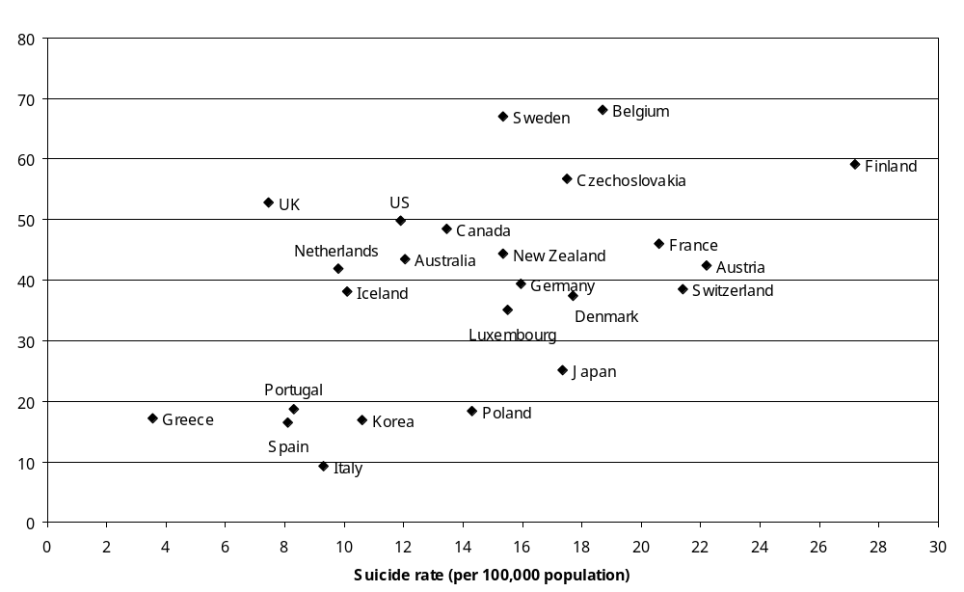
General sources: Statistics New Zealand.
The majority of the data was obtained from: EUROSTAT, NewCronos Database, 2000.
Additional sources:
Australia: Australian Bureau of Statistics, Australian Social Trends, 2000 and Australian Bureau of Statistics Yearbook, 2000.
Japan: National Institute of Population and Social Security Research, Vital Statistics, 2000.
Korea: Annual Report on Vital Statistics, National Statistical Office, Republic of Korea, 1998.
United States: US Census Bureau, Statistical Abstract of the United States, 1999.

5 Unemployment
Ecological studies have generally identified weak correlations between unemployment and suicide. In New Zealand, the increase in unemployment in the late 1980s and early 1990s coincided with rapidly increasing youth suicide rates.

Figure 5.1: Unemployment rate and age-standardised suicide rate, by sex, 1951−99
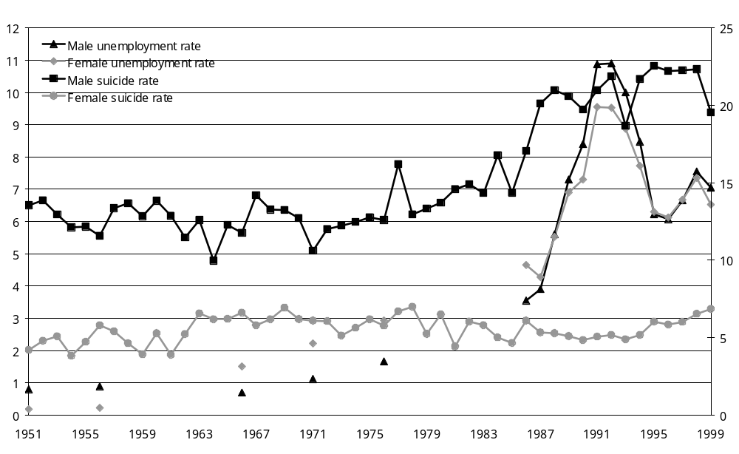
Note: The suicide rate is standardised to the Segi world population.

Key trends and observations
- The rates of unemployment for males and females have been similar over the last 50 years. Both the male and the female rates increased rapidly during the 1980s and peaked in the early 1990s. Unemployment rates for both genders then decreased sharply, before becoming relatively more stable again in the late 1990s (Figure 5.1).
- Although there are differences in unemployment patterns for different age groups, a clear overall relationship between suicide and unemployment is not readily apparent for most age groups. Although there had been a background trend of increasing youth suicide during the 1970s to early 1980s (Figure 2.1), the rapidly increasing youth suicide rate coincides with the rapidly increasing unemployment rate in the mid to late 1980s (Figures 5.1 and 5.2),.
- While the rapid rise in youth suicide coincides with a rise in unemployment rates, there was no statistically significant association during the period 1986 to 1999 of either 25−34-year-olds’ suicide rates with 25−34-year-olds’ unemployment rates, or 15−24-year-olds’ suicide rates with 15−24-year-olds’ unemployment rates (Figure 5.2; data on age-specific unemployment rates are not available prior to 1986.)

Figure 5.2: Unemployment rate and age-specific suicide rate, 15−24 and 25−34-year-olds, 1986−99
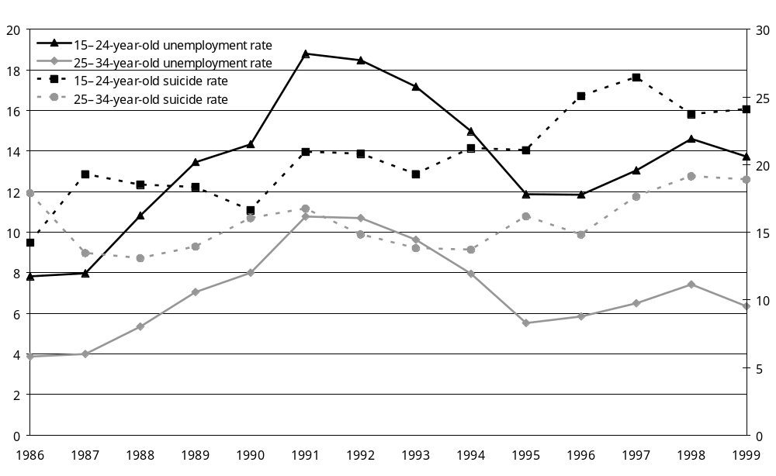
General source: Statistics New Zealand

6 Spatial Factors
Focusing solely on the total population suicide rates of a nation obscures the considerable variation that often exists within a country at the state or regional level.

There is significant variation in the rates of suicide between the various regions within New Zealand.

Figure 6.1: Age-standardised suicide rates for District Health Boards (DHBs), pooled rates, 1988−99
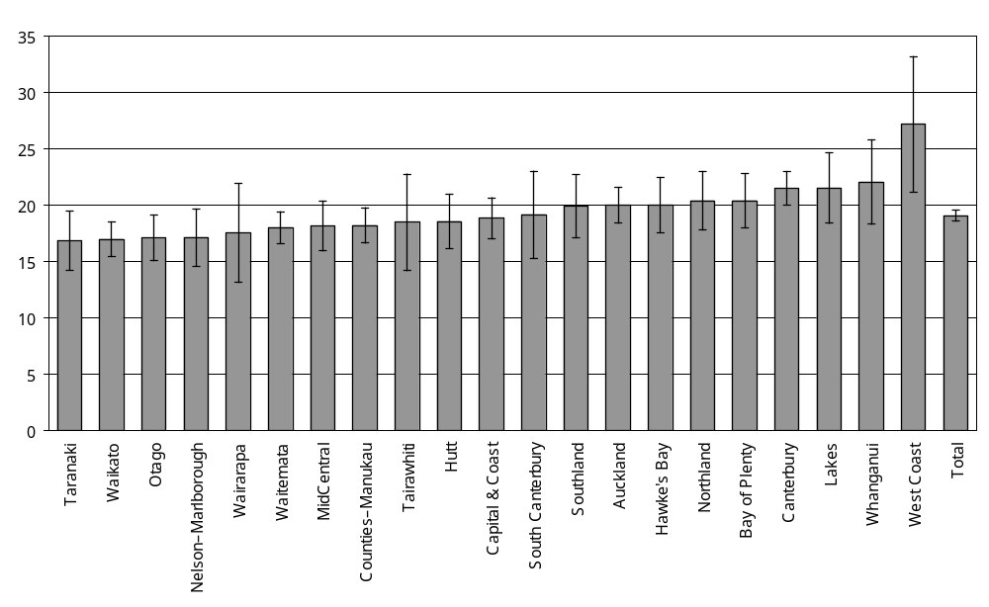
Notes: Rates are standardised to the 2001 population. 95% confidence intervals are shown.

Key trends and observations
- The pooled suicide rates (Figure 6.1 and Table 6.1) show that geographical regions (the 21 DHB regions across New Zealand) vary in their rates of suicide. The highest suicide rate was for the West Coast DHB, which was 61 percent greater than the lowest suicide rate in the Taranaki DHB.
- Excluding the West Coast DHB, the suicide rates in the remaining DHBs ranged from 12 percent less than (Taranaki) to 16 percent higher than (Whanganui) the overall New Zealand rate. Most 95 percent confidence intervals for these 20 DHBs overlapped.

Comment
Geographic mapping approaches have found considerable variability in suicide patterns within major metropolitan areas. Some studies have found a significant association between ‘rurality’ and suicide, particularly in remote and economically depressed rural areas. It is thought that access to lethal suicide methods such as agricultural poisons and guns, and the limited availability of mental health services, are some of the key influences on rural suicide rates.

It is important that we understand what differentiates the regions of New Zealand from one another in order to establish whether these differences are related to the suicide rates. The much discussed urban/rural distinction finds only limited support in the data presented (although it should be noted that DHB classifications are not an ideal way to examine the urban/rural divide).

Table 6.1: Age-standardised suicide rates for District Health Boards (DHBs), pooled rates, 1988−99
DHB | Suicide rate per 100,000 population (95% ci)
West Coast | 27.2 (21.2−33.2)
Whanganui | 22.1 (18.3−25.8)
Lakes | 21.5 (18.4−24.7)
Canterbury | 21.5 (20.1−23.0)
Bay of Plenty | 20.4 (18.0−22.8)
Northland | 20.4 (17.8−23.0)
Hawke’s Bay | 20.0 (17.6−22.5)
Auckland | 20.0 (18.4−21.6)
Southland | 19.9 (17.1−22.7)
South Canterbury | 19.2 (15.3−23.0)
Capital & Coast | 18.9 (17.0−20.7)
Hutt | 18.6 (16.2−21.0)
Tairawhiti | 18.5 (14.2−22.8)
Counties−Manukau | 18.2 (16.7−19.8)
MidCentral | 18.2 (16.0−20.4)
Waitemata | 18.0 (16.6−19.4)
Wairarapa | 17.5 (13.2−21.9)
Nelson−Marlborough | 17.2 (14.6−19.7)
Otago | 17.1 (15.1−19.1)
Waikato | 17.0 (15.5−18.5)
Taranaki | 16.9 (14.3−19.5)
Total | 19.1 (18.6−19.6)
Notes: Rates are standardised to the 2001 population. 95% confidence intervals (CI) are shown in parentheses.
General source: NZHIS

General note
The data presented in this section differs slightly from the data presented elsewhere in the report. The data used here to calculate the suicide rates includes deaths where the exact nature of the death – that is, whether it was a suicide or not – could not be determined by the coroner. As such, the pooled national suicide rate presented is slightly higher than data from other sections of the report would suggest.

7 Labour-Force Participation
In the last 50 years in New Zealand, the male labour-force participation rate (LFPR) has been consistently higher than the female LFPR. The pattern of LFPR for different age groups has been reasonably consistent over the last 15 years (with the exception of the 15−24-year-old age group). The increasing female LFPR appears to coincide with an increasing male suicide rate (Figure 7.1).

Figure 7.1: Labour-force participation rate (LFPR) and suicide rates, by sex, 1951−99
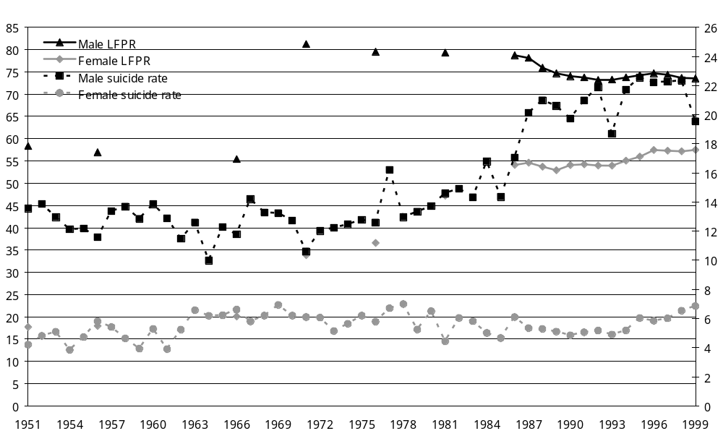
Note: The suicide rate is standardised to the Segi world population.
General source: Statistics New Zealand.

Key trends and observations
- In the last 50 years in New Zealand, the male LFPR has been consistently higher than the female LFPR, but the gap between the two has narrowed in the last 20 years.
- The pattern of LFPR for different age groups has been reasonably consistent over the last 15 years with the exception of the 15−24-year-old age group, where the LFPR has consistently decreased in this time period. However, a comparison of youth LFPR (including by gender) is limited due to changing patterns of tertiary education and limited data.
- The male LFPR jumped in the late 1960s, but otherwise is reasonably consistent. The female LFPR increased steadily from the 1960s to the 1990s.
- While the rising female LFPR is associated with a rising male suicide rate, the association was not statistically significant.

Comment
Although the findings of empirical research elsewhere are somewhat inconsistent in this area, on the whole it appears that an increase in the female labour-force participation rate (LFPR) is initially associated with increased national-level suicide rates for both sexes. Subsequently, male suicide rates continue to increase with increasing female labour-force participation, but females have an associated benefit from the changes, with their suicide rates stabilising and then later decreasing. Eventually, males also experience a gradually reducing negative association of the female LFPR with their suicide rates. These international patterns appear to be affected by factors such as marital status and urbanisation.

8 The Economic Business Cycle
Gross domestic product (GDP) has been rising steadily in New Zealand, coinciding with rising suicide rates for younger people. However, annual fluctuations in the economic business cycle were not statistically significantly associated with age-specific suicide rates.

Figure 8.1: Gross domestic product (GDP) per capita and age-standardised suicide rate, 1955−98
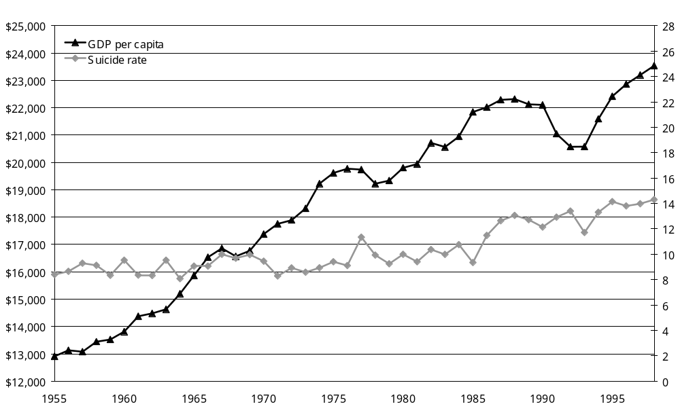
Notes: GDP is expressed in 1991/1992 prices. Suicide rate is standardised to the Segi world population.

Key trends and observations
- GDP has been steadily increasing since 1955 and there was a period of relatively high growth during the late 1990s following a fall in the early years of this decade. There is no apparent association with this pattern in GDP and overall suicide rates (Figure 8.1) or the suicide rates of the 15−24 and 25−44-year-old age groups (Figure 8.2).
- There was no apparent association of Māori suicide rates with GDP (Figure 8.3), but data was limited.
- Fluctuations in the economic business cycle, as measured by percentage change in GDP (Figure 8.4), appear to have an association with 25−44 and 45−64-year-old suicide rates, with decreases in percentage change in GDP roughly coinciding with increases in these suicide rates. However, neither of these associations was statistically significant to a 90 percent level.

Figure 8.2: Gross domestic product (GDP) per capita and suicide rate, 15−24 and 25−44-year-old age groups, 1955−98
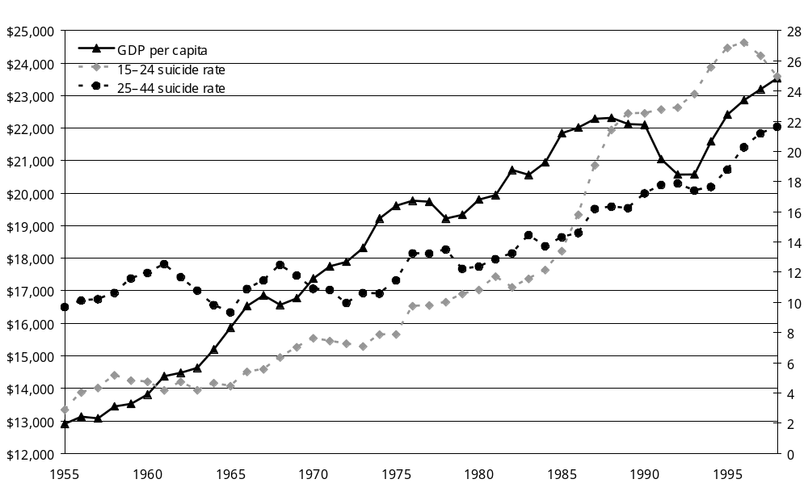
Note: GDP is expressed in 1991/92 prices.

Figure 8.3: Gross domestic product (GDP) per capita and Māori age-standardised suicide rate, 1988−99
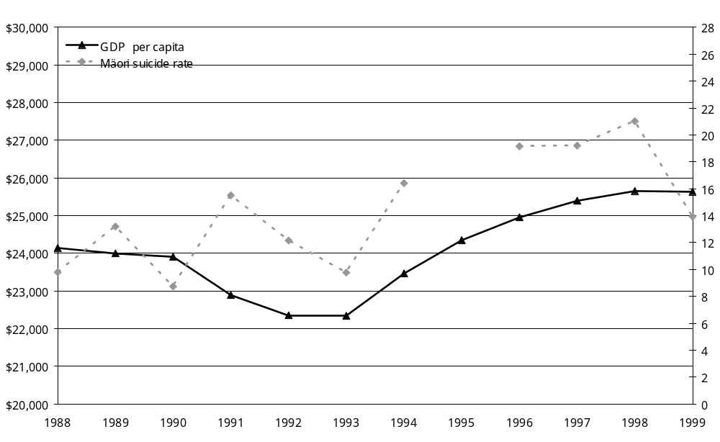
Notes: Suicide rate is standardised to the Segi world population. Suicide rates are adjusted for numerator−denominator bias. GDP is expressed in 1995/96 prices.

Figure 8.4: Percentage change in gross domestic product (GDP) per capita and age-specific suicide rate, 25−44 and 45−64-year-old age groups, 1957−97
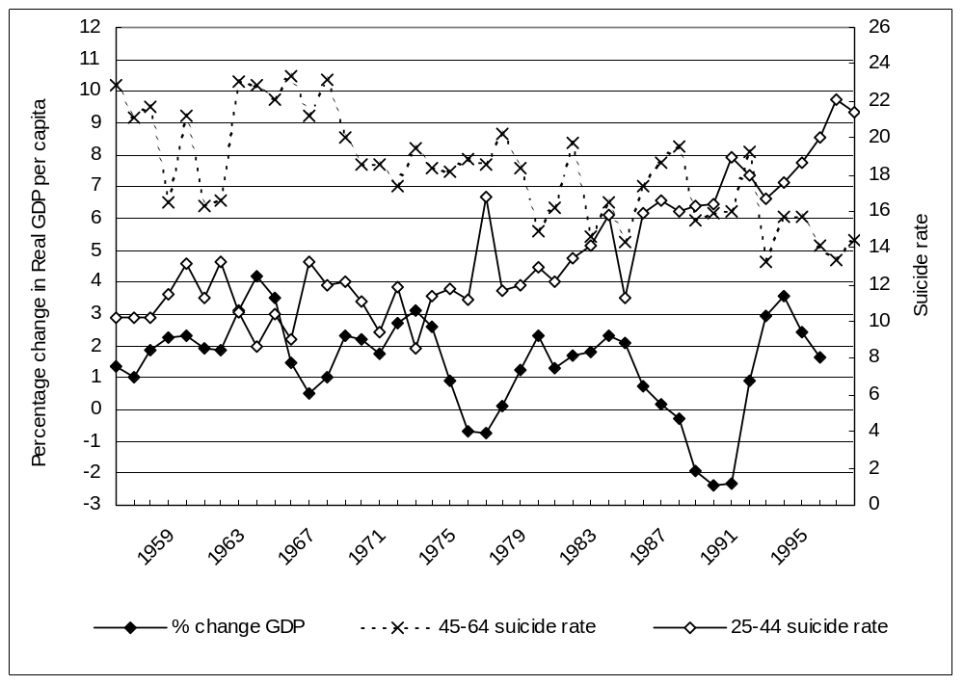
General source: NZHIS, Statistics New Zealand

9 Income Inequality
There is no simple overall association between changing suicide rates and changing income inequality in the 1980s and 1990s.

Figure 9.1: Two ratios of income inequality (50/10 and 75/25) and age-standardised suicide rate, 1982−98
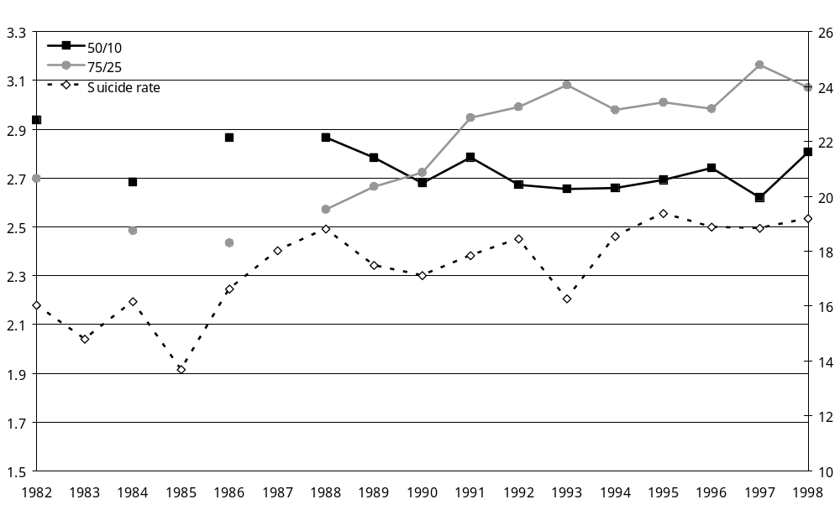
Note: The suicide rate is standardised to the 2001 population.

Key trends and observations
- There is no overall association of changing suicide rates and changing income inequality over the last 20 years in New Zealand.
- By age group, there might be some association of increasing income inequality with increasing youth suicide, but the converse is true for older people. Regarding young people, however, note that the marked upswing in income inequality (about 1987 to 1991) actually came after the marked upswing in 15−24-year-old suicide rates (about 1986 to 1989, see Figure 2.1).

Figure 9.2: Ratio of income inequality (75/25) and age-specific suicide rates (15−24 and 25−44-year-olds), 1982−98
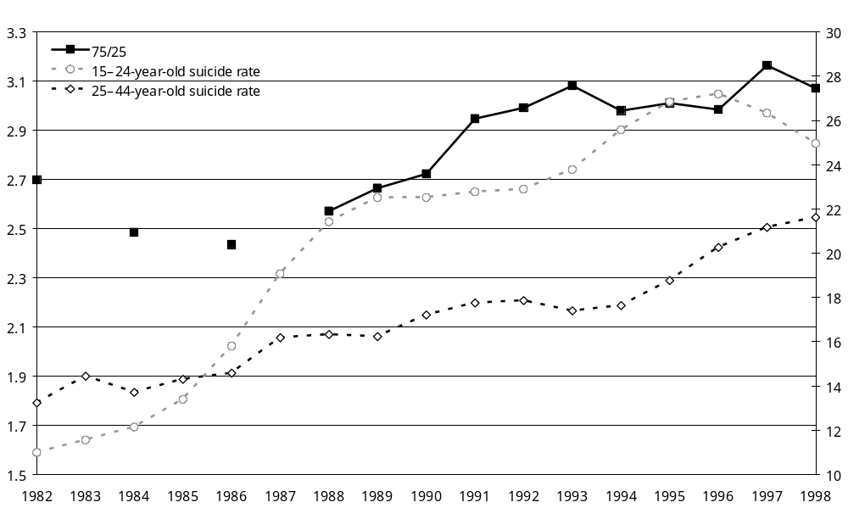

Figure 9.3: Ratio of income inequality (75/25) and age-specific suicide rates (45−64-year-olds and 65+), 1982−98
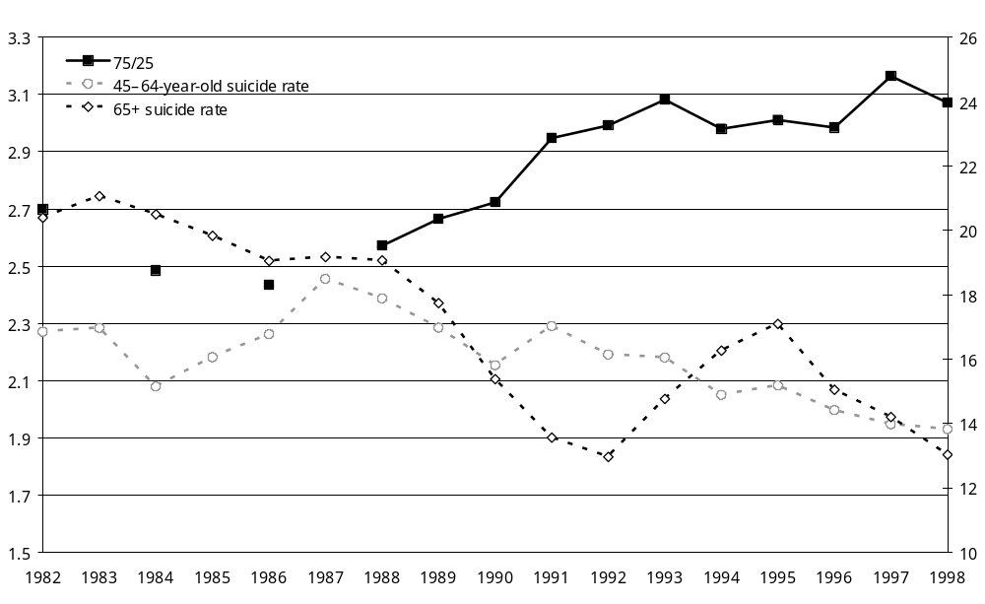
Note: In New Zealand, income inequality measured by the Gini coefficient increased dramatically in the late 1980s. However, data inadequacies prevent a long time series. In this section we use yearly ratios of 50th to 10th and 75th to 25th percentiles of household incomes from 1982 onwards.

Source: Income inequality data: M Mowbray, Distribution and Disparity: New Zealand household incomes, Ministry of Social Policy, Wellington, 2001. NZHIS
10 Availability of Means to Commit Suicide
The New Zealand trend towards increased hangings is consistent with a worldwide trend toward both increased hangings and increased use of violent suicide methods.

Figure 10.1: Suicide by hanging, males and females, 1977−96
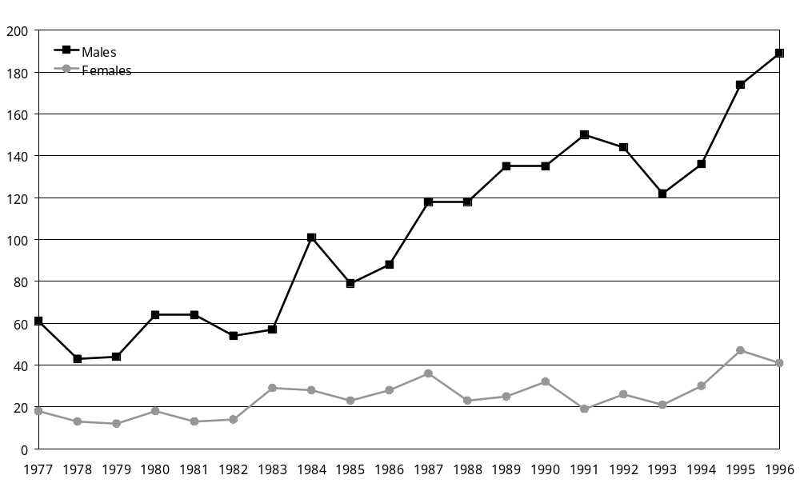

Key trends and observations
- The greater the availability of a particular method of causing death (eg, firearms), the more likely it is to be used to commit suicide. From 1977 to 1996 the number of suicides by hanging and vehicle exhaust gas increased. The ability to restrict these means is limited.
- In the same period, the number of suicides by self-poisoning and firearms decreased.

Comment
It has been argued that the increase in hangings is displacement due to decreased access to other methods. Regardless of this, due to the high proportion of suicides in New Zealand that use methods that are difficult to restrict access to (such as hanging and vehicle exhaust gas), there does not seem to be much likelihood of decreasing suicide rates in New Zealand by decreasing the availability of suicide methods.

Table 10.1: Percentage of suicides using four common methods, 1977 and 1996
 | Percentage of suicides
 | 1977 | 1996
Hanging
Males | 23.8 | 44.1
Females | 16.5 | 36.6
Total | 21.6 | 42.6
Vehicle exhaust gas
Males | 21.5 | 29.0
Females | 9.2 | 27.7
Total | 17.8 | 28.7
Self-poisoning
Males | 17.6 | 7.0
Females | 40.4 | 25.9
Total | 24.4 | 10.9
Firearms
Males | 20.7 | 10.7
Females | 2.8 | 0.9
Total | 15.3 | 8.7
General sources: Suicide methods data: AL Beautrais, 2000. Restricting Access to Means of Suicide in New Zealand. Ministry of Health: Wellington.

11 Crime, Violence and Homicide
Speculation about links between suicide and crime are commonplace. In New Zealand, the overall suicide rate seems only weakly positively related to the overall offence rate. However, this relationship appears stronger when the overall offence rate is compared to the suicide rates of the 15−24-year-old age group.

Figure 11.1: Overall rate of offences and age-standardised suicide rate, 1970−2001
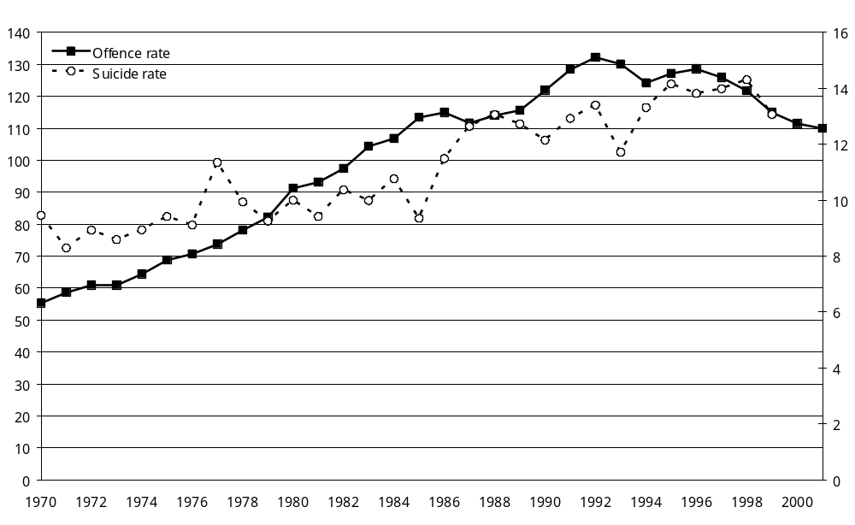
Note: Suicide rates are standardised to the Segi world population.

Key trends and observations
- There was an increase in the overall rate of offences in the years from 1970 until the early 1990s. However, this rate has declined in the 1990s (Figure 11.1).
- The rates of offences in all categories (including violent crimes) have remained reasonably stable over the years from 1994 to 2001. The most prominent change was a drop in dishonesty offences between 1996 and 2001 (Table 11.1).
- The overall suicide rate seems only weakly positively related to the overall offence rate. However, this possible association appears stronger when the overall offence rate is compared to the suicide rates of the 15−24-year-old age group (Figure 11.2), but this was not statistically significant to a 90 percent level.
- When examining 1995 data, there appears to be no obvious relationship between overall offence rates and overall suicide rates in OECD countries (Figure 11.3).
- The data indicates a possible link between crime and suicide rates. However, it seems unlikely that it is a direct causal relationship; that is, it seems unlikely that increases in crime cause the increases in suicide. A more likely scenario is that a third variable is driving both suicide and crime.

Figure 11.2: Overall rate of offences and age-specific suicide rate, 15−24-year–olds, 1970−99
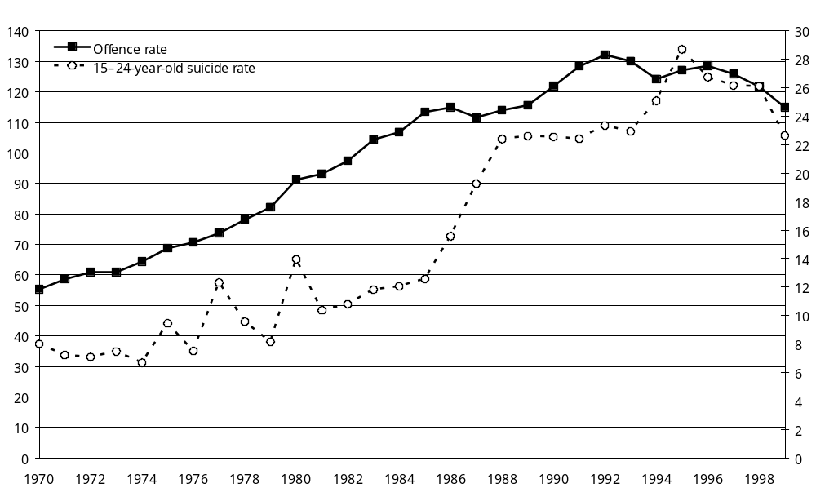

Table 11.1: Rate of recorded offences, by category, 1994−2001
Offence category | Rate of offences (per 1000 population)
Offence category | 1994 | 1995 | 1996 | 1997 | 1998 | 1999 | 2000 | 2001
Violent offences | 10.8 | 10.8 | 10.7 | 10.7 | 10.7 | 10.4 | 10.8 | 11.3
Sexual offences | 1.0 | 1.0 | 1.0 | 0.9 | 0.9 | 0.8 | 0.9 | 0.8
Drugs and anti-social offences | 13.8 | 12.9 | 13.6 | 14.4 | 15.1 | 14.7 | 13.9 | 14.2
Dishonesty offences | 79.9 | 82.9 | 83.4 | 80.4 | 76.5 | 70.6 | 66.5 | 64.2
Property damage | 10.4 | 11.1 | 11.0 | 10.7 | 10.0 | 10.3 | 10.6 | 10.5
Property abuse | 6.0 | 6.1 | 6.1 | 6.1 | 5.5 | 5.3 | 5.5 | 5.5
Administrative offences | 2.2 | 2.3 | 2.6 | 2.8 | 3.0 | 2.9 | 3.3 | 3.4

Figure 11.3: Scatter plot of selected OECD countries: suicide rates and prisoner rates, 1995
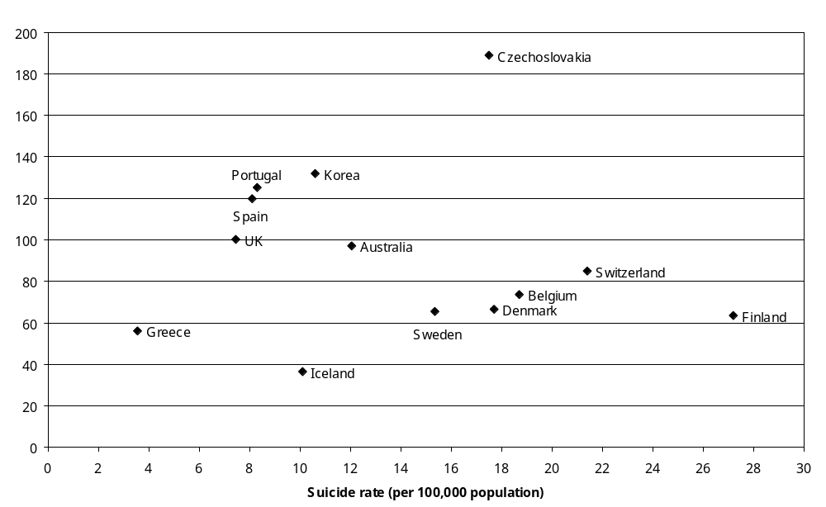
Note: The data for Figure 11.3 was obtained from: United Nations, 1998. World Population Prospects 1950-2050 (1998 Revision) Survey on crime trends and the operations of criminal justice systems (2nd to 6th survey, 1980−1997). New York: United Nations.
General source: New Zealand Police Service.

12 Fertility
Along with marriage and divorce rates, the birth/fertility rate is considered by some to be an indicator of social cohesion. In New Zealand there may be an association between the total fertility rate and the suicide rates for both Māori and the overall population, with decreasing fertility occurring as suicide rates for these groups increase. However, the fertility rate is also determined by other factors (such as the availability of contraception), so this pattern should be interpreted with caution.

Figure 12.1: Total fertility rate and age-standardised suicide rate, 1962−99
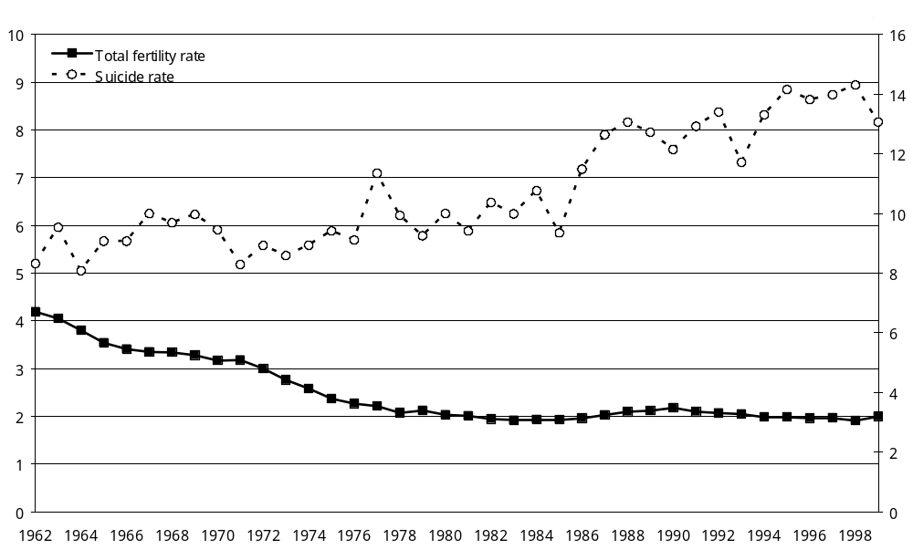
Note: Fertility rate = average number of births a woman would have during her reproductive life if she were exposed to the fertility rates characteristic of various childbearing age groups in that year.
General source: Statistics New Zealand.

Key trends and observations
- The total fertility rate has been decreasing steadily since 1962.
- There may be an association between the total fertility rate and the suicide rate for both Māori and the overall population, with decreasing fertility occurring as suicide rates for these groups increase.
- Theoretically, fertility trends might be a reflection of the social state of a country (eg, women tend to be less likely to bear children if they are uncertain about the future). However, the fertility rate is also determined by other factors, such as the availability of contraception (greatly increased since the early 1960s) and the female labour-force participation rate (LFPR).

13 Immigration
In New Zealand, inward migration may be associated with increases in the overall suicide rate, but the association is weak. As with fertility however, many factors determine and are associated with migration, making interpretation of the relationships difficult. Future analyses should assess the association of migrant status with suicide at the individual level.

Figure 13.1: Rate of long-term inward migration and age-standardised suicide rates, by sex, 1979−99
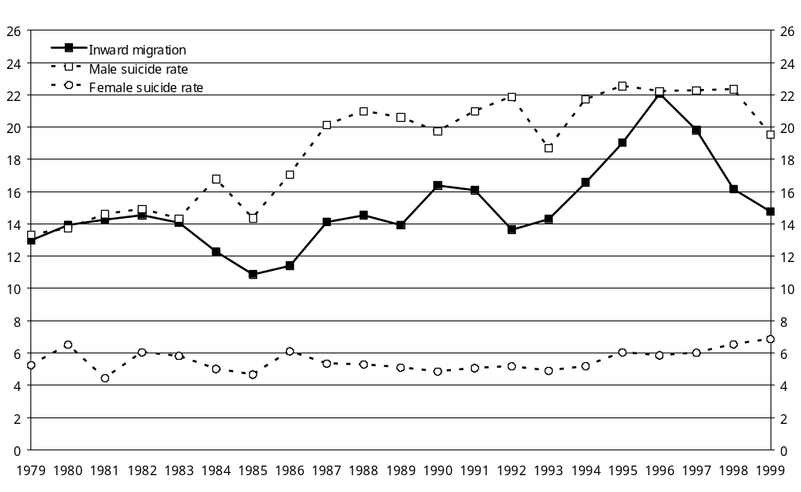
Notes: Suicide rates are standardised to the Segi world population. Long-term inward migration = immigrants intending to stay in New Zealand for 12 months or more and New Zealand residents returning after an absence of 12 months or more.

Key trends and observations
- Countries with higher rates of international immigration (and low rates of emigration) have higher suicide rates. International migrants usually have suicide rates between those of people in their country of origin and their country of destination. However, over time the suicide rates of international migrants tend to converge with those of their country of destination.
- In New Zealand, both net migration and long-term inward migration have been increasing over time. While there appears to be a trend toward increases in migration being associated with increases in the overall suicide rate, the association is weak. This association is apparent for both net migration and inward migration.
- As with the previous fertility section, many factors determine and are associated with migration. A more thorough analysis of migration as a risk factor should look at individual-level data for recent migrants.

Note: Net migration refers to the total number of arrivals to New Zealand minus the total number of departures. Long-term inward migration is defined as immigrants intending to stay in New Zealand for 12 months or more and New Zealand residents returning after an absence of 12 months or more.
General source: Statistics New Zealand.

The statistical model was a Poisson regression of: [15−24-year-old suicide rates] on [year] and [15−24-year-old unemployment rates]; and [25−34-year-old suicide rates] on [year] and [25−34-year-old unemployment rates]. The regression coefficients for the unemployment variable were: −0.0013, with a standard error of 0.0202 (p = 0.95), among 15−24-year-olds; and –0.0093, with a standard error of 0.0332 (p = 0.78), among 25−34-year-olds. Further, using 1986 to 1999 data the unemployment coefficient was not statistically significant: excluding year from the models; running equivalent models for older age groups; and for models that pooled age groups and modelled males and females separately. However, it should be noted that the statistical power of all these models is limited, being based on only 14 years of data and being reliant on survey data (Household Economic Survey).
p = 0.0005 for a statistical test of homogeneity of the rates across DHBs.
A Poisson regression model of [male suicide rates] on [year] and [female LFPR] found a non-statistically significant coefficient for female LFPR (coefficient = 0.012; standard error = 0.017; p = 0.49).
A Poisson regression model of [45−64 (or 25−44) years suicide rate] on [year] and [% change in GDP] found no statistically significant associations with % change in GDP. Addition of a squared term for year (to allow for non-linear changes in suicide rates over time) did not alter the findings.
A Poisson regression model of [15−24-year-old suicide rate] on [year] and [offence rate] found a non-statistically significant coefficient for offence rate (coefficient = 0.0079; standard error = 0.005; p = 0.11).

