Ellis Cain
COGS 202
The Good, the Bad, and the Allen & Heath GL2000

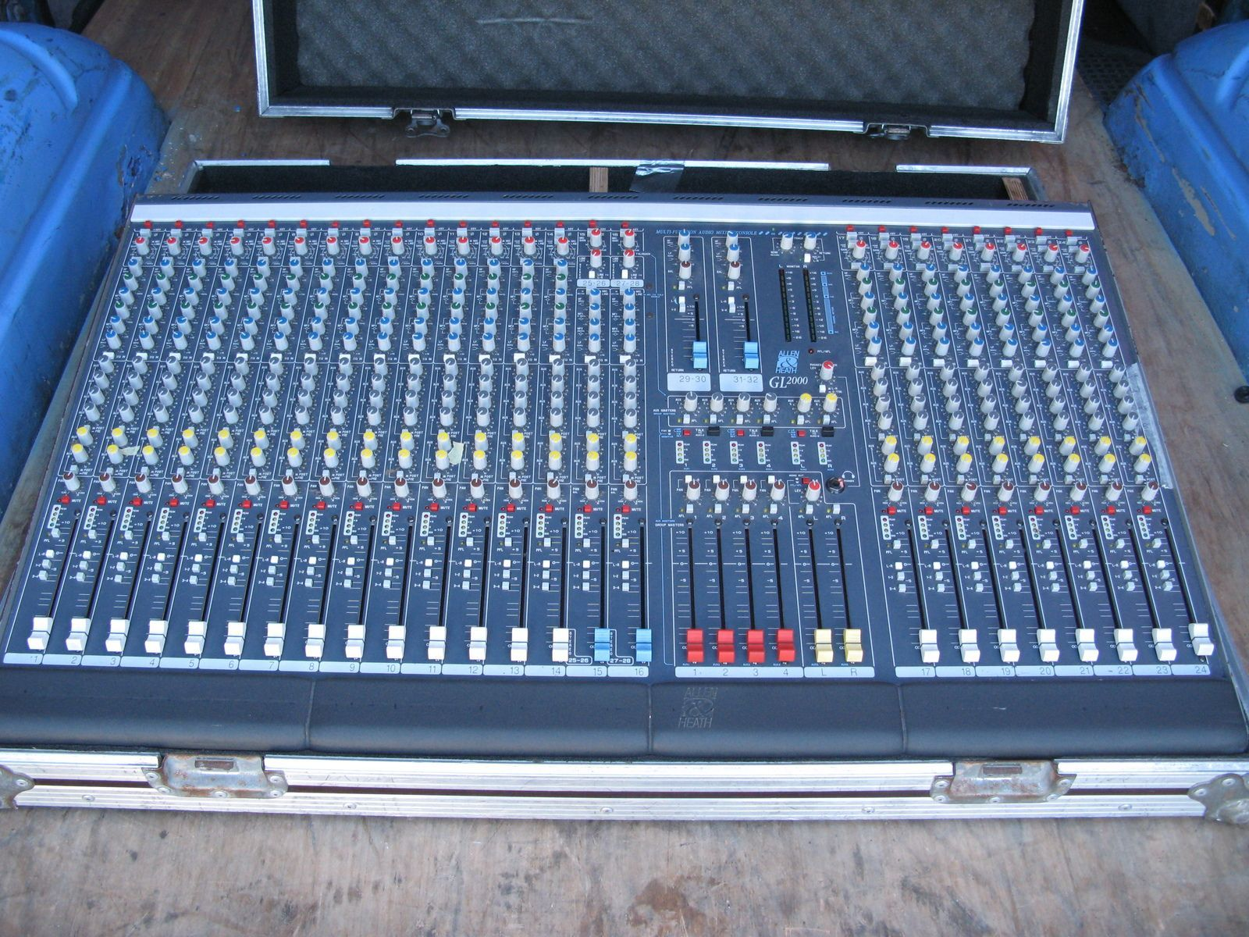
The product that I will be evaluating is the Allen & Heath GL2000. It is a live mixer soundboard, with 32 mono channels. Each channel has volume control sliders, monitor and LR balance knobs, as well as an equalizer section. There are four user-assignable groups that can be used to manage and balance setups with multiple instruments. This soundboard has a standard two stereo channel output. Overall, it has a practical and functional feature set for a live mixer, though newer boards do have some form of touch screen.

The features that I’ll be focusing on for this analysis include the per-channel controls such as volume sliders, LR balance knobs, and equalizer section. I will also discuss the LED-based volume monitor “displays”.

Of these features, the volume sliders, LR balance knobs, and LED-based volume monitor “displays” support Nielsen’s second principle of matching. This is because they map onto real-world conventions; upward motion as getting louder, turning left and right to match speaker balance, and increased light intensity as loudness. However, the equalizer section does not support this principle, since their organization is not necessarily intuitive. For example, in the equalizer section, they chose certain frequency values to be controlled by certain knobs, and then use two knobs to control frequency pass through and frequency volume.

From an aesthetic principle, the whole board goes against Nielsen’s eighth principle of minimal design. This is because the designers focused on having a very direct knob-to-function mapping, such that there isn’t any ambiguity for what a given knob/parameter does. The user does not have to fumble through menus to change a given parameter, but rather just finds the channel and parameter directly on the board and adjusts it there. Therefore, when there are 32 channels, the originally clear layout gets multiplied into a complex mess for the untrained eye, diminishing the relative visibility of each knobs’ setting. Moreover, the equalizer section will most likely only be used during the initial setup of the board. During common use, only the bottom third of the board will be monitored and used. This makes the equalizer section rarely needed.

At least for this product, the main trade-off is between practicality and the two Nielsen principle. As mentioned above, the designers focused on directness in their design. They weren’t designing the product to be aesthetically pleasing, but rather focused on the actual usage of the product and what to include. While it does have a very practical layout and workflow, the cost of design aesthetics is massive. This leads to a large learning curve; while each knob itself matches what an individual would predict (i.e. turning left and right for LR balance, pushing slider up for louder volume, etc.), the extra information becomes overwhelming and requires time and practice to be able to read/understand the board.

Therefore, this soundboard fails Miller’s law, which states that the average person can only keep 7 + 2 items in their working memory. Not only do individuals have to “grasp” each of the volume (2 items), monitor (6 items), EQ (~7 items), and balance (1 item) sections of each channel, they have to manage this 32 times for each channel, as well as the subgroups and output section of the board. Interestingly enough, for well-trained and knowledgeable individuals, this soundboard is in accordance with the Doherty Threshold, since there is almost zero wait time between the user and the soundboard. For example, the user notices an issue with the balance and can immediately adjust it, quickly hearing the result of their change. As I’ve mentioned before, reaching this level would require a lot of training to be able to navigate and understand the whole soundboard. As a closing note, this soundboard has no error message whatsoever. Even if one is trained and comfortable with using the soundboard, if something goes awry, they won’t necessarily know where the error is coming from. Usually, one would have to individually check each channel and the parameters of that channel, followed by the sources of the signal. This can be very time consuming and unintuitive. Especially if it happens during a live performance.

