GraphTCR-Mamba: heterogeneous graph learning with Mamba for TCR-epitope binding prediction†
Ellison Naz¹, Adam Fan², Wenjun Lin¹, Ping Luo^{1*}
¹Department of Computer Science & Mathematics, Algoma University, Brampton, Ontario L6V 1A3, Canada
²Bayview Secondary School, Richmond Hill, Ontario, L4C 2L4, Canada
T-cell receptor (TCR) recognition of peptide epitopes is central to adaptive immunity, yet only a small fraction of potential TCR-epitope interactions can be characterized experimentally. Existing computational approaches often model candidate pairs independently, underutilizing relational information among similar sequences. We present GraphTCR-Mamba, a heterogeneous graph framework that represents TCRs and epitopes as distinct node types, integrates sequence-similarity and observed-interaction edges, and incorporates a Mamba selective state-space branch for global information propagation. Across the IEDB, McPAS-TCR, and VDJdb benchmarks, GraphTCR-Mamba achieved AUROCs of 0.938, 0.943, and 0.993 and AUPRs of 0.925, 0.947, and 0.992, respectively, yielding the highest performance among evaluated methods. We further assessed transductive cold-start generalization by withholding interaction labels involving designated TCRs, epitopes, or both while retaining sequence-derived graph structure. Performance was consistently higher when only TCRs were held out and declined when epitopes or both interaction partners were held out, revealing a substantial gap between random pair-level and cold-start performance. Overall, GraphTCR-Mamba provides an effective framework for integrating sequence and relational information for TCR-epitope prediction, while the observed performance gap underscores the importance of cold-start evaluation for assessing generalization to unseen interaction partners.
Keywords: T cell receptor; Heterogeneous graph; TCR-epitope prediction; Mamba; Laplacian positional encoding.

Introduction
T-cell receptors (TCRs) play a central role in adaptive immunity by recognizing peptide epitopes presented on the surface of infected, malignant, or otherwise abnormal cells.¹ Determining TCR-epitope specificity experimentally, however, is costly and time-consuming, and only a small fraction of the vast space of potential TCR-epitope interactions can be characterized. Computational methods provide a scalable alternative by learning from experimentally validated interactions to predict previously uncharacterized TCR-epitope pairs, thereby prioritizing candidates for experimental validation.²
Despite substantial progress, existing computational approaches to TCR-epitope binding prediction face important challenges. Many methods evaluate TCR-epitope pairs independently, overlooking relationships among sequences that may provide useful context for prediction. In particular, TCRs with similar sequence or structural properties may share binding preferences, while related epitopes may exhibit similar recognition patterns. Incorporating such relationships could therefore improve prediction, particularly when generalizing beyond interactions observed during training. Methods that explicitly model relationships among sequences, however, often rely on attention-based architectures whose computational cost increases substantially with sequence or dataset size. These limitations are especially relevant under cold-start settings, where the model must predict interactions involving TCRs, epitopes, or both that were not observed during training.
To address these challenges, we propose GraphTCR-Mamba, a framework that combines heterogeneous graph message passing with a Mamba-based selective state-space model for TCR-epitope binding prediction. Rather than treating each candidate pair independently, GraphTCR-Mamba represents TCRs and epitopes within a heterogeneous graph and propagates information among related sequences, allowing predictions to incorporate both sequence-level features and relational context. The Mamba component provides linear-complexity global node mixing after graph construction, enabling efficient propagation of long-range information across the graph.
We evaluate GraphTCR-Mamba on three benchmark datasets, IEDB³, VDJdb⁴, and McPAS-TCR⁵, which differ in scale, curation strategy, and biological context. In addition to standard evaluation, we assess performance under cold-split settings designed to test generalization to previously unseen TCRs and epitopes. Across these datasets, GraphTCR-Mamba achieves strong and consistent predictive performance and retains meaningful predictive ability under the more challenging cold-split evaluation.
Our work makes three main contributions. First, we introduce a heterogeneous graph-based framework that integrates relational information with efficient sequence modeling for TCR-epitope binding prediction. Second, we demonstrate its performance across three benchmark datasets spanning nearly two orders of magnitude in scale and diverse curation settings. Third, we systematically evaluate generalization under cold-split settings, providing a more stringent assessment of the model's ability to predict interactions involving previously unseen TCRs and epitopes.

Methods

Datasets
Three publicly available TCR-epitope datasets were used to evaluate GraphTCR-Mamba: IEDB, VDJdb, and McPAS-TCR.^{3–5} IEDB contains experimentally validated TCR-epitope interactions, with each association supported by direct evidence of binding. Its stringent curation results in a smaller but high-confidence dataset, comprising 8,187 TCR-epitope pairs, 7,682 unique TCRs, and 980 unique epitopes after filtering. VDJdb similarly contains experimentally supported TCR-epitope associations but aggregates records from a broader range of studies, resulting in a substantially larger dataset. After filtering, VDJdb contained 71,686 pairs, 69,337 unique TCRs, and 1,352 unique epitopes.
McPAS-TCR differs from IEDB and VDJdb in the nature of its annotations. Rather than exclusively cataloging directly validated TCR-epitope binding events, McPAS-TCR associates TCR sequences with disease-related antigens and pathological contexts, including cancer, autoimmune disease, and infection. Consequently, some TCR-epitope associations may reflect disease or antigen context rather than direct experimental confirmation of binding. After filtering, McPAS-TCR contained 996 TCR-epitope pairs, corresponding to 941 TCRs and 32 epitopes. All three datasets originally included both human and mouse TCR sequences. To maintain consistency with the human-focused scope of this study, only human entries were retained for subsequent analyses.

Model Architecture
GraphTCR-Mamba formulates TCR-epitope association prediction as a link-prediction task on a heterogeneous graph comprising TCR and epitope nodes. Fig. 1 shows the architecture of the model. The framework uses domain-specific Graph-Mamba encoders that integrate edge-aware local message passing with global selective state-space modeling. TCR and epitope similarity graphs are encoded separately, while observed training associations enable information exchange between the two domains. The resulting node representations are then used by an edge classifier to predict candidate TCR-epitope interactions. This architecture extends the graph-prioritized node serialization strategy of Graph-Mamba⁶ to heterogeneous TCR-epitope graphs while retaining the efficient selective state-space modeling of Mamba.⁷

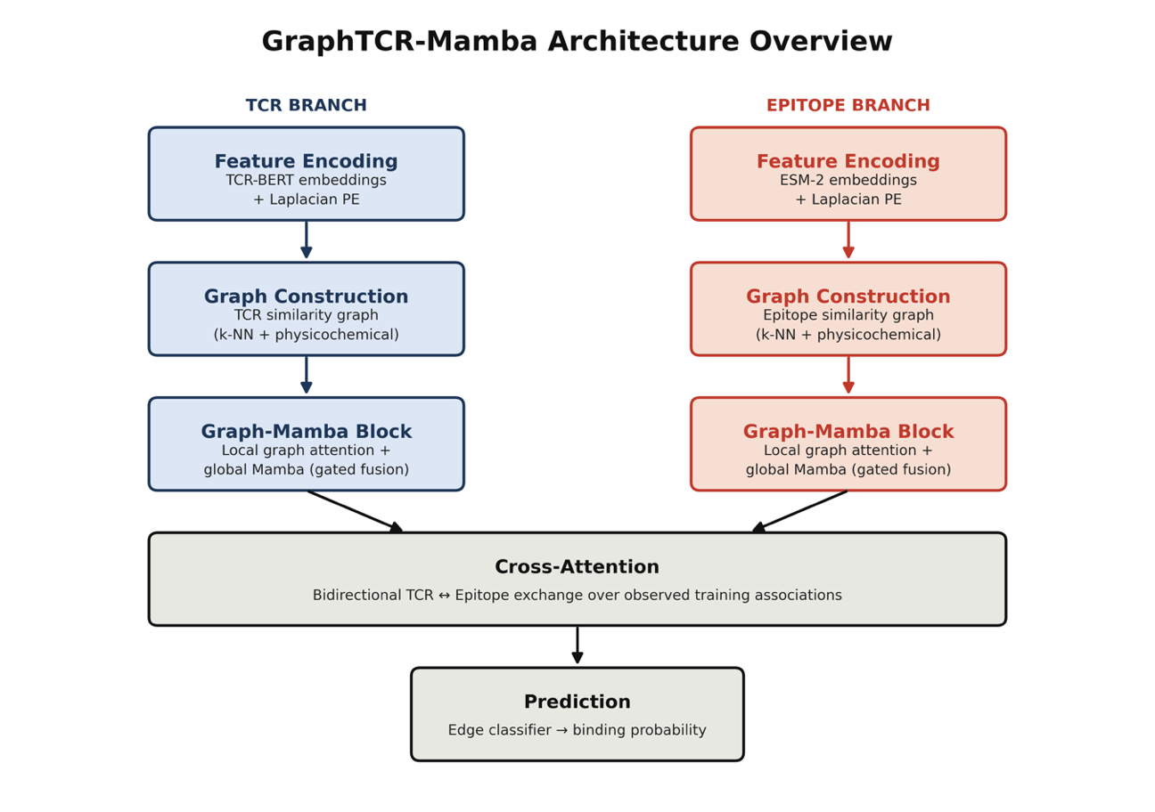

Fig. 1. Overview of the GraphTCR-Mamba architecture. TCR and epitope sequences are processed through parallel, domain-specific branches: pretrained language model embeddings (BertTCR and ESM-2) augmented with Laplacian positional encodings, followed by similarity-graph construction and stacked Graph-Mamba blocks combining local graph attention with global Mamba mixing via gated fusion. The two branches then exchange information through bidirectional cross-attention over observed training associations before a final edge classifier scores each candidate pair.

Node features and graph structure
For each TCR with paired CDR3α and CDR3β sequences, 768-dimensional mean-pooled BertTCR⁸ embeddings of the CDR3α and CDR3β sequences were concatenated to obtain the TCR representation. Epitopes were represented by 1,280-dimensional mean-pooled embeddings from the ESM-2 model.⁹ Type-specific linear layers, followed by layer normalization and ReLU activation, projected the TCR and epitope representations into a shared hidden space.
Two undirected intra-type graphs were constructed from precomputed sequence similarities. Each TCR was connected to its $k_{T}$ nearest TCR neighbors, and each epitope was connected to up to $k_{e}$ nearest epitope neighbors, with the pairwise similarity $w_{ij}$ retained as an edge feature. Similarity was defined as an equally weighted combination of standardized k-mer cosine similarity and AAindex-derived physicochemical cosine similarity.¹⁰ Known TCR-epitope binding pairs formed the cross-type edge set. Within each cross-validation fold, only positive associations from the training partition were included in message passing, ensuring that held-out interactions were not exposed to the graph encoder.
To encode position within each intra-type graph, the model additionally used the eight lowest non-trivial eigenvectors of the unweighted normalized graph Laplacian, a standard spectral positional encoding for graph networks.¹¹ For adjacency matrix A and degree matrix D,
 | $$L = I - D^{-1/2} A D^{-1/2}, p_{i} = [u_{2}(i), …, u_{9}(i)]$$ | (1)
where $u_{e}$ is the eigenvector associated with the $e$th-smallest eigenvalue of L. The positional vector was layer-normalized, linearly projected, and added to the type-specific feature projection. Thus, for node $i$ of type $r∈\left\{TCR, Epitope\right\}$:
 | $$x_{i}^{(0)} = ReLU(LN(W_{r} e_{i} + b_{r})) + W_{p} LN(p_{i})$$ | (2)

Intra-domain Graph-Mamba encoder
Each node type was processed by its own stack of two Graph-Mamba blocks. A block first applies two-head, edge-aware graph attention over the sparse similarity graph. For destination node $i$, source neighbor $j$, and attention head $m$, the unnormalized score and normalized attention coefficient are:
$s_{ij}^{m} = \frac{({(W_{Q}^{m} x_{i})}^{T}(W_{K}^{m} x_{j}))}{\sqrt{d_{h}}} + {(W_{e} w_{ij})}_{m}, α_{ij}^{m} = \frac{exp(s_{ij}^{m})}{\sum_{k∈N(i)}{exp(s_{ik}^{m})}}$ (3)
where dh = d/2 = 128. Values from neighboring nodes are aggregated separately for each head, concatenated, linearly transformed, and combined with a residual connection:
$h_{i} = LN(x_{i} + Dropout(W_{O} {Concat}_{m}[\sum_{j∈N(i)}{α_{ij}^{m} W_{V}^{m} x_{j}}]))$ (4)
The local representation H = [h₁, …, hₙ] is then serialized for global Mamba processing. Because a graph has no canonical node order, a graph-prioritized permutation is obtained by sorting nodes by degree perturbed by independent uniform noise, following the Hybrid-Degree-Noise strategy of Graph-Mamba.⁶ If $P_{π}$ denotes this permutation, the global output is:
$π = argsort(deg(v) + ε_{v}), ε_{v} \sim U(0,1); G = {P_{π}}^{-1} Mamba(P_{π} H)$ (5)
Mamba applies an input-dependent selective state-space recurrence along the permuted node sequence. In its discretized form, the recurrent state and output at position t can be summarized as:
$z_{t} = {\bar{A}}_{t} z_{t-1} + {\bar{B}}_{t} h_{π(t)}, g_{π(t)} = C_{t} z_{t} + D h_{π(t)}$ (6)
where the discretized state-space parameters depend on the current input, allowing selective propagation or suppression of context.7 In the implementation, the selective state-space dimension is 16 (controlling how much per-position context the selective scan retains), the local convolution width is 4 (capturing short-range dependencies before the global scan), and the Mamba expansion factor is 2 (the internal channel multiplier applied within each block). One noisy permutation is sampled on each training forward pass. At evaluation, outputs from five independently perturbed degree-based permutations are averaged after mapping them back to the original node order, reducing sensitivity to an arbitrary serialization.
A learned sigmoid gate controls how much global state-space context is injected into each locally aggregated node representation:
$γ_{i} = σ(W_{g}[h_{i} ∥ g_{i}] + b_{g}), {\tilde{h}}_{i} = LN(h_{i} + Dropout(q_{i} ⊙ g_{i}))$ (7)
The block concludes with a position-wise feed-forward network of width 2d, ReLU, dropout, a residual connection, and layer normalization. The local branch costs O(|E|d) on the sparse similarity graph, and the Mamba scan costs O(|V|d) with respect to node count, avoiding the O(|V|²d) global self-attention term after the similarity graph has been constructed.

Cross-domain exchange and link prediction
After the two intra-domain stacks, a pair of sparse cross-attention blocks propagates information over known training associations. TCR nodes first query their associated epitope nodes, and epitope nodes then query the updated TCR representations over the reversed association edges. For query node i and its cross-domain neighbors $N_{×}(i)$, each attention head computes:
$β_{ij}^{m} = {softmax}_{j∈N_{×}(i)}(\frac{({(W_{Q}^{×,m} q_{i})}^{T}(W_{K}^{×,m} k_{j}))}{\sqrt{d_{h}}}), c_{i} = W_{O}^{×} {Concat}_{m}[\sum_{j}{β_{ij}^{m} W_{V}^{×,m} k_{j}}]$ (8)
followed by residual layer normalization and a two-layer feed-forward network. This operation incorporates context from associations observed in the training graph. The held-out candidate edge itself is not added to cross-attention.
For a candidate pair (i, j), the final TCR and epitope embeddings are concatenated and passed through a two-layer multilayer perceptron with hidden width 256, ReLU, dropout, and a scalar output. The binding probability is:
$l_{ij} = {w_{2}}^{T} ReLU(W_{1}[h_{i}^{TCR} ∥ h_{j}^{EPI}] + b_{1}) + b_{2}, {\hat{p}}_{ij} = σ(l_{ij})$ (9)

Training configuration
Unknown TCR-epitope pairs, defined as entries with zero values in the association matrix, were sampled uniformly as negative examples. For each random seed, an equal number of positive and negative pairs was used, yielding a balanced class ratio. Positive and negative pairs were independently shuffled and partitioned into ten folds. For each fold, only positive associations from the training partition were included as cross-type edges in the graph encoder, whereas both positive and sampled negative pairs were used as candidate edges for training the link classifier.
The model was optimized using binary cross-entropy with logits and Adam with a learning rate of 0.0005 and weight decay of 0.0001. Residual and classifier dropout rates were set to 0.3, and training was limited to 150 epochs. Validation was evaluated every 10 epochs, and early stopping was applied after seven consecutive validation evaluations without improvement. Experiments were repeated using five random seeds. Hyperparameters, including the hidden dimension, number of attention heads, number of Graph-Mamba layers, dropout rate, learning rate, and weight decay, were selected through preliminary experiments on IEDB and subsequently fixed across all datasets and cold-split protocols to maintain a consistent evaluation setting.
Experiments were conducted on clusters of the Digital Research Alliance of Canada using the mamba_ssm implementation.⁷ The IEDB, VDJdb, and McPAS-TCR datasets are publicly available from their respective sources, and the implementation is available from GitHub at https://github.com/GenTensor/GraphTCR-Mamba.

Evaluation Protocol
Model performance was evaluated using stratified 10-fold cross-validation repeated across five random seeds to assess robustness to data partitioning. Performance was assessed using the area under the receiver operating characteristic curve (AUROC) and the area under the precision-recall curve (AUPR). AUROC measures discrimination between positive and negative pairs across classification thresholds, whereas AUPR emphasizes performance on the positive class and is particularly informative when evaluating imbalanced interaction data.
To assess generalization to unseen sequences, we additionally evaluated three cold-split settings: TCR-cold, in which test TCRs were absent from training; epitope-cold, in which test epitopes were absent from training; and both-cold, in which neither member of a test pair appeared in the training set. In contrast to random pair-level splits, where the same TCR or epitope may occur in both training and test sets with different partners, cold splits prevent the corresponding identities from being shared across partitions. These settings therefore provide a more stringent assessment of the model's ability to generalize to previously unseen TCRs, epitopes, or both.

Baseline Models
Four published methods were included as baselines. NetTCR-2.0 is a sequence-based deep learning model that predicts TCR-peptide interactions from paired TCRα and TCRβ CDR3 sequences.¹² HeteroTCR uses a heterogeneous graph neural network to model peptide-TCR interactions.¹³ GRAPE incorporates protein language model representations with graph-based learning to address sparsity in TCR-epitope interaction data.¹⁴ GTE is a graph-learning framework for predicting TCR-epitope binding specificity, primarily using TCRβ-chain sequence information.¹⁵ All baseline methods were evaluated using the same cross-validation partitions and negative-sampling protocol as GraphTCR-Mamba to ensure consistent comparison.

Results

Performance across benchmark datasets
Figs. 2-4 compare GraphTCR-Mamba with the baseline methods on the IEDB, VDJdb, and McPAS-TCR datasets. The largest improvement was observed on IEDB, where GraphTCR-Mamba achieved an AUROC of 0.938 and an AUPR of 0.925, exceeding the strongest baseline by 0.066 and 0.032, respectively. On McPAS-TCR, the improvements were more modest, with gains of 0.011 in AUROC and 0.012 in AUPR over the best-performing baseline. Performance on VDJdb approached the ceiling across several methods; nevertheless, GraphTCR-Mamba achieved the highest AUROC (0.993) and tied NetTCR-2.0 for the highest AUPR (0.992). Overall, GraphTCR-Mamba achieved consistently strong performance across all three datasets, with the greatest advantage observed on the more challenging IEDB dataset.
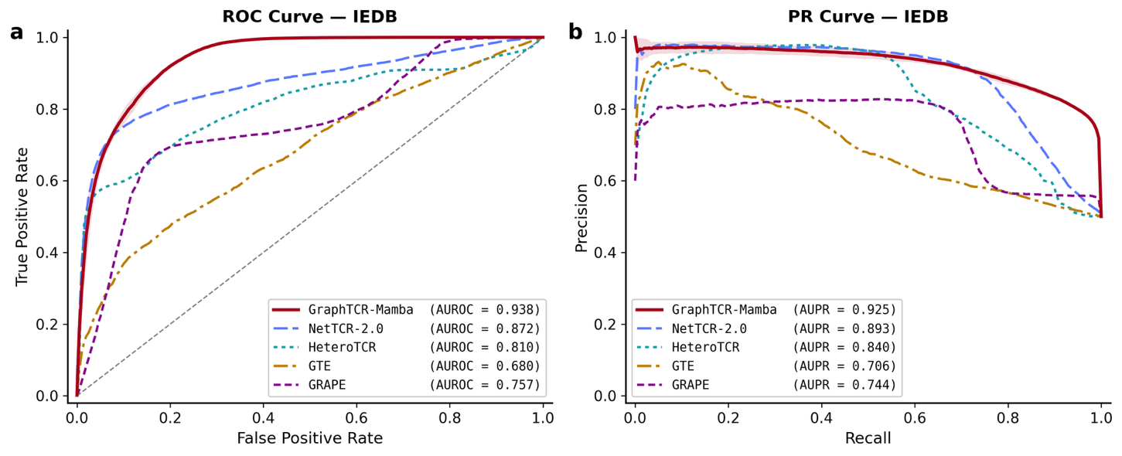
Fig. 2. Performance comparison on the IEDB dataset.
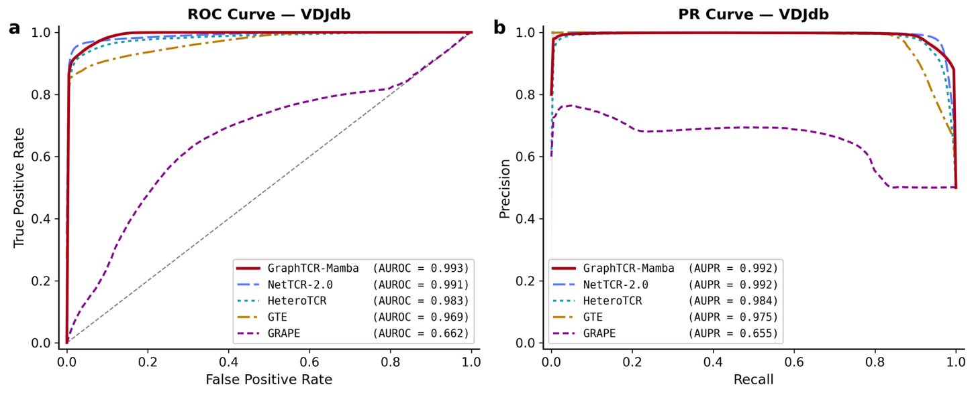
Fig. 3. Performance comparison on the VDJdb dataset.
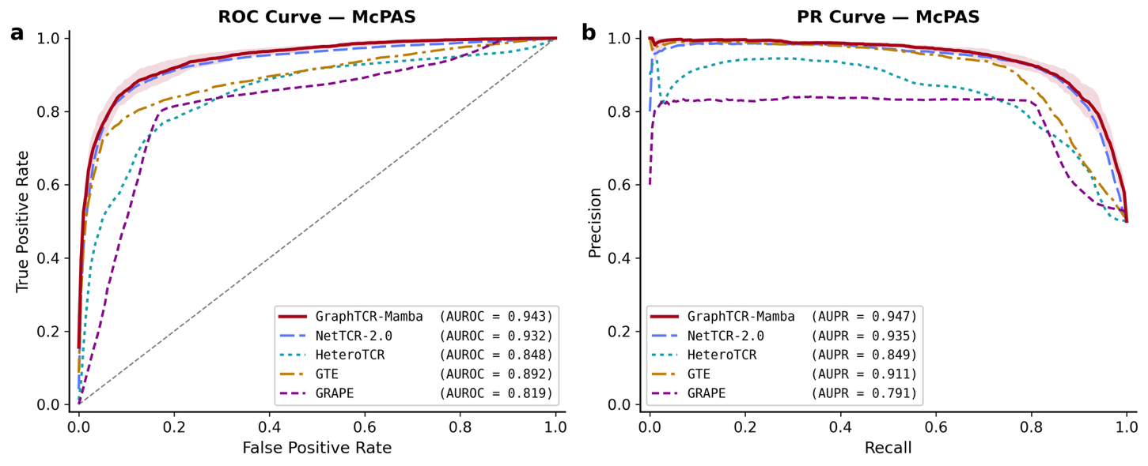
Fig. 4. Performance comparison on the McPAS-TCR dataset.

Generalization under cold-start splits
To assess whether GraphTCR-Mamba captures transferable interaction patterns beyond those observed during training, we evaluated the model under three cold-split settings for each dataset: TCR-cold, epitope-cold, and both-cold. Table 1 summarizes the results.
Across all three datasets, generalization depended strongly on which interaction partner was unseen. The model retained high discriminative performance under the TCR-cold protocol, suggesting that representations learned for observed epitopes transfer well to novel TCR sequences. Performance declined consistently when epitopes were held out, showing that generalization to new antigenic targets is substantially more difficult than generalization to new receptors.

Table 1. TCR-Epitope binding prediction performance under cold-split Protocols
Dataset | Protocol | Mean AUROC | Mean AUPR
IEDB | TCR-cold | 0.871 | 0.895
IEDB | Epitope-cold | 0.717 | 0.638
IEDB | Both-cold | 0.503 | 0.533
McPAS-TCR | TCR-cold | 0.920 | 0.901
McPAS-TCR | Epitope-cold | 0.677 | 0.638
McPAS-TCR | Both-cold | 0.568 | 0.629
VDJdb | TCR-cold | 0.987 | 00989
VDJdb | Epitope-cold | 0.856 | 0.761
VDJdb | Both-cold | 0.691 | 0.647

The both-cold protocol was the most challenging, with performance declined and showed greater fold-to-fold variability. This instability may partly reflect the smaller evaluation sets, particularly for McPAS-TCR, where three folds were excluded. Nevertheless, the consistent ordering across datasets suggests that the model relies partly on information associated with interaction partners observed during training. The model is therefore better suited to screening new TCRs against known epitopes than to predicting interactions in which both sequences are novel.

Ablation study
We evaluated the global Mamba branch and LPE under the same cold-split protocols used for the generalization analysis. Each ablated model used the same folds, negative samples, hyperparameters, and inner-split checkpoint selection as the complete model (Table 2).
Removing LPE had little effect under the TCR-cold protocol but consistently reduced performance when epitopes were unseen. Under epitope-cold evaluation, removing LPE decreased AUROC by 0.096, 0.130, and 0.063 on IEDB, McPAS-TCR, and VDJdb, respectively. The corresponding AUPR reductions were 0.081, 0.100, and 0.072. Performance also declined under the both-cold protocol, although these estimates had greater fold-to-fold variability.
The effect of the Mamba branch varied across datasets. Removing Mamba reduced epitope-cold AUROC and AUPR by 0.043 and 0.030 on McPAS-TCR and by 0.058 and 0.025 on VDJdb. In contrast, the same ablation modestly improved both metrics on IEDB. Mamba removal had little effect on TCR-cold performance for IEDB and VDJdb, while McPAS-TCR improved. These results identify LPE as a consistent contributor to generalization. The Mamba branch provides additional benefit for unseen-epitope prediction on McPAS-TCR and VDJdb, but its effect is dataset dependent.

Table 2. Cold-split ablation of the Mamba branch and LPE. Values are mean AUROC / mean AUPR across folds.
Dataset | Protocol | Full model | Without Mamba | Without LPE
IEDB | TCR-cold | 0.871 / 0.895 | 0.871 / 0.893 | 0.865 / 0.891
IEDB | Epitope-cold | 0.717 / 0.638 | 0.735 / 0.663 | 0.622 / 0.558
IEDB | Both-cold | 0.503 / 0.533 | 0.509 / 0.545 | 0.473 / 0.497
McPAS-TCR | TCR-cold | 0.920 / 0.901 | 0.930 / 0.923 | 0.919 / 0.900
McPAS-TCR | Epitope-cold | 0.677 / 0.638 | 0.634 / 0.608 | 0.547 / 0.538
McPAS-TCR | Both-cold | 0.568 / 0.629 | 0.532 / 0.597 | 0.341 / 0.540
VDJdb | TCR-cold | 0.987 / 0.989 | 0.987 / 0.989 | 0.984 / 0.987
VDJdb | Epitope-cold | 0.856 / 0.761 | 0.798 / 0.736 | 0.793 / 0.689
VDJdb | Both-cold | 0.691 / 0.647 | 0.676 / 0.640 | 0.635 / 0.584

Conclusion
We introduced GraphTCR-Mamba, a heterogeneous graph framework that combines relational message passing with Mamba-based global node modeling for TCR-epitope binding prediction. Across the IEDB, McPAS-TCR, and VDJdb datasets, GraphTCR-Mamba achieved consistently strong performance, outperforming the evaluated baseline methods. Cold-start evaluation showed that the model generalized more effectively to previously unseen TCRs than to unseen epitopes, while prediction for pairs containing both unseen TCRs and epitopes remained challenging. Ablation analysis further demonstrated the importance of Laplacian positional encoding for cold-start prediction and showed that the Mamba branch can improve generalization to unseen epitopes. Overall, GraphTCR-Mamba provides an effective framework for integrating sequence-derived relationships with selective state-space modeling and offers a promising approach for prioritizing candidate TCR-epitope interactions.

References
1. Attaf, M., Legut, M., Cole, D. K. & Sewell, A. K. The T cell antigen receptor: the Swiss army knife of the immune system. Clin. Exp. Immunol. 181, 1–18 (2015).
2. Springer, I., Besser, H., Tickotsky-Moskovitz, N., Dvorkin, S. & Louzoun, Y. Prediction of Specific TCR-Peptide Binding From Large Dictionaries of TCR-Peptide Pairs. Front. Immunol. 11, (2020).
3. Vita, R. et al. The Immune Epitope Database (IEDB): 2024 update. Nucleic Acids Res. 53, D436–D443 (2025).
4. Shugay, M. et al. VDJdb: a curated database of T-cell receptor sequences with known antigen specificity. Nucleic Acids Res. 46, D419–D427 (2018).
5. Tickotsky, N., Sagiv, T., Prilusky, J., Shifrut, E. & Friedman, N. McPAS-TCR: a manually curated catalogue of pathology-associated T cell receptor sequences. Bioinformatics 33, 2924–2929 (2017).
6. Wang, C., Tsepa, O., Ma, J. & Wang, B. Graph-Mamba: Towards Long-Range Graph Sequence Modeling with Selective State Spaces. arXiv.org https://arxiv.org/abs/2402.00789v1 (2024).
7. Gu, A. & Dao, T. Mamba: Linear-Time Sequence Modeling with Selective State Spaces. Preprint at https://doi.org/10.48550/arXiv.2312.00752 (2024).
8. Zhang, M. et al. BertTCR: a Bert-based deep learning framework for predicting cancer-related immune status based on T cell receptor repertoire. Brief. Bioinform. 25, bbae420 (2024).
9. Lin, Z. et al. Evolutionary-scale prediction of atomic-level protein structure with a language model. Science 379, 1123–1130 (2023).
10. Kawashima, S. & Kanehisa, M. AAindex: Amino Acid index database. Nucleic Acids Res. 28, 374 (2000).
11. Maskey, S. et al. Generalized Laplacian Positional Encoding for Graph Representation Learning. Preprint at https://doi.org/10.48550/arXiv.2210.15956 (2022).
12. Montemurro, A. et al. NetTCR-2.0 enables accurate prediction of TCR-peptide binding by using paired TCRα and β sequence data. Commun. Biol. 4, 1060 (2021).
13. Yu, Z., Jiang, M. & Lan, X. HeteroTCR: A heterogeneous graph neural network-based method for predicting peptide-TCR interaction. Commun. Biol. 7, 684 (2024).
14. Fu, X. et al. GRAPE: graph-regularized protein language modeling unlocks TCR-epitope binding specificity. Brief. Bioinform. 26, bbaf522 (2025).
15. Jiang, F. et al. GTE: a graph learning framework for prediction of T-cell receptors and epitopes binding specificity. Brief. Bioinform. 25, bbae343 (2024).

† This work is supported by the Algoma University Research Fund. * Corresponding author: ping.luo@algomau.ca

