|  |  |  |  |  |  |  |  |  |  |
| --- | --- | --- | --- | --- | --- | --- | --- | --- | --- |
|  | 2010 | 2011 | 2012 | 2013 | 2014 | 2015 | 2016 | 2017 | 2018 |
| January | 12 | 41 | 13 | 10 | 0 | 0 | 0 | 11 | 0 |
| February | 6 | 31 | 7 | 5 | 0 | 0 | 0 | 8 | 0 |
| March | 2 | 18 | 11 | 4 | 0 | 2 | 0 | 3 | 0 |
| April | 1 | 5 | 1 | 9 | 0 | 0 | 0 | 9 | 0 |
| May | 8 | 10 | 9 | 0 | 0 | 0 | 0 | 8 | 0 |
| June | 12 | 15 | 21 | 0 | 0 | 3 | 0 | 7 | 0 |
| July | 5 | 29 | 8 | 0 | 0 | 4 | 0 | 21 | 0 |
| August | 82 | 45 | 10 | 0 | 0 | 25 | 10 | 9 | 0 |
| September | 90 | 30 | 13 | 0 | 0 | 0 | 8 | 0 | 23 |
| October | 51 | 28 | 10 | 0 | 0 | 31 | 8 | 0 | 36 |
| November | 47 | 34 | 11 | 0 | 0 | 1 | 4 | 4 | 26 |
| December | 36 | 22 | 3 | 0 | 0 | 5 | 1 | 0 | 14 |
| Total | 352 | 308 | 127 | 28 | 0 | 67 | 31 | 80 | 99 |

**Chapter IV**

**Results and Discussion**

**Problem 1.**

Solano gave us the data from January 2010 – December 2019. According to the RHU, theses was the only data they had with regards to dengue cases because the people in the community choose to go directly to a hospital rather than in their office.

The total dengue cases of 2010 is 352; 2011 is 308, 2012 is 127, 2013 is 28, 2014 is 0, 2015 is 67, 2016 is 31, 2017 is 80 and 2018 is 99.

In the year 2010, the month of September got the highest number of dengue cases with 90 cases. While, August got the second to the highest with 82. And October as the third highest with 51 cases.

In 2011, August got the highest number of dengue cases with 45 cases. While, November got the second to the highest with 34 recorded cases. And February, as the third to the highest with 31 recorded cases.

While in 2012, June got the highest recorded dengue cases with 21 cases. While, January and September got the second to the highest with 13 cases.

In 2013, from January to April, January got the highest recorded dengue cases with 10 cases, April got the second highest record dengue cases with 9 cases. While, February got the third highest recorded dengue cases with 5 cases.

In 2015, October got the highest recorded dengue cases with 31 cases, August got the second highest recorded dengue cases with 25 cases. While, December got the third highest recorded dengue cases with 5 cases.

In 2016, August got the highest recorded dengue cases with 10 cases. While, September and October got the second highest recorded dengue cases with 8 cases.

In 2017, April got the highest recorded dengue cases with 21 cases, January got the second highest recorded dengue cases with 11 cases. While, April and August got the third highest recorded dengue cases with 9 cases.

In 2018, from September to December, October got the highest recorded dengue cases with 36 cases, November got the second highest recorded dengue cases with 26 cases. While September got the third highest recorded dengue cases with 23 cases.

Since, we had incomplete data, the researchers decided to use the data from January 2010 – April 2013 for time series analysis because it is the portion of the data that is good to model.

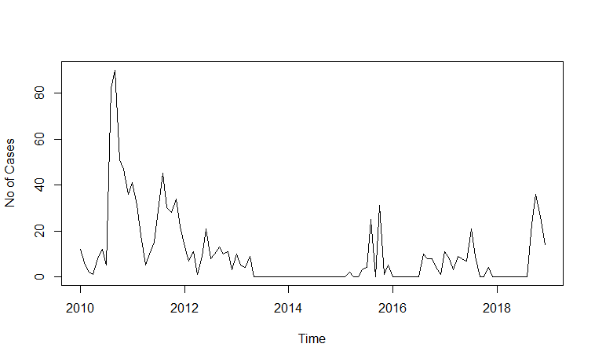

Problem 2

Problem 3

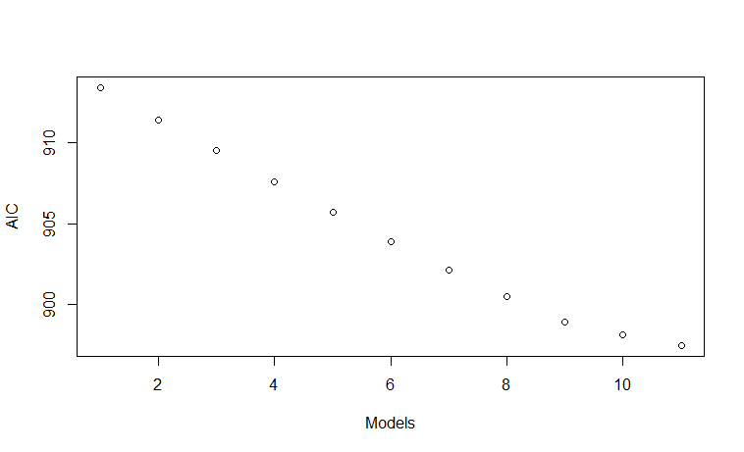

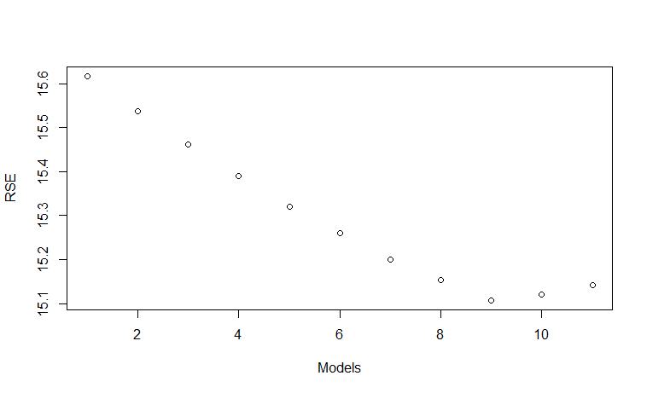

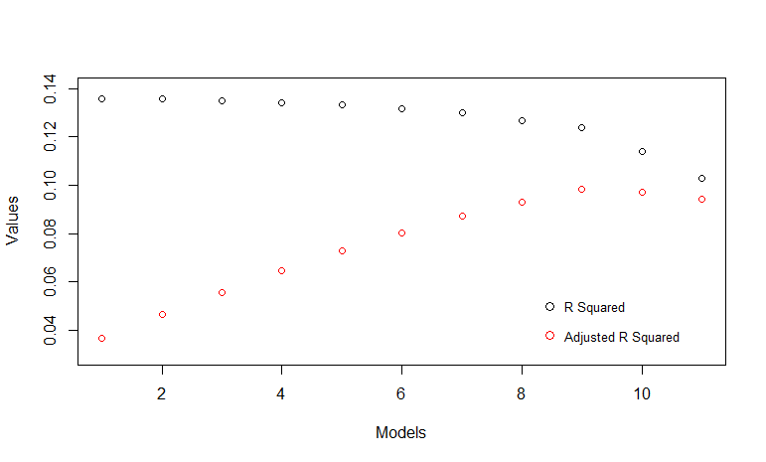

Problem Number 4

