**Chapter IV**

**Results and Discussion**

**Problem 1.**

The available dengue cases data of Regional Health Unit (RHU), Solano, Nueva Vizcaya is from January 2010 to December 2018. Below is Table 1 the monthly dengue cases of RHU.

|  |  |  |  |  |  |  |  |  |  |  |  |  |  |
| --- | --- | --- | --- | --- | --- | --- | --- | --- | --- | --- | --- | --- | --- |
| **Year** | **Jan** | **Feb** | **Mar** | **Apr** | **May** | **Jun** | **Jul** | **Aug** | **Sep** | **Oct** | **Nov** | **Dec** | **Total** |
| 2010 | 12 | 6 | 2 | 1 | 8 | 12 | 5 | 82 | 90 | 51 | 47 | 36 | 352 |
| 2011 | 41 | 31 | 18 | 5 | 10 | 15 | 29 | 45 | 30 | 28 | 34 | 22 | 308 |
| 2012 | 13 | 7 | 11 | 1 | 9 | 21 | 8 | 10 | 13 | 10 | 11 | 3 | 127 |
| 2013 | 10 | 5 | 4 | 9 | 0 | 0 | 0 | 0 | 0 | 0 | 0 | 0 | 28 |
| 2014 | 0 | 0 | 0 | 0 | 0 | 0 | 0 | 0 | 0 | 0 | 0 | 0 | 0 |
| 2015 | 0 | 0 | 2 | 0 | 0 | 3 | 4 | 25 | 0 | 31 | 1 | 5 | 67 |
| 2016 | 0 | 0 | 0 | 0 | 0 | 0 | 0 | 10 | 8 | 8 | 4 | 1 | 31 |
| 2017 | 11 | 8 | 3 | 9 | 8 | 7 | 21 | 9 | 0 | 0 | 4 | 0 | 87 |
| 2018 | 0 | 0 | 0 | 0 | 0 | 0 | 0 | 0 | 23 | 36 | 26 | 14 | 99 |

**Table 1.** The Monthly Dengue Data of Regional Health Unit (RHU), Solano, Nueva Vizcaya

The total dengue cases of 2010 was 352 with a maximum of 90 dengue cases in September and minimum of 1 dengue case in April. The total dengue cases of 2011 was 308 with a maximum of 45 dengue cases in August and minimum of 5 dengue cases in April. The total dengue cases of 2012 was 127 with a maximum of 21 dengue cases in June and minimum of 1 dengue case in April. The total dengue cases of 2013 was 28 with a maximum of 10 dengue cases in January and minimum of 4 dengue cases in March. From May 2013 to February 2015 there were no recorded dengue cases. The total dengue cases of 2015 was 67 with a maximum of 31 dengue cases in October and minimum of 1 dengue case in November. During April to May and September of 2015, there were no recorded dengue cases. The total dengue cases of 2016 was 31 with a maximum of 10 dengue cases in August and minimum of 1 dengue case in December. During January to July 2016 there were no recorded dengue cases. The total dengue cases in 2017 was 87 with a maximum of 21 dengue cases in July and minimum of 3 dengue cases in March. During September to October and December there were no recorded data. The total dengue cases in 2018 was 99 with a maximum of 36 dengue cases in October and minimum of 14 dengue cases in December. During January to August there were no recorded dengue cases.

Figure 1 shows the dengue cases from 2010 to 2018. According to the RHU, these were the only data they had concerning dengue cases because the people in the community choose to go directly to a hospital rather than in their office. The zero cases from May 2013 to February 15, April to May and September 2015, January to July 2016, September to October and December 2017 and January to August 2018 have no recorded dengue cases based on the given data of RHU, Solano, Nueva Vizcaya.

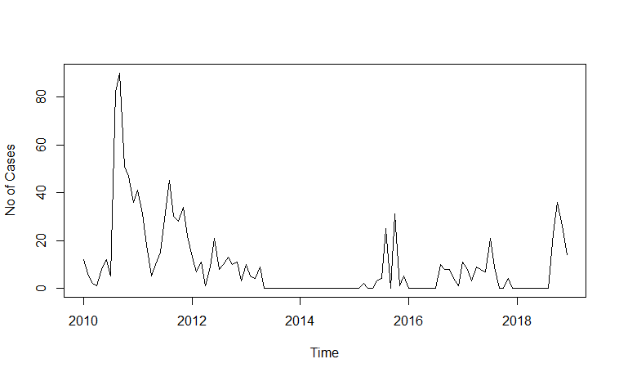

**Figure 1. The Number of Cases per Year**

**Problem 2**

Through backward elimination stepwise time series regression, 11 models were generated. These are models 1 to 11 respectively. Model 11 have significant coefficient estimates with p-values lesser than 0.05. Table 2 shows the models’ coefficient estimates. The coefficient estimates of the models did not change all throughout the process. The process shows that model 11 has 2 terms. The models were able to show varied periodic behaviors of the observed data. All of these models were evaluated for the best-fit model.

**Table 2. The models’ coefficient estimates.**

|  |  |  |  |  |  |  |  |  |  |  |  |  |
| --- | --- | --- | --- | --- | --- | --- | --- | --- | --- | --- | --- | --- |
| Model | $$a_{0}$$ | $$a_{1}$$ | $$b_{1}$$ | $$a_{2}$$ | $$b_{2}$$ | $$a_{3}$$ | $$b_{3}$$ | $$a_{4}$$ | $$b_{4}$$ | $$a_{5}$$ | $$b_{5}$$ | $$a_{6}$$ |
| 1 | 10.06* | 2.36 | -7.18* | -2.23 | 0.66 | 0.15 | 0.96 | -0.53 | -0.91 | -1.23 | 1.25 | 0.43 |
| 2 | 10.06* | 2.36 | -7.18* | -2.23 | 0.66 |  | 0.96 | -0.53 | -0.91 | -1.23 | 1.25 | 0.43 |
| 3 | 10.06* | 2.36 | -7.18* | -2.23 | 0.66 |  | 0.96 |  | -0.91 | -1.23 | 1.25 | 0.43 |
| 4 | 10.06* | 2.36 | -7.18* | -2.23 | 0.66 |  | 0.96 |  | -0.91 | -1.23 | 1.25 |  |
| 5 | 10.06* | 2.36 | -7.18* | -2.23 |  |  | 0.96 |  | -0.91 | -1.23 | 1.25 |  |
| 6 | 10.06* | 2.36 | -7.18* | -2.23 |  |  | 0.96 |  |  | -1.23 | 1.25 |  |
| 7 | 10.06* | 2.36 | -7.18* | -2.23 |  |  |  |  |  | -1.23 | 1.25 |  |
| 8 | 10.06* | 2.36 | -7.18* | -2.23 |  |  |  |  |  |  | 1.25 |  |
| 9 | 10.06* | 2.36 | -7.18* | -2.23 |  |  |  |  |  |  |  |  |
| 10 | 10.06* | 2.36 | -7.18* |  |  |  |  |  |  |  |  |  |
| 11 | 10.06* |  | -7.18* |  |  |  |  |  |  |  |  |  |

*p-value is less than 0.05

**Problem 3**

|  |  |  |  |  |
| --- | --- | --- | --- | --- |
| **Models** | **R2** | $${\overline{R}}^{2}$$ | **RSE** | **AIC** |
| **1** | 0.14 | 0.04 | 15.62 | 913. 42 |
| **2** | 0.14 | 0.05 | 15.54 | 911.42 |
| **3** | 0.14 | 0.06 | 15.46 | 909.49 |
| **4** | 0.13 | 0.06 | 15.39 | 907.58 |
| **5** | 0.13 | 0.07 | 15.32 | 905.69 |
| **6** | 0.13 | 0.08 | 15.26 | 903.90 |
| **7** | 0.13 | 0.09 | 15.20 | 902.13 |
| **8** | 0.13 | 0.09 | 15.15 | 900.50 |
| **9** | 0.12 | 0.10 | 15.11 | 898.89 |
| **10** | 0.11 | 0.10 | 15.12 | 898.11 |
| **11** | 0.10 | 0.09 | 15.14 | 897.45 |

**Table 3.** The Fit Indices of the Model

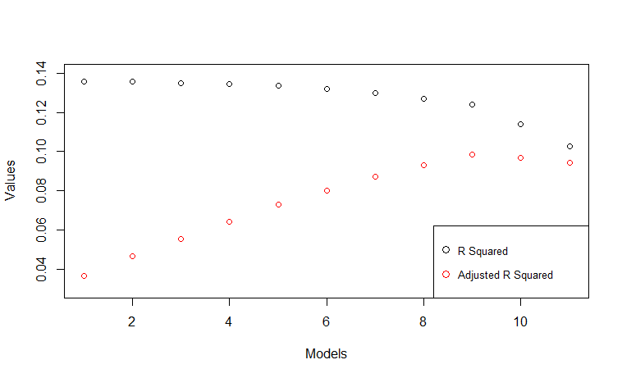

**Figure 2. The R squared and adjusted R squared values of the models.**

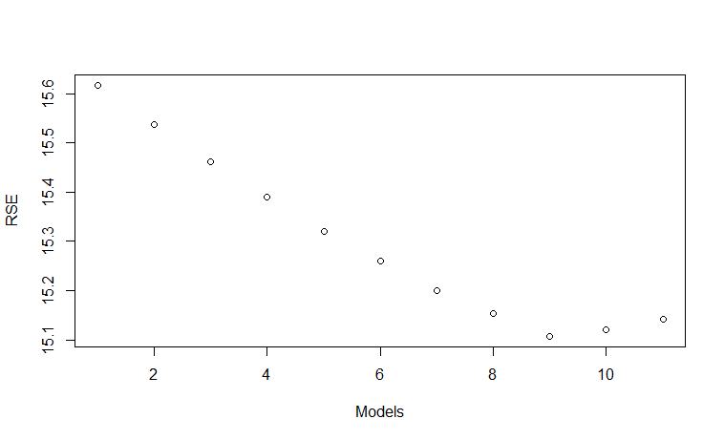**Figure 3. The RSE values of the models.**

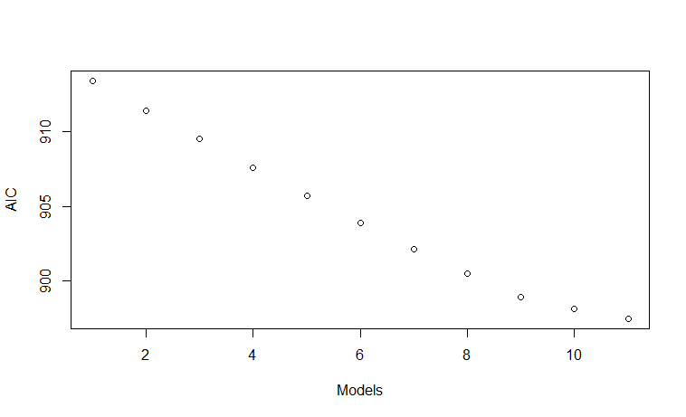**Figure 4. The AIC values of the models.**

Table 3 shows the fit indices of all the models generated. The best-fit model is model 11. It has 2 terms – the mean term, and the sine term of the first harmonic – accounting to the 12-month period – both of which are significant having p-values lesser than 0.05. Although model 9 has the highest ${\overline{R}}^{2}$ and the lowest RSE among the models, the difference of these values compared to model 11 are negligible. Furthermore, Model 11 has the best AIC among all the models suggesting it to be the best-fit model and is parsimonious.

**Problem 4.**

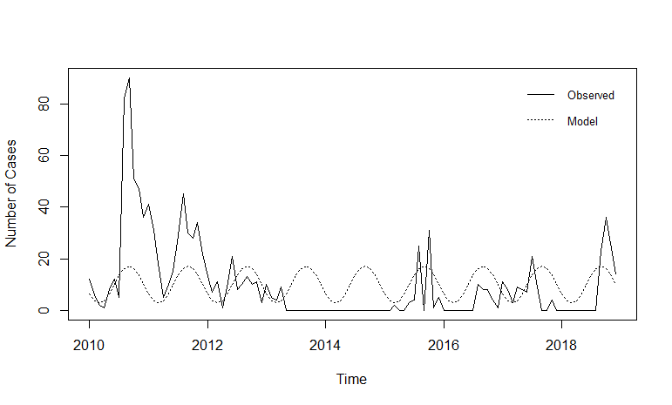

**Figure 5. The observed data and the best-fit model.**

The periodic monthly dengue cases of RHU, Solano as described by the collected data was not captured by the best-fit model. The best-fit model shows that the dengue cases in Solano peaks in September with an average of 17 cases and least in March with an average of 2 cases. Which is completely different from the obtain data.

**Chapter V**

**SUMMARY, CONCLUSION AND RECCOMENDATION**

**Summary**

From the periodic monthly dengue cases of RHU, Solano as described by the collected data was not captured by the best-fit model. The best-fit model shows that the dengue cases in Solano peaks in September with an average of 17 cases and least in March with an average of two cases. Which is completely different from the obtain data.

Eleven models were generated as candidate for the best-fit model. These models were able to show varied periodic behaviors for the dengue cases of Solano using Time series as the regression model. All of these models explained more or less 10 percent of the total variance in the observed data.

Model 11 is the best-fit model having one of the highest ${\overline{R}}^{2}$ and the least RSE and AIC among the models that have significant terms. It was able to explain 9 percent variance in the observed data. Although model 9 has the highest ${\overline{R}}^{2}$ and the lowest RSE among the models, the difference of these values compared to model 11 are negligible..

The periodic monthly dengue cases of Solano which was not captured by the best-fit model. Thus, a Time Series can describe and represent the periodic monthly dengue cases of Solano.

**Conclusion**

Coming up with 11 models and having a best-fit model which is Model 11 does not gratify that it covers the gathered data. Model 11 may not be reliable because of incomplete and missing data.

**Recommendation**

In the light of this study the researchers were able to come up with the following recommendations – most are addressed to mathematical modelers for them to conduct various studies validating the results of this study since this is the first attempt to model the dengue cases of RHU, Solano, Nueva Vizcaya:

1. The researchers recommend that mathematical modelers should conduct similar studies to dengue cases in other municipality.
2. The researchers recommend that mathematical modelers conduct similar studies using another form of analysis in the time domain and compare their findings with the findings of this study.
3. The researchers also recommend that mathematical modelers should look into modeling the dengue cases of Solano at different time scales such as weekly, and annually.
4. The researchers also recommend the conduct of studies validating the performance of model 9 or the best-fit model with additional observed data in the future.
5. The researchers recommend that RHU should gather more data or information for this study to have a better and reliable model.
6. This study will also give the future researchers an encouragement to continue this study and find complete data.

Having the positive feedback of the evaluators, we, the researchers highly recommends that this study should be acknowledge as a source of information for the next studies related.