Untitled

Orville D. Hombrebueno

# Introduction

Statistical literacy as defined by Wallman (1993) is “the ability to understand and critically evaluate statistical results that permeate our daily lives – coupled with the ability to appreciate the contributions that statistical thinking can make in public and private, professional and personal decisions” (as cited by Watson, 2011). Statistical literacy is very important to people in this ICT driven world we live in. Due to advances in technology, information is easily available and the need to use this information to guide decision making is inevitable to everyone. According to Steen (2001), statistical literacy “empowers people by giving them tools to think for themselves, to ask intelligent questions of experts, and to confront authority confidently. These are skills required to survive in the modern world” (as cited in Franklin et al., 2007, p. 3). With that said, Franklin et al. (2007) continued to point out that investing in statistical literacy is investing in the economic future of the nation and the well-being of individuals.

To advance statistical literacy, statistics education plays a big role. To improve the quality of statistics education, the government and education institutions have a lot to contribute.

# Presentation of Cases

## Philippines

### Government

Chance, Ben-Zvi, Garfield, & Medina (2007)

Langcauon & Reston (2018)

Reston, Piramide, & Loquias (2016)

Reston & Loquias (2018)

Jala & Reston (2014)

Reston & Bersales (2011)

In discussing statistical literacy, it is noteworthy to discuss the study of Watson (2011) entitled, *Foundations for Improving Statistical Literacy*. In her quest to forward and improve statistical literacy, she pointed out that variation which is the very essence of doing statistics is not given priority in the teaching of statistics. She argued that building the foundation of statistical literacy need not to be accompanied by complex calculations and theoretical assumptions but by understanding that probability associated to sampling and variation is included in the process of doing statistical investigation. Thus, she suggested two models that are critical in developing statistical understanding. The first model shows the relationship of five components in answering a statistical question considering variation in each component; data collection, data representation, data reduction, chance, inference. Figure 1 shows this model. The second model is for planning and implementation of programs that would lead to the development of statistical literacy. It is a three level model for statistical literacy; terminology, context, critical thinking. The first tier focuses on understanding and familiarization of statistical terminologies used in statistical reasoning and decision-making. The second focuses on the applications to societal concerns of this statistical language. The third focuses on critical thinking that enables people to challenge vague claims and statements. According to her, this setting does not necessarily mean that one is a prerequisite of the next but each one complements each other.

Furthermore, Watson (2011) discussed the models’ implementation by considering the different structure of responses from learners when asked various contextual statistical questions. These structures are prestructural, unistructural, multistructural, and relational. Being aware of these responses facilitates in building classroom experiences, serves as a meaningful basis for

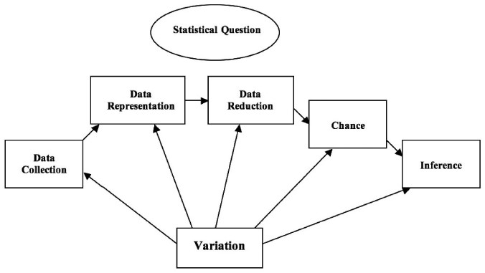

Figure 1. Relationships and Components in Statistical Thinking

developing concepts through the second model with regards to the first model; ensuring the attainment of critical thinking (Watson, 2011). She goes on by suggesting that statistical questions relating to cause-effect claims from the media are most effective to attain critical thinking and that this approach can be applied to adult learners since it can be appealing to them.

Moreover, having discussed previous studies on gauging statistical literacy which concluded that most students work consistently in context and few attain critical thinking, Watson (2011) concluded that statistical literacy is very important in the curriculum. She added that the need for context to provide learning experiences for statistical literacy establishes a connection with and its importance to other areas in the curriculum. Thus, statistical literacy should be included in the cross-curriculum part of the overall curriculum and should be explicitly stated (Watson, 2011). She finally suggests that critical thinking statistical literacy can be a tool to achieve literacy and numeracy across the curriculum.

Franklin et al. (2007) GAISE College Report ASA Revision Committee (2016)

# Summary and Conclusion

# References

Chance, B., Ben-Zvi, D., Garfield, J., & Medina, E. (2007). The role of technology in improving student learning of statistics. *Technology Innovations in Statistics Education*, *1*(1). Retrieved from <https://escholarship.org/uc/item/8sd2t4rr>

Franklin, C., Kader, G., Mewborn, D. S., Moreno, J., Peck, R., Perry, M., & Scheaffer, R. (2007). *Guidelines for assessment and instruction in statistics education (GAISE) report: A pre-k-12 curriculum framework*. Alexandria, VA: American Statistical Association.

GAISE College Report ASA Revision Committee. (2016). Guidelines for assessment and instruction in statistics education college report 2016. Retrieved July 13, 2019, from <http://www.amstat.org/education/gaise>

Jala, L. L., & Reston, E. (2014). Sustaining student engagement in a college statistics course through a reflective teaching model using youth statistics. In K. Makar, B. de Sousa, & R. Gould (Eds.), *Sustainability in Statistics Education. Proceedings of the Ninth International Conference on Teaching Statistics (ICOTS9, July, 2014), Flagstaff, Arizona, USA*. Voorburg, The Netherlands: International Statistical Institute; International Association of Statistical Education.

Langcauon, J. Y., & Reston, E. D. (2018). Using activity-based cooperative learning materials to develop high school students’ critical thinking and problem solving skills in statistics and probability. In M. A. Sorto, A. White, & L. Guyot (Eds.), *Looking Back, Looking Forward. Proceedings of the Tenth International Conference on Teaching Statistics (ICOTS10, July, 2018), Kyoto, Japan*. Voorburg, The Netherlands: International Statistical Institute; International Association of Statistical Education.

Reston, E., & Bersales, L. G. (2011). Reform efforts in training statistics teachers in the Philippines: Challenges and prospects. In C. Batanero, G. Burrill, & C. Reading (Eds.), *Teaching Statistics in School Mathematics-Challenges for Teaching and Teacher Education: A Joint ICMI/IASE Study* (pp. 41–45). Springer Science+Business Media B.V. <https://doi.org/10.1007/978-94-007-1131-0_8>

Reston, E. D., & Loquias, C. M. (2018). Improving statistical pedagogy among k to 12 mathematics teachers in the Philippines. In M. A. Sorto, A. White, & L. Guyot (Eds.), *Looking Back, Looking Forward. Proceedings of the Tenth International Conference on Teaching Statistics (ICOTS10, July, 2018), Kyoto, Japan*. Voorburg, The Netherlands: International Statistical Institute; International Association of Statistical Education.

Reston, E. D., Piramide, J., & Loquias, C. M. (2016). Promoting statistical literacy and understanding of youth population dynamics in a new statistics and probability course for senior high school. In J. Engel (Ed.), *Promoting Understanding of Statistics About Society. Proceedings of the Roundtable Conference of the International Association of Statistics Education (IASE), July 2016, Berlin, Germany*. International Statistical Institute; International Association of Statistical Education.

Watson, J. M. (2011). Foundations for improving statistical literacy. *Statistical Journal of the IOS*, *27*, 197–204. <https://doi.org/10.3233/SJI20110728>