Training-Workshop on Building Resilient Communities: DRRMT Training and Livelihood Formation for Women’s Organization
Summary of Evaluation
Barangay Vista Alegre
2025-12-23

Ratings
The training was evaluated by 14 participants. Most of the ratings for relevance, timeliness, and overall rating are excellent. The percentage of ratings for each item is shown in Figure 1. Relevance, timeliness, and overall rating has a rating of excellent with means 4.86, 4.86, and 4.86 respectively.
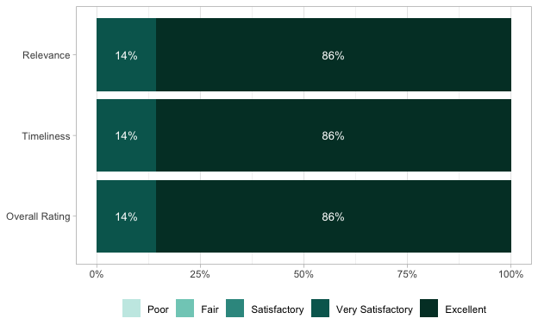
Figure 1: Percentage of Ratings

Other Training / Activity / Technical Service Needed
During the event, participants expressed the following interests in other training, activity, and technical services needed:
- Livelihood and Entrepreneurship Development: Trainings related to starting and managing one’s own business.
- Food Production: Mushroom production and processing, turmeric-based product development, and wine production.
- Arts, Crafts, and Creative Skills: Bead making (including ethnic bracelet and headdress–inspired designs).
- Technical and Vocational Skills: Dress making.
The repeated mention of mushroom production and processing and wine making reflects strong community interest in these areas.

Comments / Suggestions on How to Improve Our Services
Participants expressed strong appreciation for the training. Several respondents conveyed positive remarks such as congratulations and encouragement to continue the program.
Key feedback includes:
- Positive Feedback: Participants praised the quality of the training and the effectiveness of the session, noting that it was excellent and informative.
- Suggestions for Improvement: There were repeated requests for more trainings and seminars, particularly to broaden participants’ knowledge and skills, including deeper learning on mushroom production and processing.
Overall, the feedback reflects high participant satisfaction and a strong demand for additional and more frequent capacity-building activities.

