Training-Workshop on Building Resilient Communities: DRRMT Training and Livelihood Formation for Women’s Organization
Summary of Evaluation
Barangay Paitan
2025-12-22

Ratings
The training was evaluated by 22 participants. Most of the ratings for relevance, timeliness, and overall rating are excellent. The percentage of ratings for each item is shown in Figure 1. Relevance, timeliness, and overall rating has a rating of excellent with means 4.73, 4.73, and 4.77 respectively.
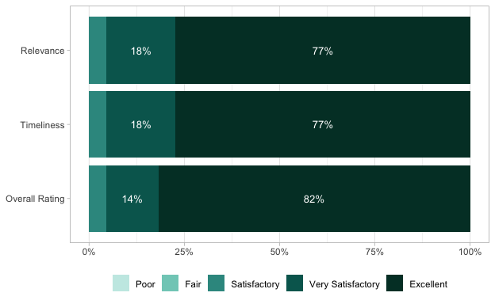
Figure 1: Percentage of Ratings

Other training/activity/technical service needed
During the event, participants expressed the following interests in other training, activity, and technical services needed:
- Livelihood and Entrepreneurship Development: Business-related trainings, women and business–related trainings, and livelihood programs addressing women’s needs.
- Agriculture and Food Production: Rice production and pest management training, Bread making and baking activities.
- Technical and Vocational Skills: Dressmaking and garment production, electrical servicing, and automotive.
The repeated mention of dress making and bread making highlights a strong interest in these areas.

Comments / Suggestions on How to Improve Our Services
Participants generally expressed positive feedback particularly appreciating the competence of the speakers and the quality of instruction.
Positive Observations:
Participants commended the presence of skilled speakers and trainers, noting that the instructors were effective and capable of facilitating learning.
Suggestions for Improvement:
- Discipline and Timeliness: Participants emphasized the importance of unity, discipline, and early or timely conduct of activities to ensure smooth implementation.
- Capacity-Building Needs: There were repeated requests for more training opportunities, particularly in dressmaking.
- Continuous Development: Participants suggested sustained engagement through continuous review of performance and follow-up activities to further enhance skills and learning outcomes.
Overall, the feedback indicates satisfaction with the trainers and program delivery, alongside a strong demand for additional trainings and continuous improvement initiatives.

