One Variable: Quantitative
Orville D. Hombrebueno
2024-12-04
Table of contents

The Data

Edgar Anderson’s Iris Data
This famous (Fisher’s or Anderson’s) iris data set gives the measurements in centimeters of the variables sepal length and width and petal length and width, respectively, for 50 flowers from each of 3 species of iris. The species are Iris setosa, versicolor, and virginica.
The first 6 rows of the iris data set are shown in Table 1.
Table 1: The first 6 observations of the data set.
Sepal Length | Sepal Width | Petal Length | Petal Width | Species
5.1 | 3.5 | 1.4 | 0.2 | setosa
4.9 | 3.0 | 1.4 | 0.2 | setosa
4.7 | 3.2 | 1.3 | 0.2 | setosa
4.6 | 3.1 | 1.5 | 0.2 | setosa
5.0 | 3.6 | 1.4 | 0.2 | setosa
5.4 | 3.9 | 1.7 | 0.4 | setosa

Descriptive Statistics
The mean, standard deviation, minimum, and maximum of the data set by species are shown in Table 2. There is a total of 150 observations; 50 observations per species.
Table 2: Summary statistics of the data set.
Characteristic | N = 150¹
Sepal Length | 5.84 ± 0.83 (4.30 - 7.90)
Sepal Width | 3.06 ± 0.44 (2.00 - 4.40)
Petal Length | 3.76 ± 1.77 (1.00 - 6.90)
Petal Width | 1.20 ± 0.76 (0.10 - 2.50)
Species
setosa | 50 (33%)
versicolor | 50 (33%)
virginica | 50 (33%)
¹Mean ± SD (Min - Max); n (%)
A visualization of sepal length is shown in Figure 1.
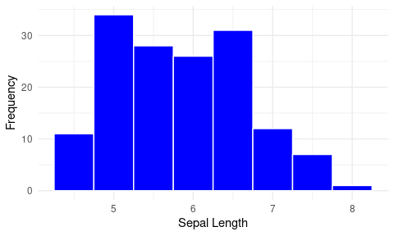
Figure 1: Histogram of sepal length.

Hypothesis Testing

Two-Sided

Research Question
Is the mean sepal length different from the expected average of 5.8 cm?

Hypothesis and Test Statistics
- $H_{0}:μ=5.8$; the mean sepal length is equal to 5.8 cm.
- $H_{a}:μ≠5.8$; the mean sepal length is different from 5.8 cm.
- Significance level, $α=5\%$.
- one sample t-test
- The variance is unknown.
- $n>30$; large sample.

Results and Interpretation
The test statistics is shown on Table 3.
Table 3: Test statistics.
estimate | statistic | p.value | method | alternative
5.84 | 0.64 | 0.52 | One Sample t-test | two.sided

Based on the p-value being greater than 5% (p-value = 0.52), we do not reject the null hypothesis. There is no sufficient evidence that the mean sepal length is different from 5.8 cm.

One-Sided

Research Question
Is the mean sepal length greater than the expected average of 5.7 cm?

Hypothesis and Test Statistics
- $H_{0}:μ=5.7$; the mean sepal length is equal to 5.7 cm.
- $H_{a}:μ>5.7$; the mean sepal length is greater than 5.7 cm.
- Significance level, $α=5\%$.
- one sample t-test
- The variance is unknown.
- $n>30$; large sample.

Results and Interpretation
The test statistics is shown in Table 4.
Table 4: Test statistics.
estimate | statistic | p.value | method | alternative
5.84 | 2.12 | 0.02 | One Sample t-test | greater

Based on the results and the p-value being lesser than 5% (p-value = 0.02), we reject the null hypothesis. There is sufficient evidence that the mean sepal length is greater than the expected average of 5.7 cm.

