One Variable: Qualitative
Orville D. Hombrebueno
2024-12-02
Table of contents

The Data

The Titanic Data Set
The Titanic_full data set of the {ggstatsplot} package is a data frame with 2201 rows and 5 variables.
- id. Dummy identity number for each person.
- Class. 1st, 2nd, 3rd, Crew.
- Sex. Male, Female.
- Age. Child, Adult.
- Survived. No, Yes.
This data set provides information on the fate of passengers on the fatal maiden voyage of the ocean liner Titanic, summarized according to economic status (class), sex, age and survival.
The first 6 rows of the titanic data set are shown in Table 1.
Table 1: The first 6 observations of the data set.
id | Class | Sex | Age | Survived
1 | 3rd | Male | Child | No
2 | 3rd | Male | Child | No
3 | 3rd | Male | Child | No
4 | 3rd | Male | Child | No
5 | 3rd | Male | Child | No
6 | 3rd | Male | Child | No

Descriptive Statistics
The frequency distribution of the variables in the data set is shown in Table 2. Most of the passengers are crew members, male, and adult. Only 32% of the passengers survived.
Table 2: Summary statistics of the data set.
Characteristic | N = 2,201¹
Class
1st | 325 (15%)
2nd | 285 (13%)
3rd | 706 (32%)
Crew | 885 (40%)
Sex
Female | 470 (21%)
Male | 1,731 (79%)
Age
Adult | 2,092 (95%)
Child | 109 (5.0%)
Survived | 711 (32%)
¹n (%)
A visualization of the Survived variable is shown in Figure 1.
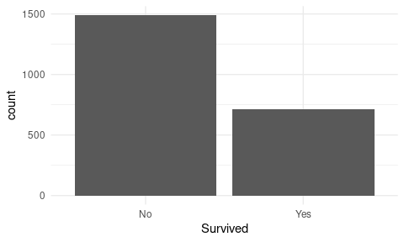
Figure 1: Bar chart

Hypothesis Testing
::: panel-tabset ## Two-Sided

Research Question
Do the passengers have a 50/50 chance of surviving?

Hypothesis and Test Statistics
- $H_{0}:p=50\%$; proportions of surviving are equal.
- $H_{a}:p≠50\%$; proportions of surviving are different.
- Significance level, $α=5\%$.
- one proportion z-test
- Success-failure condition is met.

Results and Interpretation
The test statistics is shown on Table 3.
Table 3: Test statistics.
estimate | statistic | p.value | method | alternative
0.32 | 6.92 | 0.01 | 1-sample proportions test with continuity correction | two.sided

Based on the p-value being less than 5% (p-value = .001), we reject the null hypothesis. There is a strong evidence that the proportion of surviving is different among passengers. This may be influenced by certain factors like class, gender, or age?

One-Sided

Research Question
Is the survival rate less than the expected survival rate of 35%?

Hypothesis and Test Statistics
- $H_{0}:p=35\%$; the survival rate is equal to the expected survival rate of 35%.
- $H_{a}:p<35\%$; the survival rate is less than the expected survival rate of 35%.
- Significance level, $α=5\%$.
- one proportion Z-test
- Success-failure condition is met.

Results and Interpretation
The test statistics is shown in Table 4.
Table 4: Test statistics.
estimate | statistic | p.value | method | alternative
0.32 | 6.92 | 0 | 1-sample proportions test with continuity correction | less

Based on the results and the p-value being lesser than 5% (p-value = 0.004), we reject the null hypothesis. There is strong evidence that the survival rate is less than the expected survival rate of 35%.

